BUSINESS STRATEGY & INVESTABILITY REPORT
PrivacyGuard AI
AI-Powered Digital Footprint & Privacy Risk Platform
Prepared as: AI Co-Founder / Growth Strategist / YC Advisor Review
Source: Day 23 Customer & MVP Blueprint + Startup Validation Report
Date: August 1, 2026
Confidential — Prepared for Founder Use Only

Table of Contents
1. Executive Summary
2. Startup Summary (Source Blueprint)
3. Core Assumptions Extracted
4. Business Reality Check
5. Business Strategy Report
5.1 Business Model Canvas
5.2 Revenue & Pricing Strategy
5.3 Go-To-Market Strategy
5.4 Customer Acquisition Strategy
5.5 First 100 Users Plan
5.6 Competitive Position & Moat
5.7 Reverse SWOT Analysis
5.8 Investor One-Liner
5.9 30-Second Founder Pitch
6. Investment Scorecard
7. Visual Dashboard
8. Founder Action Sheet — Top 10 Actions
9. Sustainability Verdict

1. Executive Summary
PrivacyGuard AI is a concept-stage, India-first consumer app targeting a real and growing problem: people don't know which apps hold their data or how exposed they are. The category is validated at the macro level — global competitors (DeleteMe, Incogni, Aura) prove people will pay for privacy tools, and India's DPDP Act 2023 plus rising breach awareness create a genuine timing window. No India-first consumer privacy brand currently exists at scale.
However, the venture has zero direct evidence today: no customer interviews, no landing page, no waitlist, no prototype, and no pricing conversations. The single biggest unresolved question is not whether the problem exists — it clearly does — but whether Indian consumers will pay for the solution, given a documented history of weak willingness-to-pay for consumer security/privacy software in this market.
This report evaluates PrivacyGuard AI against revenue potential, distribution strength, evidence quality, and execution readiness — not feature completeness. The verdict: this is a Validate-stage opportunity, not an Investable one. The next 30 days of direct customer contact (interviews, a landing page, and 5 real pricing conversations) will determine whether it becomes fundable.

2. Startup Summary (Source Blueprint)
- Product: An AI-powered app-permissions and data-exposure scanner that outputs a plain-language "privacy score" plus 2–3 one-tap fixes for a non-technical Indian audience.
- Market: India first (DPDP Act 2023 tailwind, 850M+ smartphone users), with a longer-term path into US/Canada/UK/Australia/Europe.
- Target customer: 18–35 urban Indians — students, early-career professionals, freelancers — active on 10+ apps daily, moderate-to-high digital literacy but low privacy-settings literacy.
- Competitive gap: DeleteMe, Incogni, Aura and Mozilla Monitor are US-priced ($8–15/mo), removal-focused, and jargon-heavy; none are India-first, education-led, or priced for local willingness-to-pay.
- Stage: Idea/concept only. No interviews, landing page, prototype, or paying users exist as of this report.
- Founder-market fit: Moderate (5.7/10) — genuine domain passion, but low current network access, low credibility signal in a trust-sensitive category, and no prior validation effort completed.
- Sizing: TAM ~$33B (global), SAM ~$10B (launch geographies), SOM ~$0.4M–$3M ARR realistic 3-year India beachhead — small and consumer-price-sensitive relative to the ambition.
- Stated verdict in source materials: "Promising but Unvalidated" / "Conditional GO — validate before you build."

3. Core Assumptions Extracted
Dimension | Stated Assumption | Evidence Level
Customer | Priority-Curious Priya (24, urban India) will adopt a free scan and convert to ₹99–199/mo | Anecdotal only — no interviews
MVP | A single-feature scanner + privacy score is enough to prove the core loop (scan → score → fix) | Reasoned, untested
Value proposition | Plain-language, India-priced transparency beats jargon-heavy, US-priced incumbents | Directionally plausible, unverified with users
Pricing | ₹99–299/month freemium, 3–5x below US competitor pricing, is the right price point | Hypothesis — 0 pricing conversations held
Revenue | $0.4M–$3M ARR achievable in India within 3 years via freemium conversion | Top-down model, not bottom-up funnel data
GTM | Breach-news and spam-surge trigger content, campus word-of-mouth, and referral will drive signups | Unverified — no channel has been tested

These are reasonable starting hypotheses, but every one of them is currently unverified. The Founder Action Sheet in Section 8 exists to convert each of these into evidence.

4. Business Reality Check

Who pays?
Primary: individual Indian consumers (18–35, urban) on a freemium-to-paid subscription. Secondary and likely more reliable: institutions (colleges, fintechs, employers) via a B2B2C pilot, where budgets exist and DPDP compliance pressure gives a real "why now."

Why do they pay?
For relief from a specific anxiety moment (breach news, spam-call surge) resolved by a fast, understandable first result — not for ongoing feature depth. The willingness to pay is trigger-based and emotional, not habitual, which favors point-in-time monetization (one-time or triggered upgrades) over a hard subscription assumption.

How will they discover the product?
Realistically: founder-led manual outreach, campus/peer networks, and shareable "what's your privacy score" social content tied to breach news cycles. No paid acquisition budget or channel has been tested; discovery depends entirely on organic and referral mechanics working, which is unproven.

Biggest growth risks
- No tested acquisition channel — all GTM assumptions are theoretical.
- A single founder with a small network cannot manually source enough interviews or early users to reach statistical confidence quickly.
- Category requires unusually high trust for a first-time, unknown brand to earn attention at all (the trust paradox).

Biggest monetization risks
- India has a well-documented pattern of low consumer willingness-to-pay for privacy/security software specifically.
- Free alternatives exist (Google/Apple privacy dashboards, Mozilla Monitor) that partially cover the same anxiety at zero cost.
- Freemium core-scan-free-forever model risks a large free tier with a thin paid conversion funnel if the "aha moment" isn't sharp enough.

Weakest assumptions to validate first
- That users will pay anything at all — not just find the score interesting.
- That a plain-language score is sufficiently differentiated from free platform dashboards to justify payment.
- That referral/organic growth can reach meaningful volume without paid acquisition.

5. Business Strategy Report

5.1 Business Model Canvas
Block | Summary
Value Proposition | Fast, plain-language privacy score + top 2–3 one-tap fixes, built India-first with minimal-permission, radically transparent design.
Customer Segments | Primary: urban Indians 18–35, moderate digital literacy. Secondary: parents/families. Tertiary (B2B2C): colleges, fintechs, employers.
Channels | Organic social content on breach triggers, campus word-of-mouth, referral loop, direct outreach; B2B2C pilots as a distribution shortcut.
Customer Relationships | Self-serve freemium app with lightweight monthly check-ins; human-touch B2B2C pilot relationships for institutional deals.
Revenue Streams | Freemium subscription (₹99–299/mo), family/parental plan upsell, B2B2C licensing, future SMB DPDP-lite tier.
Key Resources | Founder technical ability, a lean scan engine, a transparent minimal-permission data policy, early trust signals/audits.
Key Activities | Build/iterate the scanner, run structured validation interviews, produce trigger-based content, manage trust/compliance posture.
Key Partners | None yet secured — potential: campus communities, fintech/college pilots, future cyber-insurance or identity-protection bundlers.
Cost Structure | Low capex — founder time, hosting, minimal-permission engineering; cost grows with credibility-building (audits, legal/DPDP counsel).

5.2 Revenue & Pricing Strategy
The pricing hypothesis (₹99–299/month freemium) is reasonable relative to US comparables, but pricing has never been tested in a real conversation. Two structural risks apply regardless of the exact number: (1) India's consumer security spend is historically thin, and (2) free platform-native alternatives create an anchor of $0.
Stream | Model | Confidence
Consumer freemium | ₹99–299/mo for continuous monitoring, alerts, family coverage | Low — untested pricing
Family/parental plan | Higher ARPU bundle for household coverage | Low — not yet designed
B2B2C licensing | Per-seat or flat fee to colleges/fintechs/employers | Medium — institutions have budgets and a DPDP-driven reason to buy
SMB DPDP-lite (future) | Simplified compliance tier undercutting enterprise tools | Speculative — not scoped
Recommendation: treat B2B2C as the primary near-term revenue validation path — institutional buyers have both budget and a regulatory trigger (DPDP Act), which materially de-risks the weakest link in the consumer plan (willingness to pay).

5.3 Go-To-Market Strategy
GTM should be sequenced around trigger events rather than always-on marketing, since the target persona is not chronically anxious about privacy — she reacts to specific incidents (a breach in the news, a spam-call spike). The flow: trigger → shareable content → transparent landing page → fast free scan → convert/refer. See the Visual Dashboard in Section 7 for the flow diagram.
- Phase 1 (Weeks 1–4): Manual, trigger-based outreach and interviews; no paid spend.
- Phase 2 (Months 2–3): Landing page + waitlist live; content tied to real breach news cycles; first B2B2C pilot conversations opened.
- Phase 3 (Months 4–6): Narrow MVP live with 100+ real users; referral loop tested; first paid conversions measured.

5.4 Customer Acquisition Strategy
- Zero paid acquisition until organic/referral mechanics are proven — the founder cannot fund CAC experiments yet.
- Lead with trust, not features: publish the minimal-permission data policy before asking for a single sign-up.
- Use breach-news and spam-surge moments as the content calendar, not a generic drip campaign.
- Treat every early user as an interview subject first, a user second — acquisition and validation should be the same motion for the first 90 days.

5.5 First 100 Users Plan
Source | Target Users | Method
Direct founder outreach | 30 | 1:1 messages to campus network + early-career contacts, framed as interviews first
Trigger-based social content | 25 | Post tied to a real breach/spam news moment with a shareable "what's your score" hook
Campus/community shares | 20 | WhatsApp/Telegram/campus groups, positioned as a free tool, not a pitch
Referral from early users | 15 | Simple share-with-a-friend prompt after first scan
Micro-influencer / community post | 10 | One relevant student-community or tech micro-influencer mention

5.6 Competitive Position & Moat
Today PrivacyGuard AI has no moat — it has a positioning gap. DeleteMe, Incogni, and Aura are removal-focused, US-priced, and jargon-heavy; Mozilla Monitor is free but shallow. None are India-first. That gap is real, but a moat has to be built through trust, distribution, and local coverage — none of which exist yet.
Moat Candidate | Status
India-first pricing & language | Planned, not built
Education-first UX (why exposed, not just removal) | Design principle only, unshipped
Trust via minimal-permission architecture + audits | Stated intent, no audits yet
Distribution via referral + B2B2C relationships | Zero relationships secured
DPDP-Act-aligned compliance posture | Not yet built
None of these are defensible against a fast-moving, well-funded entrant (Aura, Incogni, or a Big Tech player) localizing India pricing. Speed to real user trust and local distribution — not feature complexity — is the only realistic moat available to a solo founder.

5.7 Reverse SWOT Analysis
A reverse SWOT stress-tests strengths as future weaknesses and turns threats into strategic opportunities.
Element | Reframe
Strength → Risk | "India-first" positioning is a strength today, but becomes a ceiling if the founder never validates expansion markets — the SAM outside India is 4x larger.
Weakness → Fixable Now | No interviews/landing page is a weakness that costs almost nothing to fix in 30 days — this is the cheapest risk to retire.
Opportunity → Overstated | The "$33B TAM" is an illustrative ceiling, not a near-term target; treating it as real risks over-optimistic planning versus the realistic $0.4–3M SOM.
Threat → Opportunity | A slow-moving incumbent market (no India-first player) is also evidence that consumer willingness-to-pay may be genuinely low there — worth confirming before assuming it's purely a timing gap.

5.8 Investor One-Liner
"PrivacyGuard AI is building India's first plain-language privacy-score app for the 850M smartphone users left behind by US-priced, jargon-heavy privacy tools — currently pre-validation, seeking evidence before scale."

5.9 30-Second Founder Pitch
"Most Indians have no idea which apps are quietly holding their data — and when a breach hits the news, all they can do is panic. Existing privacy tools are built for Americans: expensive, technical, and confusing. PrivacyGuard AI gives anyone a plain-language privacy score and three simple fixes in under two minutes, priced for India. We're validating demand now with real users before we build further — the goal is to become the trusted first stop for digital privacy in India, the way DeleteMe and Incogni are in the US."

6. Investment Scorecard (0–100)
Dimension | Score | Reasoning
Business Viability | 48 | Real problem and timing, but no revenue engine proven; freemium-to-paid conversion in India is unverified.
Revenue Potential | 38 | SOM is small ($0.4–3M ARR) and dependent on an unproven willingness-to-pay assumption; B2B2C could raise this materially if pursued.
GTM Strength | 45 | A sensible trigger-based, low-cost GTM plan exists on paper, but zero channels have been tested and no CAC data exists.
Competitive Strength | 55 | Clearest score — the India-first, education-led positioning gap versus DeleteMe/Incogni/Aura/Mozilla Monitor is genuinely open today.
Investor Readiness | 22 | Idea-stage only: no interviews, landing page, prototype, or pricing conversations. Not fundable in current form.

Composite average: 41.6 / 100 — consistent with a Validate verdict rather than Investable.

7. Visual Dashboard
The infographic below summarizes the business model, revenue streams, GTM flow, first-100-users plan, competitive moat, key risks, scorecards, and final verdict on a single page.
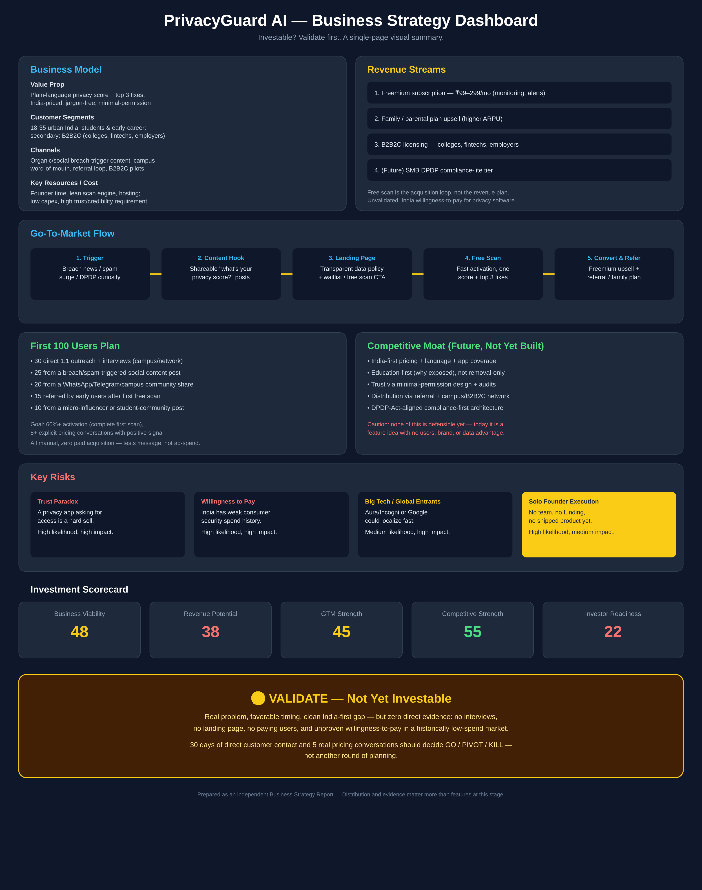

8. Founder Action Sheet — Top 10 Actions
- 1. Run 20–30 structured interviews with the defined ICP, explicitly asking about willingness to pay in rupees.
- 2. Publish a one-page landing site with a clear value proposition and an email waitlist.
- 3. Write and test a single-sentence value proposition with at least 10 people outside your existing network.
- 4. Deep-dive DeleteMe, Incogni, Aura, and Mozilla Monitor on pricing, features, and messaging gaps.
- 5. Set an India-specific pricing hypothesis (₹99–299/month freemium) and commit to testing it, not assuming it.
- 6. Scope exactly one MVP feature — the app permissions & exposure scanner — and nothing else.
- 7. Build a clickable prototype (Figma) or an ultra-lean single-feature web tool.
- 8. Test the prototype with 10–15 real users and measure activation (do they complete the first scan?).
- 9. Hold 5 explicit pricing conversations — not hypothetical, real "would you pay ₹X" conversations.
- 10. Open at least one B2B2C pilot conversation (college, fintech, or employer) to test the higher-confidence revenue path in parallel with the consumer funnel.

9. Sustainability Verdict
🟡 VALIDATE — Not Yet Investable
PrivacyGuard AI addresses a real and growing problem with genuinely favorable India-market timing and a clear, currently-open competitive gap — but it has no direct evidence of demand, no tested acquisition channel, and no validated willingness to pay, which are the three things that actually determine whether this becomes a sustainable business. It is not investable in its current form, and it should not raise or scale yet.
The path forward is narrow but achievable for a solo founder: complete the 30-day validation plan (structured interviews, a live landing page, and five real pricing conversations, including at least one B2B2C pilot), and let that evidence — not further planning — decide whether to build, pivot toward B2B2C/family verticals, or shut the idea down.

