Brazilian E-commerce Olist

In this project, I performed an end-to-end analysis of the Olist e-commerce dataset. The project focused on preparing raw data, generating insights through SQL queries, and creating interactive dashboards using Excel, Power BI, and Tableau.
Dataset
Project Objective
The goal of the project was to analyze customer orders, payments, product categories, shipping timelines, and reviews to uncover patterns that could help improve business decisions related to customer satisfaction, delivery performance, and product performance.

KPI
- Weekday Vs Weekend (order_purchase_timestamp) Payment Statistics
- Number of Orders with review score 5 and payment type as credit card.
- Average number of days taken for order_delivered_customer_date for pet_shop
- Average price and payment values from customers of sao paulo city
- Relationship between shipping days (order_delivered_customer_date - order_purchase_timestamp) Vs review scores.

Steps Performed
- Data Cleaning & Pre-processing
- Imported multiple CSV files containing orders, products, payments, customers, reviews, and geolocation data.
- Checked and handled missing values in important columns (e.g., order_delivered_customer_date, review_score).
- Removed duplicate rows to ensure data accuracy.
- Standardized date columns by converting them to a consistent datetime format.
- Renamed columns for better readability and consistency across files.
- Filtered out records with invalid or incomplete information (e.g., orders with no delivery date).

- Data Merging & Integration
- Joined datasets using common keys (order_id, customer_id, product_id) to build a single dataset for analysis.
- Created calculated fields (e.g., shipping_days as the difference between order_delivered_customer_date and order_purchase_timestamp).
- Merged geolocation data to map customer locations for regional analysis.
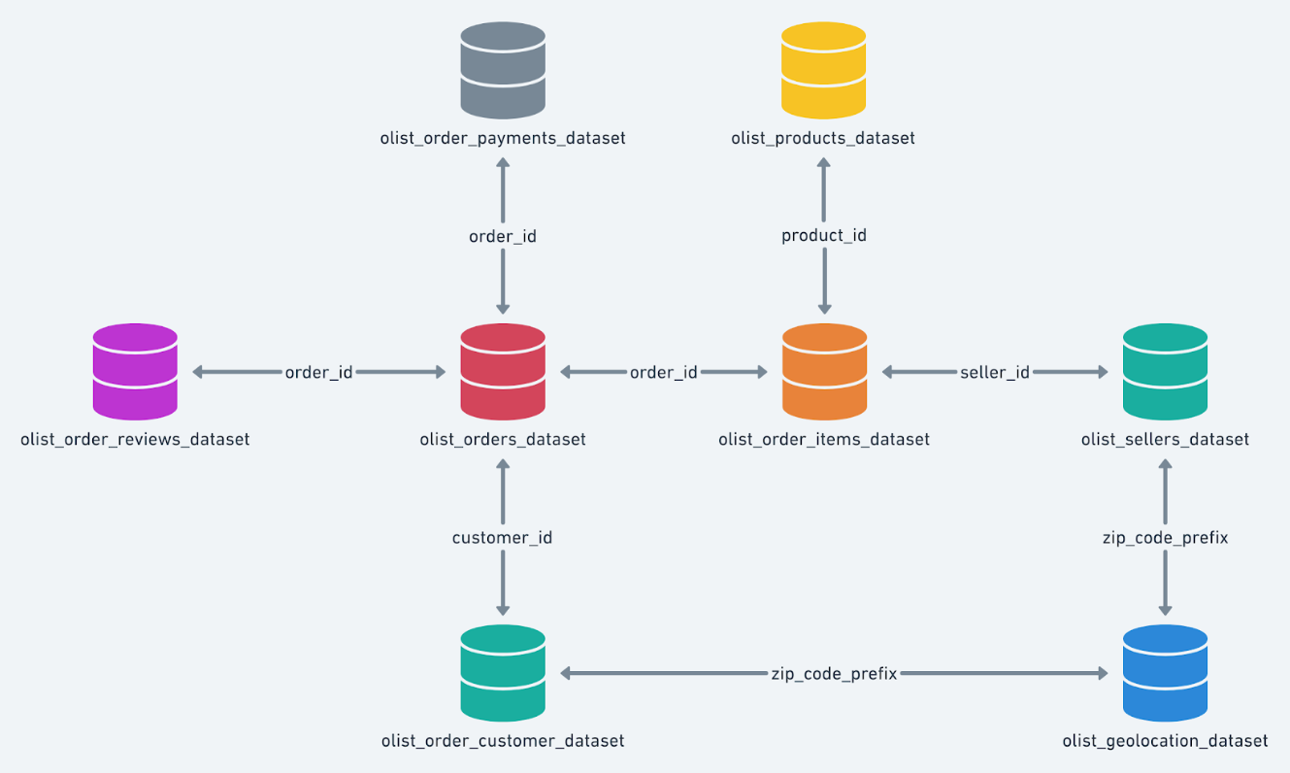

- SQL Querying
Wrote SQL queries to:
- Calculate total sales, average order value, and payment statistics.
- Identify top-selling products and categories.
- Analyze customer reviews and link them to shipping performance.
- Compare weekday vs. weekend order patterns.
- Extract insights about customer states and cities with the highest sales.

- Dashboard Development

Excel
Designed summary dashboards highlighting key KPIs:
  - Total orders, revenue, and average review scores.
  - Pivot tables for product category sales and city-wise orders.
  - Conditional formatting to highlight high and low performers.
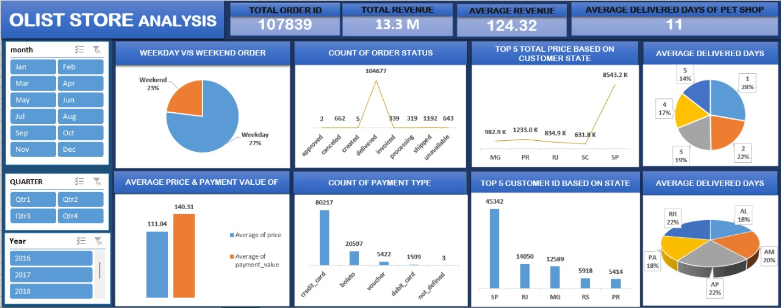

Power BI
Built interactive reports:
  - Monthly sales trends and payment value analysis.
  - Review score distribution and its relation to delivery performance.
  - Regional sales heatmaps showing city and state-wise performance.
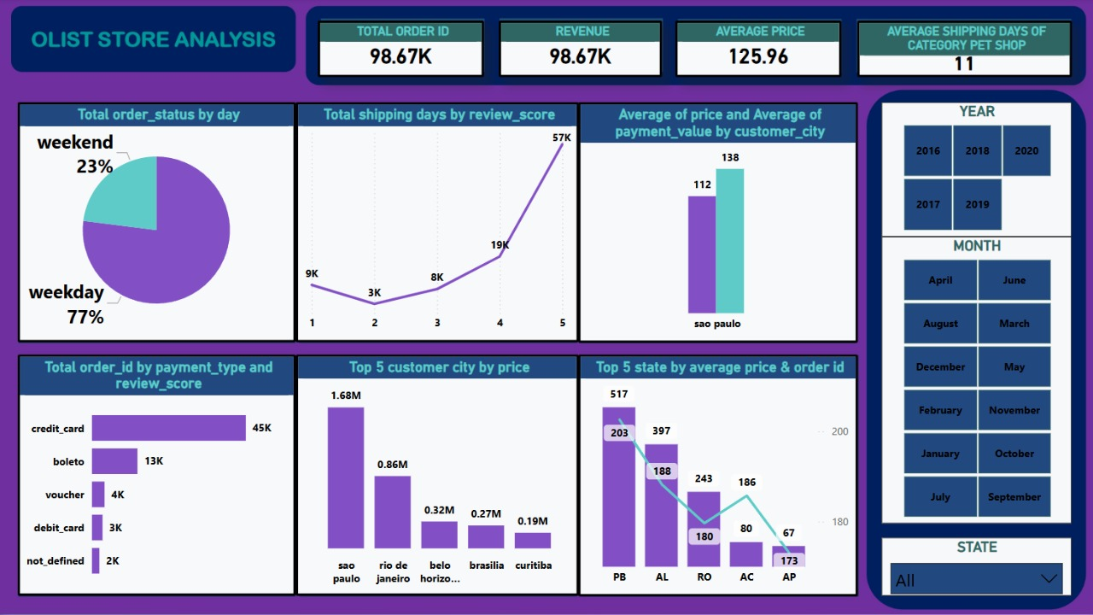

Tableau
Created visualizations for:
  - Weekday vs. weekend order comparison using pie and bar charts.
  - Average shipping days by review score.
  - State-level sales contribution.
  - Category-wise sales contribution with dynamic filters.
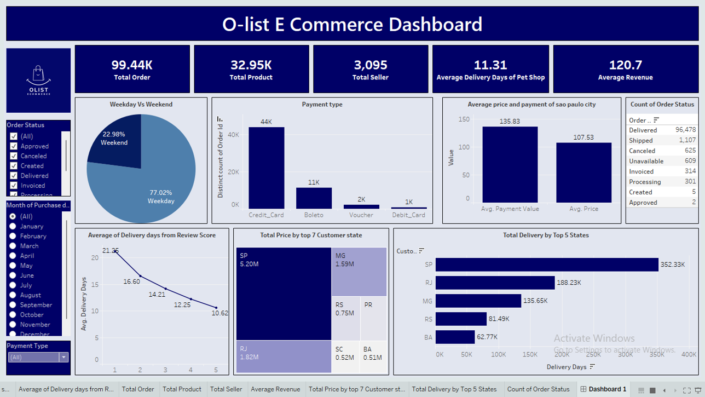

Key Insights
- Majority of orders were placed during weekdays, with higher volume and revenue compared to weekends.
- Faster shipping correlated with higher customer review scores, indicating delivery speed impacts satisfaction.
- Certain states (e.g., São Paulo) generated the most orders and revenue.
- Payments by credit card dominated, while other payment types were less frequently used.
- A small percentage of orders caused most of the late delivery complaints.

Tools Used
- Excel (for cleaning, pivot tables, basic dashboards)
- SQL (for querying and data extraction)
- Power BI (for advanced, interactive dashboards)
- Tableau (for dynamic visual analytics)
- GitHub (for version control and project documentation)

Outcome
- Delivered a clean, unified dataset ready for analytics.
- Developed dashboards that help visualize business-critical metrics and trends.
- Generated actionable insights for improving shipping efficiency and customer satisfaction.

