**Core JAVA Assignment_1**

**Codes:**



**Screenshots of the Output Step wise:**

1. **Application Output:**

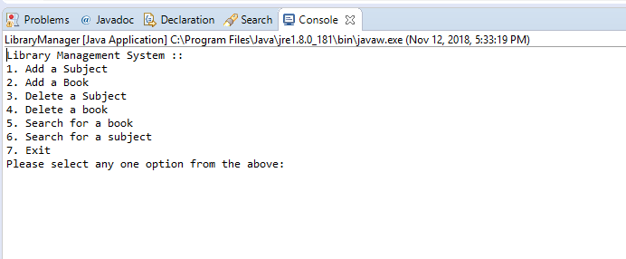

1. **Adding a subject:**

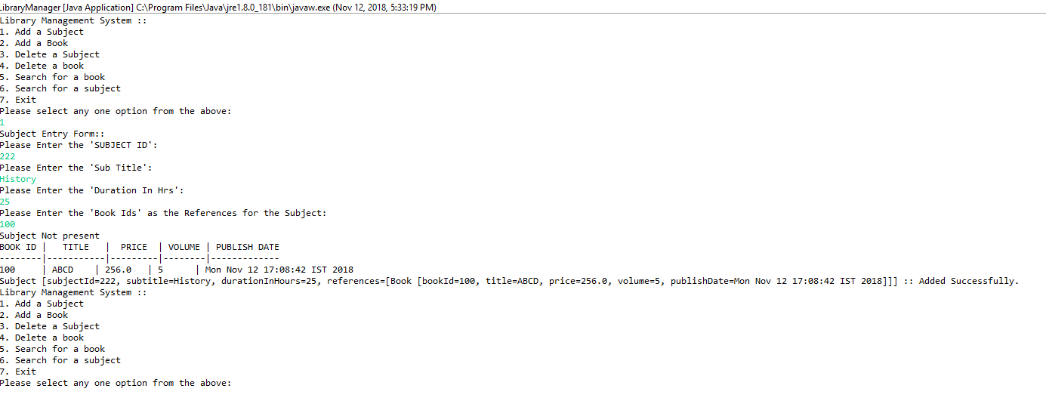

1. **Adding a Book:**

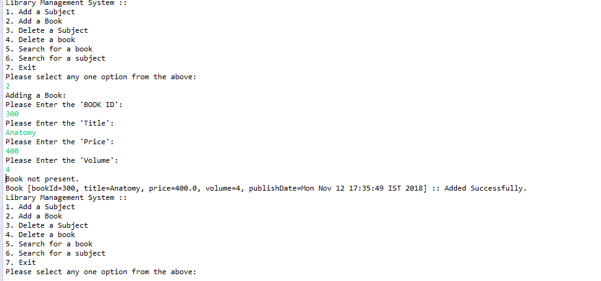

1. **Search a Book:**

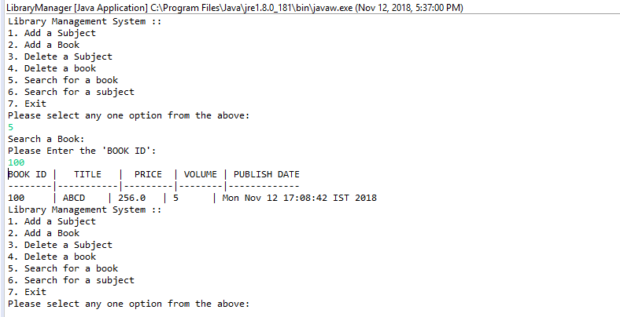

1. **Search a Subject:**

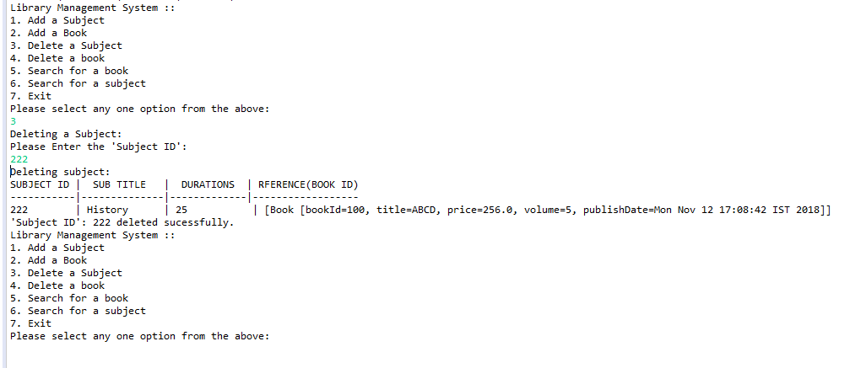

1. **Delete a Book:**

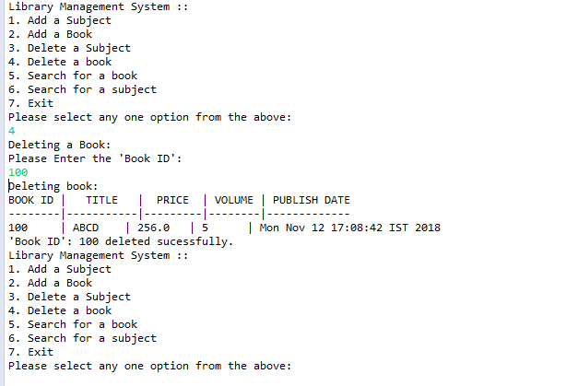

1. **Delete a Subject:**

