**JAVA Assignment**

**Code Snippets:**



**Screenshots of the Output Step wise:**

1. Add a Book

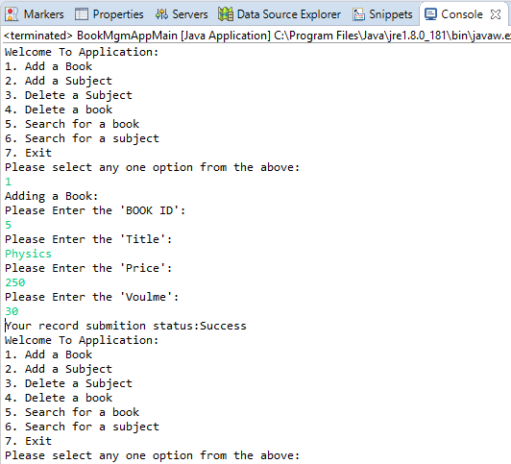

2. Add a Subject

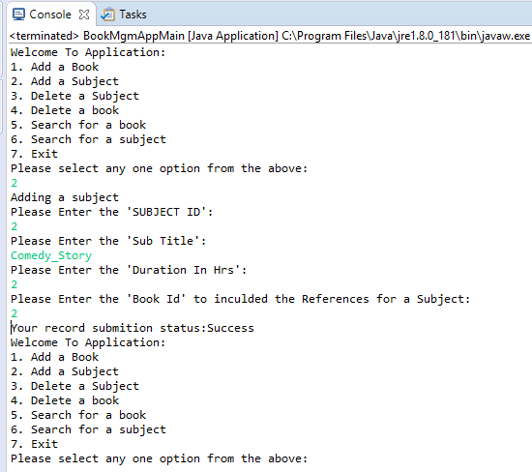

3. Delete a Subject

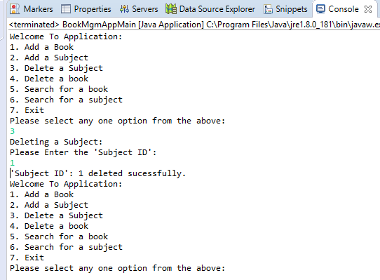

4. Delete a Book

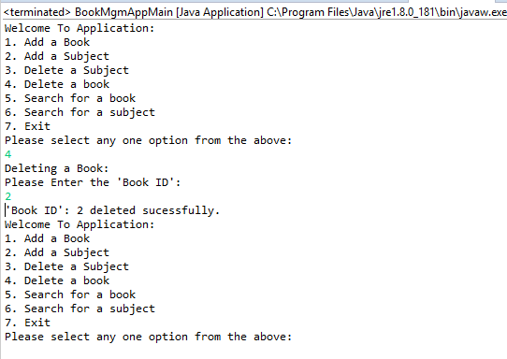

5. Search for a Book

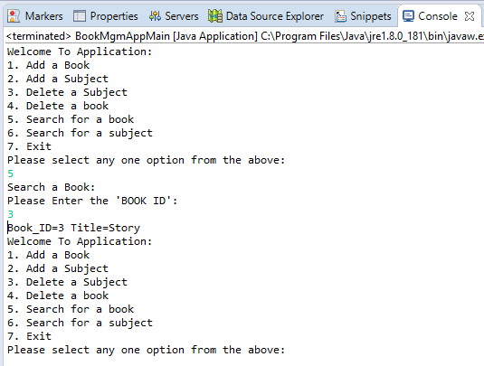

6. Search for a Subject

