Feature Extraction, Model Training & Testing Analysis
Solar Cell Quality Control | Evidence from saved Keras models and held-out test sets

1. Executive summary
The project uses MobileNetV2 transfer learning for solar-cell electroluminescence image classification. A binary model is trained first, then a five-class model reuses the feature extractor for defect-type classification. Fine-tuning the deeper feature extractor improves the measured five-class test accuracy from 83.67% to 96.00% and macro F1 from 0.8324 to 0.9603.
Model | Test images | Accuracy | Macro F1 | Parameters
Stage 1 binary | 600 | 56.17% (Keras evaluate) | 0.3333* | 2,259,265
Stage 2 frozen | 300 | 83.67% | 0.8324 | 2,264,389
Stage 2 fine-tuned / final | 300 | 96.00% | 0.9603 | 2,264,389
*The Stage 1 classification report produced 50.00% accuracy and all-positive-class predictions, while Keras evaluate returned 56.17%. This inconsistency is documented as a reproducibility issue requiring a deterministic evaluation pass.
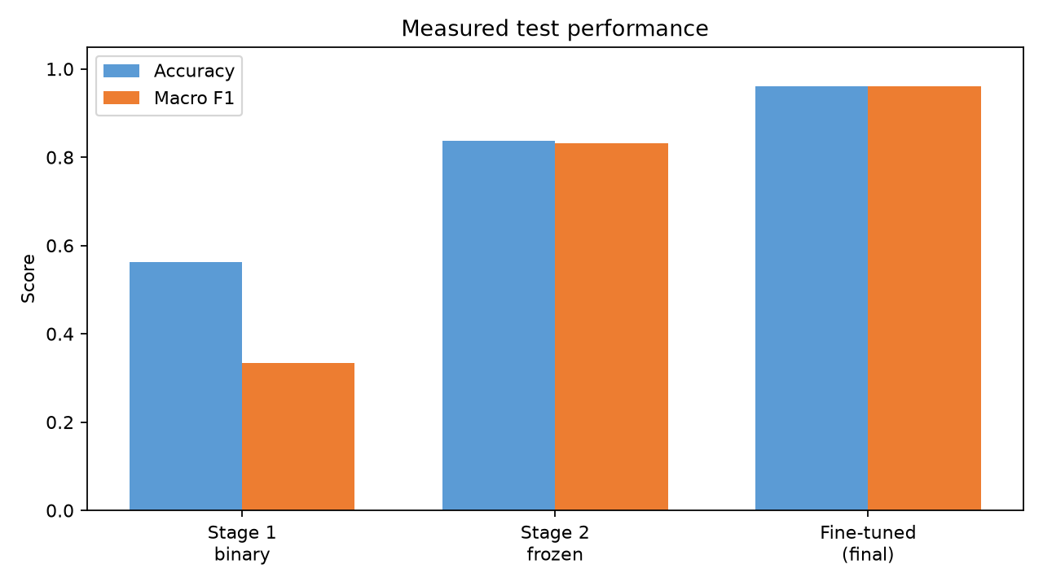

2. Feature extraction architecture
The model pipeline uses image augmentation, normalization, a MobileNetV2 convolutional backbone, global average pooling, dropout, and a dense classification head. The backbone provides learned visual features such as edges, textures, cell boundaries, and defect patterns; global average pooling converts feature maps into a compact vector before classification.
Component | Role
Input | 224 × 224 RGB electroluminescence image
Data augmentation | Training-only variation to improve robustness
Normalization | Aligns input pixel distribution with model training
MobileNetV2 backbone | Pre-trained convolutional feature extractor
GlobalAveragePooling2D | Reduces spatial feature maps to a feature vector
Dropout (0.3) | Regularization before classification
Dense head | 2 outputs for Stage 1; 5 softmax outputs for Stage 2

3. Training strategy
Stage 1 performs binary Correct/Defective classification. Stage 2 replaces the binary head with a five-class softmax head for functional, halide segregation, layer delamination, phase degradation, and pinhole classes. The notebook freezes the Stage 1 feature extractor during initial Stage 2 training. A later fine-tuning phase unfreezes deeper layers and recompiles with Adam at a learning rate of 1e-5.
Phase | Objective | Loss / optimizer | Observed outcome
Stage 1 | Learn binary quality representations | Sparse categorical cross-entropy / Adam | Saved MobileNetV2 binary model
Stage 2 transfer | Map frozen features to five defect classes | Sparse categorical cross-entropy / Adam | 83.67% test accuracy
Fine-tuning | Adapt deeper features to perovskite/tandem defects | Sparse categorical cross-entropy / Adam, 1e-5 | 96.00% test accuracy

4. Final-model testing analysis
The final model was loaded from both final_solar_cell_quality_model.keras and the fine-tuned Stage 2 model; both produced the same 300-image test results. The test set is balanced with 60 images per class.
Class | Precision | Recall | F1 | Support
Halide segregation | 0.8696 | 1.0000 | 0.9302 | 60
Layer delamination | 1.0000 | 0.9500 | 0.9744 | 60
Phase degradation | 1.0000 | 0.8833 | 0.9381 | 60
Pinhole | 1.0000 | 1.0000 | 1.0000 | 60
Functional | 0.9508 | 0.9667 | 0.9587 | 60
Macro average | 0.9641 | 0.9600 | 0.9603 | 300
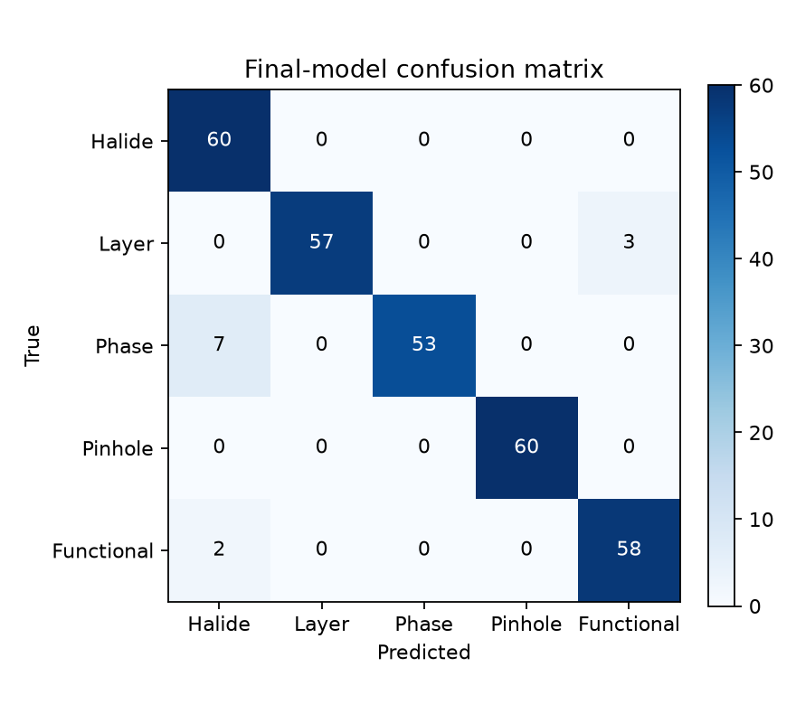
The dominant residual error is confusion of phase degradation with halide segregation: 7 phase-degradation images were predicted as halide segregation. Three layer-delamination images and two functional images were also misclassified. Pinhole detection was perfect on this test set.

5. Interpretation
- Fine-tuning is materially beneficial: accuracy rises by 12.33 percentage points over the frozen Stage 2 model.
- The final model is strongest on pinhole and layer-delamination images and weakest on phase-degradation recall.
- Balanced test support makes macro-averaged metrics representative of the class-level behavior.
- The result is a five-class diagnostic model; the functional class is the pass condition used by the application.

6. Validation caveats and recommendations
- The Stage 1 evaluation is internally inconsistent: Keras evaluate and the separately generated classification report disagree. Re-run evaluation with augmentation disabled or deterministic preprocessing before using Stage 1 metrics in a publication.
- Keep augmentation layers inactive during validation and testing, and verify that the deployed preprocessing exactly matches training.
- Report confidence calibration and class-specific error costs before production use, especially for false functional predictions.
- Expand the held-out test set with images from different acquisition conditions and manufacturers to measure domain robustness.
- Track model version, class-name order, image manifest, random seeds, and preprocessing configuration with every training run.
Source artifacts: models/*.keras, models/stage2_class_names.json, and notebooks/01_dataset_exploration.ipynb.

