Preprocessing & Exploratory Data Analysis
Solar Cell Quality Control | Reproducible dataset assessment
This report documents the inventory, quality checks, preprocessing assumptions, and exploratory findings for the image datasets used by the solar-cell quality-control project.

1. Executive summary
The custom five-class dataset contains 1,250 valid images: 750 train, 200 validation, and 300 test images. All custom images are 224 × 224 RGB PNG files with balanced classes and splits. The processed binary dataset contains 4,000 images, while the raw PVEL-AD inventory contains 14,155 readable images.
Recommended pipeline: verify files before loading, preserve the split boundaries, resize to 224 × 224, convert to RGB, apply the model’s expected normalization consistently, and use augmentation only on training data.

2. Dataset inventory
Dataset | Images | Splits | Classes
Custom perovskite/tandem | 1250 | train / val / test | 5
Processed binary | 4000 | train / validation / test | 2
Raw PVEL-AD | 14155 | trainval / test / othertypes | 3
Custom dataset counts:
Split | Functional | Halide segregation | Layer delamination | Phase degradation | Pinhole | Total
train | 150 | 150 | 150 | 150 | 150 | 750
val | 40 | 40 | 40 | 40 | 40 | 200
test | 60 | 60 | 60 | 60 | 60 | 300
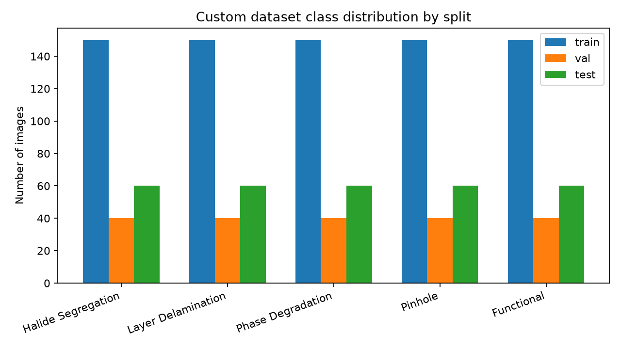

3. Image-quality checks
All 1,250 custom images passed PIL integrity checks; no unreadable files were found in that dataset. There are 0 duplicate-content groups in the custom dataset. Image mode is uniformly RGB, and width is uniformly 224 pixels.
Check | Result | Interpretation
Unreadable custom images | 0 | No custom-image corruption detected
Custom image dimensions | 224 × 224 | Already aligned with MobileNetV2 input size
Custom color mode | RGB | No grayscale conversion required
Duplicate-content groups | 0 | Check before future re-splitting to prevent leakage
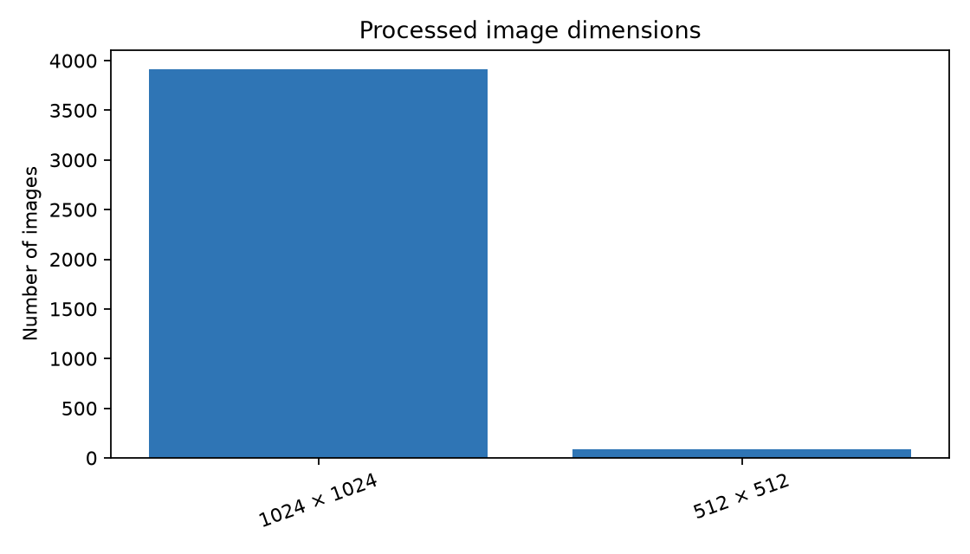

4. Exploratory findings
The custom dataset is exactly balanced: each of the five classes contributes 250 training images, 40 validation images, and 60 test images. This supports macro-averaged metrics and makes accuracy interpretable without class-weight correction. The processed binary dataset is also balanced between Correct and Defective classes.
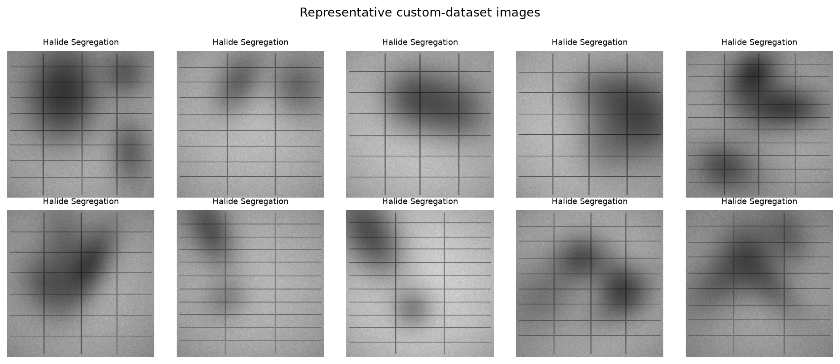

5. Preprocessing specification
Stage | Recommendation
File validation | Read each file with PIL and exclude unreadable files; keep a manifest with path, split, class, dimensions, mode, and content hash.
Split preservation | Use the existing train/validation/test directories. Do not move images across splits after exploratory analysis.
Color and shape | Convert to RGB and resize to 224 × 224, matching the deployed model input.
Pixel scaling | Use the same preprocessing expected during training and inference. Do not independently normalize validation/test images.
Augmentation | Apply mild geometric/photometric augmentation to training images only; avoid transformations that alter defect semantics.
Reproducibility | Set seeds for Python, NumPy, and TensorFlow; record the manifest and preprocessing configuration.

6. Risks and next steps
- Review duplicate hashes before creating any new random split; near-duplicate images can inflate evaluation scores.
- Confirm that the deployed model uses the same RGB conversion and pixel scaling as training.
- Track per-class precision, recall, F1-score, and a confusion matrix in addition to overall accuracy.
- Add an automated data-quality check to CI or the training entry point so missing, corrupt, or mis-sized images fail early.
Generated from the project data directory by scripts/generate_eda_report.py.

