Homework 5

2023-11-29

library(tidyverse)  
library(dplyr)  
library(stringr)  
library(forcats)  
library(ggplot2)  
library(ggthemes)  
library(broom)  
library(purrr)  
library(tidyr)  
library(scales)  
library(sf)  
library(tigris)

#Choice A

#Loading data and creating object  
  
homicides <- read.csv("homicide-data.csv")  
  
homicides <- homicides %>%  
 mutate(city_name = str_c(city, state, sep = ", ")) %>%  
 select(city_name, everything()) %>%  
 filter( city_name == "Baltimore, MD")

city_boundaries <- block_groups(state = "MD",county = "Baltimore city")

## | | | 0% | | | 1% | |= | 1% | |= | 2% | |== | 2% | |== | 3% | |== | 4% | |=== | 4% | |=== | 5% | |==== | 5% | |==== | 6% | |===== | 7% | |===== | 8% | |====== | 8% | |====== | 9% | |======= | 9% | |======= | 10% | |======= | 11% | |======== | 11% | |======== | 12% | |========= | 12% | |========= | 13% | |========== | 14% | |========== | 15% | |=========== | 16% | |============ | 17% | |============ | 18% | |============= | 18% | |============= | 19% | |============== | 19% | |============== | 20% | |============== | 21% | |=============== | 21% | |=============== | 22% | |================ | 22% | |================ | 23% | |================= | 24% | |================= | 25% | |================== | 25% | |================== | 26% | |=================== | 26% | |=================== | 27% | |=================== | 28% | |==================== | 28% | |==================== | 29% | |===================== | 29% | |===================== | 30% | |===================== | 31% | |====================== | 31% | |====================== | 32% | |======================= | 32% | |======================= | 33% | |======================== | 34% | |======================== | 35% | |========================= | 35% | |========================= | 36% | |========================== | 37% | |========================== | 38% | |=========================== | 38% | |=========================== | 39% | |============================ | 39% | |============================ | 40% | |============================ | 41% | |============================= | 41% | |============================= | 42% | |============================== | 42% | |============================== | 43% | |=============================== | 44% | |=============================== | 45% | |================================ | 45% | |================================ | 46% | |================================= | 47% | |================================= | 48% | |================================== | 48% | |================================== | 49% | |=================================== | 49% | |=================================== | 50% | |=================================== | 51% | |==================================== | 51% | |==================================== | 52% | |===================================== | 52% | |===================================== | 53% | |===================================== | 54% | |====================================== | 54% | |====================================== | 55% | |======================================= | 55% | |======================================= | 56% | |======================================== | 56% | |======================================== | 57% | |======================================== | 58% | |========================================= | 58% | |========================================= | 59% | |========================================== | 59% | |========================================== | 60% | |========================================== | 61% | |=========================================== | 61% | |=========================================== | 62% | |============================================ | 62% | |============================================ | 63% | |============================================ | 64% | |============================================= | 64% | |============================================= | 65% | |============================================== | 65% | |============================================== | 66% | |=============================================== | 66% | |=============================================== | 67% | |=============================================== | 68% | |================================================ | 68% | |================================================ | 69% | |================================================= | 69% | |================================================= | 70% | |================================================= | 71% | |================================================== | 71% | |================================================== | 72% | |=================================================== | 72% | |=================================================== | 73% | |=================================================== | 74% | |==================================================== | 74% | |==================================================== | 75% | |===================================================== | 75% | |===================================================== | 76% | |====================================================== | 76% | |====================================================== | 77% | |====================================================== | 78% | |======================================================= | 78% | |======================================================= | 79% | |======================================================== | 79% | |======================================================== | 80% | |======================================================== | 81% | |========================================================= | 81% | |========================================================= | 82% | |========================================================== | 82% | |========================================================== | 83% | |========================================================== | 84% | |=========================================================== | 84% | |=========================================================== | 85% | |============================================================ | 85% | |============================================================ | 86% | |============================================================= | 87% | |============================================================= | 88% | |============================================================== | 88% | |============================================================== | 89% | |=============================================================== | 89% | |=============================================================== | 90% | |=============================================================== | 91% | |================================================================ | 91% | |================================================================ | 92% | |================================================================= | 92% | |================================================================= | 93% | |================================================================== | 94% | |================================================================== | 95% | |=================================================================== | 95% | |=================================================================== | 96% | |==================================================================== | 96% | |==================================================================== | 97% | |==================================================================== | 98% | |===================================================================== | 98% | |===================================================================== | 99% | |======================================================================| 100%

homicides_sf <- st_as_sf(homicides, coords = c("lon", "lat"), crs = 4326)

# Create a simplified dataframe for plotting  
plot_data <- homicides_sf %>%  
 mutate(  
 race_group = fct_lump(victim_race, n = 3),  
 solved_unsolved = ifelse(disposition %in% c("Closed without arrest", "Open/No arrest"), "Unsolved", "Solved")  
 )

# Create the plot  
ggplot() +  
 geom_sf(data = city_boundaries) +  
 geom_sf(data = plot_data, aes(color = race_group), size = 2) +  
 facet_grid(solved_unsolved ~ .) +  
 labs(title = "Homicides in Your City", subtitle = "Solved vs. Unsolved, by Race") +  
 theme_minimal()

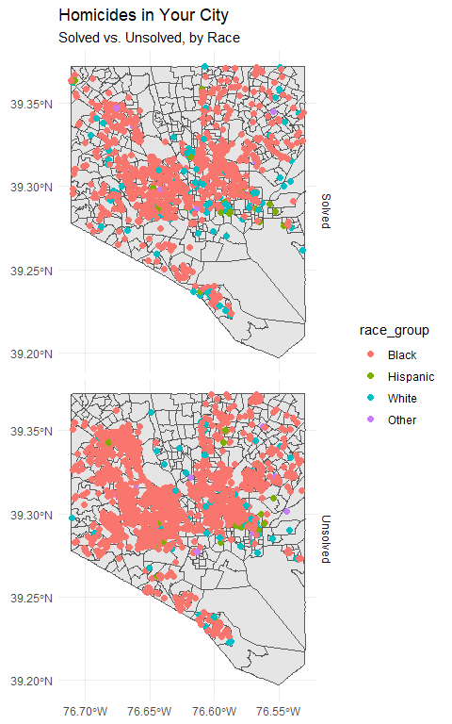

## R Markdown

This is an R Markdown document. Markdown is a simple formatting syntax for authoring HTML, PDF, and MS Word documents. For more details on using R Markdown see <http://rmarkdown.rstudio.com>.

When you click the **Knit** button a document will be generated that includes both content as well as the output of any embedded R code chunks within the document. You can embed an R code chunk like this: