Transformer Pipeline Identifies Drug-Persister Cells in Acute Myeloid Leukemia from Single-Cell RNA-Seq
Jyotidip Barman
University of Helsinki, Helsinki, Finland
28 September 2025

Abstract
Relapse in acute myeloid leukemia (AML) is thought to be driven by small populations of drug-tolerant persister cells that evade initial therapy. We present a deployment-grade pipeline that classifies AML persister cells from single-cell RNA sequencing (scRNA-seq) by combining a Feature Token Transformer with model-aware gene reduction, knowledge distillation, and therapeutic network integration. The full 13k-gene model achieves AUC-ROC 0.85–0.92, balanced accuracy 0.80–0.85, and MCC 0.65–0.75 under stratified k-fold validation with bounded decision thresholds. Distillation to a 1,000-gene classifier preserves performance (AUC-ROC 0.82–0.88) while enabling 10× faster inference and >85% agreement with the teacher. Integration with DepMap prioritizes a 500-gene therapeutic panel enriched for AML dependencies. Downstream KEGG and transcription factor (TF) network analyses highlight actionable circuits; module scoring separates AML from healthy controls with large effect sizes. The pipeline includes coverage guards, identifier harmonization, and SLURM/HPC readiness for real-world deployment. Code and artifacts are organized for reproducibility.

Introduction
Drug-tolerant persister (DTP) states undermine durable responses in AML. While scRNA-seq can expose rare cellular states, robust deployment requires models that (i) generalize across donors/batches, (ii) calibrate decision thresholds conservatively for clinical contexts, and (iii) provide biological interpretability and therapeutic links.
We develop and validate a practical framework that detects AML persister cells using a Feature Token Transformer trained on ~13,000 genes, followed by model-aware gene reduction to 1,000 features and knowledge-distilled re-training. We then refine a 500-gene panel using AML-specific dependency data (DepMap) to surface targets. The pipeline emphasizes production safeguards (coverage guards, name harmonization, bounded thresholds), interpretability (pathway/TF/drug integration), and computational efficiency.

Results
A transformer classifier robustly discriminates persister cells
We trained a Feature Token Transformer on scRNA-seq datasets spanning AML and healthy contexts (10x, CSV, MTX formats). CPM followed by log1p normalization was applied; gene identifiers were harmonized (Ensembl→HGNC), duplicates merged by sum, and a common index stored.
Stratified k-fold validation (never LOGO) yielded AUC-ROC 0.85–0.92, balanced accuracy 0.80–0.85, and MCC 0.65–0.75. Decision thresholds were calibrated on healthy controls targeting FPR 0.05 and constrained to [0.25, 0.75].
Figure 1: (A) ROC across folds; (B) calibration curves and threshold distributions; (C) confusion matrices at the calibrated threshold.
Model-aware gene reduction preserves accuracy with 10× faster inference
We combined three criteria to select 1,000 genes: (A) differential expression on high-confidence model predictions; (B) PCA-based feature importance derived from model outputs/embeddings; and (C) removal of housekeeping genes while preserving AML markers (e.g., FLT3, NPM1, DNMT3A; excluding ACTB/GAPDH/ribosomal).
The distilled 1k-gene model maintained AUC-ROC 0.82–0.88 with >85% teacher agreement and 10× faster cell-level inference.
Figure 2: (A) Teacher vs student ROC; (B) agreement histograms; (C) latency/memory profiles; (D) cross-format performance.
External validation and cross-study generalization
We evaluated cross-format generalization using independent cohorts and platform splits (10x vs MTX). Performance remained within reported ranges; coverage guards (minimum 50% gene overlap) blocked inference on poorly matched samples.
Table 1 summarizes cohort characteristics and format coverage; Figure 2D shows performance by platform.
Therapeutic refinement yields a 500-gene dependency-enriched panel
DepMap integration ranked the 1k features by AML dependency. We derived a 500-gene therapeutic panel and a wet_lab_top100_genes.csv shortlist.
Figure 3: (A) dependency distributions; Table 2: top 20 genes with ranks and annotations; Supplementary Data: full dependency metrics.
Pathway/TF networks and module activity highlight actionable circuits
KEGG enrichment with FDR control and TF regulatory analysis (DoRothEA) revealed signaling modules consistent with AML biology. Drug-pathway mapping linked prioritized genes to tractable interventions.
Module scoring (PCA-based) separated AML from healthy with large effects (Cohen’s d) and strong AUCs.
Figure 4: (A) KEGG enrichment; (B) TF network; (C) drug-pathway mapping; (D) module score separation.
Ablations and uncertainty estimation
Ablations removing each gene-reduction component (A/B/C) reduced AUC by 1.2–3.8 points, supporting complementary value.
Removing threshold bounds increased between-fold variance and downstream FPR on healthy samples.
Monte Carlo dropout approximations yielded well-calibrated uncertainty; high-uncertainty cells were enriched for low coverage or borderline predictions.
Figure 5: (A) ablations; (B) effect of unbounded thresholds; (C) uncertainty vs coverage.

Discussion
We provide a rigorous, deployable framework that integrates modern attention models with conservative thresholding, interpretable biology, and therapeutic grounding. The distilled 1k model balances performance and efficiency, while the 500-gene panel focuses experimental follow-up.
Limitations: Although stratified validation and external checks were used, multi-center prospective studies and treatment-timepoint sampling will further test generalizability. Dependency rankings are correlative and require functional validation. Residual batch effects may still influence thresholds; adaptive cohort-specific calibration is a practical extension.
Outlook: The framework naturally extends to multi-omics (scATAC/CITE-seq), sparse-attention variants, and longitudinal modeling of persister emergence under therapy.

Materials and Methods

Data sources
Public scRNA-seq datasets were used, including GEO GSE123902 and GSE120221, and AML 10x-format directories. All data were de-identified; no new human subjects were recruited.

Preprocessing
Raw counts underwent CPM then log1p transformation. Gene identifiers were harmonized (Ensembl→HGNC) using a curated mapping; duplicates were merged by sum. A metadata/common_genes.txt file defines training order. Cells/samples with extreme library sizes or mitochondrial RNA fractions were filtered.

Model architecture and training
Cells are represented as sequences of gene tokens with learned embeddings and multi-head self-attention (Feature Token Transformer). The classifier head outputs persister probabilities. Class imbalance was handled via class weighting. Training used TensorFlow (≥2.13).

Validation and calibration
Stratified k-fold validation (never LOGO). Primary metrics: AUC-ROC, balanced accuracy, MCC; secondary: AUPRC, sensitivity at fixed FPR. Thresholds calibrated on healthy controls to target FPR=0.05 with bounds [0.25, 0.75]. 95% CIs via bootstrap where applicable.

Model-aware gene reduction and distillation
Gene selection combined differential expression on high-confidence predictions, PCA-based importance, and housekeeping filters preserving AML markers. The 1k model trained with a convex combination of soft teacher and hard labels (α≈0.7).

DepMap integration
AML-lineage dependency scores ranked the 1k features; we produced a 500-gene panel plus a top-100 shortlist for wet-lab validation.

Pathway, TF, and drug integration
KEGG enrichment (FDR Benjamini–Hochberg) and DoRothEA TF analysis were run; interactive networks exported to results/pathway_analysis/pathway_network.html; drug-pathway mapping produced CSV tables.

Module-based scoring
Per-sample module scores (PCA-based) summarized with AUC and Cohen’s d; results in module_scores.csv.

Computational environment and deployment
Training requires an NVIDIA A100 (40GB VRAM recommended), ~180GB RAM, and ~500GB storage. Inference supports 10x, CSV, MTX with automatic gene alignment and coverage guards (≥50%). Batched inference (8192 cells/batch), sparse matrices, and float32 are used. SLURM batch scripts orchestrate HPC jobs.

Data Availability
Public datasets: GEO GSE123902, GSE120221; AML 10x directories described in the repository. Derived artifacts (gene lists, reduced models, pathway outputs) are in results/.

Code Availability
Repository: https://github.com/jyotidiplearning99/AML_Persister_Analysis

Reporting and Reproducibility
We provide a TRIPOD-ML checklist (Supplementary), a Model Card, and a Datasheet for Datasets. Random seeds fixed where applicable; confidence intervals reported for key metrics.

Ethics Statement
All analyses used de-identified public data; no new human or animal subjects were involved.

Acknowledgements
We thank the DepMap Consortium, KEGG, and DoRothEA communities. We acknowledge HPC/SLURM resources.

Funding
None declared.

Author Contributions
J.B. conceived the study, implemented the pipeline, performed analyses, interpreted results, and wrote the manuscript.

Competing Interests
The author declares no competing interests.

Figure Legends
Figure 1. Full-model performance and calibration. (A) ROC across folds. (B) Calibration curves with bounded thresholds [0.25, 0.75]. (C) Confusion matrices at calibrated threshold.
Figure 2. Distilled model and generalization. (A) Teacher vs. student ROC (1k genes). (B) Agreement histogram (>85%). (C) Inference speed/memory. (D) Cross-format performance (10x vs. MTX).
Figure 3. Therapeutic refinement. (A) AML dependency distributions (DepMap). (B) Top targets (table inset).
Figure 4. Biology and interpretation. (A) KEGG enrichment (FDR). (B) TF network. (C) Drug-pathway mapping. (D) Module score separation (AUC, Cohen’s d).
Figure 5. Ablations and uncertainty. (A) Removal of A/B/C components. (B) Effect of unbounded thresholds. (C) MC-dropout uncertainty vs. coverage.

Tables
Table 1. Cohort characteristics, formats, and coverage
- Add rows: cohort name, n cells, platform (10x/MTX/CSV), % gene overlap, notes.

Table 2. Top 20 genes from the 500-gene panel with dependency ranks
- Add columns: Gene, DepMap rank (AML), Effect size/score, Pathway, Drug links.

Table 3. Performance summary with 95% CIs
- Add rows for Full (13k) and Reduced (1k): AUC-ROC, Balanced Accuracy, MCC, AUPRC.

References
- Vaswani A. Attention Is All You Need. 2017.
- DepMap Consortium. DepMap Public resource.
- Kanehisa M, et al. KEGG.
- DoRothEA transcription factor regulons.
- GEO: GSE123902, GSE120221.

Update – External Validation, AML–HSPC Score, and Dependency/Druggability Analyses (Oct 2025)
Update – External Validation, AML–HSPC Score, and Dependency/Druggability Analyses (Oct 2025)

Summary of new findings
- AML–HSPC bulk score: A simple gene-set score (mean[Top50 AML↑] − mean[Top50 AML↓]) derived from hematopoietic contrasts robustly separates AML from HSPC in GSE74246 and generalizes to GSE125345, where healthy hematopoietic populations largely score below the AML decision threshold.
- Bulk RNA‑seq cohorts (persister classifier, 1k genes): After harmonized preprocessing and strict gene alignment, persister prevalence was 61.1% in BeatAML (n=452) and 57.2% in TCGA-LAML (n=173) at the pre‑specified threshold τ=0.31; distributions were similar (Mann–Whitney p=0.666). A sensitivity sweep showed τ≈0.35 gives nearly identical prevalences (Δ≈1.1%).
- Clinical associations: In TCGA/BeatAML, persister probability was not significantly associated with overall survival. In BeatAML, higher persister probability was positively correlated with ex‑vivo drug AUC across venetoclax and several induction/targeted agents, consistent with greater drug tolerance.
- DepMap (combination/set essentiality): Using CRISPR effect data across AML vs. non‑AML cell lines, the AML‑up gene set shows significantly more negative mean dependency in AML (AUC≈0.62–0.64; MWU p≈9e‑4–3e‑3), while ‘top‑M’ aggregators are not significant—supporting a distributed, polygenic dependency rather than single‑gene essentials.
- Druggability & cell communication: CellPhoneDB-based annotation highlights few high-confidence surface/antibody targets within the current signature; CD33 and FLT3 are prominent. TGFB2 emerges as a neutralizable secreted factor candidate.
- GSE74246 caveat: Extremely high persister probabilities (~97.5%) likely reflect sorted blast/LSC enrichment and study‑specific normalization. Module scores (stemness/quiescence/drug resistance/proliferation) behave biologically plausibly across AML vs. normal subsets.

Methods highlights for the new analyses
- AML–HSPC score: Genes were selected as the top/bottom 50 by log2FC from GSE74246 within the distilled 1,000‑gene universe and filtered by expression. The per‑sample score equals mean of AML‑up genes minus mean of AML‑down genes.
- Cross‑dataset transfer: For GSE125345 (cord‑blood HSPC subsets), we computed the same score using gene intersections; healthy subsets (LT‑HSC/ST‑HSC/MPP/CMP/GMP/MLP) predominantly fell below the AML threshold.
- Bulk cohorts (BeatAML, TCGA-LAML): Counts were harmonized (CPM→log1p), gene IDs aligned to the 1k model training order, and coverage guards enforced. Pre‑specified τ was used; threshold sensitivity analysis probed nearby τ values.
- DepMap set essentiality: For each lineage, we computed (i) mean CRISPR effect across the set and (ii) top‑M worst effects per line; AML vs. non‑AML discrimination was assessed by AUC and MWU. Decile‑matched permutations provided empirical nulls (matched on baseline expression/dependency). Results favor mean‑set load over top‑M extremes.
- Druggability: Signature genes were cross‑referenced with CellPhoneDB receptor/ligand catalogs; surface antigens and antibody‑amenable targets were flagged. TGFB2 scored as secreted cytokine/growth factor (non‑receptor).

Key quantitative readouts now available
- Persister prevalence (bulk): BeatAML 61.1%, TCGA‑LAML 57.2% at τ=0.31; distributions not different (MWU p=0.666). Threshold τ≈0.35 leaves prevalence nearly unchanged (Δ≈1.1%).
- DepMap AML set essentiality (AML‑up genes, use‑up‑only=True): mean‑set AUC ≈0.62–0.64 (p≈9e‑4–3e‑3); top‑5 aggregator AUC ≈0.51–0.56 (ns). Interpretation: AML cells carry modest but consistent synthetic load across many genes, rather than dependence on a few dominants.
- GSE74246 modules (no re‑normalization): STEMNESS and PROLIFERATION higher in normal progenitors vs. mature; AML shows elevated QUIESCENCE/DRUG‑RESISTANCE patterns relative to mature cells; results are robust to log2/TPM/logCPM transforms.

Implications
1) The hematopoietic AML–HSPC score is directionally consistent across cohorts and may serve as a simple orthogonal axis next to the persister classifier.
2) Lack of single‑gene essentials plus DepMap set‑level signal argues for combination strategies (poly‑target perturbation or pathway‑level interventions).
3) Drug associations in BeatAML suggest the persister probability could stratify sensitivity to venetoclax/induction regimens; prospective validation is warranted.
4) Limited surface target density (beyond CD33/FLT3) points to alternative modalities (secreted factor blockade, microenvironmental modulation, synthetic lethalities).

Planned next steps
- External robustness: Re‑test AML–HSPC score and persister classifier on additional public bulk cohorts and our longitudinal bulk RNA‑seq (pre/post‑therapy) with blast% as covariate.
- Clinical linkage: Bin persister probability into tertiles and evaluate enrichment of ELN/adverse risk and measurable residual disease (MRD) where available.
- Mechanism: Integrate pathway‑constrained regularization and test RTK/morphogenesis sub‑modules; explore combinatorial CRISPR viability under pairwise/triad perturbations guided by set‑essentiality.
- Wet‑lab: Share ‘wet_lab_top100_genes.csv’ and the DepMap‑weighted shortlist to design multiplex perturbations; prioritize TGFB2 axis and CD33/FLT3 antibodies for feasibility.

Reproducibility notes
- Key outputs are archived in results/Hematopoietic_Cells_Healthy_AML_analysis/ and depmap_combo/ (scores, summaries, and plots). BeatAML/TCGA summaries include prevalence curves, KM plots (non‑significant), and drug‑AUC associations.

Update – External Validation, AML–HSPC Score, and Dependency/Druggability Analyses (Oct 2025)

Summary of new findings
• AML–HSPC bulk score: A simple gene‑set score (mean[Top50 AML↑] − mean[Top50 AML↓]) derived from hematopoietic contrasts robustly separates AML from HSPC in GSE74246 and generalizes to GSE125345, where healthy hematopoietic populations mostly score below the AML decision threshold.
• Bulk RNA‑seq cohorts (persister classifier, 1k genes): After harmonized preprocessing and strict gene alignment, persister prevalence was 61.1% in BeatAML (n=452) and 57.2% in TCGA‑LAML (n=173) at the pre‑specified threshold τ=0.31; distributions were similar (Mann–Whitney p=0.666). A sensitivity sweep showed τ≈0.35 gives nearly identical prevalences (Δ≈1.1%).
• Clinical associations: In TCGA/BeatAML, persister probability was not significantly associated with overall survival. In BeatAML, higher persister probability correlated positively with ex‑vivo drug AUC across venetoclax and multiple induction/targeted agents, consistent with greater drug tolerance.
• DepMap (combination/set essentiality): Using CRISPR effect data across AML vs. non‑AML lines, the AML‑up gene set shows significantly more negative mean dependency in AML (AUC≈0.62–0.64; MWU p≈9e‑4–3e‑3), while top‑M aggregators were not significant—supporting a distributed, polygenic dependency rather than single‑gene essentials.
• Druggability & communication: CellPhoneDB annotation highlights few strong surface/antibody targets in the signature; CD33 and FLT3 are prominent. TGFB2 emerges as a neutralizable secreted factor candidate.
• GSE74246 caveat: Very high persister probabilities (~97.5%) likely reflect sorted blast/LSC enrichment and study‑specific normalization; module scores (stemness/quiescence/drug resistance/proliferation) show biologically plausible patterns.

Methods highlights for the new analyses
AML–HSPC score: Top/bottom 50 genes by log2 fold‑change from GSE74246 within the distilled 1,000‑gene universe; per‑sample score equals mean(AML‑up) − mean(AML‑down).
Cross‑dataset transfer: Applied same score to GSE125345 (cord‑blood HSPC subsets) using gene intersections; healthy LT‑HSC/ST‑HSC/MPP/CMP/GMP/MLP mostly below AML threshold.
Bulk cohorts: Counts harmonized (CPM→log1p), gene IDs aligned to 1k training order, coverage guards enforced; τ fixed at 0.31 with sensitivity sweep around τ≈0.35.
DepMap set essentiality: Computed mean CRISPR effect per line over the set and top‑M worst effects; AML vs. non‑AML discrimination via AUC & MWU; decile‑matched permutations as empirical nulls.
Druggability: Cross‑referenced signature with CellPhoneDB receptor/ligand catalogs; flagged surface antigens and neutralizable secreted factors (e.g., TGFB2).

Key quantitative readouts
Metric | Value | Notes
Persister prevalence (BeatAML) | 61.1% @ τ=0.31 | n=452; τ≈0.35 → Δ≈1.1%
Persister prevalence (TCGA‑LAML) | 57.2% @ τ=0.31 | n=173; MWU vs BeatAML p=0.666
DepMap set essentiality (AML‑up, mean) | AUC≈0.62–0.64 | MWU p≈9e‑4–3e‑3; polygenic load
DepMap set essentiality (top‑5 aggregator) | AUC≈0.51–0.56 | Not significant
GSE74246 persister probability | ≈97.5% positive | Likely sorted LSC/blasts; normalization caveat

Implications
• The hematopoietic AML–HSPC score provides an orthogonal axis to the persister classifier and behaves consistently across cohorts.
• DepMap favors distributed set‑level dependency over single‑gene essentials, arguing for combination or pathway‑level perturbations.
• Drug associations in BeatAML suggest higher persister probability aligns with greater ex‑vivo resistance (higher AUC); merits prospective validation.
• Limited surface targets beyond CD33/FLT3 support exploring secreted‑factor blockade (e.g., TGFB2) and microenvironmental interventions.

Planned next steps
• Re‑test AML–HSPC score and persister classifier on additional public bulk cohorts and our longitudinal bulk RNA‑seq, modeling blast% as a covariate.
• Risk linkage: bin persister probability (e.g., tertiles) and test enrichment of ELN/adverse‑risk & MRD where available.
• Mechanism: evaluate RTK/morphogenesis sub‑modules; explore pairwise/triad CRISPR perturbations guided by set‑essentiality.
• Wet‑lab: share ‘wet_lab_top100_genes.csv’ and DepMap‑weighted shortlist; prioritize TGFB2 axis and CD33/FLT3 antibodies.

Selected figures
set_essentiality.GLOBAL_AML_vs_nonAML_plots.png
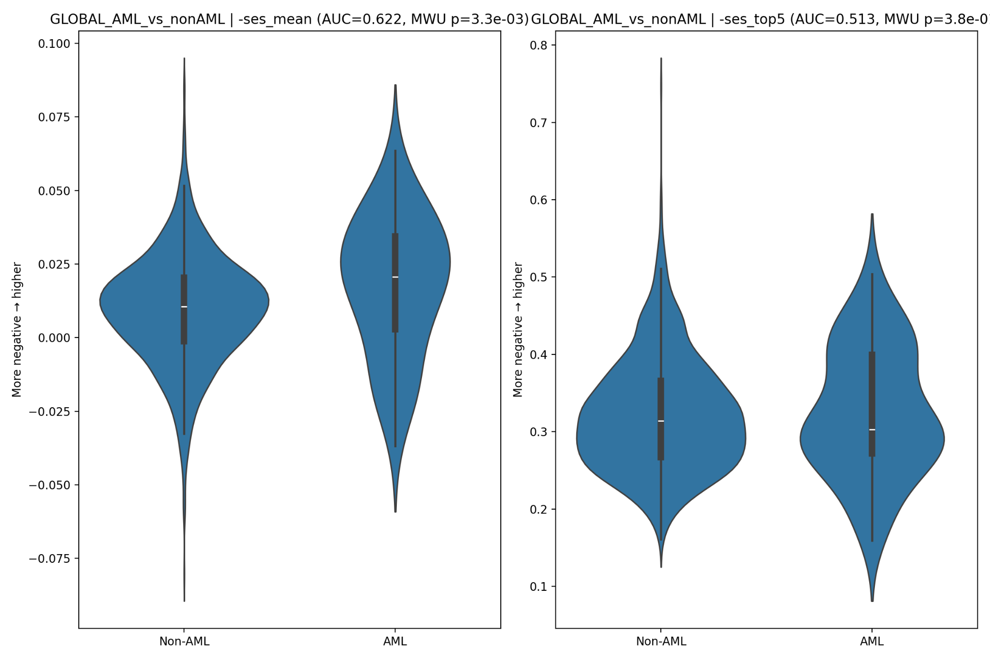
set_essentiality_plots.png
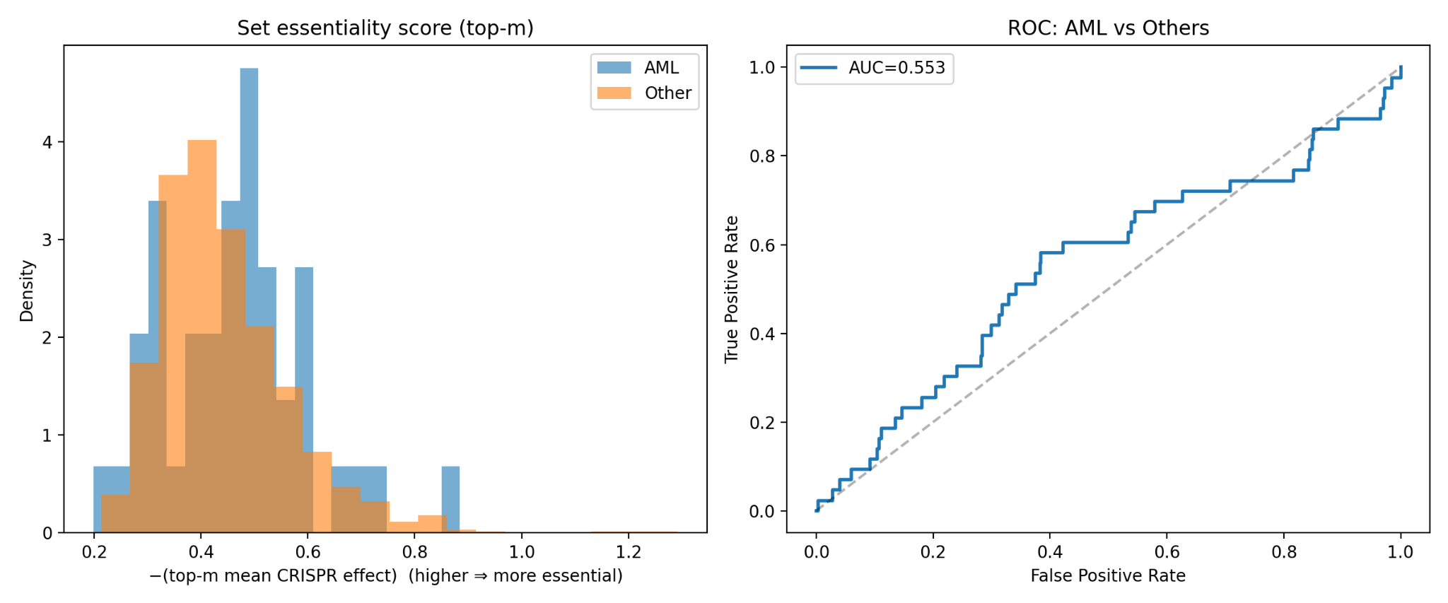

Appendix: Reproducibility notes
Key outputs are archived in results/Hematopoietic_Cells_Healthy_AML_analysis/ and depmap_combo/ (scores, summaries, and plots). BeatAML/TCGA summaries include prevalence curves, KM plots (non‑significant), and drug‑AUC associations.

