**INFOTRIXS INTERNSHIP**

**Task1:**

1. For monolith: 1 EC2 instance create, deploy WordPress and MYSQL on the same instance.
2. For microservice: 2 EC2 instance create, 1 for WordPress and 1 for MYSQL on the different instance.
3. Create a welcome page in WordPress that will be the homepage.

**Pre-requisites:**

* Configure the necessary security group for the instances.
* EC2 instance type: t2 micro, AMI: Ubuntu
* Lab Performed on Monolith: [A]

**Step1**: Login to AWS free tier account. Search for EC2 instance in the dashboard.

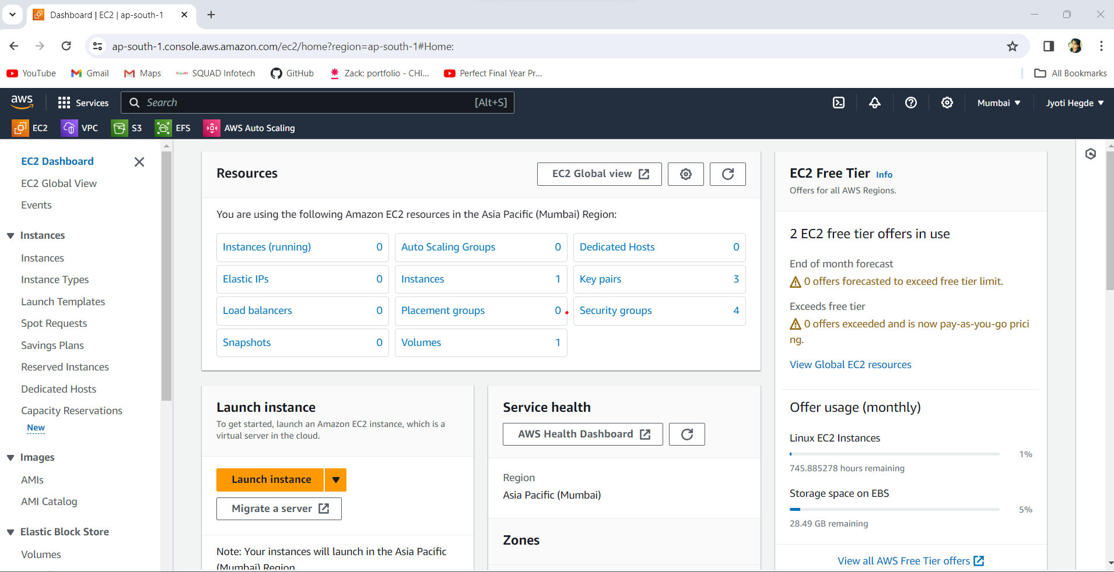

**Step 2**: Create one EC2 instance.

* Name: monolithec2-task1
* AMI: Ubuntu.

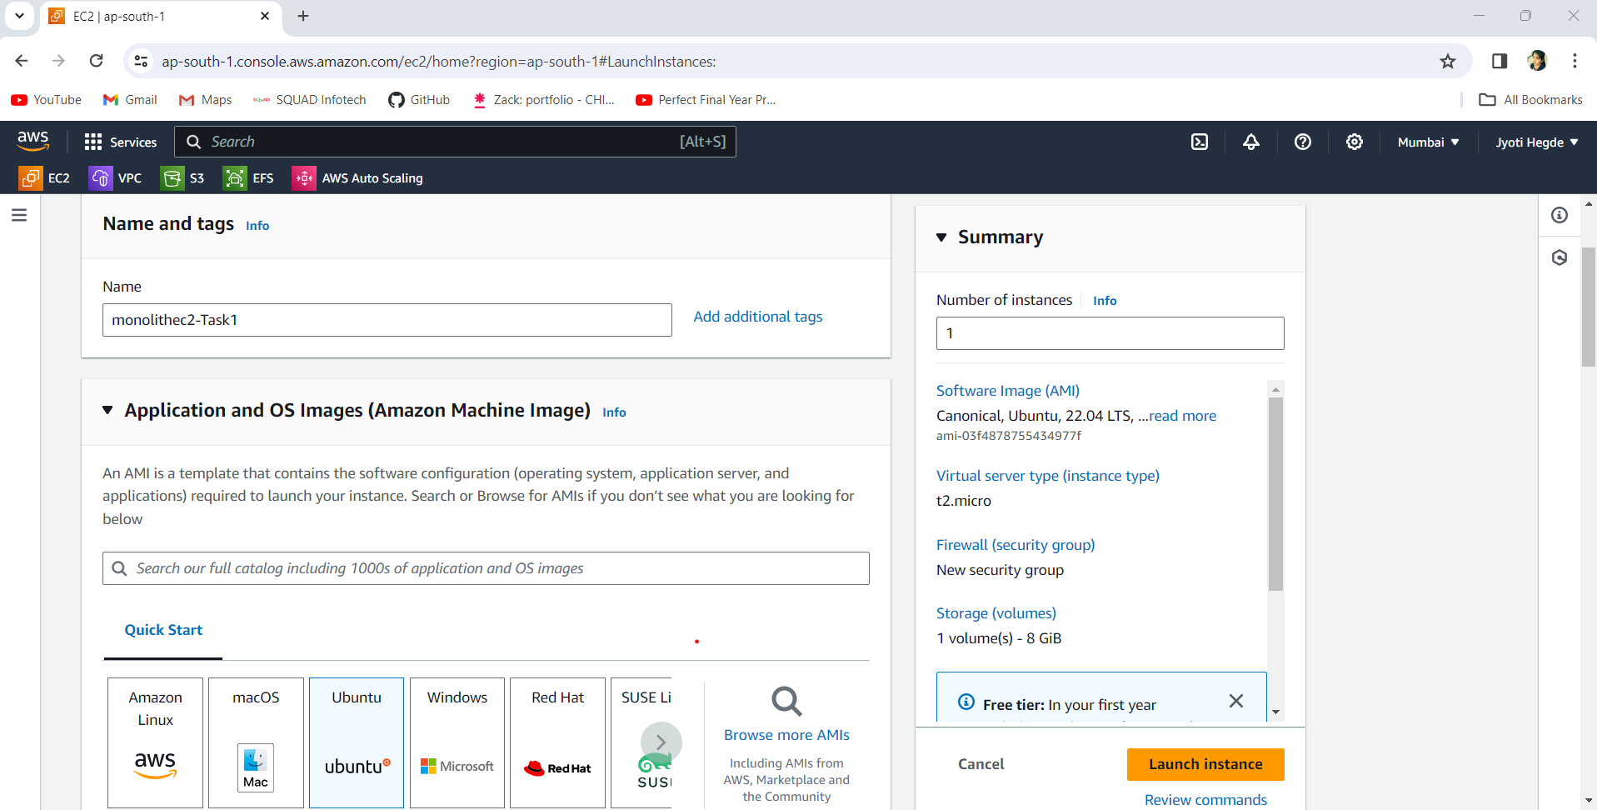

* Instance Type: t2.micro
* Key pair: monolith-key (new created)

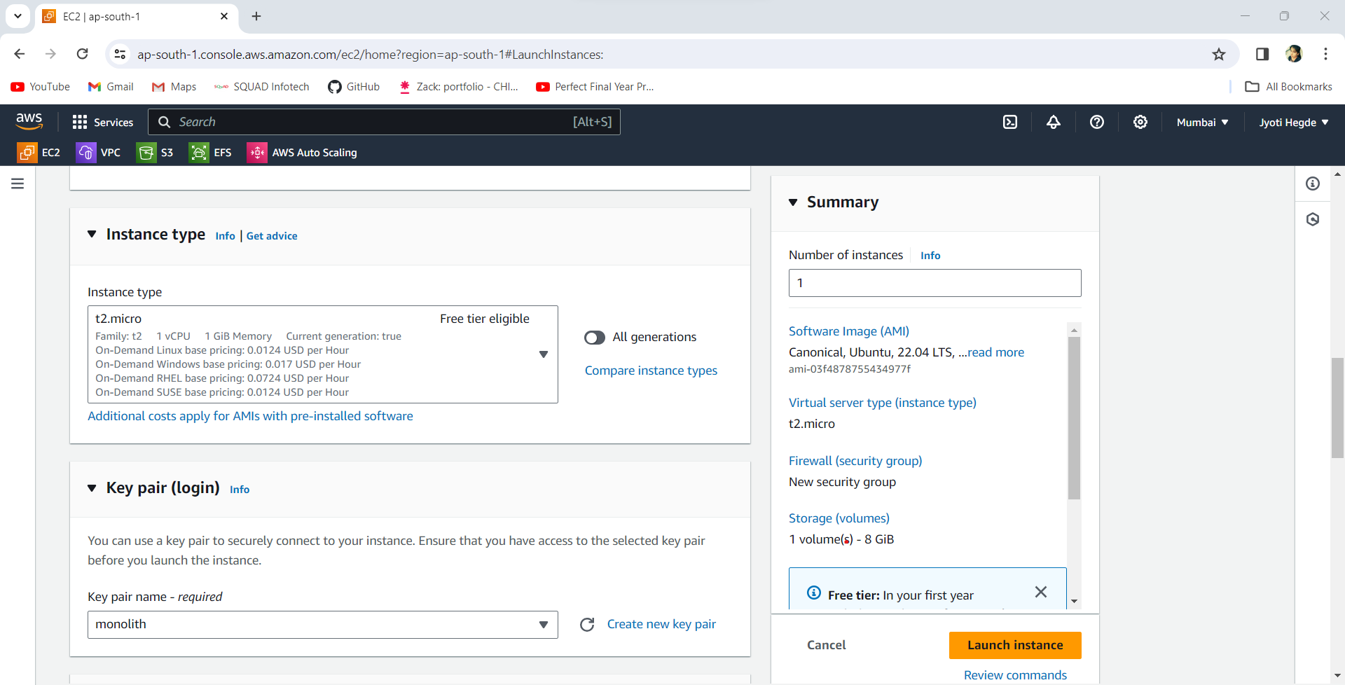

**Step 3**: allowed inbound traffic for SSH, HTTP/HTTPS (port 80 and 443) for WordPress access and port 3306 for MySQL access.

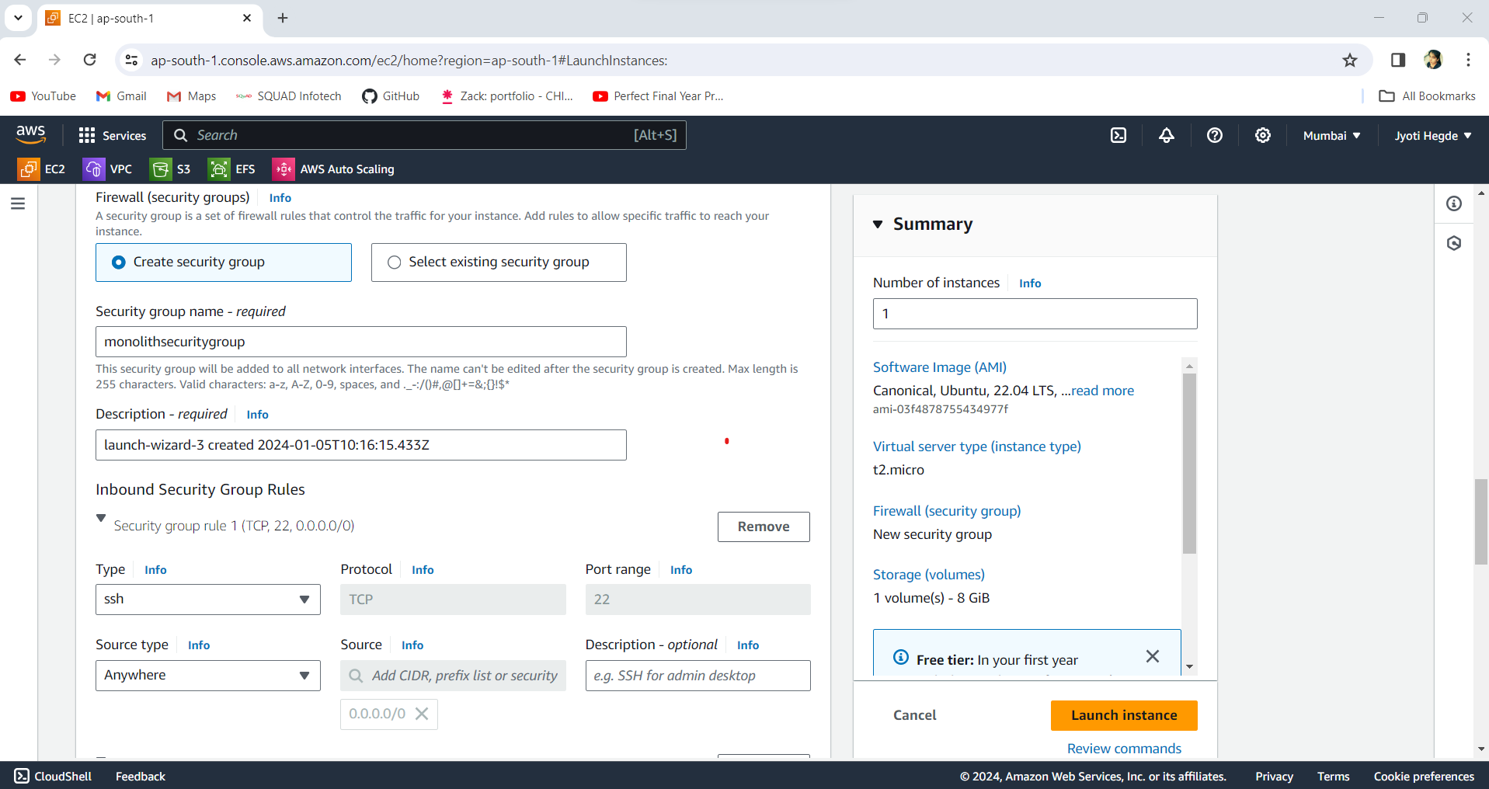

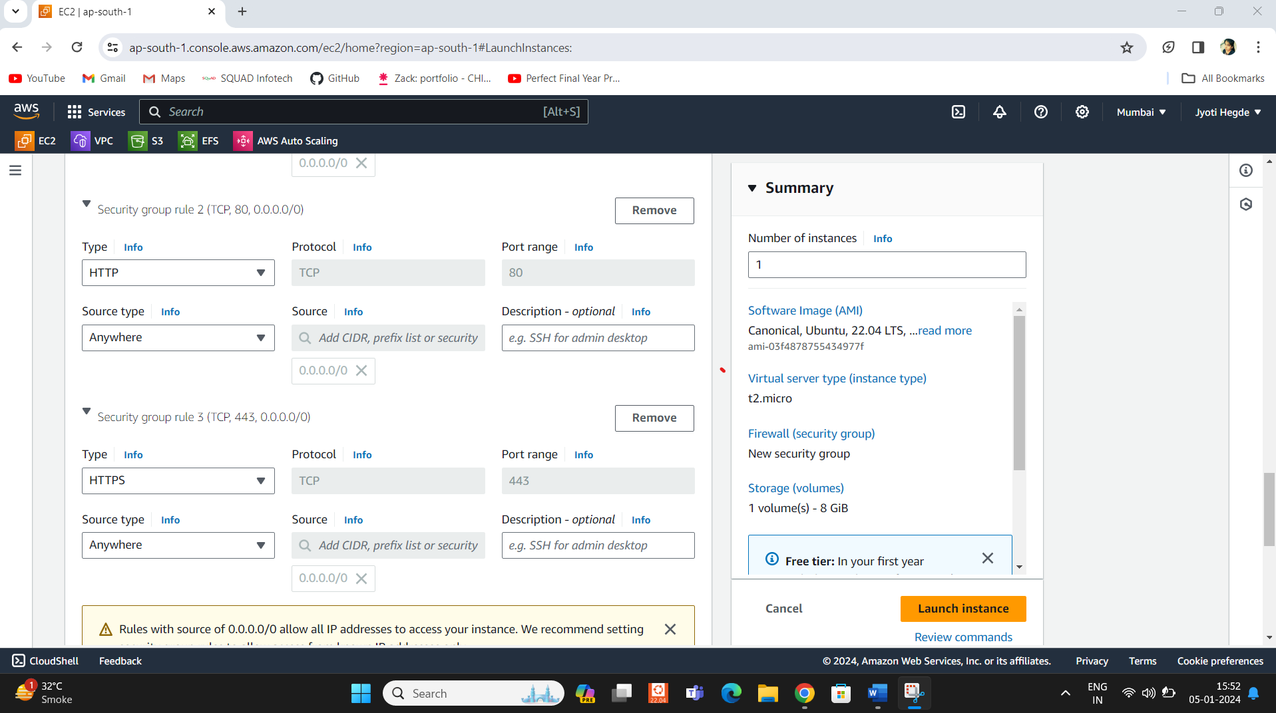

**Step 4**: The EC2 Instance launched Successfully->Click on connect to further process.

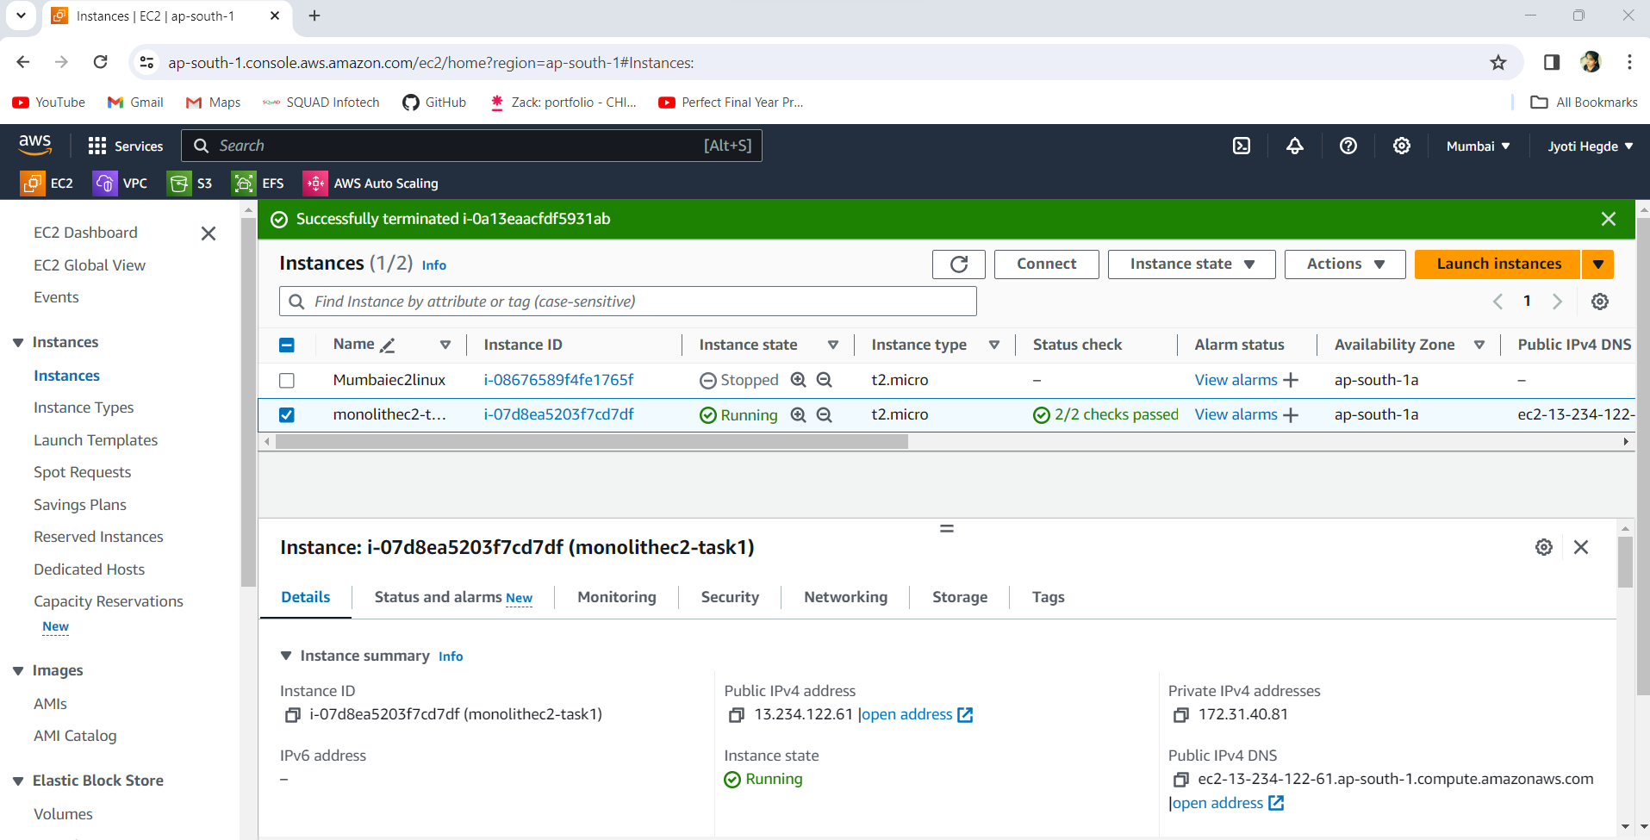

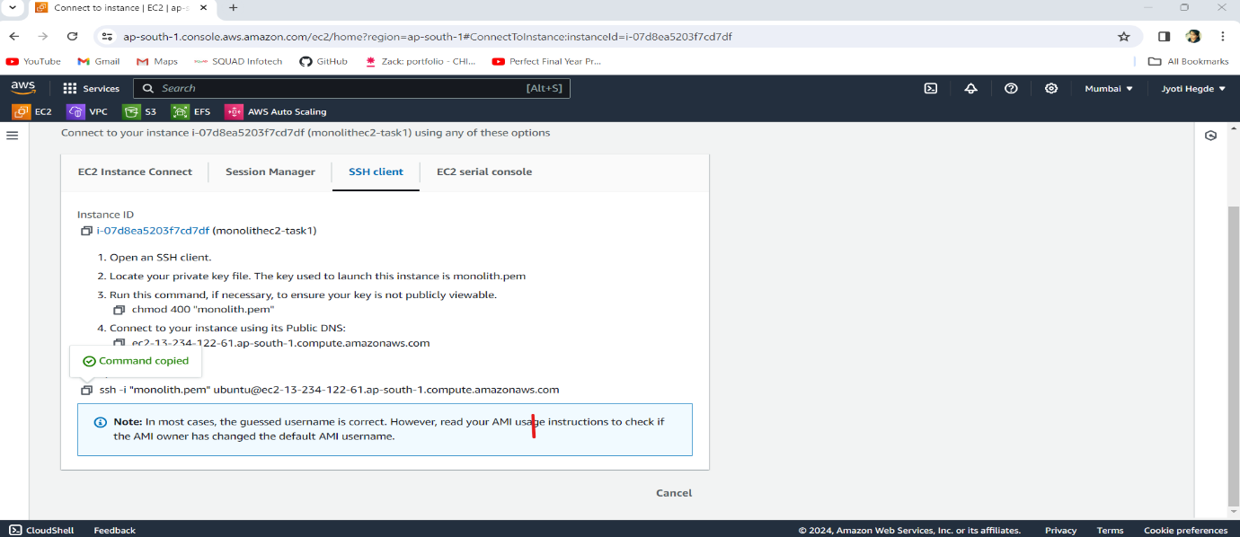**Step 5**: To connect the Ubuntu, we need to copy the ssh.

**Step 6**: Open terminal, go to the download folder (where our security key is downloaded)

* **cd downloads**

paste the ssh path (copied above) on terminal to connect our Ubuntu server with our EC2 instance.

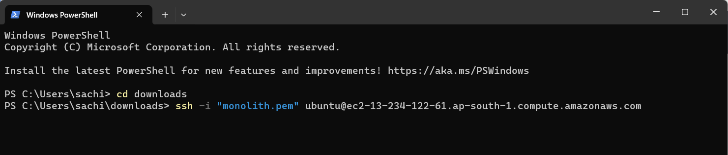

**Step 7**: Installed apache2 server on Ubuntu.

* **sudo apt install apache2**

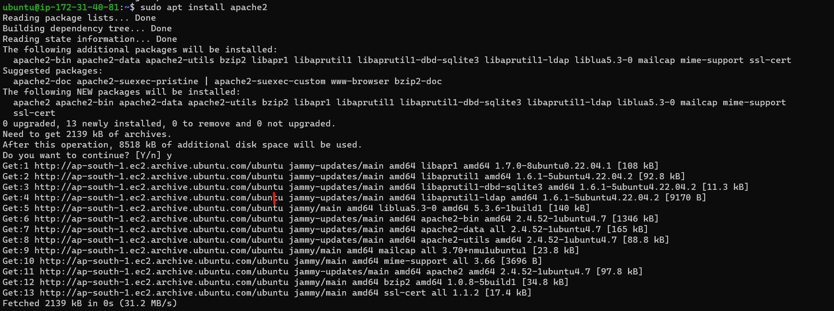

**Step 8**: Now copy the public IP of the EC2 and paste on the new tab

* http://<public-ip>

The Apache2 Default page open means our wordpress is up and running successfully.

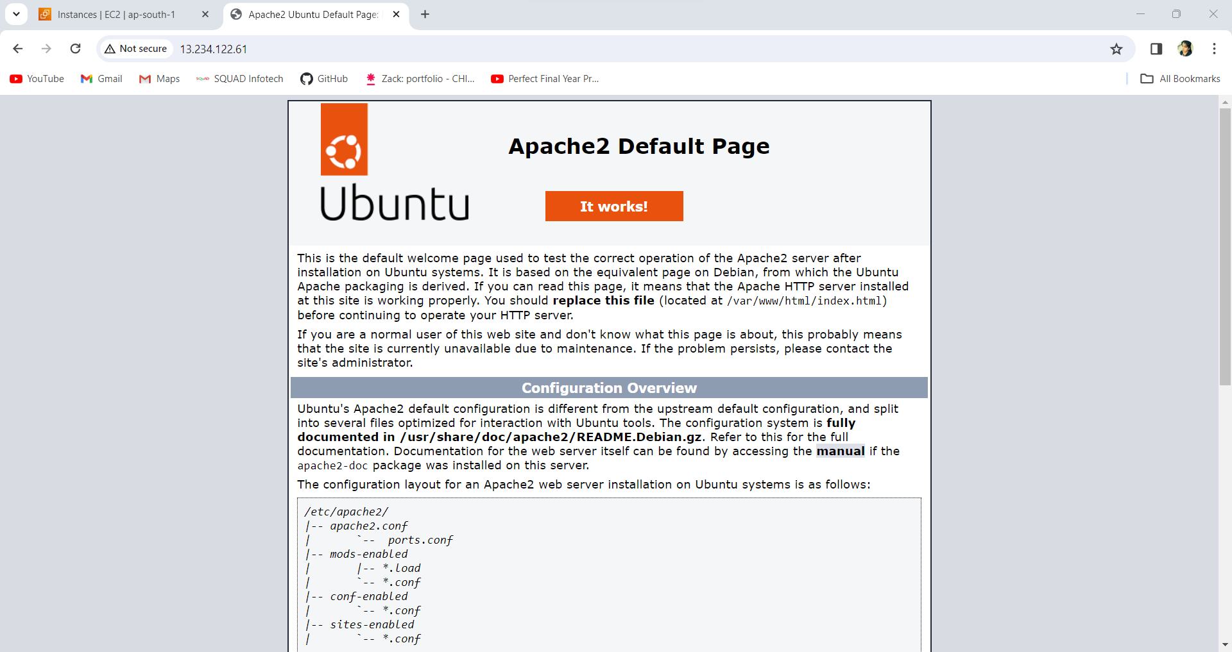

**Step 9**: Installed php runtime and php mysql connector.

* **sudo apt install php libapache2-mod-php php-mysql**

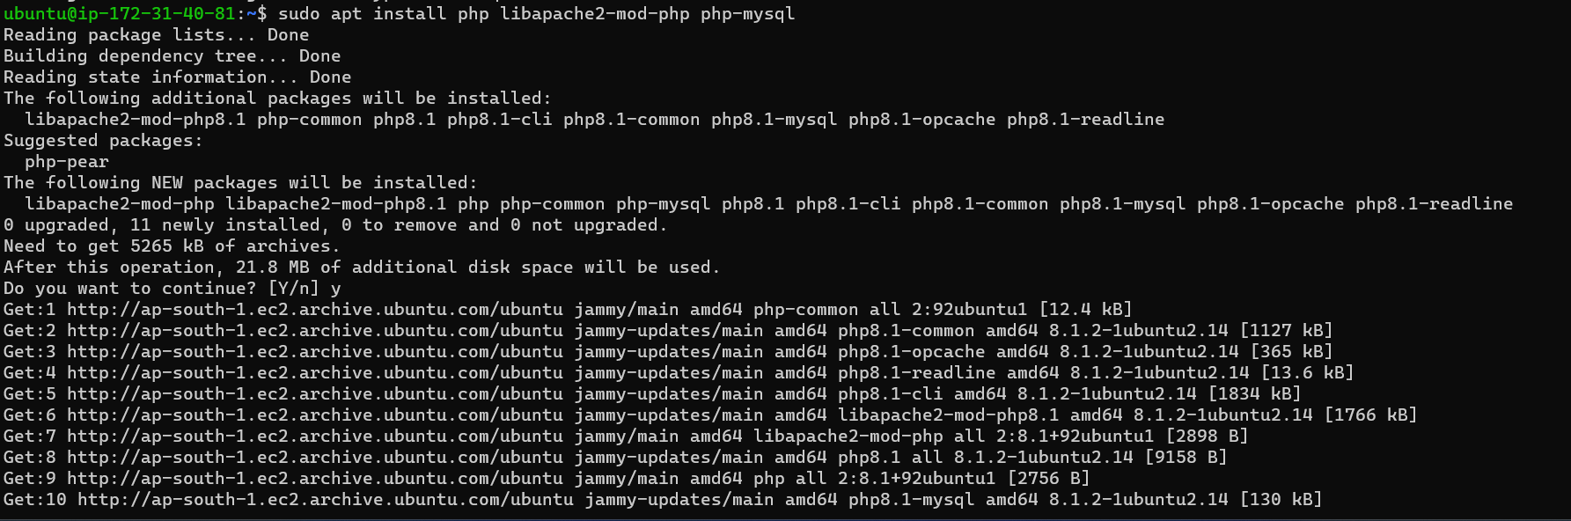

**Step 10**: Intalled MySql Server.

* **Sudo apt install mysql-server**

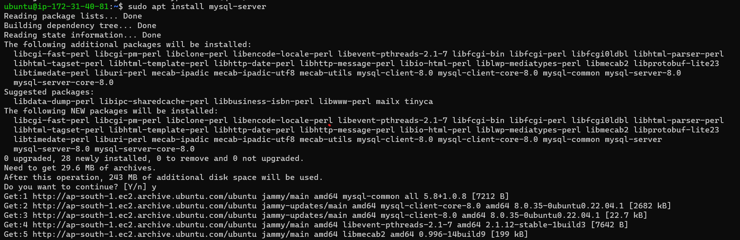

**Step 11**: Login to MySql Server

* **sudo mysql -u root**

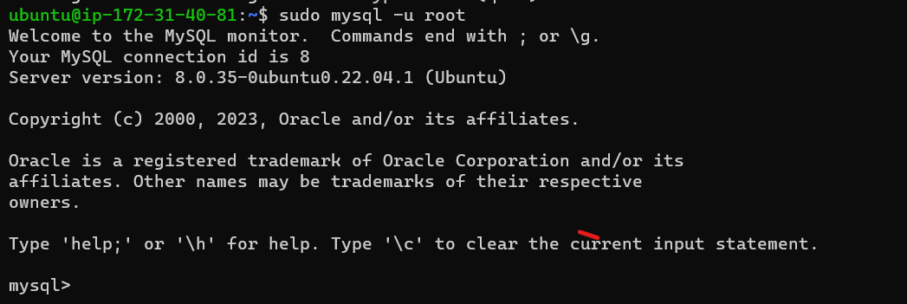

**Step 12**: Change authentication plugin to mysql_native_password (Choose strong Password)



**Step 13**: Create new database user for wordpress

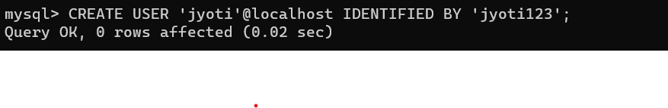

**Step 14**: Create a database for wordpress

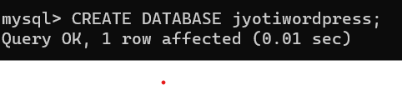

**Step 15**: Grant all Privileges on the database ‘wordpress’ to the newly created user.

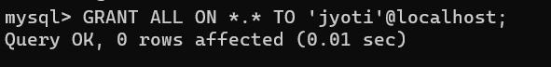

**Step 16**: For download wordpress ->go to the wordpress.org website on Google, copy the download link.

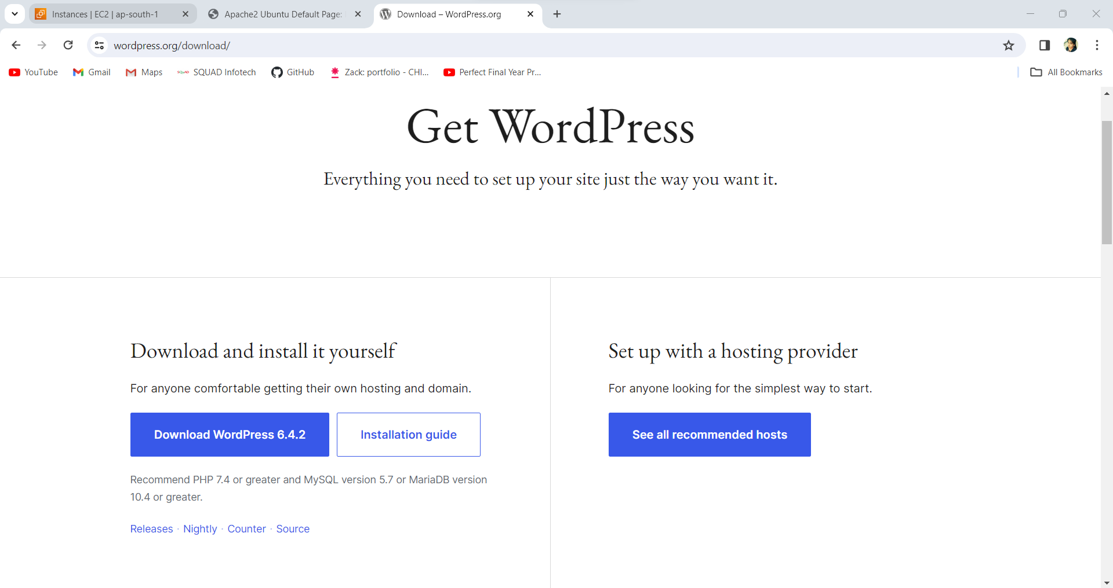

**Step 17**: on terminal type command as:

* cd /tmp
* wget https://wordpress.org/latest.tar.gz

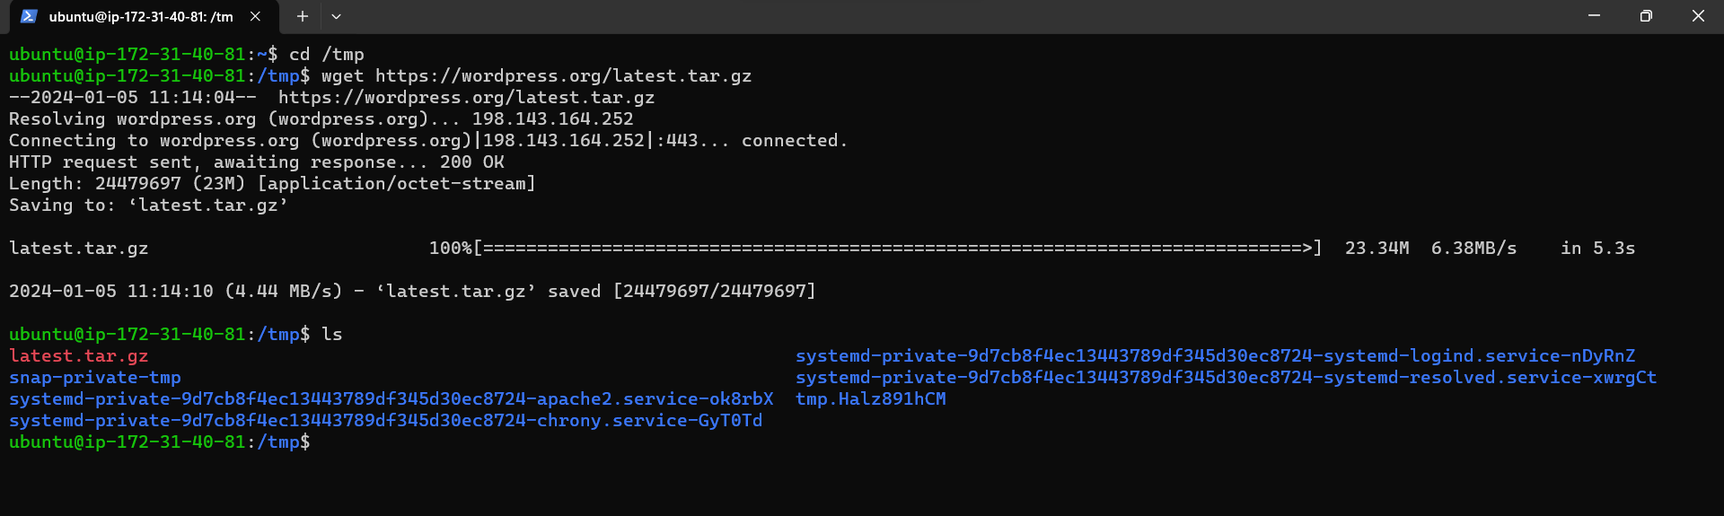

**Step 18**: Extract the zip file.

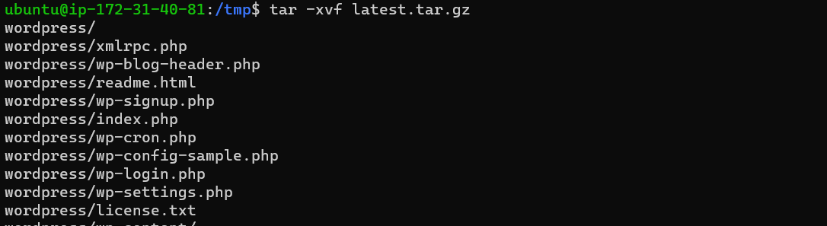

**Step 19**: Now WordPress is successfully installed.

* ls



**Step 20**: wordpress file contain index.html

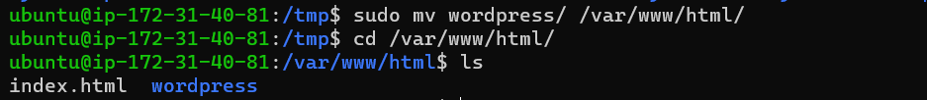

**Step 21**: Now copy the public IP of the EC2 and paste on the new tab as below,

* http://<public-ip-of-ec2>/wordpress

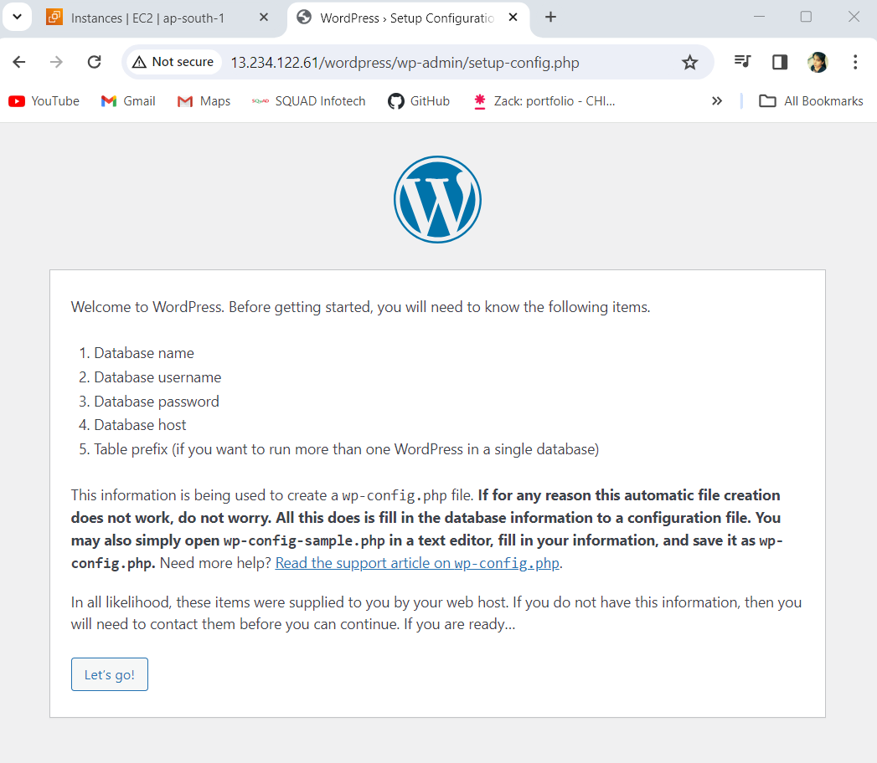

**Step 22**: go to next step and fill all details – database name, username & password.

Click on submit.

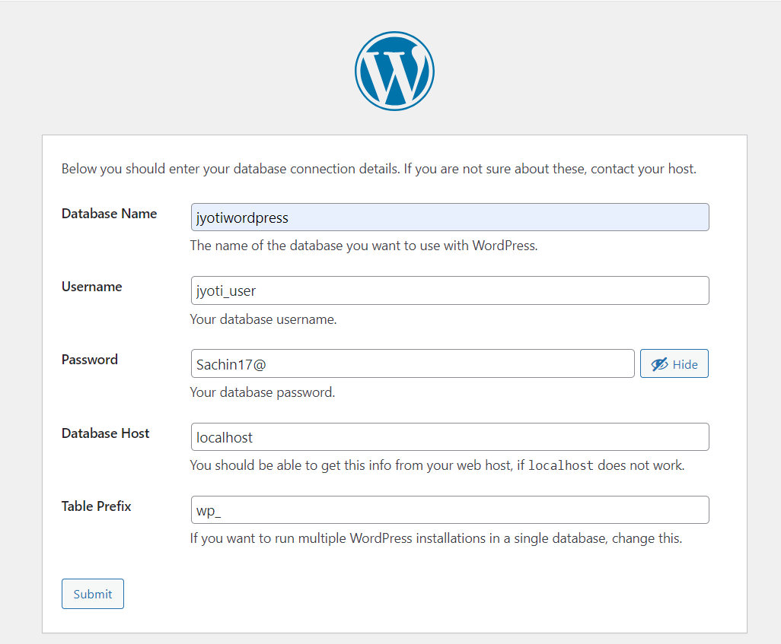

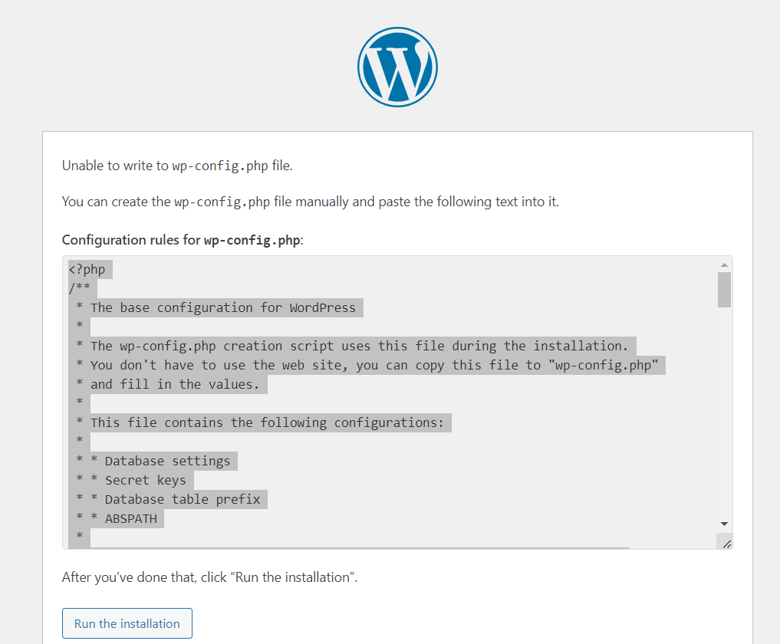**Step** **23**: wp-config.php error occur to fix it copy the code below.

**Step 24**: on the terminal, inside wordpress folder-> create nano wp.config.php file and paste above copied code.



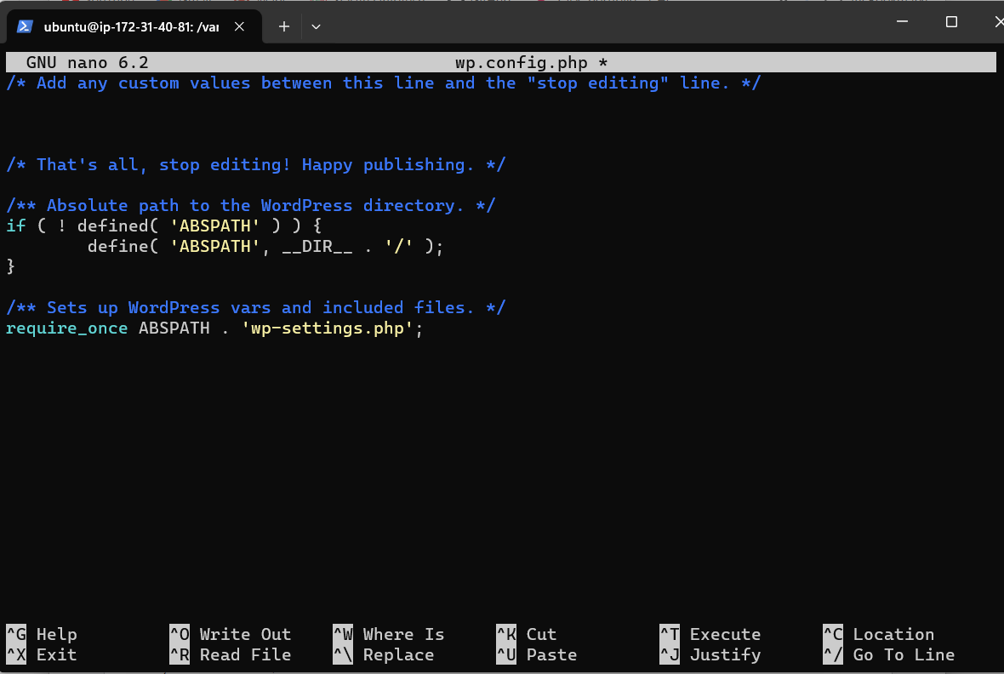

**Step 25**: Click on Run the installation button.

**Step 26**: Fill all the details to host/deploy your webpage.

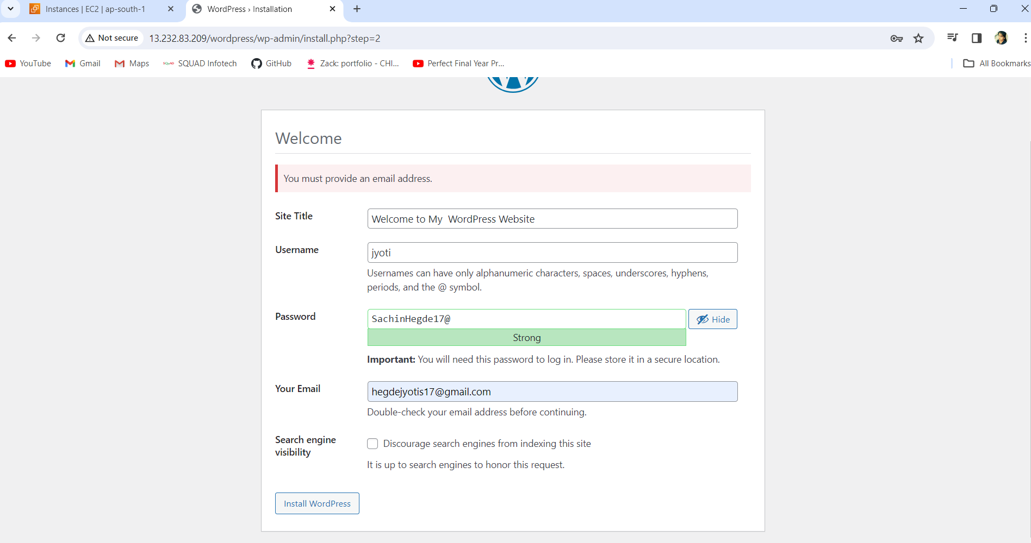

**Step 27**: Now install wordpress and Login with username & password.

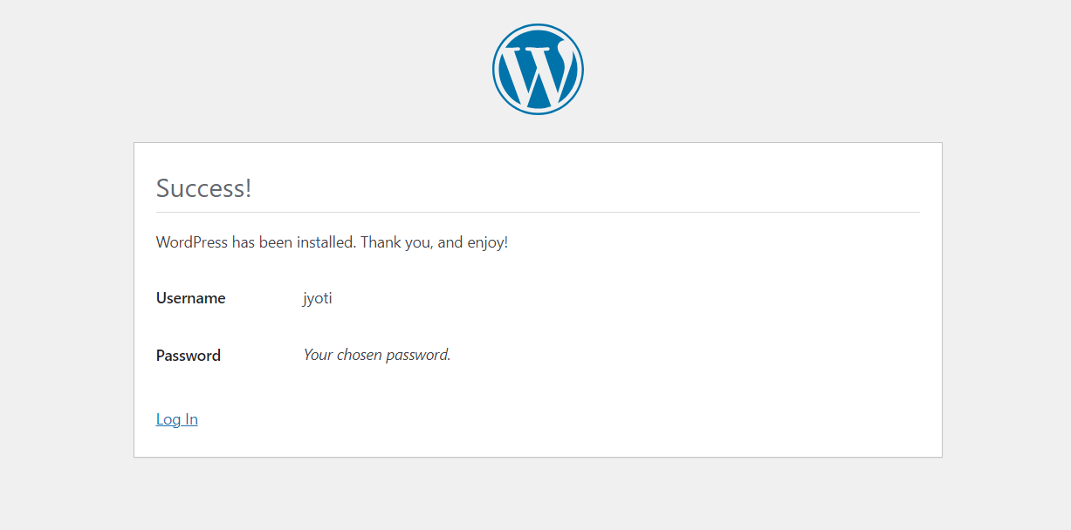

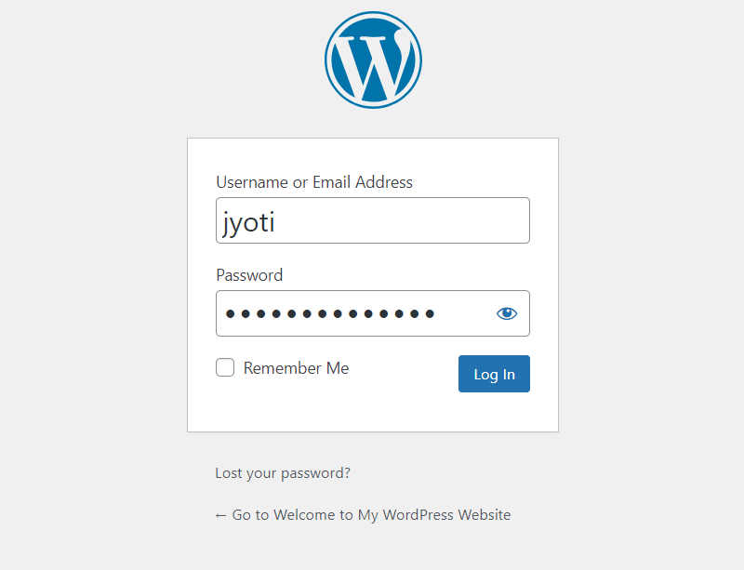

**Step 28**: See your first webpage is open successfully on the wordpress.

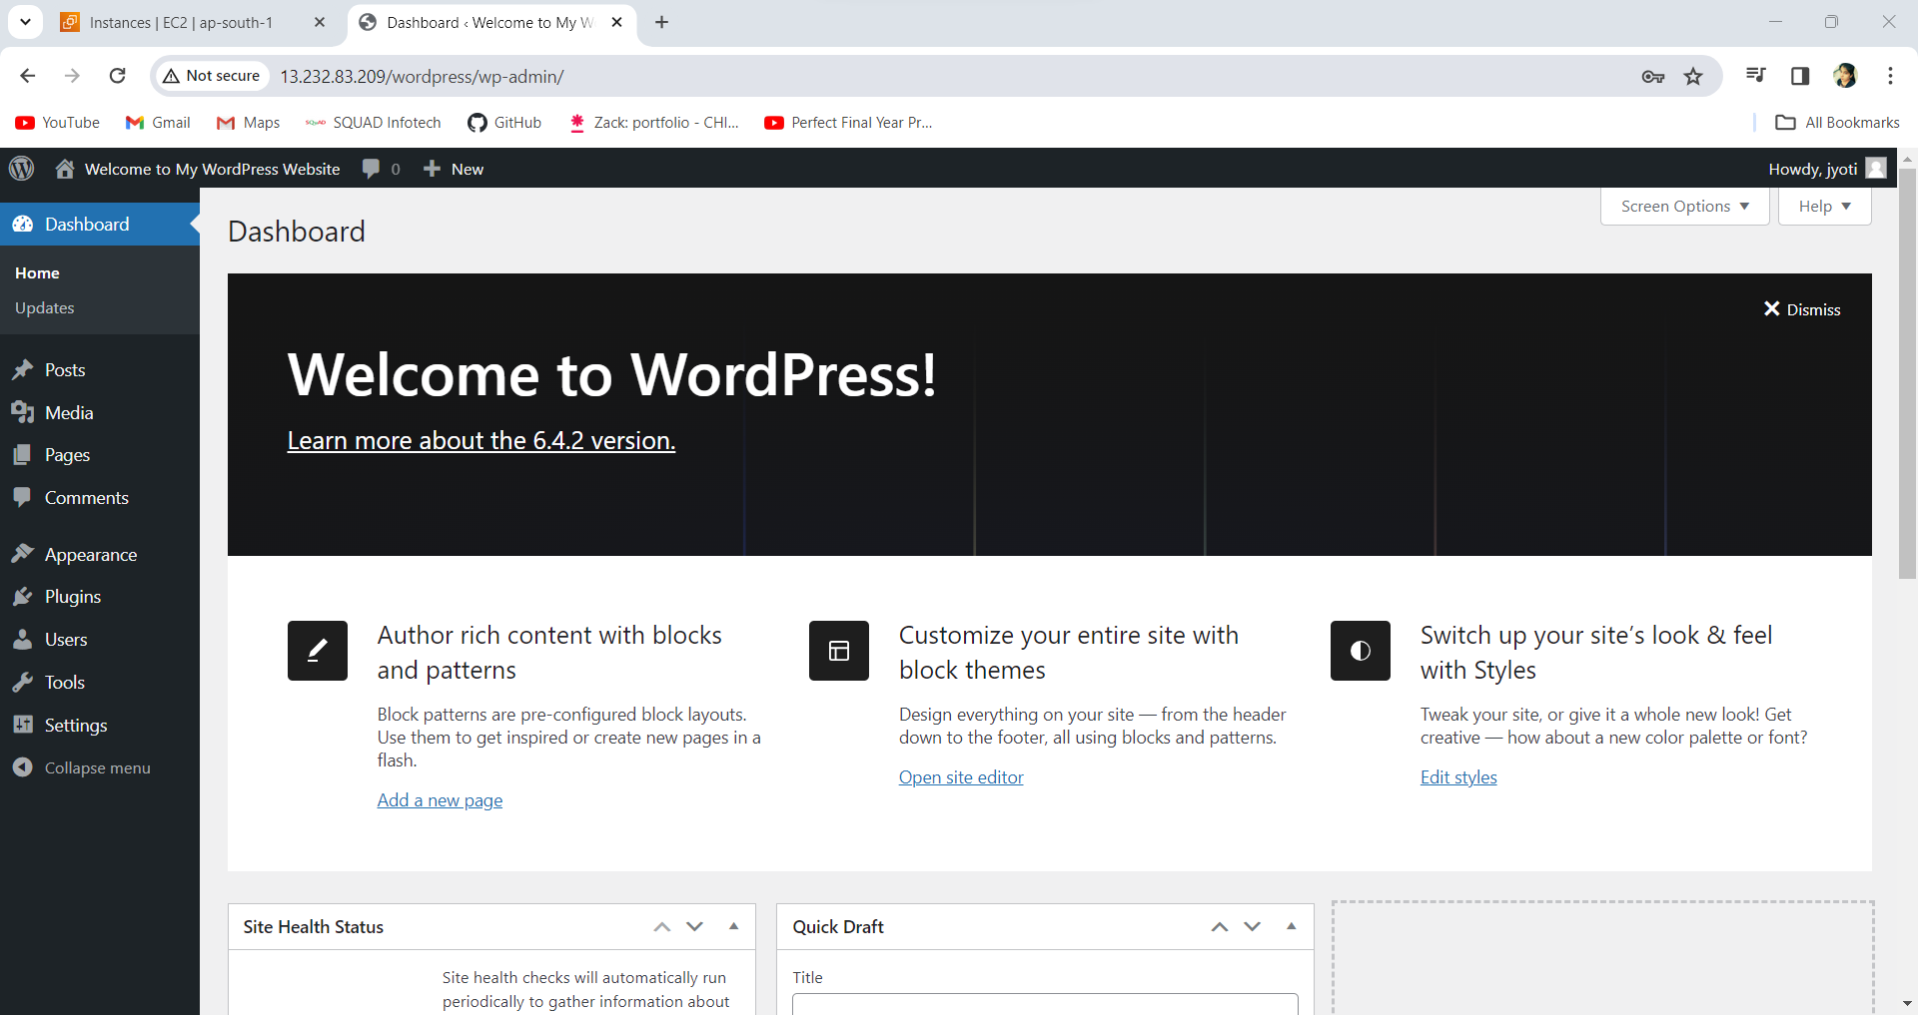

***Welcome to My WordPress Website***

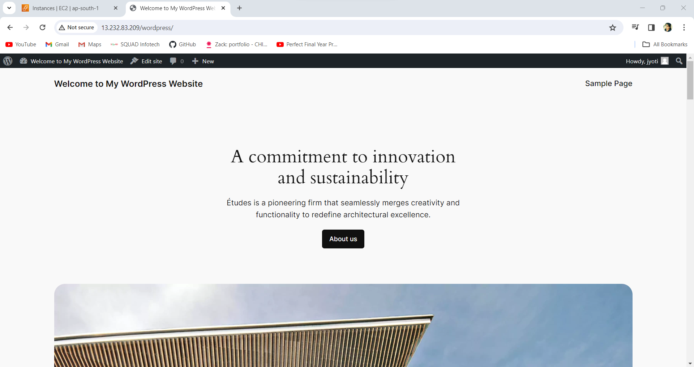

**Conclusion:** successfully performed my 1st task for monolith. In that 1 EC2 instance created, deployed WordPress and MYSQL on the same instance and created welcome page as “Welcome to My WordPress Website” as homepage.