JVM (Java Virtual Machine) Architecture

1. [Java Virtual Machine](https://www.javatpoint.com/internal-details-of-jvm)
2. [Internal Architecture of JVM](https://www.javatpoint.com/internal-details-of-jvm#jvminternalarch)

JVM (Java Virtual Machine) is an abstract machine. It is a specification that provides runtime environment in which java bytecode can be executed.

JVMs are available for many hardware and software platforms (i.e. JVM is platform dependent).

What is JVM

It is:

1. **A specification** where working of Java Virtual Machine is specified. But implementation provider is independent to choose the algorithm. Its implementation has been provided by Oracle and other companies.
2. **An implementation** Its implementation is known as JRE (Java Runtime Environment).
3. **Runtime Instance** Whenever you write java command on the command prompt to run the java class, an instance of JVM is created.

What it does

The JVM performs following operation:

* Loads code
* Verifies code
* Executes code
* Provides runtime environment

JVM provides definitions for the:

* Memory area
* Class file format
* Register set
* Garbage-collected heap
* Fatal error reporting etc.

## **JVM Architecture**

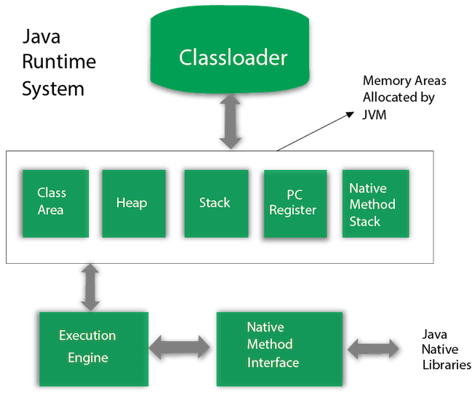

### **1) Classloader**

Classloader is a subsystem of JVM which is used to **load class files.** Whenever we run the java program, it is loaded first by the classloader. There are three built-in classloaders in Java.

1. **Bootstrap ClassLoader**: This is the first classloader which is the super class of Extension classloader. It loads the rt.jar file which contains all class files of Java Standard Edition like java.lang package classes, java.net package classes, java.util package classes, java.io package classes, java.sql package classes etc.
2. **Extension ClassLoader**: This is the child classloader of Bootstrap and parent classloader of System classloader. It loads the jar files located inside $JAVA_HOME/jre/lib/ext directory.
3. **System/Application ClassLoader**: This is the child classloader of Extension classloader. It loads the classfiles from classpath. By default, classpath is set to current directory. You can change the classpath using "-cp" or "-classpath" switch. It is also known as Application classloader.

### **1) Classloader**

Classloader is a subsystem of JVM which is used to load class files. Whenever we run the java program, it is loaded first by the classloader. There are three built-in classloaders in Java.

1. **Bootstrap ClassLoader**: This is the first classloader which is the super class of Extension classloader. It loads the rt.jar file which contains all class files of Java Standard Edition like java.lang package classes, java.net package classes, java.util package classes, java.io package classes, java.sql package classes etc.
2. **Extension ClassLoader**: This is the child classloader of Bootstrap and parent classloader of System classloader. It loades the jar files located inside $JAVA_HOME/jre/lib/ext directory.
3. **System/Application ClassLoader**: This is the child classloader of Extension classloader. It loads the classfiles from classpath. By default, classpath is set to current directory. You can change the classpath using "-cp" or "-classpath" switch. It is also known as Application classloader.