# **1.|Car Wheel Problem**

**Puzzle:**

A car has 4 tyres and 1 spare tyre. Each tyre can travel a maximum distance of 20000 kilometers before wearing off. What is the maximum distance the car can travel. You are allowed to change tyres (using the spare tyre) unlimited number of times.

Note: All tyres are used upto their full strength.

**Puzzle Solution:**

25000  
Divide the lifetime of spare tire into 4 equal part i.e., 5000 and swap it at each completion of 5000 Kms distance.  
Let four tyres be A, B, C and D and spare tyre be S.  
5000 KMs: Replace A with S.  
10000 KMs: Put A back to its original position and replace B with S  
15000 KMs: Put B back to its original position and replace C with S  
20000 KMs: Put C back to its original position and replace D with S

# **2.|Burning Rope Timer Puzzle**

[November 7, 2013 9:37 pm](http://www.crazyforcode.com/burning-ropes-puzzle/) | [Leave a Comment](http://www.crazyforcode.com/burning-ropes-puzzle/#comments) | [crazyadmin](http://www.crazyforcode.com/author/dev1/" \o "by crazyadmin)

**Puzzle:**  
A man has two ropes of varying thickness (Those two ropes are not identical, they aren’t the same density nor the same length nor the same width). Each rope burns in 60 minutes. He actually wants to measure 45 mins. How can he measure 45 mins using only these two ropes.  
He can’t cut the one rope in half because the ropes are non-homogeneous and he can’t be sure how long it will burn.

**Puzzle Solution:**

He will burn one of the rope at both the ends and the second rope at one end. After half an hour, the first one burns completely and at this point of time, he will burn the other end of the second rope so now it will take 15 mins more to completely burn. so total time is 30+15 i.e. 45mins.

# **3.|Probability of getting one rupee coin from bag**

[August 28, 2013 9:36 pm](http://www.crazyforcode.com/probability-rupee-coin-bag/) | [7 Comments](http://www.crazyforcode.com/probability-rupee-coin-bag/#comments) | [crazyadmin](http://www.crazyforcode.com/author/dev1/" \o "by crazyadmin)

**Problem:**

A bag contains (x) one rupee coins and (y) 50 paise coins. One coin is taken from the bag and put away. If a coin is now taken at random from the bag, what is the probability that it is a one rupee coin?

Case I: Let the first coin removed be one rupee coin One rupee coins left = (x – 1) Fifty paise coins left = y. Probability of getting a one rupee coin in the first and second draw = x/(x + y) × (x – 1)/(x – 1 + y)  
Case II: Let the first coin removed be fifty paise coin One rupee coins left = x Fifty paise coins left = y – 1. Probability of getting a fifty paise coin in the first and one rupee coin in second draw  
= y / (x + y) × x / (x + y – 1)  
Total probability = sum of these two = x/(x + y) [after simplification].

# **4.|Probability of picking 2 socks of same color**

[August 10, 2013 10:34 am](http://www.crazyforcode.com/probability-picking-2-socks-color/) | [Leave a Comment](http://www.crazyforcode.com/probability-picking-2-socks-color/#comments) | [crazyadmin](http://www.crazyforcode.com/author/dev1/" \o "by crazyadmin)

**Problem:**  
There are 6 pairs of black socks and 6 pairs of white socks. What is the probability to pick a pair of black or white socks when 2 socks are selected randomly in darkness.

**Solution:**

Ways to pick any 2 socks from 24 socks = 24C2  
Ways to pick 2 BLACK socks from 12 BLACK socks = 12C2

Probability of picking 2 BLACK socks (P1)= 12C2 / 24C2 = 66/276  
Probability of picking 2 WHITE socks (P2)= 12C2 / 24C2 = 66/276

Probability of picking any 2 same color socks = P1+P2 = 66/276 + 66/276 = 11/23

# **5.|How can four employees calculate the average of their salaries without knowing other’s salary**

[June 22, 2013 4:54 pm](http://www.crazyforcode.com/how-can-four-employees-calculate-the-average-of-their-salaries-without-knowing-others-salary/) | [3 Comments](http://www.crazyforcode.com/how-can-four-employees-calculate-the-average-of-their-salaries-without-knowing-others-salary/#comments) | [crazyadmin](http://www.crazyforcode.com/author/dev1/)

This solution has a limitation that information is partially passed  and there needs some trust level.

Salary of A: i

Salary of B: j

Salary of C: k

Salary of D: l

A passes to B (i + a) where a is a number that A knows B takes this a passes to C (i + j + a + b). C takes this and passes to D (i + j + k + a + b + c). D takes this and passes to A (i + j + k + l + a + b + c + d)

Now one after another they remove their constants.  
Ex: A now passes to B: i + j + k + l + b + c + d (He has removed a)

B passes to C after removing of his constant (b).

Thus Finally D gets x + y + z + u + d. He takes away his constant and now he has i + j + k + l.

So the average is:(i + j + k + l) / 4.

Let us know if you know any other solution.

# **6. | 1000 light bulbs switched on/off by 1000 persons passing by**

There are 1000 light bulbs and 1000 persons. All light bulbs are initially off. Person 1 goes flipping light bulb 1, 2, 3, 4, … person 2 then flips 2, 4, 6, 8, … person 3 then 3, 6, 9, … etc until all 1000 persons have done this. What is the status of light bulb 25, 93, 576, 132, 605, 26, 45, 37, 36 after all persons have flipped their respective light bulbs? Is there a general solution to predict the status of a light bulb? How many light bulbs are on after all 1000 persons have gone by?

**Explanation:** The key observations are:

1. Person 1 flips the light bulb 1, 2, 3, … which are multiples of 1.
2. Person 2 flips the light bulb 2, 4, 6, … which are multiples of 2.
3. Person 3 flips the light bulb 3, 6, 9, … which are multiples of 3.
4. Similarly, Person 1000 flips the light bulb 1000 which is multiple of 1000.
5. From the above observations, we can say that person i will flip light bulbs which are multiples of i,
6. Thus, a light bulb j will be flipped by all persons for whom j is a multiple of their person number. In other words light bulb j will be flipped by all persons whose person number i is a factor of j,
7. **Examples:**
   * **(i)** Light Bulb 10 will be flipped by persons 1, 2, 5, 10 whose person numbers are factors of 10.
   * **(ii)** Light Bulb 12 will be flipped by persons 1, 2, 3, 4, 6, 12 whose person numbers are factors of 12.
8. Thus, the light bulb 25 will be flipped by persons 1, 5, 25, so it will be flipped 3 times which is odd and since initially all bulbs were “off”, now light bulb 25 will be “on”.
9. The light bulb 93 will be flipped by persons 1, 3, 31, 93, so it will be flipped 4 times which is even and since initially all bulbs were “off”, now light bulb 93 will be “off”.
10. The light bulb 576 will be flipped by persons 1, 2, 3, 4, 6, 8, 9, 12, 16, 18, 24, 32, 36, 48, 64, 72, 96, 144, 192, 288, 576, so it will be flipped 21 times which is odd and since initially all bulbs were “off”, now light bulb 576 will be “on”.
11. The light bulb 132 will be flipped by persons 1, 2, 3, 4, 6, 11, 12, 22, 33, 44, 66, 132, so it will be flipped 12 times which is even and since initially all bulbs were “off”, now light bulb 132 will be “off”.
12. The light bulb 605 will be flipped by persons 1, 5, 11, 55, 121, 605, so it will be flipped 6 times which is even and since initially all bulbs were “off”, now light bulb 605 will be “off”.
13. The light bulb 26 will be flipped by persons 1, 2, 13, 26, so it will be flipped 4 times which is even and since initially all bulbs were “off”, now light bulb 26 will be “off”.
14. The light bulb 45 will be flipped by persons 1, 3, 5, 9, 15, 45, so it will be flipped 6 times which is even and since initially all bulbs were “off”, now light bulb 45 will be “off”.
15. The light bulb 37 being prime numbered bulb will be flipped by p

# **7. | (Finding the poisoned wine)**

You have 240 barrels of wine, one of which has been poisoned. After drinking the poisoned wine, one dies exactly 24 hours. You have 5 slaves whom you are willing to sacrifice in order to determine which barrel contains the poisoned wine. How do you achieve this in 48 hours?

   
   
Let us number the barrels with 5 digit numbers consisting of 0, 1 and 2. Let us number the slaves as 1, 10, 100, 1000, 10000.

Number 0 on a barrel represents the wine in the barrel will not be taken by the slave.

Number 1 on a barrel represents the wine in the barrel will taken by the slave on 1st day.

Number 2 on a barrel represents the wine in the barrel will be taken by the slave on 2nd day(after 24 hours).

The action corresponding to the digit in the unit place will be executed by slave numbered 1.

The action corresponding to the digit in the tenth place will be executed by slave numbered 10.

The action corresponding to the digit in the 100th place will be executed by slave numbered 100.

The action corresponding to the digit in the 1000th place will be executed by slave numbered 1000.

The action corresponding to the digit in the 10000th place will be executed by slave numbered 10000.

Example: Let us say the barrel is numbered 11201. The wine in this barrel is taken on the first day by the slave numbered 10000, 1000 and 1. It is taken on the second day by slave numbered 100. And it is not taken by the slave numbered 10.

So if the slave numbered 10000, 1000 and 1 die within first 24 hours, slave numbered 100 dies in the next 24 hours and the slave numbered 10 does not die, then the poisoned barrel has to be 11201.

This way total number possible is 3 * 3 * 3 * 3 * 3 = 3^5 = 243 barrels!! So with the help of 5 slaves and within 48 hours we will be able to find a poisoned barrel among 243 barrels.

# **8. | (Monty Hall problem)**

Suppose you’re on a game show, and you’re given the choice of three doors: Behind one door is a car; behind the others, goats. You pick a door, say No. 1, and the host, who knows what’s behind the doors, opens another door, say No. 3, which has a goat. He then says to you, “Do you want to pick door No. 2?” Is it to your advantage to switch your choice?

# **9.| (3 Bulbs and 3 Switches)**

There is a room with a door (closed) and three light bulbs. Outside the room there are three switches, connected to the bulbs. You may manipulate the switches as you wish, but once you open the door you can’t change them. Identify each switch with its bulb.

Let the bulbs be X, Y and Z

Turn on switch X for 5 to 10 minutes. Turn it off and turn on switch Y. Open the door and touch the light bulb.

1. if the light is on, it is Y

2. if the light is off and hot, it is X

3. if the light is off and cold, it is Z

# **10. | (Find the Jar with contaminated pills)**

You have 5 jars of pills. Each pill weighs 10 grams, except for contaminated pills contained in one jar, where each pill weighs 9 grams. Given a scale, how could you tell which jar had the contaminated pills in just one measurement?

**Solution:**  
Take out 1 pill from jar 1, 2 pills from jar 2, 3 pills from jar 3, 4 pills from jar 4 and 5 pills from jar 5. Put all these 15 pills on scale. The correct wight is 150 (15*10). But one of the jars has contaminated pills. So the wight will definitely less than 150. If the wight is 149 then jar 1 has contaminated pills because the there is only one contaminated pill. If the wight is 148 then jar 2, if the wight is 147 then jar 3, if 146 then jar 4, if 145 then jar 5.

# **11.| (Find the fastest 3 horses)**

There are 25 horses among which you need to find out the fastest 3 horses. You can conduct race among at most 5 to find out their relative speed. At no point you can find out the actual speed of the horse in a race. Find out how many races are required to get the top 3 horses.

 The solution is 7.

# **12 | (A Man with Medical Condition and 2 Pills)**

A man has a medical condition that requires him to take two kinds of pills, call them A and B. The man must take exactly one A pill and exactly one B pill each day, or he will die. The pills are taken by first dissolving them in water.

The man has a jar of A pills and a jar of B pills. One day, as he is about to take his pills, he takes out one A pill from the A jar and puts it in a glass of water. Then he accidentally takes out two B pills from the B jar and puts them in the water. Now, he is in the situation of having a glass of water with three dissolved pills, one A pill and two B pills. Unfortunately, the pills are very expensive, so the thought of throwing out the water with the 3 pills and starting over is out of the question. How should the man proceed in order to get the right quantity of A and B while not wasting any pills?

 

**Solution:**  
Add one more A pill to the glass and let it dissolve. Take half of the water today and half tomorrow. It works under following assumptions.

The dissolved Pills can be used next day.

The man has to take pills at least for one more day.

# **13 | (Maximize probability of White Ball)**

There are two empty bowls in a room. You have 50 white balls and 50 black balls. After you place the balls in the bowls, a random ball will be picked from a random bowl. Distribute the balls (all of them) into the bowls to maximize the chance of picking a white ball.

**Explanation:**  
First, let us assume that we divided the balls into jars equally so each jar will contain 50 balls.  
So the probability of selecting a white ball will be=probability of selecting the first jar*probability of white ball in the first jar + probability of selecting the second jar*probability of white ball in the second jar  
=(1/2)*(0/50)+(1/2)*(50/50)=0.5  
Since we have to maximize the probability so we will increase the probability of white ball in the first jar and keep the second probability same mean equal to 1  
so we add 49 white balls with 50 black balls in the first jar and only one white ball in the second jar  
so the probability will be now=

(1/2)*(49/99)+(1/2)*(1/1)=0.747

Therefore, probability of getting white ball becomes 1/2*1 + 1/2*49/99 which is approximately 3/4.

# **14 | (100 Prisoners with Red/Black Hats)**

100 prisoners in jail are standing in a queue facing in one direction. Each prisoner is wearing a hat of color either black or red. A prisoner can see hats of all prisoners in front of him in the queue, but cannot see his hat and hats of prisoners standing behind him.  
The jailer is going to ask color of each prisoner’s hat starting from the last prisoner in queue. If a prisoner tells the correct color, then is saved, otherwise executed. **How many prisoners can be saved at most** if they are allowed to discuss a strategy before the jailer starts asking colors of their hats.

**Answer:**  
At-most 99 prisoners can be saved and the 100th prisoner has 50-50 chances of being executed.  
The idea is that every prisoner counts number of red hats in front of him.

100th prisoner says red if the number of red hats is even. He may or may not be saved, but he coneys enough information to save 99th prisoner.

The 99’th prisoner decides his answer on the basis of answer of 100’th prisoner’s answer. There are following possibilities and 99’th prisoner can figure out color of his hat in every case.

If 100’th prisoner said ‘Red’ (There must have been even number of red hats in front of him)  
a) If 99’th prisoner sees even number of red hats in front of him, then his color is black.  
b) If 99’th prisoner sees odd number of red hats in front of him, then his color is red.

If 100’th prisoner said ‘Black’ (There must have been odd number of red hats in front of him)  
a) If 99’th prisoner sees even number of red hats in front of him, then his color is Red.  
b) If 99’th prisoner sees odd number of red hats in front of him, then his color is Black.

The 98’th prisoner decides his answer on the basis of answer of 99’th prisoner’s answer and uses same logic.

Similarly other prisoners from 97 to 1 are saved.

# **15| (Strategy for a 2 Player Coin Game)**

Consider a two player coin game where each player gets turn one by one. There is a row of even number of coins, and a player on his/her turn can pick a coin from any of the two corners of the row. The player that collects coins with more value wins the game. Develop a strategy for the player making the first turn, such he/she never looses the game.

18 20 15 30 10 14  
Sum of odd coins = 18 + 15 + 10 = 43  
Sum of even coins = 20 + 30 + 14 = 64.  
Since the sum of even coins is more, the first  
player decides to collect all even coins. He first  
picks 14, now the other player can only pick a coin  
(10 or 18). Whichever is picked the other player,  
the first player again gets an opportunity to pick  
an even coin and block all even coins.

# **16 | (Camel and Banana Puzzle)**

A person has 3000 bananas and a camel. The person wants to transport maximum number of bananas to a destination which is 1000 KMs away, using only the camel as a mode of transportation. The camel cannot carry more than 1000 bananas at a time and eats a banana every km it travels. What is the maximum number of bananas that can be transferred to the destination using only camel (no other mode of transportation is allowed).

# **17 | (100 Doors)**

There are 100 doors in a row, all doors are initially closed. A person walks through all doors multiple times and toggle (if open then close, if close then open) them in following way:

In first walk, the person toggles every door

In second walk, the person toggles every second door, i.e., 2nd, 4th, 6th, 8th, …

In third walk, the person toggles every third door, i.e. 3rd, 6th, 9th, …

………  
……….

In 100th walk, the person toggles 100th door.

**Which doors are open in the end?**

 

**Solution:**  
A door is toggled in ith walk if i divides door number. For example the door number 45 is toggled in 1st, 3rd, 5th, 9thand 15th walk.  
The door is switched back to initial stage for every pair of divisors. For example 45 is toggled 6 times for 3 pairs (5, 9), (15, 3) and (1, 45).  
It looks like all doors would become closes at the end. But there are door numbers which would become open, for example 16, the pair (4, 4) means only one walk. Similarly all other perfect squares like 4, 9, ….

So the answer is 1, 4, 9, 16, 25, 36, 49, 64, 81 and 100.

# **18 | (Torch and Bridge)**

There are 4 persons (A, B, C and D) who want to cross a bridge in night.

A takes 1 minute to cross the bridge.  
B takes 2 minutes to cross the bridge.  
C takes 5 minutes to cross the bridge.  
D takes 8 minutes to cross the bridge.

There is only one torch with them and the bridge cannot be crossed without the torch. There cannot be more than two persons on the bridge at any time, and when two people cross the bridge together, they must move at the slower person’s pace

**Can they all cross the bridge in 15 minutes?**

A and B cross the bridge. A comes back. Time taken 3 minutes. Now B is on the other side.  
C and D cross the bridge. B comes back. Time taken 8 + 2 minutes. Now C and D are on the other side.  
A and B cross the bridge. Time taken is 2 minutes. All are on the other side.

Total time spent is 3 + 10 + 2 = 15 minutes.

# **19 | (Poison and Rat)**

There are 1000 wine bottles. One of the bottles contains poisoned wine. A rat dies after one hour of drinking the poisoned wine. How many minimum rats are needed to figure out which bottle contains poison in hour.

**Solution:**  
We need to figure out in hour. We need 10 rats to figure out the poisoned bottle. The result is based on binary number system. We get 10 using ⌈ Log21000 ⌉.

The idea is to number bottles from 1 to 1000 and write their corresponding binary numbers on the bottle. Each rat is assigned a position in the binary numbers written on bottles. Let us take an example. Rat 1 represents first bit in every bottle, rat 2 represents second bit and so on. If rat numbers 5, 7 and 9 die, then bottle number 42 (Binary 0000101010) is poisoned

# **20 | (Days of month using 2 dice)**

How can you represent days of month using two 6 sided dice? You can write one number on each face of the dice from 0 to 9 and you have to represent days from 1 to 31, for example for 1, one dice should show 0 and another should show 1, similarly for 29 one dice should show 2 and another should show 9.

   
   
 

**Answer:**  
Dice 1: 0 1 2 3 5 7  
Dice 2: 0 1 2 4 6 8

**Explanation:**  
You have to show 11, 22 so 1 and 2 should be present in both dices, similarly to show 01, 09. 0 should be present in both dices, now the trick is for showing 9 you can use dice with 6 printed on one of the face.

# **21| (3 Ants and Triangle)**

There are 3 ants sitting on three corners of a triangle. All ants randomly pick a direction and start moving along edge of the triangle. What is the probability that any two ants collide?

**Hint:** Every ant has two choices (pick either of two edges going through the corner on which ant is initially sitting).

 **Answer:**  
Collision doesn’t happen only in following two cases  
1) All ants move in counterclockwise direction.  
[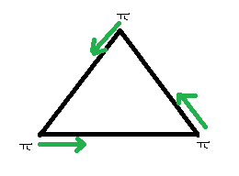](https://www.geeksforgeeks.org/wp-content/uploads/gq/2015/06/antPuzzl1e2.png)

2) All ants move in clockwise direction.  
[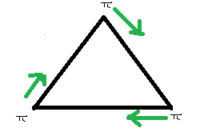](https://www.geeksforgeeks.org/wp-content/uploads/gq/2015/06/antPuzzl1e1.png)

Since every ant has two choices (pick either of two edges going through the corner on which ant is initially sitting), there are total 23 possibilities.

Out of 23 possibilities, only 2 don’t cause collision. So, the probability of collision is **6/8** and the probability of non-collision is **2/8**.

# **22 | (Maximum Chocolates)**

You have 15 Rs with you. You go to a shop and shopkeeper tells you price as 1 Rs per chocolate. He also tells you that you can get a chocolate in return of 3 wrappers. How many maximum chocolates you can eat?

 Answer: 22  
Buy and eat **15** chocolates  
Return 15 wrappers and get **5** more chocolates.  
Return 3 wrappers, get **1**chocolate and eat it (keep 2 wrappers)  
Now we have 3 wrappers. Return 3 and get **1**more chocolate.

So total chocolates = 15 + 5 + 1 + 1

# **23 | (10 Coins Puzzle)**

You are blindfolded and 10 coins are place in front of you on table. You are allowed to touch the coins, but can’t tell which way up they are by feel. You are told that there are 5 coins head up, and 5 coins tails up but not which ones are which.

Can you make two piles of coins each with the same number of heads up? You can flip the coins any number of times.

Make 2 piles with equal number of coins. Now, flip all the coins in one of the pile.

Let’s consider a simple case:

**P1 :** H T T T T  
**P2 :** H H H H T

By filping **P1**

**P1 :** T H H H H

**P2 :** H H H H T

**P1**(heads) = **P2**(heads)

# **24 | (Chessboard and dominos)**

There is an 8 by 8 chessboard in which two diagonally opposite corners have been cut off.You are given 31 dominos, and a single domino can cover exactly two squares. Can you use the 31 dominos to cover the entire board?

**Answer:**  
No

**Explanation:**  
At first it seems that there were 8*8 = 64 squares  
then 2 have been cut off so Squares remaining= 64-2 = 62  
And there are 31 dominos, so they will cover the remaining chessboard coz = 31*2 = 62

But this is not the answer:

Each domino we set on the chessboard will always take **1 Black** and **1 White** square.Therefore, **31 dominos** will take **31 white** square and 31 black squares exactly. On this chessbord however, we must have **32 black** and **30 white** squares. Hence it is not possible to do so.

# **25 | (Hourglasses Puzzle)**

**Question:** Measure 9 minutes from a 4 minutes hourglass and a 7 minutes hourglass?

**Answer:**  
**At 0 minutes:**start both hourglasses at the same time.  
**At 4 minutes:** 4 minutes hourglass runs out and flip it. 7 minutes hourglass is left with 3 minutes.  
**At 7 minutes:** 4 minutes hourglass is left with 1 minute. 7 minutes hourglass runs out and flip it.  
**At 8 minutes:** 4 minutes hourglass runs out and 7 is filled with 6 minutes and 1 minute in other side. Flip it as the sand is left with 1 minute.  
**At 9 minutes:** 7 minutes hourglass becomes empty from above side.

Hence we measured 9 minutes.

# **26 | (Newspaper Puzzle)**

**Question:** A newspaper made of 16 large sheets of paper folded in half. The newspaper has 64 pages altogether. The first sheet contains pages 1, 2, 63, 64.

[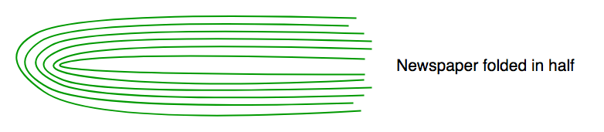](https://cdncontribute.geeksforgeeks.org/wp-content/uploads/newspaper-puzzle.png)

If we pick up a sheet containing page number 45. What are the other pages that this sheet contains?

On the back of 45, it is 46. The numbers are arranged in pairs, with the first pair adding up to 64 and the second pair adding up to 66.

Then,  
64-45 = 19  
66-46 = 20

So the four pages in this sheet are 19, 20, 45, 46.

# **27 | (Last Palindrome Date Before 10/02/2001)**

In year 2001 on October 2, 2001, the date in MMDDYYYY format was a palindrome (same forwards as backwards), 10/02/2001 -> “10022001”

When was the last palindrome date before 10/02/2001?

When you first look at it, 12th month comes to mind as we have to find the latest date, so it seems it would be 1321. But we have to keep in mind that we want the maximum year in 1300 century with a valid date, so lets think about 1390 that will give the date as 09/31, is this a valid date…? No, because September has only 30 days, so last will be the 31st August. Which means the correct date would be 08/31/1380.

# **28 | (Minimum cut Puzzle)**

You have got someone working for you for five days and a gold bar to pay him. You must give them a piece of gold at the end of every day. What are the fewest number of cuts to the bar of gold that will allow you to pay him 1/5th each day?

**Explanation:**

[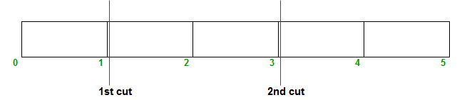](https://contribute.geeksforgeeks.org/wp-content/uploads/puzzle_31.jpg)

After two cut there are **three** pieces of 1 unit and two 2 unit.

On **1st** day: Give him 1 unit.  
On **2nd** day: Give him 2 unit and take back 1 unit.  
On **3rd** day: Give him 1 unit (he already have 2 unit)  
On **4th** day: Give him 2 unit and take back 1 unit.(he already have 2 unit)  
On **5th** day: Give him 1 unit.(he already have  two 2 unit)

Similar Puzzle: [Pay an employee using a 7 units gold rod?](http://quiz.geeksforgeeks.org/puzzle-4-pay-an-employee-using-a-gold-rod-of-7-units/)

# **29| (Completion of Task)**

A man is allocated a task. He doubles the task done everyday. If the man completely does the task in 18 days, how many days did it take for the man to complete 25% of the task?

 16

100% of task = 18 days

As he doubles the task everyday. So,

50% of task = 17 days

25% of task = 16 days.

# **30 | (Prisoner and Policeman Puzzle)**

Policeman decided to punish the Prisoner and asked him to make a statement. The Prisoner should make such a statement so that he would be alive.  
If the statement is held true by Policeman, the Prisoner will be hanged to death and if the statement is held false, the Prisoner will be shot dead.

 Answer:  
The Prisoner said, ‘I will be shot dead’  
If Policeman says the statement is true, the Prisoner will be hanged to death which will make his statement false.  
If Policeman says the statement is false, the Prisoner will be shot dead which will make the statement true.

# **31 (2 Eggs and 100 Floors)**

The following is a description of the instance of this famous puzzle involving 2 eggs and a building with 100 floors.

Suppose that we wish to know which stories in a 100-story building are safe to drop eggs from, and which will cause the eggs to break on landing. What strategy should be used to drop eggs such that total number of drops in worst case is minimized and we find the required floor.

We may make a few assumptions:

* An egg that survives a fall can be used again.
* A broken egg must be discarded.
* The effect of a fall is the same for all eggs.
* If an egg breaks when dropped, then it would break if dropped from a higher floor.
* If an egg survives a fall then it would survive a shorter fall.

# **32 | (Tic Tac Toe Puzzle)**

**Statement:**  
The game of Tic-Tac-Toe is being played between two players and it is in below state after six moves.

[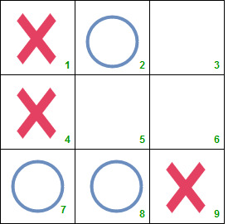](https://www.geeksforgeeks.org/wp-content/uploads/tic_tac_toe.jpg)

Can you answer following questions?

1. Who will win the game, O or X?
2. Which was the sixth mark and at which position?

Assume that both the players are intelligent enough.

**Solution:**  
O will win the game. The sixth mark was X in square 9.  
  
   
**Explanation:**  
The 7th mark must be placed in square 5 which is the win situation for both X and O. Hence, the 6th mark must be placed in a line already containing two of the opponents marks. There are two such possibilities – the 6th mark would have been either O in square 7 or X in square 9.

As we know both the players are intelligent enough, the 6th mark could not be O in square 7. Instead, he would have placed O in square 5 and would have won.

Hence, the sixth mark must be X placed in square 9. And the seventh mark will be O. Thus O will win the game.

# **33| (Find missing Row in Excel)**

We are given an excel sheet which contains integers from 1 to 50, including both. However, the numbers are in a jumbled form and there is 1 integer missing. You have to write a code to identify the missing integer. Only the logic is required.

**Solution:**  
We know that the sum of all the numbers from 1 to n is (n*(n+1)/2)  
Therefore, sum of all the numbers from 1 to 50 is

50*(50+1)/2 (Here, n = 50)

= 50*(51)/2

= 25*51

= 1275.

Therefore, all we need to do is to sum all the integers present in the file and subtract the sum from 1275. The difference between 1275 and this sum would give us the missing integer.

perm_identity

# **Puzzle 42 | (Placing the numbers)**

Place the numbers**1, 2, 3, 4, 5, 6, 7, 8** into the eight circles in figure given below, in such a way that no number is adjacent to a number that is next to it in the sequence.For example **1** should not be adjacent to 2 but can be adjacent to **3, 4, 5, 6, 7, 8**. Similarly for others.

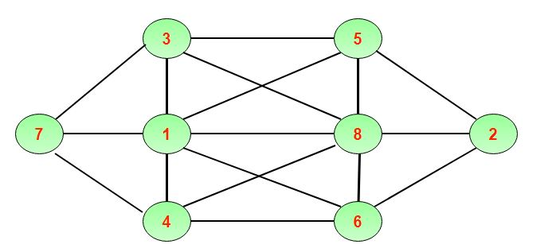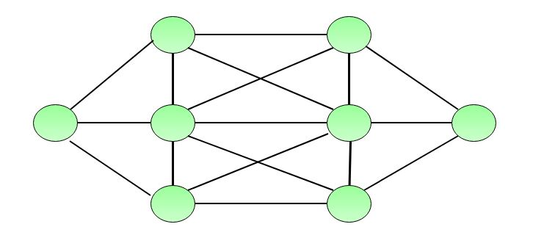

**Smart Solution:**

* The easiest numbers to place are 1 and 8, because each has only one number to which it cannot be adjacent, namely, 2 and 7, respectively. ​
* The hardest circles to fill are those in the middle, as each is adjacent to six others.

# **34.Minimum distance for Lizard**

A lizard is present on one corner of cube, It wants to reach diagonally opposite corner of cube. You have to calculate minimum distance lizard has to cover to reach its destination.

Note : Lizard can’t fly, it moves along the wall.

You are given **a** representing side of cube.you have to calculate minimum distance lizard has to travel.  
Examples:

Input : 5

Output :11.1803

Input :2

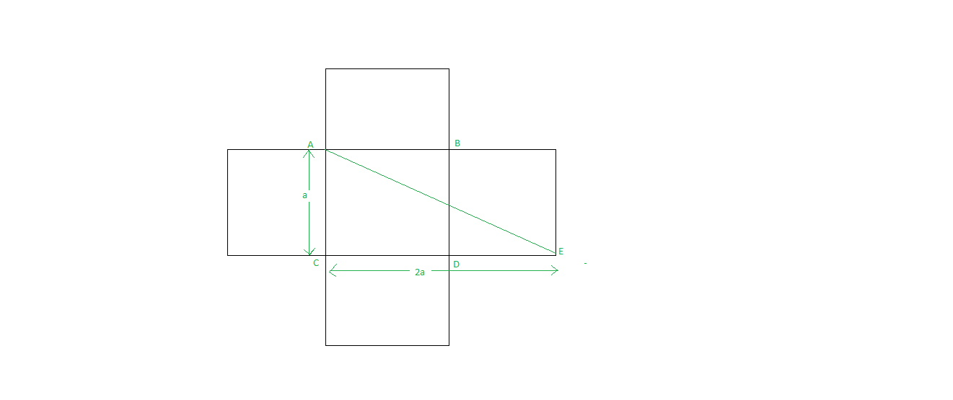Output :4.47214

# **35.| Guess the total number of coins**

There are 10 robbers named as’A’, ‘B’, ‘C’, ‘D’, ‘E’, ‘F’, ‘G’, ‘H’, ‘I’, ‘J’ they stole some coins from a bank and they decided to divide these coins equally among themselves. So they divide the coins into 10 parts but the last robber ‘J’ got 1 coin less than other robbers. So the remaining 9 robbers murder ‘J’. They again decided to divide the coins into 9 parts. But this time again the last robber ‘I’ got 1 less coin than other robbers. So again the remaining 8 robbers murder ‘I’ and try to divide all coins in between remaining 8 robbers. But again this time ‘H’ got one less coin than the other. Now, this process goes on until 1 robber left i.e. is ‘A’. After that ‘A’ take all the coins and run away. Now you have to guess the total number of coins.

**Answer:**2519

**Explanation:**  
In a first attempt if there was 1 more coin then the coins could be easily divided among 10 robbers. And in the second attempt also the coins could be equally divided in among 9 robbers and so on. So let just add one coin to the total number of the coin. So the total coins become N+1.  
now this (N+1) should be divisible by 10. It should be divisible by 9, 8, 7, 6, 5, 4, 3, 2, 1.  
So our answer should be LCM of (10, 9, 8, 7, 6, 5, 4, 3, 2, 1).  
Total Number of coins = LCM of (10, 9, 8, 7, 6, 5, 4, 3, 2, 1) which is 2520.  
Now we have to subtract 1 coin which we have added before, so the total number of coins is 2519.

7559  
10079  
12599  
15119  
17639  
20159  
22679  
25199  
27719  
30239  
32759  
35279  
37799  
40319  
42839  
45359  
47879  
50399  
52919  
55439  
57959  
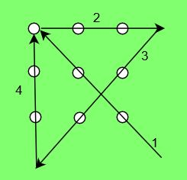60479  
62999  
65519  
68039  
70559  
73079  
75599  
78119  
80639  
83159  
85679  
88199  
90719  
93239  
95759  
98279

# **36.TCS DIGITAL PUZZLE | Lateral Thinking 2**

Lateral thinking is the most interesting test module of tcs digital hiring process.

**Problem:** Join all nine dots by drawing minimum number of straight lines. The straight lines must be continuous i.e. one must not lift the pen from the paper once start drawing.



**Problem: Move 3 matchsticks from the given set of matchsticks arranged as show in the figure, to make 3 square boxes.**

