The Java volatile keyword is used to mark a Java variable as "being stored in main memory". More precisely that means, that every read of a volatile variable will be read from the computer's main memory, and not from the CPU cache, and that every write to a volatile variable will be written to main memory, and not just to the CPU cache.

Actually, since Java 5 the volatile keyword guarantees more than just that volatile variables are written to and read from main memory. I will explain that in the following sections.

**Variable Visibility Problems**

The Java volatile keyword guarantees visibility of changes to variables across threads. This may sound a bit abstract, so let me elaborate.

In a multithreaded application where the threads operate on non-volatile variables, each thread may copy variables from main memory into a CPU cache while working on them, for performance reasons. If your computer contains more than one CPU, each thread may run on a different CPU. That means, that each thread may copy the variables into the CPU cache of different CPUs. This is illustrated here:

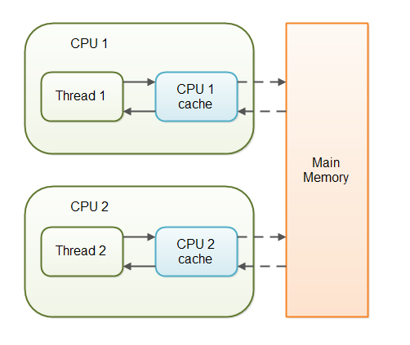

With non-volatile variables there are no guarantees about when the Java Virtual Machine (JVM) reads data from main memory into CPU caches, or writes data from CPU caches to main memory. This can cause several problems which I will explain in the following sections.

Imagine a situation in which two or more threads have access to a shared object which contains a counter variable declared like this:

public class SharedObject {

public int counter = 0;

}

Imagine too, that only Thread 1 increments the counter variable, but both Thread 1 and Thread 2 may read the counter variable from time to time.

If the counter variable is not declared volatile there is no guarantee about when the value of the counter variable is written from the CPU cache back to main memory. This means, that the countervariable value in the CPU cache may not be the same as in main memory. This situation is illustrated here:

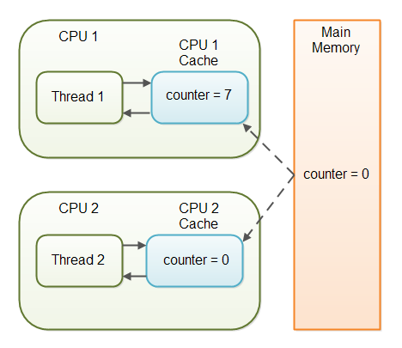

The problem with threads not seeing the latest value of a variable because it has not yet been written back to main memory by another thread, is called a "visibility" problem. The updates of one thread are not visible to other threads.

**The Java volatile Visibility Guarantee**

The Java volatile keyword is intended to address variable visibility problems. By declaring the countervariable volatile all writes to the counter variable will be written back to main memory immediately. Also, all reads of the counter variable will be read directly from main memory.

Here is how the volatile declaration of the counter variable looks:

public class SharedObject {

public **volatile** int counter = 0;

}

Declaring a variable volatile thus *guarantees the visibility* for other threads of writes to that variable.

In the scenario given above, where one thread (T1) modifies the counter, and another thread (T2) reads the counter (but never modifies it), declaring the counter variable volatile is enough to guarantee visibility for T2 of writes to the counter variable.

If, however, both T1 and T2 were incrementing the counter variable, then declaring the counter variable volatile would not have been enough. More on that later.

**Full volatile Visibility Guarantee**

Actually, the visibility guarantee of Java volatile goes beyond the volatile variable itself. The visibility guarantee is as follows:

* If Thread A writes to a volatile variable and Thread B subsequently reads the same volatile variable, then all variables visible to Thread A before writing the volatile variable, will also be visible to Thread B after it has read the volatile variable.
* If Thread A reads a volatile variable, then all all variables visible to Thread A when reading the volatile variable will also be re-read from main memory.

Let me illustrate that with a code example:

public class MyClass {

private int years;

private int months

private volatile int days;

public void update(int years, int months, int days){

this.years = years;

this.months = months;

this.days = days;

}

}

The udpate() method writes three variables, of which only days is volatile.

The full volatile visibility guarantee means, that when a value is written to days, then all variables visible to the thread are also written to main memory. That means, that when a value is written to days, the values of years and months are also written to main memory.

When reading the values of years, months and days you could do it like this:

public class MyClass {

private int years;

private int months

private volatile int days;

**public int totalDays() {**

**int total = this.days;**

**total += months * 30;**

**total += years * 365;**

**return total;**

**}**

public void update(int years, int months, int days){

this.years = years;

this.months = months;

this.days = days;

}

}

Notice the totalDays() method starts by reading the value of days into the total variable. When reading the value of days, the values of months and years are also read into main memory. Therefore you are guaranteed to see the latest values of days, months and years with the above read sequence.

**Instruction Reordering Challenges**

The Java VM and the CPU are allowed to reorder instructions in the program for performance reasons, as long as the semantic meaning of the instructions remain the same. For instance, look at the following instructions:

int a = 1;

int b = 2;

a++;

b++;

These instructions could be reordered to the following sequence without losing the semantic meaning of the program:

'

int a = 1;

a++;

int b = 2;

b++;

However, instruction reordering present a challenge when one of the variables is a volatile variable. Let us look at the MyClass class from the example earlier in this Java volatile tutorial:

public class MyClass {

private int years;

private int months

private volatile int days;

public void update(int years, int months, int days){

this.years = years;

this.months = months;

this.days = days;

}

}

Once the update() method writes a value to days, the newly written values to years and months are also written to main memory. But, what if the Java VM reordered the instructions, like this:

public void update(int years, int months, int days){

this.days = days;

this.months = months;

this.years = years;

}

The values of months and years are still written to main memory when the days variable is modified, but this time it happens before the new values have been written to months and years. The new values are thus not properly made visible to other threads. The semantic meaning of the reordered instructions has changed.

Java has a solution for this problem, as we will see in the next section.

**The Java volatile Happens-Before Guarantee**

To address the instruction reordering challenge, the Java volatile keyword gives a "happens-before" guarantee, in addition to the visibility guarantee. The happens-before guarantee guarantees that:

* Reads from and writes to other variables cannot be reordered to occur after a write to a volatilevariable, if the reads / writes originally occurred before the write to the volatile variable.   
  The reads / writes before a write to a volatile variable are guaranteed to "happen before" the write to the volatile variable. Notice that it is still possible for e.g. reads / writes of other variables located after a write to a volatile to be reordered to occur before that write to the volatile. Just not the other way around. From after to before is allowed, but from before to after is not allowed.
* Reads from and writes to other variables cannot be reordered to occur before a read of a volatilevariable, if the reads / writes originally occurred after the read of the volatile variable. Notice that it is possible for reads of other variables that occur before the read of a volatile variable can be reordered to occur after the read of the volatile. Just not the other way around. From before to after is allowed, but from after to before is not allowed.

The above happens-before guarantee assures that the visibility guarantee of the volatile keyword are being enforced.

**volatile is Not Always Enough**

Even if the volatile keyword guarantees that all reads of a volatile variable are read directly from main memory, and all writes to a volatile variable are written directly to main memory, there are still situations where it is not enough to declare a variable volatile.

In the situation explained earlier where only Thread 1 writes to the shared counter variable, declaring the counter variable volatile is enough to make sure that Thread 2 always sees the latest written value.

In fact, multiple threads could even be writing to a shared volatile variable, and still have the correct value stored in main memory, if the new value written to the variable does not depend on its previous value. In other words, if a thread writing a value to the shared volatile variable does not first need to read its value to figure out its next value.

As soon as a thread needs to first read the value of a volatile variable, and based on that value generate a new value for the shared volatile variable, a volatile variable is no longer enough to guarantee correct visibility. The short time gap in between the reading of the volatile variable and the writing of its new value, creates an [**race condition**](http://tutorials.jenkov.com/java-concurrency/race-conditions-and-critical-sections.html) where multiple threads might read the same value of the volatile variable, generate a new value for the variable, and when writing the value back to main memory - overwrite each other's values.

The situation where multiple threads are incrementing the same counter is exactly such a situation where a volatile variable is not enough. The following sections explain this case in more detail.

Imagine if Thread 1 reads a shared counter variable with the value 0 into its CPU cache, increment it to 1 and not write the changed value back into main memory. Thread 2 could then read the same countervariable from main memory where the value of the variable is still 0, into its own CPU cache. Thread 2 could then also increment the counter to 1, and also not write it back to main memory. This situation is illustrated in the diagram below:

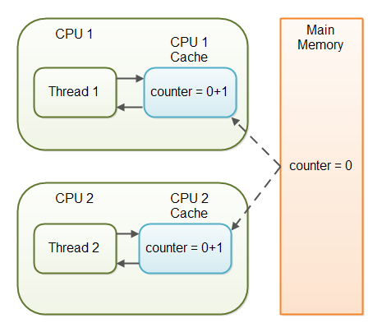

Thread 1 and Thread 2 are now practically out of sync. The real value of the shared counter variable should have been 2, but each of the threads has the value 1 for the variable in their CPU caches, and in main memory the value is still 0. It is a mess! Even if the threads eventually write their value for the shared counter variable back to main memory, the value will be wrong.

**When is volatile Enough?**

As I have mentioned earlier, if two threads are both reading and writing to a shared variable, then using the volatile keyword for that is not enough. You need to use a [**synchronized**](http://tutorials.jenkov.com/java-concurrency/synchronized.html) in that case to guarantee that the reading and writing of the variable is atomic. Reading or writing a volatile variable does not block threads reading or writing. For this to happen you must use the synchronized keyword around critical sections.

As an alternative to a synchronized block you could also use one of the many atomic data types found in the **[java.util.concurrent package](http://tutorials.jenkov.com/java-util-concurrent/index.html)**. For instance, the **[AtomicLong](http://tutorials.jenkov.com/java-util-concurrent/atomiclong.html)** or **[AtomicReference](http://tutorials.jenkov.com/java-util-concurrent/atomicreference.html)** or one of the others.

In case only one thread reads and writes the value of a volatile variable and other threads only read the variable, then the reading threads are guaranteed to see the latest value written to the volatile variable. Without making the variable volatile, this would not be guaranteed.

The volatile keyword is guaranteed to work on 32 bit and 64 variables.

**Performance Considerations of volatile**

Reading and writing of volatile variables causes the variable to be read or written to main memory. Reading from and writing to main memory is more expensive than accessing the CPU cache. Accessing volatile variables also prevent instruction reordering which is a normal performance enhancement technique. Thus, you should only use volatile variables when you really need to enforce visibility of variables.

volatile keyword in Java

Using volatile is yet another way (like synchronized, atomic wrapper) of making class thread safe. Thread safe means that a method or class instance can be used by multiple threads at the same time without any problem.

Consider below simple example.

**class** SharedObj

{

// Changes made to sharedVar in one thread

// may not immediately reflect in other thread

**static int** sharedVar = 6;

}

[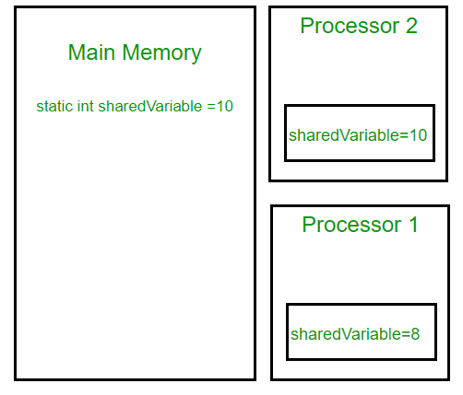](https://cdncontribute.geeksforgeeks.org/wp-content/uploads/volatile-keyword-in-java.png)Suppose that two threads are working on **SharedObj**. If two threads run on different processors each thread may have its own local copy of **sharedVariable**. If one thread modifies its value the change might not reflect in the original one in the main memory instantly. This depends on the [write policy](https://en.wikipedia.org/wiki/CPU_cache#Write_policies) of cache. Now the other thread is not aware of the modified value which leads to data inconsistency.

Below diagram shows that if two threads are run on different processors, then value of **sharedVariable** may be different in different threads.

Note that write of normal variables without any synchronization actions, might not be visible to any reading thread (this behavior is called [sequential consistency](https://en.wikipedia.org/wiki/Sequential_consistency)). Although most modern hardware provide good cache coherence therefore most probably the changes in one cache are reflected in other but it’s not a good practice to rely on hardware for to ‘fix’ a faulty application.

class SharedObj

{

// volatile keyword here makes sure that

// the changes made in one thread are

// immediately reflect in other thread

static **volatile** int sharedVar = 6;

}

Note that volatile should not be confused with static modifier. static variables are class members that are shared among all objects. There is only one copy of them in main memory.

**volatile vs synchronized:**  
Before we move on let’s take a look at two important features of locks and synchronization.

1. **Mutual Exclusion:** It means that only one thread or process can execute a block of code (critical section) at a time.
2. **Visibility**: It means that changes made by one thread to shared data are visible to other threads.

Java’s synchronized keyword guarantees both mutual exclusion and visibility. If we make the blocks of threads that modifies the value of shared variable synchronized only one thread can enter the block and changes made by it will be reflected in the main memory. All other thread trying to enter the block at the same time will be blocked and put to sleep.

In some cases we may only desire the visibility and not atomicity. Use of synchronized in such situation is an overkill and may cause scalability problems. Here volatile comes to the rescue. Volatile variables have the visibility features of synchronized but not the atomicity features. The values of volatile variable will never be cached and all writes and reads will be done to and from the main memory. However, use of volatile is limited to very restricted set of cases as most of the times atomicity is desired. For example a simple increment statement such as x = x + 1; or x++ seems to be a single operation but is s really a compound read-modify-write sequence of operations that must execute atomically.

**volatile in Java vs C/C++:**  
Volatile in java is different from [“volatile” qualifier in C/C++](https://www.geeksforgeeks.org/understanding-volatile-qualifier-in-c/). For Java, “volatile” tells the compiler that the value of a variable must never be cached as its value may change outside of the scope of the program itself. In C/C++, “volatile” is needed when developing embedded systems or device drivers, where you need to read or write a memory-mapped hardware device. The contents of a particular device register could change at any time, so you need the “volatile” keyword to ensure that such accesses aren’t optimized away by the compiler.

**References:**  
<https://www.ibm.com/developerworks/java/library/j-jtp06197/>  
<https://docs.oracle.com/javase/tutorial/essential/concurrency/atomic.html>  
<http://tutorials.jenkov.com/java-concurrency/volatile.html>  
<https://pveentjer.wordpress.com/2008/05/17/jmm-thank-god-or-the-devil-for-strong-cache-coherence/>

public class VolatileTest {

private static final Logger LOGGER = MyLoggerFactory.getSimplestLogger();

private static volatile int MY_INT = 0;

public static void main(String[] args) {

new ChangeListener().start();

new ChangeMaker().start();

}

static class ChangeListener extends Thread {

@Override

public void run() {

int local_value = MY_INT;

while ( local_value < 5){

if( local_value!= MY_INT){

LOGGER.log(Level.INFO,"Got Change for MY_INT : {0}", MY_INT);

local_value= MY_INT;

}

}

}

}

static class ChangeMaker extends Thread{

@Override

public void run() {

int local_value = MY_INT;

while (MY_INT <5){

LOGGER.log(Level.INFO, "Incrementing MY_INT to {0}", local_value+1);

MY_INT = ++local_value;

try {

Thread.sleep(500);

} catch (InterruptedException e) { e.printStackTrace(); }

}

}

}

}

**With the volatile keyword** the output is :

Incrementing MY_INT to 1

Got Change for MY_INT : 1

Incrementing MY_INT to 2

Got Change for MY_INT : 2

Incrementing MY_INT to 3

Got Change for MY_INT : 3

Incrementing MY_INT to 4

Got Change for MY_INT : 4

Incrementing MY_INT to 5

Got Change for MY_INT : 5

**Without the volatile keyword** the output is :

Incrementing MY_INT to 1

Incrementing MY_INT to 2

Incrementing MY_INT to 3

Incrementing MY_INT to 4

Incrementing MY_INT to 5

.....And the change listener loop infinitely...

## Explanation

So what happens? Each thread has its own stack, and so its own copy of variables it can access. When the thread is created, it copies the value of all accessible variables in its own memory. The volatile keyword is used to say to the jvm "Warning, this variable may be modified in an other Thread". Without this keyword the JVM is free to make some optimizations, like never refreshing those local copies in some threads. The volatile force the thread to update the original variable for each variable. The volatile keyword could be used on every kind of variable, either primitive or objects! Maybe the subject of another article, more detailed...

**Never used volatile and never met this problem...**

Like all threads issues, it happens under specials circumstances. Really special for this one... My example has big chances to show mainly because the ChangeListener thread is busy, thanks to the loop, and the JVM consider that this thread has no time for updating the local variables. Executing some synchronized methods or adding an other variable which is volatile (or even executing some simple lines of code) could modify the JVM behavior and "correct" this problem...

**Should I do a big refactor to identify all variables who needs volatile?**

 Be pragmatic! If you think your project needs it, do it. I think that the essential is to be aware of that, to know what is the goal of each keyword of the java language in order to take the good decisions.