**Module-2**

**Introduction to programming**

**Overview of C Programming**

**Q.1 THEORY EXERCISE:**

**Write an essay covering the history and evolution of C programming. Explain its importance and why it is still used today.**

1. Origins (1960s):

* + Developed at Bell Labs by Ken Thompson and Dennis Ritchie.
  + Evolved from the B programming language, which was a derivative of BCPL.
  + Created to facilitate the development of the Unix operating system.

1. Rise in Popularity (1970s):
   * Gained traction with the release of Unix in 1971.
   * The publication of "The C Programming Language" by Ritchie and Brian Kernighan in 1978 standardized C's syntax and usage.
2. Standardization (1980s):
   * The need for a standardized version arose due to variations in implementations.
   * ANSI C (C89/C90) was established in 1989, introducing function prototypes and standard libraries.
3. Evolution in the 1990s:
   * Emergence of C++ introduced object-oriented features, but C remained relevant for systems programming.
   * C99 standard introduced new features like variable-length arrays and inline functions.
4. Modern Updates (2000s and Beyond):
   * C11 introduced multi-threading support and improved Unicode handling.
   * C18 focused on bug fixes and clarifications rather than new features.
5. Current Relevance:
   * C is foundational in operating systems, embedded systems, and high-performance applications.
   * Continues to influence modern languages (e.g., C++, C#, Objective-C).
   * Remains a popular choice for teaching programming concepts due to its simplicity and power.
6. Legacy:
   * C's adaptability and efficiency ensure its ongoing significance in the programming landscape.

**Explain its importance and why it is still used today.**

1. Foundation for Modern Languages:
   * Influences many languages (C++, C#, Java, Python), providing a solid base for learning.
2. Efficiency and Performance:
   * Known for low-level memory manipulation, making it ideal for system programming and performance-critical applications.
3. Portability:
   * Code can be compiled and run on various hardware platforms with minimal changes.
4. System-Level Programming:
   * Extensively used in operating systems, device drivers, and embedded systems due to direct hardware interaction.
5. Rich Ecosystem and Libraries:
   * A vast array of libraries and frameworks enhances functionality and speeds up development.
6. Simplicity and Control:
   * Offers a straightforward syntax and high control over system resources, aiding debugging and optimization.
7. Educational Value:
   * Commonly used in computer science education to teach fundamental programming concepts and algorithms.
8. Community and Support:
   * A large, active community provides resources, tutorials, and forums for problem-solving.
9. Legacy Systems:
   * Many existing systems are written in C, necessitating ongoing use for maintenance and updates.
10. Continued Development:
    * Regular updates (C11, C18) introduce new features, ensuring relevance in modern programming.

• **LAB EXERCISE:**

**o Research and provide three real-world applications where C programming is extensively used, such as in embedded systems, operating systems, or game development**

1. Embedded Systems: C is widely used in automotive control systems, medical devices, and consumer electronics, enabling efficient hardware interaction and real-time processing.
2. Operating Systems: C is fundamental in developing operating systems, including creating kernels, device drivers, and system libraries, due to its low-level capabilities.
3. Game Development: C is utilized in game engines and graphics programming, providing the performance needed for real-time rendering and complex simulations.

**2. Setting Up Environment •**

**THEORY EXERCISE:**

**o Describe the steps to install a C compiler (e.g., GCC) and set up an Integrated Development Environment (IDE) like DevC++, VS Code, or CodeBlocks.**

Installing GCC Compiler

For Windows:

1. Download MinGW:
   * Go to the MinGW-w64 website.
   * Download the installer (e.g., mingw-w64-install.exe).
2. Run the Installer:
   * Choose the architecture (e.g., x86_64 for 64-bit).
   * Select the threads model (e.g., posix) and exception model (e.g., seh).
   * Choose the installation directory (e.g., C:\mingw-w64).
3. Add to System PATH:
   * Right-click on "This PC" or "My Computer" and select "Properties."
   * Click on "Advanced system settings."
   * Click on "Environment Variables."
   * Under "System variables," find the Path variable and click "Edit."
   * Add the path to the bin directory of MinGW (e.g., C:\mingw-w64\bin).
4. Verify Installation:
   * Open Command Prompt and type gcc --version. If installed correctly, it will display the GCC version.

Setting Up IDEs

1. DevC++

1. Download DevC++:
   * Go to the Dev-C++ website.
   * Download the latest version.
2. Install DevC++:
   * Run the installer and follow the prompts to install.
3. Configure Compiler:
   * Open DevC++.
   * Go to "Tools" > "Compiler Options."
   * Ensure that the selected compiler is GCC.
4. Create a New Project:
   * Go to "File" > "New" > "Project" to start coding in C.

2. Visual Studio Code (VS Code)

1. Download VS Code:
   * Go to the Visual Studio Code website.
   * Download and install the appropriate version for your OS.
2. Install C/C++ Extension:
   * Open VS Code.
   * Go to the Extensions view by clicking on the Extensions icon in the Activity Bar or pressing Ctrl +Shift +X.
   * Search for "C/C++" and install the extension provided by Microsoft.
3. Configure Build Tasks:
   * Create a new file with a .c extension.
   * Press Ctrl + Shift +B to configure build tasks.
   * Select "C/C++: gcc build active file" to create a tasks.json file.
4. Run Your Code:
   * Use the terminal in VS Code to compile and run your C programs using GCC commands.

3. Code::Blocks

1. Download Code::Blocks:
   * Go to the Code::Blocks website.
   * Download the version that includes MinGW (e.g., "codeblocks-20.03mingw-setup.exe").
2. Install Code: :Blocks:
   * Run the installer and follow the prompts to install.
3. Configure Compiler:
   * Open Code: :Blocks.
   * Go to "Settings" > "Compiler."
   * Ensure that the selected compiler is GCC.
4. Create a New Project:
   * Go to "File" > "New" > "Project" and select "Console Application" to start coding in C.

**• LAB EXERCISE:**

**o Install a C compiler on your system and configure the IDE. Write your first program to print "Hello, World!" and run it.**

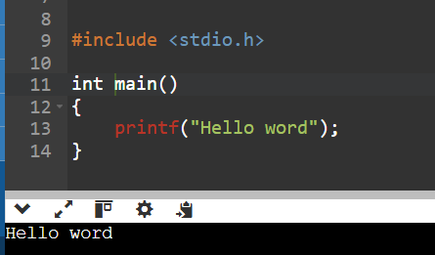

**3.Basic Structure of a C Program**

• **THEORY EXERCISE:**

**O Explain the basic structure of a C program, including headers, main function, comments, data types, and variables. Provide examples.**

- Basic Structure of C Program

---------------------------------------------------

1) header file adding (to add library)

#include<stdio.h>

# : preprocessor

include : keyword to add some library file

<> : brackets to add header file.

stdio.h : Standard Input Output header file

one header file for input & output

2) main()

-Function to start the execution of the code from here.

3) {

..... Block of code

}

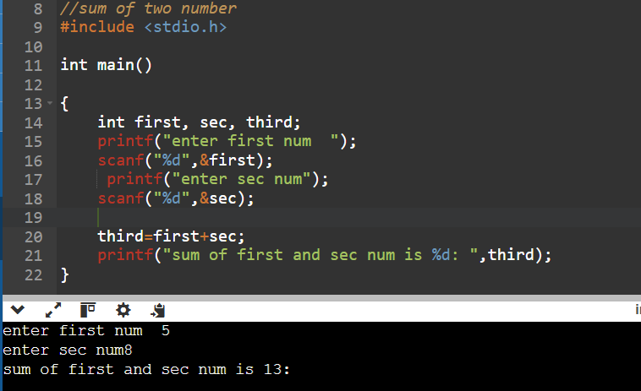

• **LAB EXERCISE:**

**o Write a C program that includes variables, constants, and comments. Declare and use different data types (int, char, float) and display their values.**

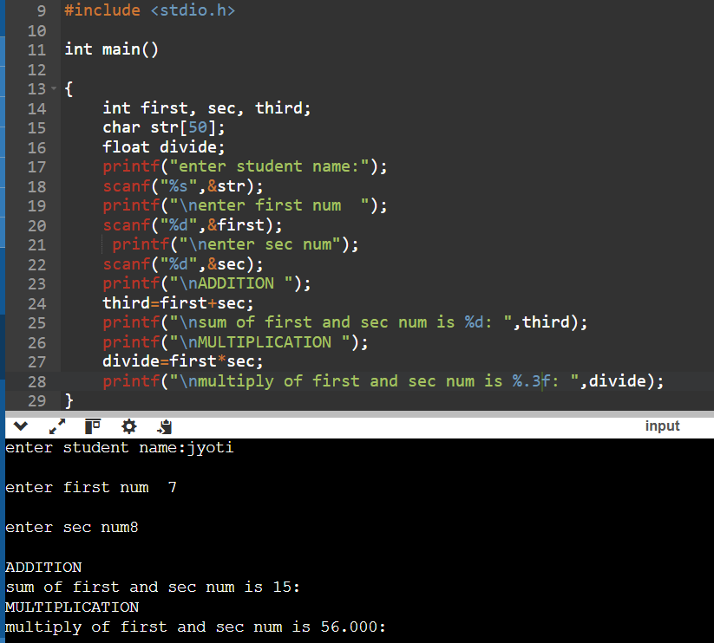

**4.Operators in C**

• **THEORY EXERCISE:**

**o Write notes explaining each type of operator in C: arithmetic, relational, logical, assignment, increment/decrement, bitwise, and conditional operators.**

Operators :

1) Arithmetic Operators

+, -, *, /

2) Assignment / Short hand Operator.

+=, -=, *=, /=, %=

a=a+10 (a+=10)

3) Increment/Decrement Op. (inc by 1, dec. by 1)

++, --

unary op. : a++ (a=a+1)

-------------------------------

one operand (a), one operator (+)

binary op. : a+b

----------------------------------

Two operands (a, b) , one operator (+)

Increment:

Postfix : a++ (store->increment)

Prefix : ++a (increment->store)

Decrement :

Postfix : a-- (store->increment)

Prefix : --a (increment->store)

4) Relational operators/conditional/comparision

>, <, <=, >=, ==, != (= & ==)

a>b

a<b

a>=b

a >=50

a<=b

a==b

a!=b

5) Logical operators

-to combine expressions by one condition

&& - and :

- all the conditions have to be true.

|| - or

- One of the any condition has to be true.

! - not

- true expression prove’s false

• **LAB EXERCISE:**

**o Write a C program that accepts two integers from the user and performs arithmetic, relational, and logical operations on them. Display the results.**

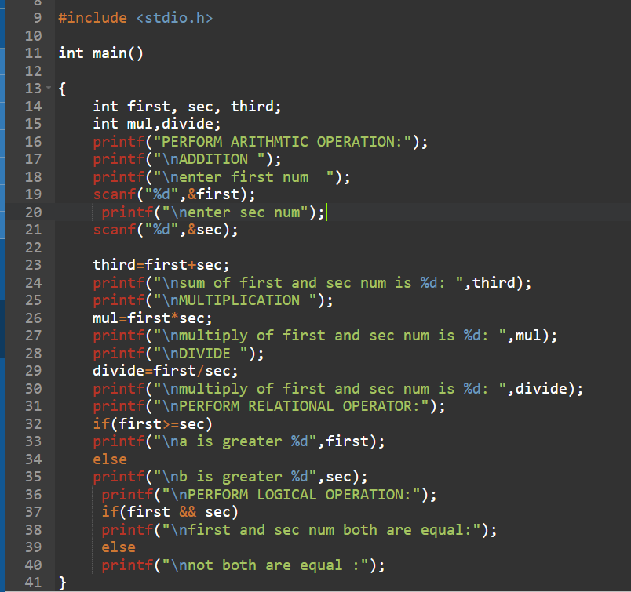

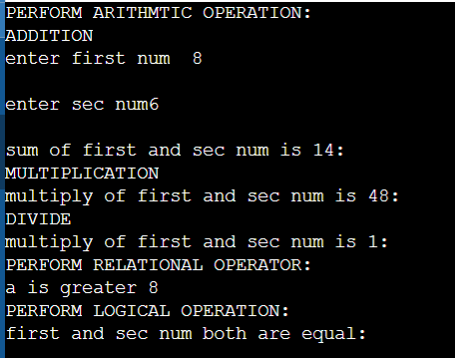

**5.Control Flow Statements in C**

• **THEORY EXERCISE:**

**o Explain decision-making statements in C (if, else, nested if-else, switch). Provide examples of each.**

--> Conditional Statements in C

-Decision making statements

-Comparision Statements

----------------------------------------------

1) if

2) if.. else

3) if ..else if.. else

4) nested if

5) switch.. case

1) if

-to execute one condition by checking.

syntax : if(condition) //true

{

block of code.

}

2) if…else

-to evalate the condition by true or false

syntax :

if(condition) //true

{

block of code for true condition.

}

else

{

block of code for false condition

}

3) if ..else if.. else (evaluate high to low)

-else if ladder.

-to evaluate multiple conditions.

4) nested if

if inside if

syntax :

if(condition-1) //outer if

{

if(condition-2) //inner if

{

block of code condition-1 & 2

}

else

{

block of code for condition1

}

}

else

{

}

5) switch ... case

-to make menu driven code.

-never use comparision operator

- keywords are used : switch, case, break, default

-switch case can be only applied on integer & character data types.

• **LAB EXERCISE:**

**6 TOPS Technologies 2024**

**o Write a C program to check if a number is even or odd using an if-else statement. Extend the program using a switch statement to display the month name based on the user’s input (1 for January, 2 for February, etc.).**

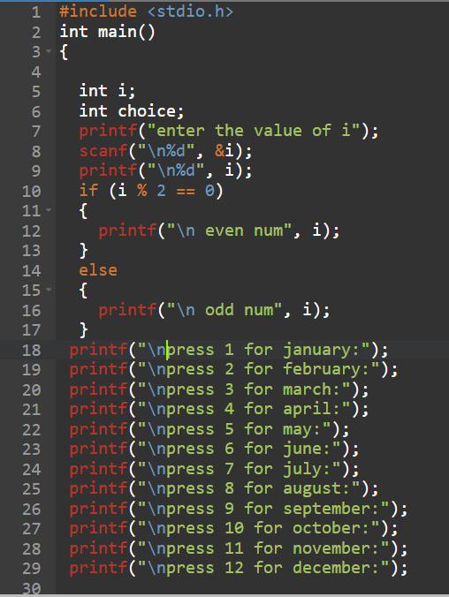

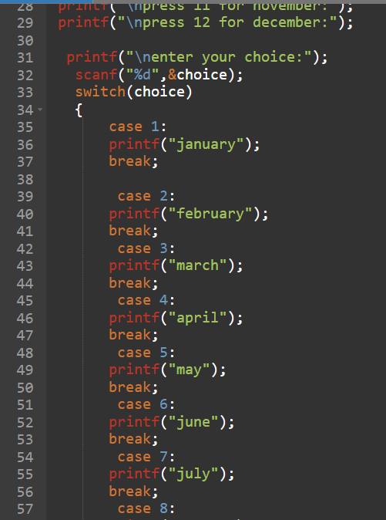

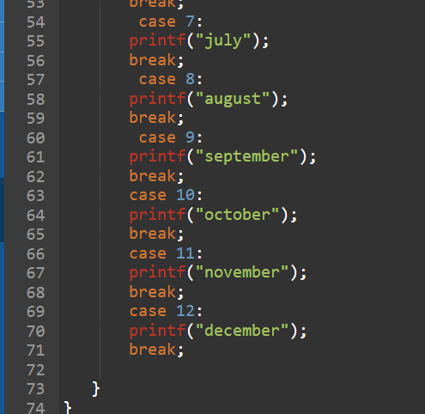

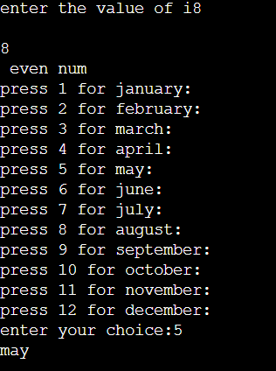

**6.Looping in C**

**• THEORY EXERCISE:**

**o Compare and contrast while loops, for loops, and do-while loops. Explain the scenarios in which each loop is most appropriate.**

1. While Loop

* Syntax:

while (condition) {

// Code to execute

}

* Key Points:
  + Checks the condition before executing the loop.
  + May not run at all if the condition is false initially.
* Best For: Situations where the number of iterations is unknown and depends on a condition (e.g., reading user input until a specific value).

2. For Loop

* Syntax:

for (initialization; condition; increment)

{

// Code to execute

}

* Key Points:
  + Combines initialization, condition check, and increment in one line.
  + Runs a specific number of times based on the condition.
* Best For: Count-controlled iterations where the number of loops is known (e.g., iterating through an array).

3. Do-While Loop

* Syntax:

do {

// Code to execute

} while (condition);

**• LAB EXERCISE:**

**o Write a C program to print numbers from 1 to 10 using all three types of loops (while, for, do-wh**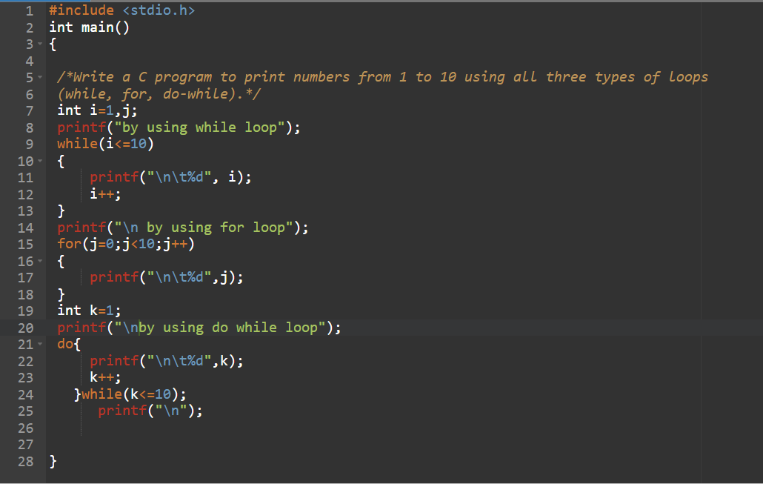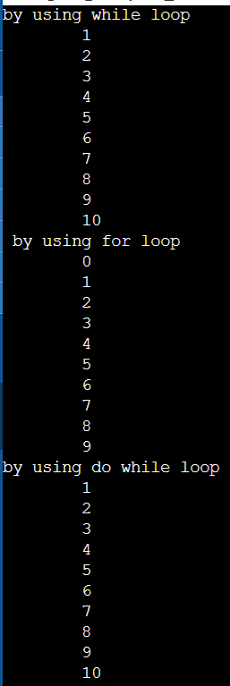

**7.Loop Control Statements**

**• THEORY EXERCISE:**

**o Explain the use of break, continue, and goto statements in C. Provide examples of each.**

-- Control Statements :

----------------------------------

-break

to terminate or break the code.

rest of the code will not be executed.

-continue

to skip the specific iteration.

rest of the code will be executed.

-goto (without loop)

to define one label & repeate the code by goto that label.

**LAB EXERCISE:**

**o Write a C program that uses the break statement to stop printing numbers**

**when it reaches 5. Modify the program to skip printing the number 3 using the**

**continue statement.**

* **Program using break statement :**

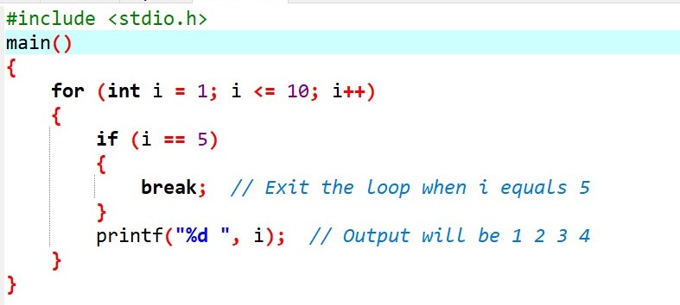

* **Modify the program to skip printing the number 3 using continue statement :**

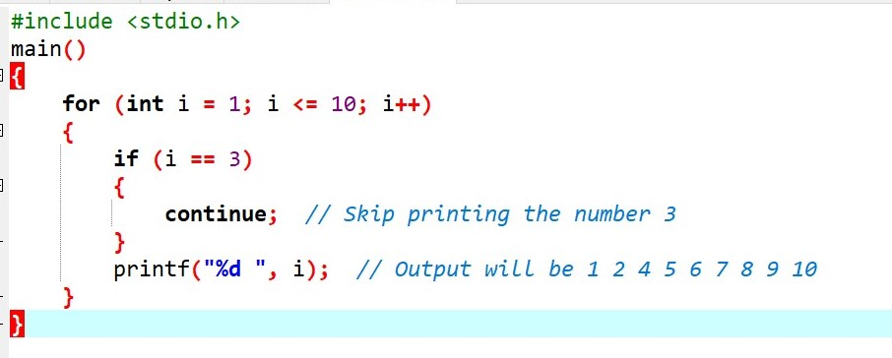

1. **Functions in C •**

**THEORY EXERCISE:**

**o What are functions in C? Explain function declaration, definition, and how to call a function. Provide examples.**

-Function/method : block of code

#include <stdio.h>

// Function Declaration

int add(int a, int b);

int main() {

int num1 = 5, num2 = 10;

int sum;

// Function Call

sum = add(num1, num2);

printf("The sum of %d and %d is %d\n", num1, num2, sum);

return 0;

}

// Function Definition

int add(int a, int b)

{

return a + b; // Returns the sum of a and b

}

**LAB EXERCISE:**

**o Write a C program that calculates the factorial of a number using a function.**

**Include function declaration, definition, and call.**

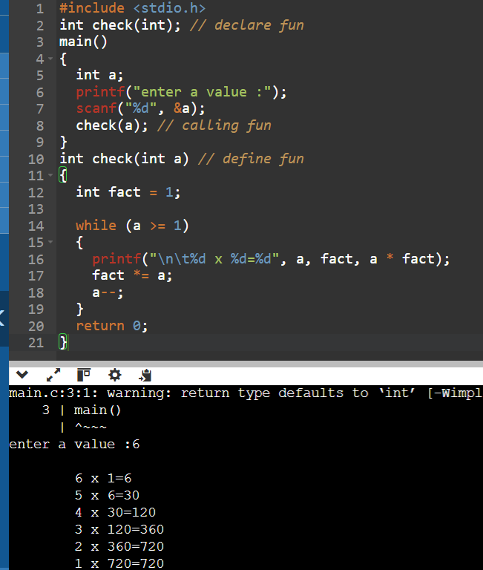

1. **Arrays in C**

**• THEORY EXERCISE:**

**o Explain the concept of arrays in C. Differentiate between one-dimensional and multi-dimensional arrays with examples.**

-An array in C is a way to store multiple values of the same type in a single variable. Think of it as a row of boxes, where each box can hold a value, and you can easily access these values using their position (index).

Key Points About Arrays:

* Fixed Size: You need to decide how many items you want to store when you create the array.
* Same Type: All items in an array must be of the same type (like all integers or all floats).
* Indexing: You access items in an array using an index, which starts at 0.

|  |  |  |  |  |
| --- | --- | --- | --- | --- |
| **Feature** | **One-Dimensional Array** | |  | | --- | |  |  |  | | --- | | **Multi-Dimensional Array** | |
| Shape | A single row of values. | Multiple rows and columns (2D), or even higher dimensions. |
| Accessing elements | Accessed using a single index. | Accessed using multiple indices (row, column, etc.). |
| Declaration | data_type array_name[size]; | data_type array_name[rows][columns]; |
| Example | |  | | --- | |  |  |  | | --- | | int arr[5] = {1, 2, 3, 4, 5}; | | int matrix[2][3] = {{1, 2, 3}, {4, 5, 6}}; |

**• LAB EXERCISE:**

**o Write a C program that stores 5 integers in a one-dimensional array and prints them. Extend this to handle a two-dimensional array (3x3 matrix) and calculate the sum of all elements.**

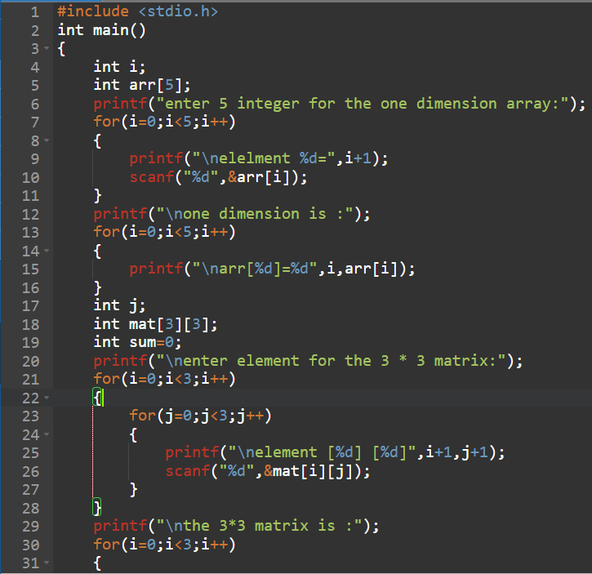

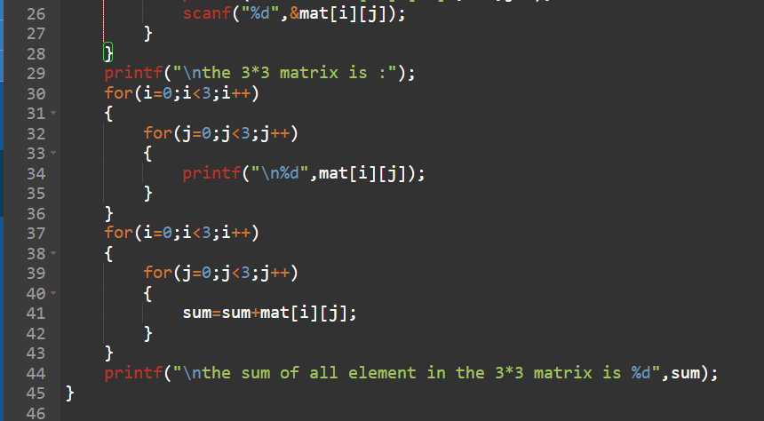

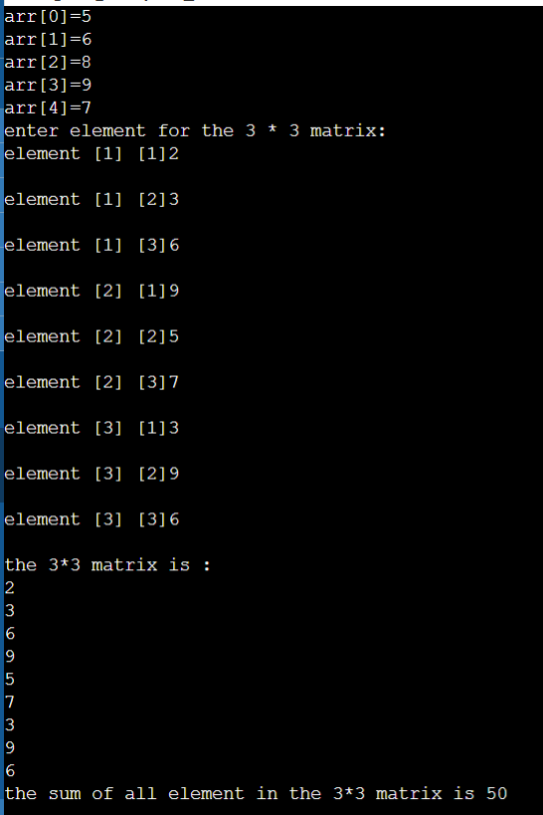

1. **Pointers in C**

**• THEORY EXERCISE:**

**o Explain what pointers are in C and how they are declared and initialized. Why are pointers important in C?**

What are Pointers?

* Definition: Pointers are variables that store memory addresses of other variables.
* Purpose: They allow direct memory manipulation and efficient data handling.

Declaration

* Syntax: data_type *pointer_name;
  + Example: int *ptr; (declares a pointer to an integer)

Initialization

* Using Address-of Operator: Assign the address of a variable using **&**
* Example:

**int var = 10;**

**int *ptr = &var;**

**• LAB EXERCISE:**

**o Write a C program to demonstrate pointer usage. Use a pointer to modify the value of a variable and print the result.**

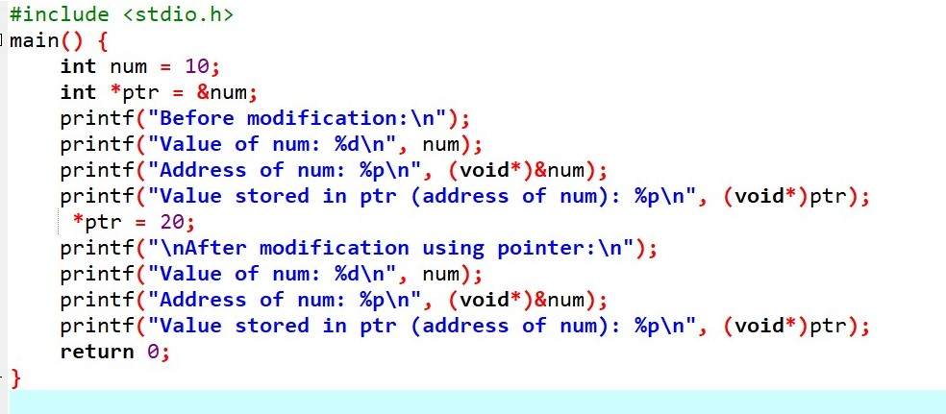

1. **Strings in C**

• **THEORY EXERCISE:**

**o Explain string handling functions like strlen(), strcpy(), strcat(), strcmp(), and strchr(). Provide examples of when these functions are useful.**

* strlen(): Get the length of a string
* The strlen() function returns the number of characters in a string, excluding the null character ('\0').
* Syntax : size_t strlen(const char *str);
* Example :

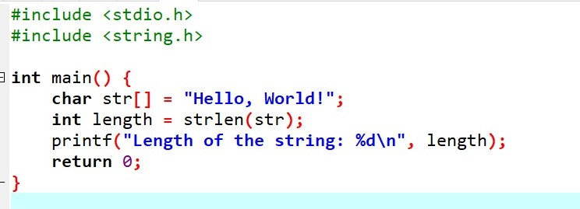

* strcpy(): Copy a string
* The strcpy() function copies the content of one string into another.
* Syantax : char *strcpy(char *dest, const char *src);
* Example :

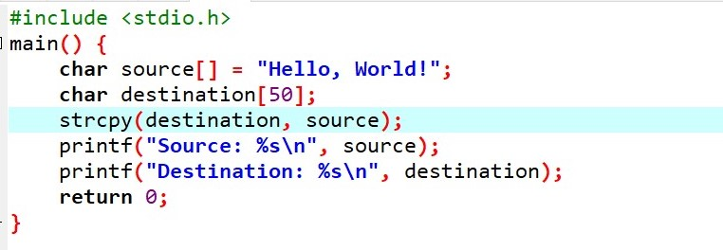

* strcat(): Concatenate two strings
* The strcat() function appends one string to the end of another string.
* Syntax : char *strcat(char *dest, const char *src);
* Example :

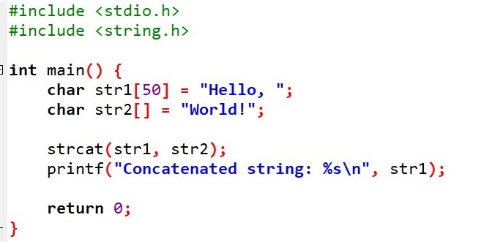

* strcmp(): Compare two strings
* The strcmp() function compares two strings lexicographically (character by character).
* Syntax : int strcmp(const char *str1, const char *str2);
* Example :

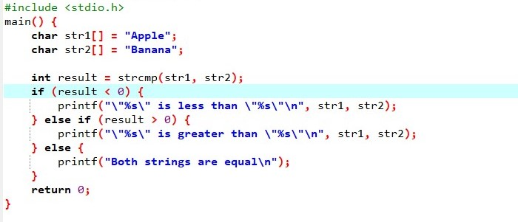

* strchr(): Find the first occurrence of a character in a string
* The strchr() function searches for the first occurrence of a specified character in a string.
* Syntax : char *strchr(const char *str, int c);
* Example :

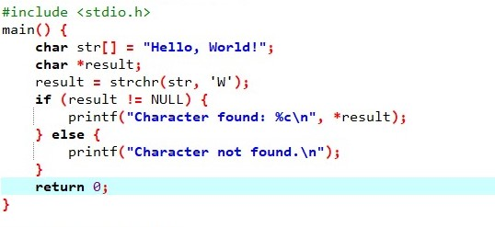

• **LAB EXERCISE:**

**o Write a C program that takes two strings from the user and concatenates them using strcat(). Display the concatenated string and its length using strlen().**

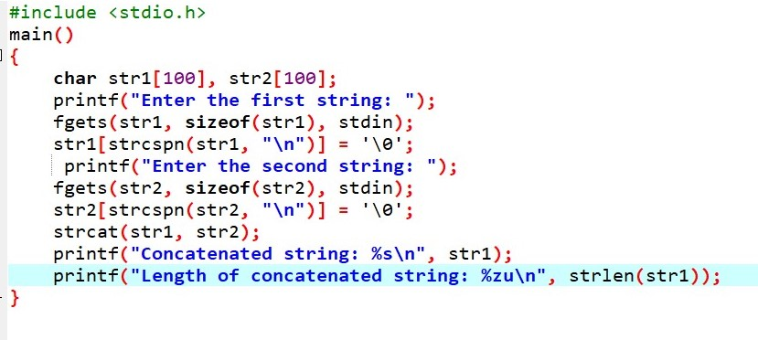

1. **Structures in C**

• **THEORY EXERCISE:**

**o Explain the concept of structures in C. Describe how to declare, initialize, and access structure members.**

* Concept of Structures in C : A structure in C is a user-defined data type that allows grouping of different types of variables (called members or fields) under a single name. Each member of a structure can have a different data type (e.g., integers, floats, arrays, or even other structures).
* Declaring a Structure : To define a structure, you use the struct keyword followed by the structure name and its members inside curly braces.

Here is the syntax to declare a structure:

struct structure_name

{

data_type member1;

data_type member2;

// More members

};

* Initializing a Structure : There are two ways to initialize a structure :
* At the time of declaration (Static Initialization): You can initialize the structure members when you declare a structure variable:

struct Student student1 = {"John Doe", 20, 85.5};

* After Declaration (Dynamic Initialization): You can declare the structure first and then assign values to its members individually:

struct Student student1; strcpy(student1.name, "John Doe"); // Using strcpy for string assignment student1.age = 20; student1.marks = 85.5;

* Accessing Structure Members : Structure members can be accessed using the dot operator (.) for individual structure variables. If the structure variable is a pointer, you use the arrow operator (->) to access the members.

• **LAB EXERCISE:**

**o Write a C program that defines a structure to store a student's details (name, roll number, and marks). Use an array of structures to store details of 3 students and print them.**

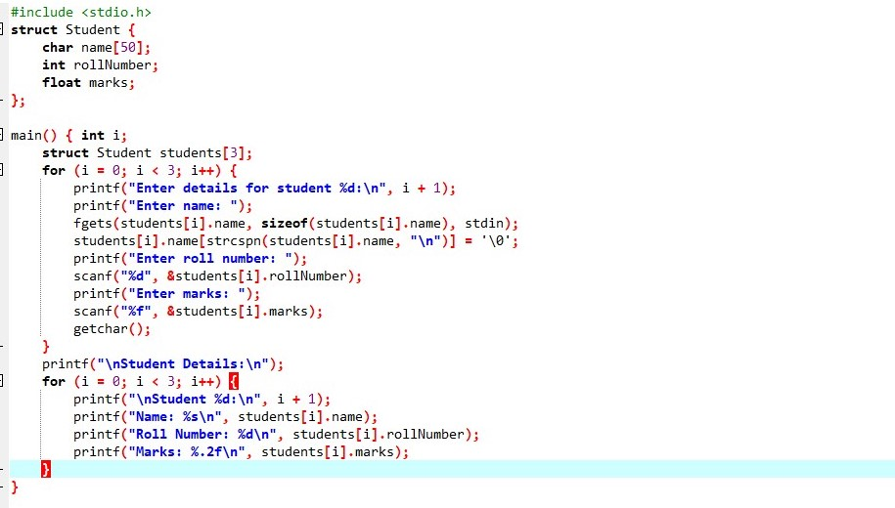

1. **File Handling in C**

**• THEORY EXERCISE:**

**o Explain the importance of file handling in C. Discuss how to perform file operations like opening, closing, reading, and writing files.**

* Importance of File Handling in C :
* Persistent Data Storage:
* Data Sharing:
* Efficient Data Management:
* Flexible Data Operations:
* Basic File Operations in C :
* Opening a File : To perform any operation on a file, you first need to open the file using the fopen() function. This function requires two arguments 1=The name of the file. 2=The mode in which you want to open the file.
* Syntax :

FILE *fopen(const char *filename, const char *mode);

* Reading from a File : Once the file is opened in read mode, you can read from it using functions like fgetc(), fgets(), or fread().
* Writing to a File : You can write data to a file using fputc(), fputs(), or fwrite().
* Closing a File : After performing the required operations (read or write), it’s essential to close the file using fclose() to release resources and ensure data integrity

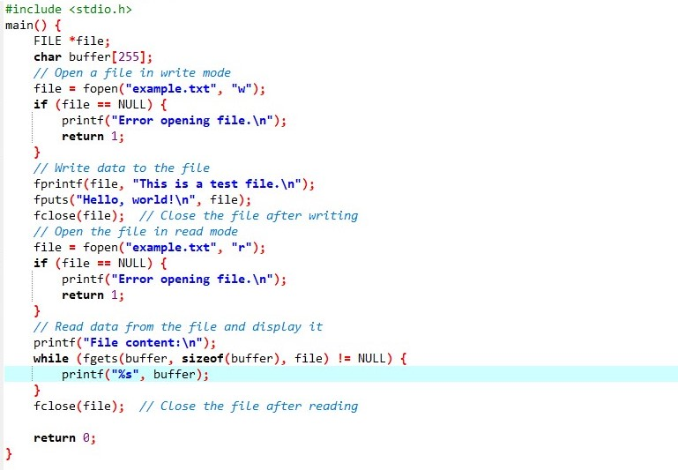

**• LAB EXERCISE: o Write a C program to create a file, write a string into it, close the file, then open the file again to read and display its contents.**

