**SQL-ASSESSMENT**

**Write SQL query to solve the problem given below**

There given a table named as product

The products are the computer components like keyboard, motherboard, monitor , speaker, etc..

The product table contains attributes like product id, product name, price and product code

Example of such table is given below :

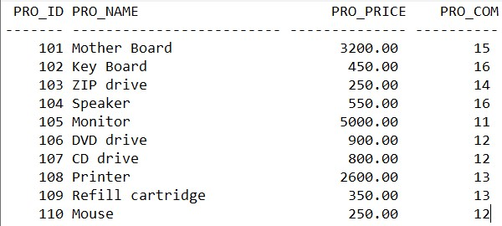

Make sure to user right sql syntax to solve the query given below :

* Write sql query to find the items whose prices are higher than or equal 250rs. Order the result by product price in descending, then product name in ascending. Return pro_name and pro_price
* Write a sql query to find the cheapest item. Return pro_name and pro_price.
* Write the sql query to calculate the average price of the items for each company. Return average price and company code.
* Write the sql query to find the average total for all the product mention in the table

1.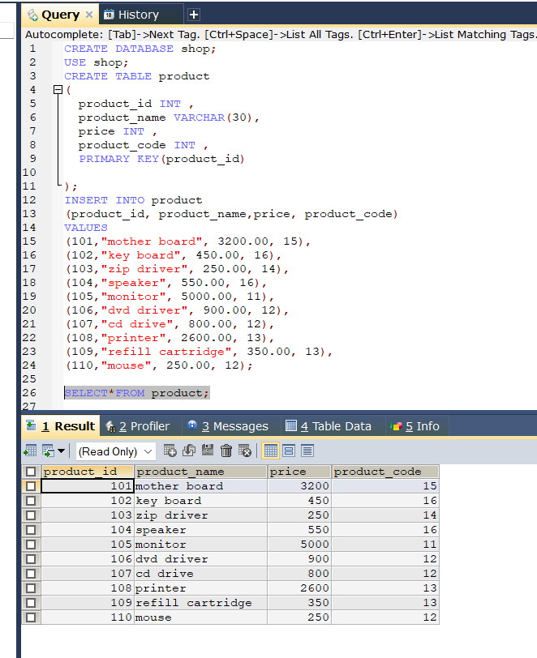

2. 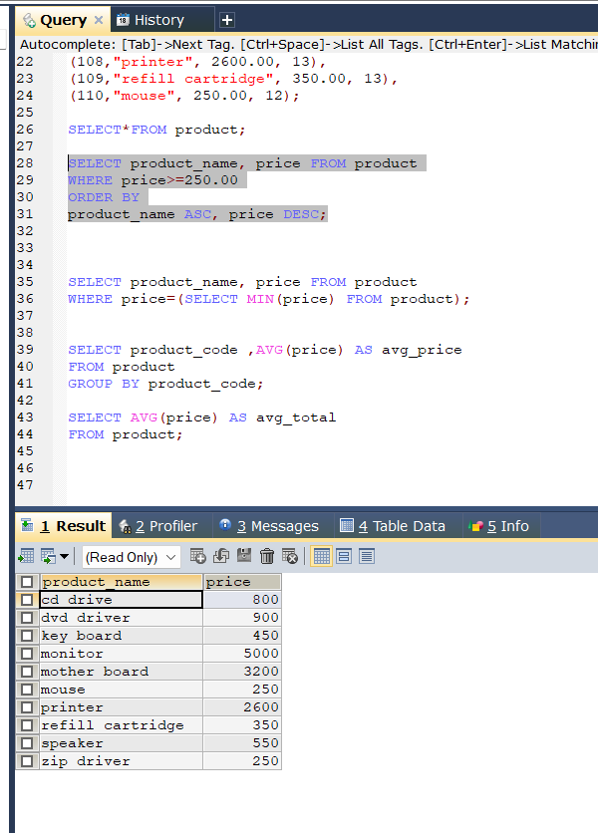

3. 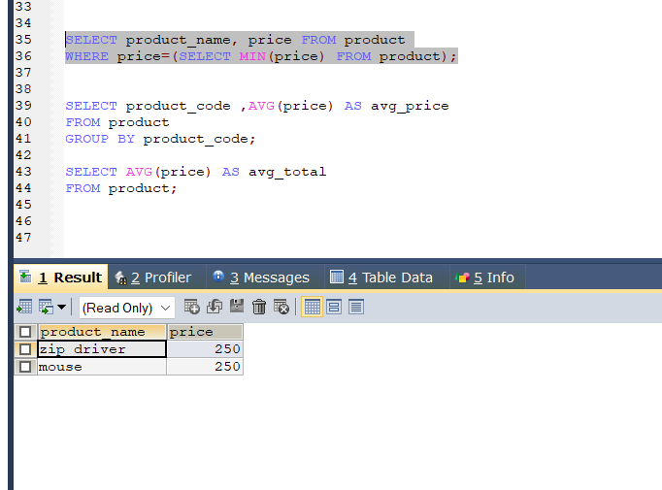

4. 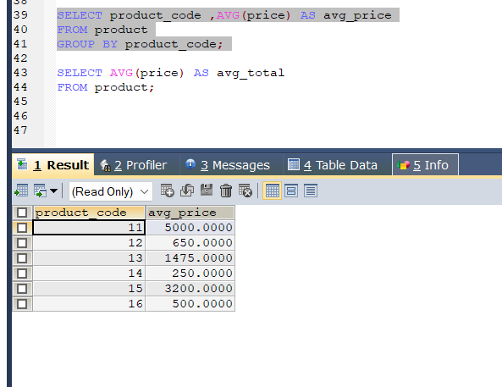

5. 