|  |  |  |  |  |  |  |  |  |  |  |  |
| --- | --- | --- | --- | --- | --- | --- | --- | --- | --- | --- | --- |
|  | | **Hope Foundation’s**  **Finolex Academy of Management and Technology, Ratnagiri** | | | | | | | | | |
| **Information Technology Department** | | | | | | | | | |
| Subject name: DevOps Lab | | | | | | | | Subject Code: ITL803 | | | |
| Class | | BE IT | | Semester – VIII (CBCGS) | | | | Academic year: 2019-20 | | | |
| Name of Student | | Jyoti Subhash Nachankar | | | | | **QUIZ Score :** | | | | |
| Roll No | | 33 | | | Assignment/Experiment No. | | | | | 01 | |
| **Title: To Understand the concept of DevOps with related technologies** | | | | | | | | | | | |
|  | | | | | | | | | | | |
| **1.Lab objectives applicable**  **LOB1.**To understand the concept of DevOps with associated technologies and methodologies. | | | | | | | | | | | |
| **2. Lab outcomes applicable:**  **LO2** -Students understood the technologies involved in DevOps process. | | | | | | | | | | | |
| **3. Learning Objectives:**   1. To understand concept of devops and its benefits 2. To know the open source tools to achieve the benefits of DevOps culture | | | | | | | | | | | |
| **4. Practical applications of the assignment/experiment: To get the faster release of software and continuous feedback,its important to know the related technologies** | | | | | | | | | | | |
| **5. Prerequisites**:   1. Knowledge of waterfall model in software development 2. Internet Access 3. Knowledge linux operating system | | | | | | | | | | | |
| **6. Hardware Requirements**:   1. Internet Access with Browser 2. Access to root privilegees   **7. Software Requirements:**  Browser like Chrome, Internet Explorer Edge | | | | | | | | | | | |
|  | | | | | | | | | | | |
| **8. Quiz Questions (if any): (Online Exam will be taken separately batchwise, attach the certificate/ Marks obtained)**   1. What is DevOps ? 2. What are the devops development life cycles? 3. How the devops is different than agile technology? | | | | | | | | | | | |
|  | | | | | | | | | | | |
| **9. Experiment/Assignment Evaluation:** | | | | | | | | | | | |
| **Sr. No.** | **Parameters** | | | | | | | | **Marks obtained** | | **Out of** |
| **1** | Technical Understanding (Assessment may be done based on Q & A **or** any other relevant method.) Teacher should mention the other method used - | | | | | | | |  | | 6 |
| **2** | Neatness/presentation | | | | | | | |  | | 2 |
| **3** | Punctuality | | | | | | | |  | | 2 |
| **Date of performance (DOP)** | | |  | | | **Total marks obtained** | | |  | | **10** |
| **Date of checking (DOC)** | | |  | | | **Signature of teacher** | | | | | |

**10.Theory-.**

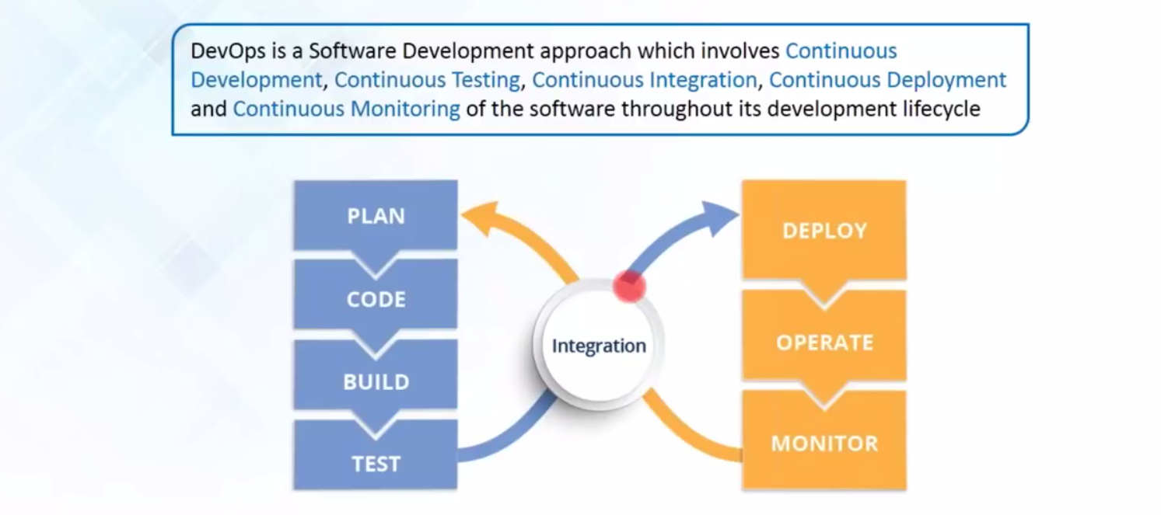

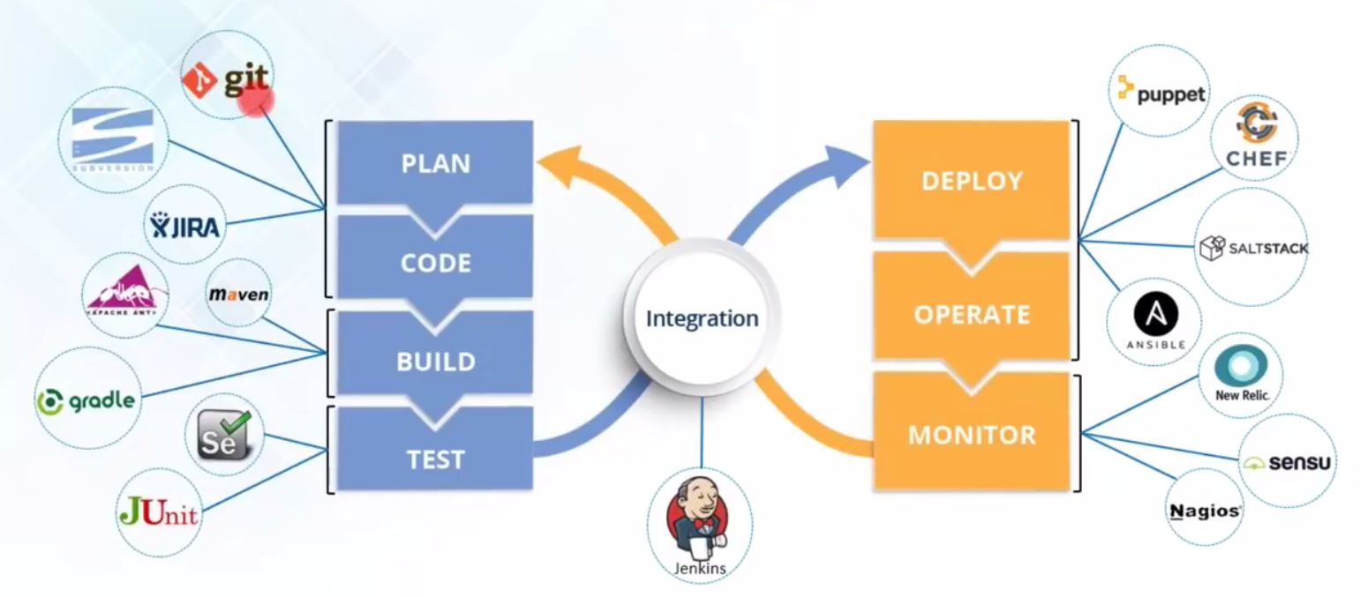

1. **Results:**

**13. Learning Outcomes Achieved**

1. Students Configured Azure Cloud Account and Queuing Server
2. Students Configured Azure Message Queue
3. Message was sent using producer program code and consumed by the receiver
4. Discussion about how SaaS Web services transfer messages using qu
   1. For invoking web services as well as passing results message queues are used
5. **Engineering Relevance**

## Benefits of DevOps

Implementing a DevOps practice can add value to your organization through a number of benefits, including the following:

* Faster code delivery
* Faster time to market
* Higher-quality software
* Improved collaboration between developers and operations
* Decreased time to resolution for fixing bugs and vulnerabilities
* A culture that brings business, development, and operations together for improved responsiveness to market demands

## DevOps tools

DevOps tools cover a range of processes within the software development life cycle:

* Define and plan, which focuses on planning DevOps workflows for iterations, release management, and issue tracking. Notable tools or tool vendors in this space include Atlassian, CA Technologies, IBM, iRise, and Jama Software.
* Code, build, and configure, which focuses on code development and review, source code management, and code merging. Notable tools/tool vendors include BitBucket, Electric Cloud, GitLab, GitHub, and IBM.
* Test, which verifies that the quality of the software release and code are maintained throughout the development process and that the highest quality deploys to production. Notable tools/tool vendors include Delphix, FlawCheck, HP, IBM, Microsoft, Parasoft, SonarSource, Skytap, and ThoughtWorks.
* Packaging and preproduction, which refers to the activities involved once the release is ready for deployment; it’s also called staging or preproduction. Notable tools/tool vendors include IBM, Inedo’s ProGet, Jfrog’s Artifactory, Sonatype Nexus repository.
* Release, deploy, and orchestration, which is the process of actually releasing software and usually involves change management, release approvals, release automation, schedule orchestration, provisioning, and deploying into production. Tools/tool vendors in this space include Automatic, Clarive, BMC, IBM, Flexagon, VMware, and XebiaLabs.
* Continuous management and configuration includes continuous configuration automation, configuration management, and infrastructure as code. Notable tools/tool vendors include Ansible, Chef, IBM, Puppet Labs, Otter, and Salt.
* Monitoring reports application performance and helps identify issues impacting the user experience. Tools/tool vendors include Big Panda, IBM, New Relic, Plumbr, and Wireshark.

**References** :

[IBM DevOps: Shorten releases, improve reliability, and stay ahead of the competition](https://www.ibm.com/cloud/devops)

* Read the eBook, [DevOps for Dummies](https://www.ibm.com/account/reg/signup?formid=urx-30746)
* [Try IBM UrbanCode Velocity](https://www.ibm.com/account/reg/signup?formid=urx-36281) free for 60 days