|  |  |  |  |  |  |  |  |  |  |  |  |
| --- | --- | --- | --- | --- | --- | --- | --- | --- | --- | --- | --- |
|  | | **Hope Foundation’s**  **Finolex Academy of Management and Technology, Ratnagiri** | | | | | | | | | |
| **Information Technology Department** | | | | | | | | | |
| Subject name: DevOps Lab | | | | | | | | Subject Code: ITL803 | | | |
| Class | | BE IT | | Semester – VIII (CBCGS) | | | | Academic year: 2019-20 | | | |
| Name of Student | | Jyoti Subhash Nachankar | | | | | **QUIZ Score :** | | | | |
| Roll No | | 33 | | | Assignment/Experiment No. | | | | | 03 | |
| **Title: Integrating Jenkins to the GitHub to automate the jobs with every commit on**  **GitHub** | | | | | | | | | | | |
|  | | | | | | | | | | | |
| **1.Lab objectives applicable**  LOB1:To be familiarized with Jenkins, which is used to build & test software Applications & Continuous integration in DevOps environment. | | | | | | | | | | | |
| **2. Lab outcomes applicable:**  LO2:Students understood the installations of Jenkins and its uses | | | | | | | | | | | |
| **3. Learning Objectives:**   1. To understand the integration of Jenkins with GitHub 2. To understand the working of GitHub | | | | | | | | | | | |
| **4. Practical applications of the assignment/experiment: Adding the developed source code to the central repository for safety reasons and also to perform auto building the code from different developer** | | | | | | | | | | | |
| **5. Prerequisites**:   1. GitHub account 2. Internet Access 3. GitHub commands | | | | | | | | | | | |
| **6. Hardware Requirements**:   1. Internet Access with Browser 2. Access to root privileges   **7. Software Requirements:**  Jenkins and git utility | | | | | | | | | | | |
|  | | | | | | | | | | | |
| **8. Quiz Questions (if any): (Online Exam will be taken separately batchwise, attach the certificate/ Marks obtained)**   1. What GitHub? 2. What are the commands to push code to GitHub ? 3. How to clone any gitHub repository? | | | | | | | | | | | |
|  | | | | | | | | | | | |
| **9. Experiment/Assignment Evaluation:** | | | | | | | | | | | |
| **Sr. No.** | **Parameters** | | | | | | | | **Marks obtained** | | **Out of** |
| **1** | Technical Understanding (Assessment may be done based on Q & A **or** any other relevant method.) Teacher should mention the other method used - | | | | | | | |  | | 6 |
| **2** | Neatness/presentation | | | | | | | |  | | 2 |
| **3** | Punctuality | | | | | | | |  | | 2 |
| **Date of performance (DOP)** | | |  | | | **Total marks obtained** | | |  | | **10** |
| **Date of checking (DOC)** | | |  | | | **Signature of teacher** | | | | | |

**10.Theory-.**

GitHub is a website and cloud-based service that helps developers store and manage their code, as well as track and control changes to their code. To understand exactly what GitHub is, you need to know two connected principles:

* Version control
* Git

What Is Git?

Git is a specific open-source version control system created by Linus Torvalds in 2005.

Specifically, Git is a distributed version control system, which means that the entire codebase and history is available on every developer’s computer, which allows for easy branching and merging.

**11. Installation Steps / Performance Steps –**

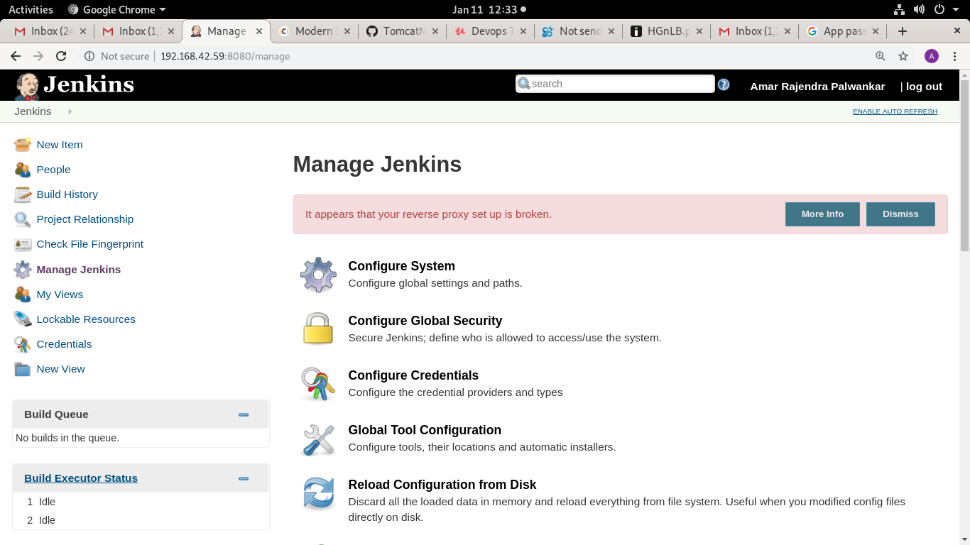

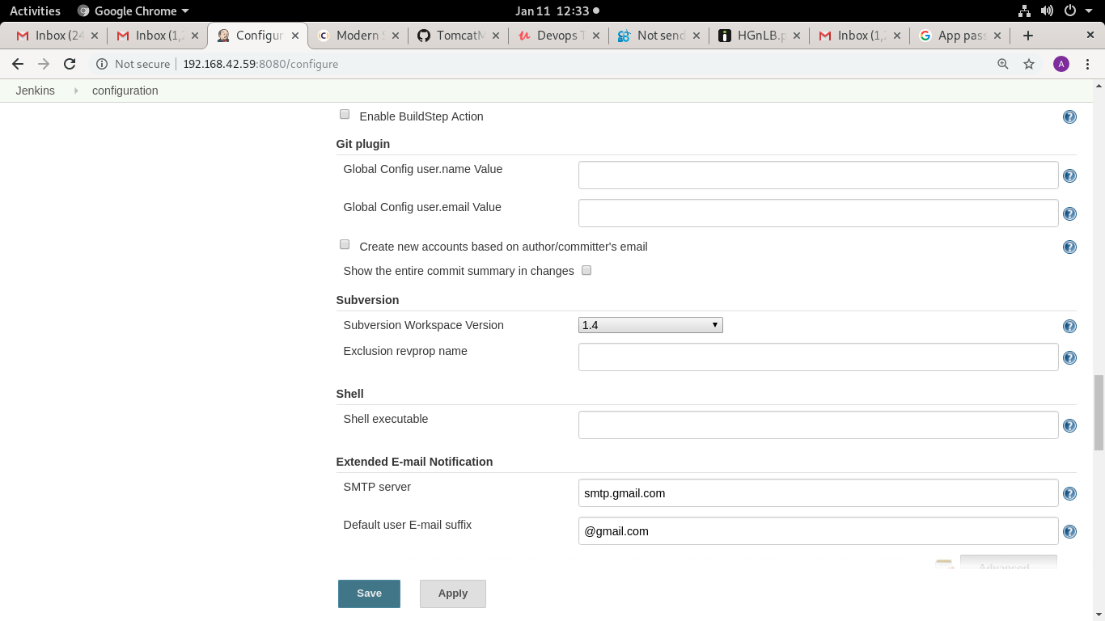

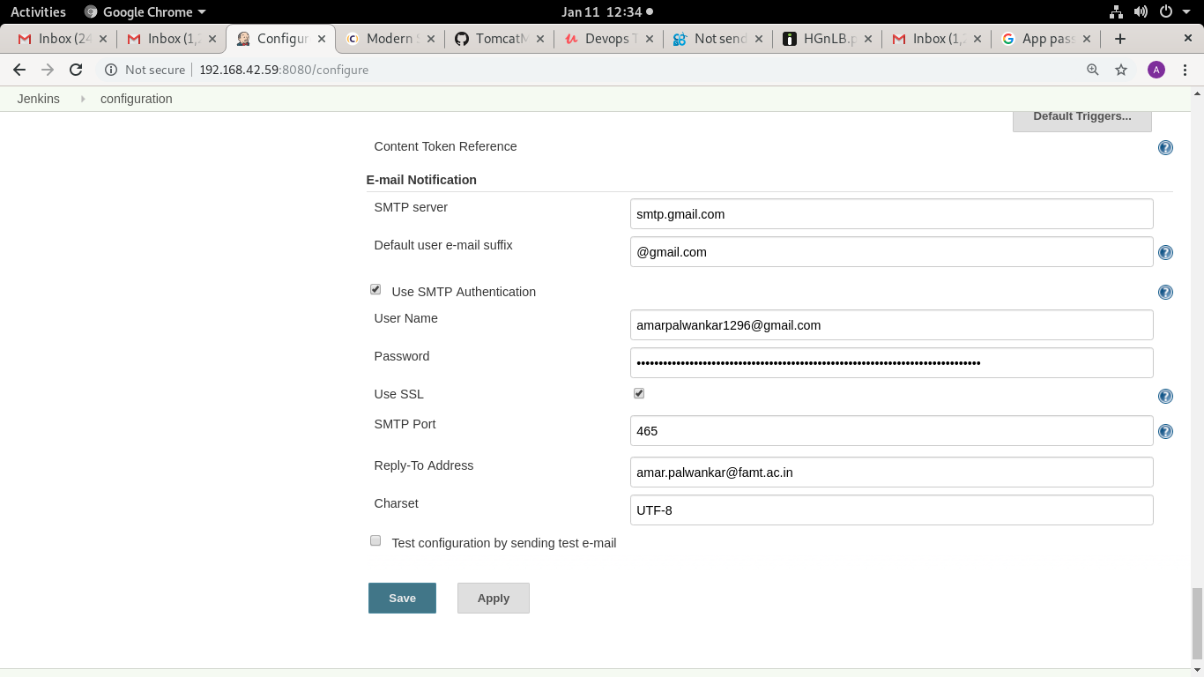

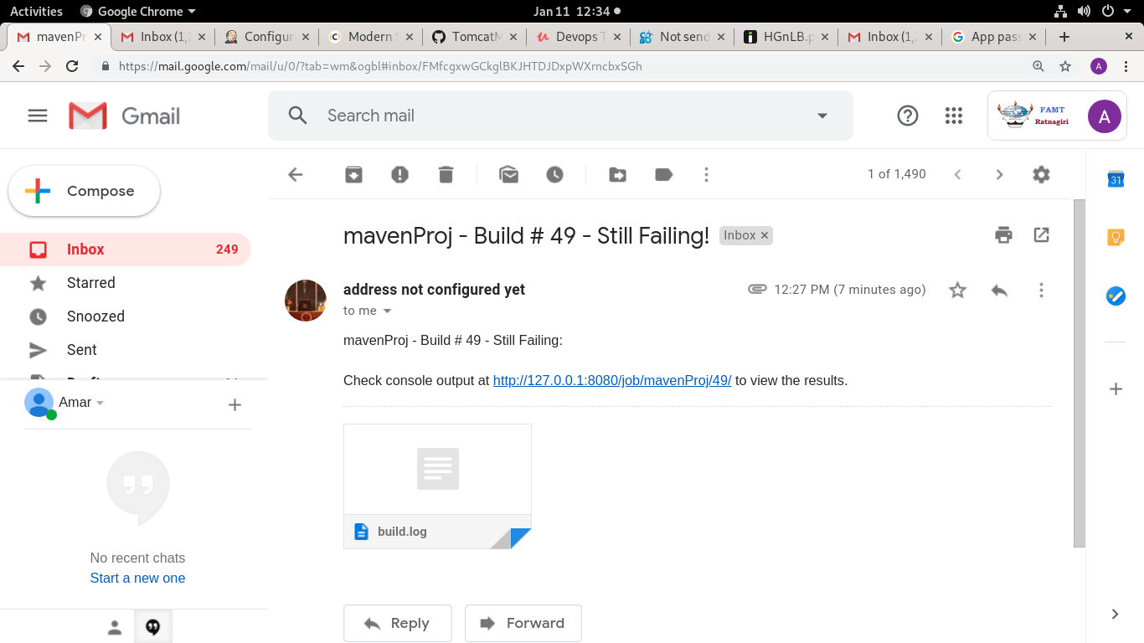

**12. Learning Outcomes Achieved.**

1.Student understood the integration of Jenkins and GitHub service

2.Students understood the enabling of Jenkins plugins.

3.Students understood the writing a simple trigger code on Jenkins

4.Students understood the Git commands on terminals.

**13. Conclusion:**

1. **Applications of the studied technique in industry**
   1. Jenkins are used to automate the tasks in the industry
   2. GitHub is used to track the changes made in code
2. **Engineering Relevance** 
   1. Version controlling the software
   2. To perform pipeline as code
3. **Skills Developed**
   1. GitHub integration with Jenkins
   2. Safe guarding the source code using GitHub

**14.References:**

1.https://kinsta.com/knowledgebase/what-is-github/

2.https://www.blazemeter.com/blog/how-to-integrate-your-github-repository-to-your-jenkins-project/