Tick the correct answers

1. Our mouth helps us_____________.
2. walk
3. eat
4. We have ____________________ in the morning.
5. breakfast
6. lunch
7. dinner
8. The _________________ of the house let in fresh air and sunlight.
9. roof
10. floor
11. windows
12. We should always wear _________________ clothes.
13. unclean
14. clean
15. torn
16. Our legs and feet help us _______________ .
17. eat
18. walk
19. draw
20. Which part of our body helps us eat food?
21. leg
22. foot
23. mouth
24. Which sense organ tells us that the telephone is ringing?
25. ear
26. skin
27. tongue
28. Which is not a part of body?
29. nose
30. rose
31. ear
32. My brother is my parents __________________
33. don
34. daughter
35. grandfather
36. All the members of family share the same ______________.
37. first name
38. middle name
39. surname
40. We are our parents _____________________.
41. children
42. cousins
43. aunts
44. Our cousins are our _________________ children.
45. parents’
46. uncle’s
47. friend’s
48. Food like rice and sugar give us ___________________.
49. sunshine
50. meat
51. energy
52. Which meal do we have in the morning?
53. dinner
54. breakfast
55. lunch
56. We should not ___________________ food .
57. cook
58. eat
59. waste
60. Fruits and vegetables keep us ________________________.
61. healthy
62. sick
63. dull
64. The top covering of a house is called a _________________.
65. roof
66. floor
67. door
68. In which room of our house do we study?
69. bathroom
70. dining room
71. study room
72. We take a bath in the ______________________.
73. kitchen
74. bathroom
75. bedroom
76. A house made of mud, wood and straw is called ___________________________ .
77. kachcha house
78. pakka house
79. apartment
80. We wear cotton clothes in ______________________ .
81. summer
82. winter.
83. Raincoats protect us from _______________________ .
84. rain
85. heat
86. wind
87. Woollen clothes protect us from _____________________.
88. cold
89. dust
90. heat
91. We go to school in _________________________________.
92. dull dress
93. school uniform
94. fancy dress

Answer the following questions

1. How many sense organs do we have?

____________________________________________________________________________________________________________

1. How do our hands and fingers help us?

____________________________________________________________________________________________________________

1. Name the five sense organs.

____________________________________________________________________________________________________________

Find food items hidden in the magic box given below.

|  |  |  |  |  |  |  |
| --- | --- | --- | --- | --- | --- | --- |
| **D** | A | L | A | B | C | D |
| **C** | H | E | E | S | E | **B** |
| E | F | G | H | I | J | R |
| **N** | O | O | D | L | E | E |
| L | M | N | O | P | Q | A |
| **R** | I | C | E | S | T | D |
| **M** | I | L | K | V | W | X |

1. ________________________ 2 ______________________

3 ________________________ 4 _______________________

5 ________________________ 6 _______________________

1. Which sense organ tells you that the ice cream is cold?

______________________________________________________

1. How many fingers do we have?

______________________________________________________

1. Name any three parts of body.

____________________________________________________________________________________________________________

1. Name one thing that all family members share.

______________________________________________________

1. Who all make a family?

____________________________________________________________________________________________________________

1. What is the family of four members called?

____________________________________________________________________________________________________________

1. How many meals do you have in a day?

______________________________________________________

1. Where do we get water from?

____________________________________________________________________________________________________________

1. Name two foods that give us energy.

______________________________________________________

1. Which type of food should we avoid for dinner?

______________________________________________________

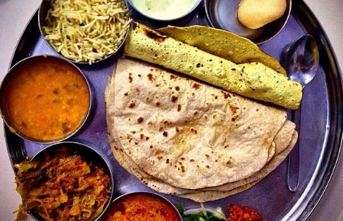 We eat food because

1. It gives us ___________________.
2. It makes us ___________________ and __________________.
3. It helps us _____________________ .

Find the names of five body parts hidden in the given word grid.

|  |  |  |  |  |
| --- | --- | --- | --- | --- |
| X | Y | **T** | W | I |
| Y | **F** | H | O | Y |
| **M** | O | U | **T** | **H** |
| Q | O | M | O | A |
| R | T | B | E | N |
| S | G | W | S | D |

1. ________________________ 2 ______________________

3 ________________________ 4 _______________________

5 ________________________

1. Where do we sleep and take rest?

____________________________________________________________________________________________________________

1. Name the part of a house that lets in sunlight and fresh air.

______________________________________________________

1. Why do we need house?

____________________________________________________________________________________________________________

1. Where is food cooked?

______________________________________________________

1. Name any two clothes we need to keep ourselves warm in winter.

______________________________________________________

1. Name the three main seasons.

____________________________________________________________________________________________________________

1. Why do we wear clothes?

____________________________________________________________________________________________________________

1. What type of clothes do we wear in summer?

______________________________________________________

1. Why do we wear woolen clothes in winter?

_______________________________________________________________________________________________________

1. Why do we carry an umbrella on a rainy day?

_______________________________________________________________________________________________________

Rhyming words

|  |  |
| --- | --- |
| LAND |  |
| BREAD |  |
| TWIN |  |
| ROSE |  |

Fill in the blanks.

(taste, leg, feet, hear, brother, care, family, hand, finger, walk)

1. Our ears help us ____________________ .
2. Our legs help us _____________________ .
3. Our tongue helps us __________________ .
4. Our _________________ and _________________ help us skate.
5. Our _______________ and _________________help us write.
6. Your parents son is your _____________________ .
7. Mother, father and children live together and make a _______________ .
8. Our parents love and take ________________ of us.

Which sense organ do you use to know about the following of your birthday cake?



1. Beautiful shape : ________________________
2. Nice smell : ____________________________
3. Sweet taste : ___________________________
4. Softness : ______________________________

(oily, big, parents, neat, clean, five, rainy, rice, sugar, live, chew, villages, seasons, woollen)

1. A family that has many members is called a ______________ family.
2. Food gives us energy to _____________ and ______________ .
3. We cannot _______________ without water.
4. Eat slowly and _______________________ well.
5. Kachcha houses are found in _________________________.
6. We must keep our house ___________________ and ___________________.
7. We wear different clothes in different _________________.
8. We wear _____________________ clothes in winter.
9. We use umbrellas and raincoats on _______________________ days.
10. We have ______________________ sense organs.
11. _____________________ look after their children.
12. We must avoid _______________________ food for dinner.

Match the following houses with the materials they are made of.

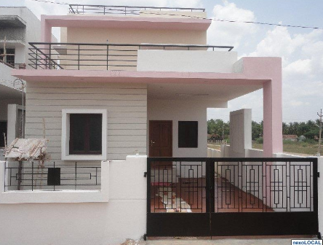 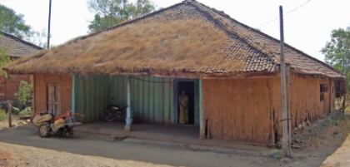

Mud iron brick straw wood cement

Name the following.

1. A family of four members - __________________________
2. A sense organ that help us see the things _______________
3. A food that give us energy ___________________________
4. A room where we study _____________________________
5. Name four things you see in your bedroom.

_______________________________________________________

1. Where do you find a mug and a bucket?

______________________________________________________

Look at the given picture and answer following questions.



1. Name the type of house shown in the picture.

___________________________________

1. Which materials are used in making this house?

______________________________________________________

1. Where do we find this type of house? _______________________

Write T for true and F for false sentences

1. My mother and father are my parents.
2. There are many members in a small family.
3. Parents earn money for their family.
4. Children should not help their parents.
5. On rainy days, we wear woolen clothes.
6. Kachcha houses are made of mud, wood andstraw.
7. We should drink a glass of tea before we go to bed.
8. Members of a family care for each other.

Match

|  |  |
| --- | --- |
| Rice, butter and sugar ■ | ■ Need water |
| Food we have at night is ■ | ■ Give energy |
| All living things ■ | ■ Dinner |
| Wash your hands ■ | ■ Strong and healthy |
| Food makes us ■ | ■ Before and after every meal |
| Summer ■ | ■ Raincoats |
| Winter ■ | ■ Cotton clothes |
| Monsoon ■ | ■ Woolen clothes |
| School ■ | ■ Chew well |
| Tongue ■ | ■ Rest |
| Food ■ | ■ Uniform |
| Bedroom ■ | ■ taste |

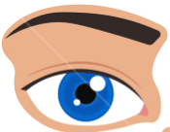 This sense organ helps me to hear

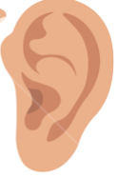 This sense organ helps me to taste

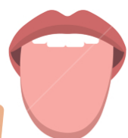 This sense organ helps me to see

 This sense organ helps me to feel

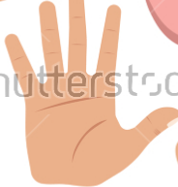 This sense organ helps me to smell.

Fill in the blank boxes

|  |  |
| --- | --- |
| 6 🗶 2 =________ | 6 🗶 6 = ________ |
| 5 🗶 5 =________ | 5 🗶 8 =________ |
| 4 🗶 9 =________ | 4 🗶 7 =________ |
| 5 🗶 9 =________ | 6 🗶 4 = ________ |
| 3 🗶 4 = ________ | 3 🗶 7 =________ |

Subtract the numbers

|  |  |
| --- | --- |
| 3 - 2 =________ | 5 – 4 = ________ |
| 5 - 3 =________ | 8 - 6 =________ |
| 4 – 4 =________ | 6 - 2 =________ |
| 4 – 2 =________ | 5 - 1 = ________ |
| 6 – 3 = ________ | 7 - 3 =________ |

Add the numbers on a number line.

|  |  |  |  |  |  |  |  |  |  |  |
| --- | --- | --- | --- | --- | --- | --- | --- | --- | --- | --- |
|  |  |  |  |  |  |  |  |  |  |  |
| 0 | 1 | 2 | 3 | 4 | 5 | 6 | 7 | 8 | 9 | 10 |
|  |  |  |  |  |  |  |  |  |  |  |

|  |  |
| --- | --- |
| 3 + 2 =________ | 1 + 4 = ________ |
| 5 + 3 =________ | 2 + 6 =________ |
| 4 + 4 =________ | 6 + 2 =________ |
| 4 + 2 =________ | 5 + 1 = ________ |
| 6 + 3 = ________ | 6 + 3 =________ |

Subtract the number on number line.

|  |  |  |  |  |  |  |  |  |  |  |  |
| --- | --- | --- | --- | --- | --- | --- | --- | --- | --- | --- | --- |
|  |  |  |  |  |  | |  |  |  |  |  |
| 0 | 1 | 2 | 3 | 4 | 5 | | 6 | 7 | 8 | 9 | 10 |
|  |  |  |  |  |  | |  |  |  |  |  |
| 7 - 5 =________ | | | | | | 5 – 2 = ________ | | | | | |
| 5 - 2 =________ | | | | | | 8 - 4 =________ | | | | | |
| 4 – 0 =________ | | | | | | 6 - 4 =________ | | | | | |
| 4 – 1 =________ | | | | | | 5 - 3 = ________ | | | | | |
| 6 – 2 = ________ | | | | | | 7 - 4 =________ | | | | | |

Put the correct signs (> < =)

|  |  |
| --- | --- |
| 6 ______ 3 | 2 _______ 6 |
| 7 ______ 10 | 8 _______ 1 |
| 9 ______ 9 | 3 _______ 3 |
| 4 ______ 8 | 7 _______ 2 |

Write the number names for the following

|  |  |
| --- | --- |
| 1 - | 11 - |
| 2 - | 12 - |
| 3 - | 13 - |
| 4 - | 14 - |
| 5 - | 15 - |
| 6 - | 16 - |
| 7 - | 17 - |
| 8 - | 18 - |
| 9 - | 19 - |
| 10 - | 20 - |

|  |  |  |  |  |  |  |  |  |  |  |  |  |  |
| --- | --- | --- | --- | --- | --- | --- | --- | --- | --- | --- | --- | --- | --- |
| Anita has 3 balls. Her mother gives her 5 more. How many balls does Anita have in all?   |  |  | | --- | --- | | Tens | Ones | |  |  | |  |  | | Riya has 6 apples. She eats 2 of them. How many apples are left?   |  |  | | --- | --- | | Tens | Ones | |  |  | |  |  | |
| 6 birds sit on a tree. 4 fly away. How many birds are left on the tree?   |  |  | | --- | --- | | Tens | Ones | |  |  | |  |  | | Amit has 5 marbles. Rajat has 4 marbles. How many total marbles with them?   |  |  | | --- | --- | | Tens | Ones | |  |  | |  |  | |
| There are 9 green leaves on a tree. 6 leaves fall down. How many leaves are left on the tree?   |  |  | | --- | --- | | Tens | Ones | |  |  | |  |  | | Priya eats 3 biscuits. Then she eats 5 biscuits more. How many biscuits she eat in total?   |  |  | | --- | --- | | Tens | Ones | |  |  | |  |  | |

Write table 4, 5, 6.

|  |  |  |  |  |  |
| --- | --- | --- | --- | --- | --- |
| 4 🗶 1 |  | 5 🗶 1 |  | 6 🗶 1 |  |
|  |  |  |  |  |  |
|  |  |  |  |  |  |
|  |  |  |  |  |  |
|  |  |  |  |  |  |
|  |  |  |  |  |  |
|  |  |  |  |  |  |
|  |  |  |  |  |  |
|  |  |  |  |  |  |
|  |  |  |  |  |  |