### ****Q1. What is the difference between SQL and MySQL?****

|  |  |
| --- | --- |
| sql | mysql |
| SQL (Structured Query Language) is used to perform operations on the records stored in the database, such as updating records, inserting records, deleting records, creating and modifying database tables, views, etc.  Exp: [Oracle](https://www.javatpoint.com/oracle-tutorial), [MySQL](https://www.javatpoint.com/mysql-tutorial), [MongoDB](https://www.javatpoint.com/mongodb-tutorial), [PostgreSQL](https://www.javatpoint.com/postgresql-tutorial), [SQL Server](https://www.javatpoint.com/sql-server-tutorial), [DB2](https://www.javatpoint.com/db2-tutorial), etc. | It is free and open source n relational dbms.  It is used for both small and large applications.  Exp:SQL Server, Informix etc. |

### ****Q2. What are the different subsets of SQL?****

|  |  |  |  |
| --- | --- | --- | --- |
| ddl | dml | tcl | dcl |
| deals with schema creationand modifications | It allows you to access and manipulate data. | This commands deal with the transaction within the database. | deal with the user authorization and security |
| Cdat(create,drop,alter  ,truncate) | ,select,Insert,update,delete (UISD) | Commit,save point,rollback,set transaction | Grant,revoke |

### ****Q3. What do you mean by DBMS? What are its different types?****

It is A software system that interacts with the user, applications, and the database itself to capture and analyze data.

A database is a structured collection of data. The data stored in the database can be modified, retrieved and deleted and can be of any type like strings, numbers, images, etc.

There are two types of DBMS:

* Relational Database Management System: The data is stored in relations (tables). Example – MySQL.
* Non-Relational Database Management System: There is no concept of relations, tuples and attributes.  Example – MongoDB

**Q4. What is RDBMS? How is it different from DBMS?**

Rdbms is a database where we can store our data in form of tables.we can create relation between tables. That’s why retrieving data is faster .Efficiently manage large amount of data and is used in large businessapplication.

DBMS:It is the software system that allows the access to the data in the database.interface between user and database.

**Ex:dbase,Microsoft access ,foxpro,libreoffice**

|  |  |
| --- | --- |
| DBMS | RDBMS |
| Data stores as file . | Data stored in the form of tables |
| Data elements need to be access individually. | Multiple data can access at the same time. |
| No relation between the data | There is relation between the tables . |
| Normalization is not present. | Normalization is present. |
| It stores data in either a navigational or hierarchical form.(IN TREE LIKE STRUCTURE) | It uses a tabular structure where the headers are the column names, and the rows contain corresponding values. |
| It deals with small quantity of data. | It deals with large amount of data. |
| Support single user | Support multiple users. |
| Data fetching is slower when large amount of data | Data fetching is fast . |
| Examples: XML, Window Registry, etc | Examples: MySQL, PostgreSQL, SQL Server, Oracle, Microsoft Access etc. |

### Q5. What is a Self-Join?

Self join is use to join a table itself.self join is mostly used to combine and compare rows from the same database table.

Syntax:select a.colname,b.colname from table 1 tb ,table2 tb2 on t1.ccommoncol=t2.commoncolname;

### Q6. What is the SELECT statement?

### Select statement is use to select the data or retrieve the information.

### Exp:select * from table name;

### Q7. What are some common clauses used with SELECT query in SQL?

Ans:select colname from tablename where condition ;

Select colname from tablesname order by colname;

Select used with order by,group by ,having

### Q8. What are UNION, MINUS and INTERSECT commands?

Union:combine the 2 table but remove duplicate entries.

Minus-return rows from the first query not from the second query.

Intersect:combine result from the both query into a single row.(common elements)

### Q9. What is Cursor? How to use a Cursor?

It is an object that is used to make the connection for executing SQL queries. It acts as middleware between SQLite database connection and SQL query. It is created after giving connection to SQLite database.

Exp:

**import**sqlite3

 connection **=**sqlite3.connect('hotel_data.db')

connection.execute(''' CREATE TABLE hotel(FIND INT PRIMARY KEY     NOT NULL,FNAME           TEXT    NOT NULL,COST            INT     NOT NULL,WEIGHT        INT);''')

 # insert query to insert food  details in

# the above table

connection.execute("INSERT INTO hotel VALUES (1, 'cakes',800,10 )")

print("All data in food table\n")

 # create a cursor object for select query

cursor **=**connection.execute("SELECT * from hotel ")

 # display all data from hotel table

**for**row **in**cursor:

    print(row)

### Q10. List the different types of relationships in SQL.

|  |  |  |
| --- | --- | --- |
| ONE-TO-ONE | **One-to-Many and Many-to-One** | **Many-to-Many** |
| which each record in one table corresponds to the maximum of one record in the other.  Exp;one employee can go in 1 office.  Person can have only 1 passport  1 school has 1 principal | ONE class many students ,I student can register for mutliple course .  1 teacher can teaches many students  Many students study 1 subject | MANY AUTHOR HAVE HAVE MANY BOOK  Many books issued by many students . |
| The relationship between 2 tables where each record in 1 table is associated with the maximum of1record in the other table. | Where a record in a table is associated with multiple records in the other table. |  |

### Q11. What is OLTP?difference between olap and oltp ?

OLAP:online analytical processing .it is introduced by e.f.code .consists of a type of software tools that are used for data analysis for business decisions .It is a category of software technology that enables analysts ,managers to analyze the complex data derived from the data warehouse.

Exp: suppose in a region any product which is more sell .analyst/managers will check which product Is and why and in which weather product is selling more ,on the basis of this they can store more product..

OLTP::online transaction processing :It is an online database query response system.

It is used to store day to day online transactions . (insert,update,delete)

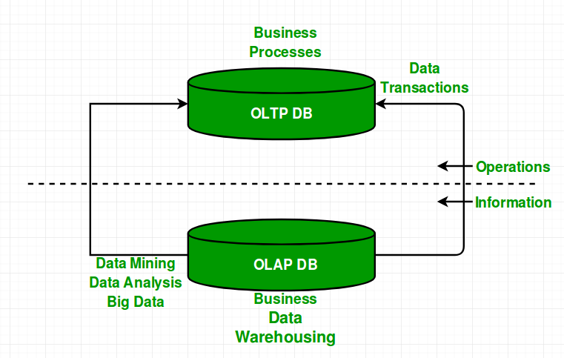

**Comparisons of OLAP vs OLTP :**

|  |  |
| --- | --- |
| **olap** | **oltp** |
| **It is well -known as an online database query management system.** | **It is well-known as an online database modifying system.** |
| **Consists of historical data from various database.** | **Consists of only of operational**  **Current data.** |
| **It is subject-oriented. Used for data mining ,analytics,decisions**  **Making ,big data etc.** | **It is application oriented.used for business tasks.** |
| **Tables are not normalized.** | **Tables are normalized.** |
| **It only need backup from time to time as compared to oltp.** | Backup and recovery process is maintained rigorously(very strict) |
| Only read and rarely write operation. | Both read and write operations. |
| Improve the efficiency of business analysts . | Enhances the user productivity |

### Q12. How to create empty tables with the same structure as another table?

**Ans:Create table tbname as (select* from department where 1=2);**

**Where 1=2 means it is false statement which we can use to copy of the table structure .**

### Q13. What is PostgreSQL?

### It is an open source rdbms developed by a worldwide team of volunteers.

### ****Q14. What are SQL comments?**/* */**

### Q15. What is the usage of the NVL() function?

Ans:nvl() function is used for null value substitution.it allows you to replace null values with a default valueit will take 2 parameters and returns the first if it is not null otherwise it return the second.

Syntax:null(colname,substitute)

Ans :select nvl(value,10) from customers.

### Q16. Explain character-manipulation functions? Explains its different types in SQL.

Change,extract and edit the character string using character manipulation routines.

1)Lower:it will convert all the strings into lower case letter

Exp:select lower(colname) from tablename;

1. upper:this function will convert all the upper case letter into small letters.e

Exp:select upper(colname) from tablename;

3)initcap(colname):it will give only first letter capital and all other are small Sntx:select INITCAP(“STRING”)

**Character-Manipulative Functions**

1. **CONCAT();IT ADDS 2 OR MORE strings together.,if I want to concatenate 2columns then we Can also do this**

**A)if both strings are null,concat returns null.**

**B)if 1 string is null and other is not null then it will return not-null argument.**

**Syntax:select concat(str1,str2…)**

1. **LENGTH(COL|eXPRESSION):COUNT THE LENGTH OF THE GIVEN STRING AND also count the spaces .**

**3)Substr(string,start,endpoint):it will return the string from start to end point .if length is not given it will return complete string till the last.**

**4)LPAD and RPAD :---->IT return the strings padded to the left or right .**

**Syntax:lpad(column|EXPRESSION,n,string)**

**Exp:select lpad(‘hello’,21,’geek’)**

**Ans:**geekgeekgeekgeekhello

**TRIM :F**unction removes all specified characters from the beginning and the end of the given string.

Syntax:TRIM([ characters FROM ]string)

Exp:SELECT TRIM('G' FROM 'GEEKS') FROM DUAL;--- eeks

2exp:

|  |  |  |
| --- | --- | --- |
| **Name** | **City** | **Salary** |
| John | London | 3000 |
| Marry | New York | 2750 |
| Jo | Paris | 2800 |
| Kim | Amsterdam | 3100 |

Update employee set name=TRIM(name)

Select* from employee;

|  |  |  |
| --- | --- | --- |
| **Name** | **City** | **Salary** |
| John | London | 3000 |
| Marry | New York | 2750 |
| Jo | Paris | 2800 |
| Kim | Amsterdam | 3100 |

**REPLACE :**function replaces all occurrences of a substring within a string, with a new substring.

Sntax:replace(string,old_string,new_string)

Exp;SELECT REPLACE('ABC ABC ABC', 'a', 'c');---->cBC cBC cBC

### Q17 Write the SQL query to get the third maximum salary of an employee from a table named employees.

Offset 2 means drop first 2 row and then print 3 row .,limit 1 means want to access only 1 record

Ans1)select salary from tablename order by salary desc limit 1 offset 2;

#using top keyword

Select top 1 salary from (select top 3 salary from tablename order by salary desc ) as comp order by salary asc;

INNER QUERY WILL EXECUTE FIRST HERE so salary column will arrange in desc order and we will pic k top 3 data ,now again we arrange this 3 data in asc order and select top 1 will execute now

#using subquery

Select salary from (select salary from tablename order by salary desc limit 3) as cmp order by salary limit 1;

SELECT MAX(salary) FROM emp

WHERE salary<(SELECT MAX(salary) FROM emp

WHERE salary <(SELECT  MAX (salary) FROM emp));

### ****Q18. What is the difference between the RANK() and DENSE_RANK() functions?****

**Window function:**

**we perform calculations on data using various aggregated functions such as max,min and avg.we get a single output row using this functions .**

**Window function perform an aggregate operations for each row and returns result in details.**

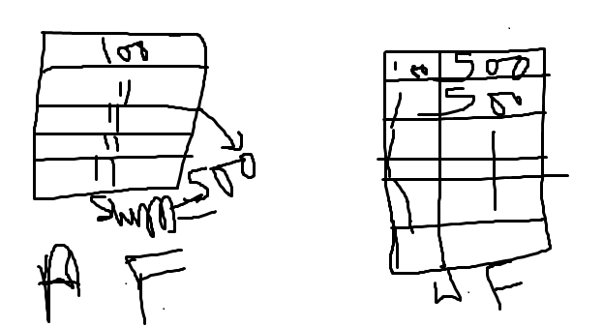

In above picture a.f it will give single output for each row but using window function output will be display for each row .

Syntax:window_function([all]expression)over ([partition_list][order by order list])

Over():it is the replacement of group by .it creates a window with multiple rows.

Window_function:specify the name of the window function.

All:optional keyword.when I will include all it will count all values including duplicate ones.

DISTINCT KEYWORD IS not supported in window functions.

Partiton_list::this clause is used to divide or breaks the rows into partitions,and the partition boundary separates these partitions.The window function operates on each partition, and when it crosses the partition boundary, it will be initialized again.

Order by-sorts the rows within each partition.if order by in not specified ,order by uses the entire table.

Aggregate functions :it performs calculations across a set of rows and return a single output row.

Select sum(salary) from tablename ;

Select f_name,l_name ,salary sum(salary) over() sum_salary From employees;

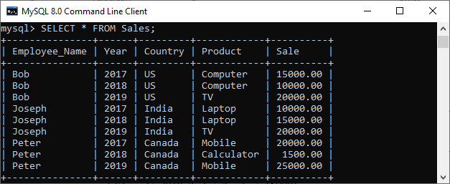

**To understand the window function ,lets check how aggregate functions works**

**Slect sum(sale) as total_sales from sales;**

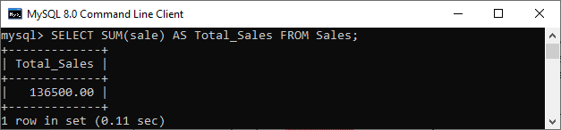

**Now we have product such as computer ,tv**

**Select year ,product ,sum(sale) as total_sales from sales group by year order by product**

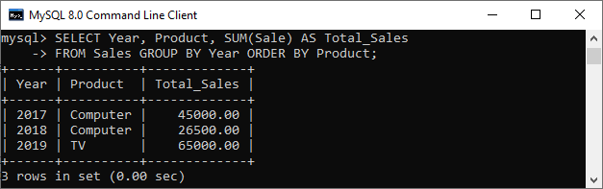

**In above both examples ,we can see that an aggregate function reduces the number of rows into a single row after the execution of the query.**

1. **returns sales for each product** each product along with total sales of the

products by the given year:

Select year,product,sale,sum(sale) over(partition by year) as total_sales from sales;

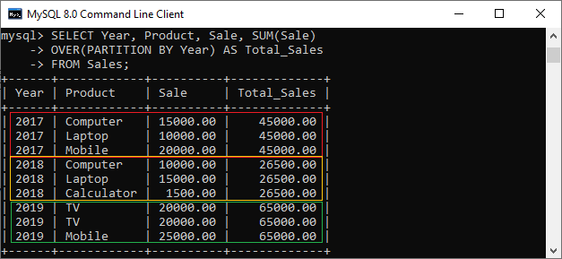in the above example, we can see that the window operation uses an **OVER** clause, which is responsible for partitioning the query rows into groups that processed by the window function.

Rank() vs dense _rank()

| **id** | **first_name** | **last_name** | **month** | **sold products** |
| --- | --- | --- | --- | --- |
| 1 | Lisa | Black | 5 | 2300 |
| 2 | Mary | Jacobs | 5 | 2400 |
| 3 | Lisa | Black | 6 | 2700 |
| 4 | Mary | Jacobs | 6 | 2700 |
| 5 | Alex | Smith | 6 | 2900 |
| 6 | Mary | Jacobs | 7 | 1200 |
| 7 | Lisa | Black | 7 | 1200 |
| 8 | Alex | Smith | 7 | 1000 |

Task: display each sales assistant’s first and last name and number of sold products. We also want to rank them in terms of the number of products sold in descending order.

Select rank() over(order by sold products desc) as r,

Dense_rank() over(order by sold products desc) as dr,f_name,l_name month ,

Sold products from sales_assistants;

Rank():skips the number of positions after records with the same rank numberskips the number of positions after records with the same rank number

.RANK_DENSE returns position numbers from 1 to 6 because it doesn’t skip records with the same rank number:

| **r** | **dr** | **first_name** | **last_name** | **month** | **sold products** |
| --- | --- | --- | --- | --- | --- |
| 1 | 1 | Alex | Smith | 6 | 2900 |
| 2 | 2 | Lisa | Black | 6 | 2700 |
| 2 | 2 | Mary | Jacobs | 6 | 2700 |
| 4 | 3 | Mary | Jacobs | 5 | 2400 |
| 5 | 4 | Lisa | Black | 5 | 2300 |
| 6 | 5 | Mary | Jacobs | 7 | 1200 |
| 6 | 5 | Lisa | Black | 7 | 1200 |
| 8 | 6 | Alex | Smith | 7 | 1000 |

Rank():In r column and sold products1200 1200 same rank, after same rank skip 1 number

In dense_rank():after matching element rank will not skip.

**Q19. What are Tables and Fields?**

|  |  |  |  |
| --- | --- | --- | --- |
| Roll number | name | address | fees |
| 1 | rahul | badli | 73489 |
| 2 | karan | kathura | 38976 |

Student:database name

Table name/entity:computer science :which is related to real world entity./table is the structured inside database that contains data,organized in columns and rows format.

Columns/attribute/field/features:describe entity features

Rows/record/tuple:reLAted information about the data .

**Q20)what are the constraints in sql?**

Sql constraints are usedto specify rules for data in a table.it can be specified when table is created with the CREATE TABLE statement ,after the table created with ALTER TABLE statement

.It ensures the accuracy and reliability of the data in the table.If there is any violation between the constraint and the data action ,the action is aborted.

Constraints can be column level or table level. Column level constraints apply to a column, and table level constraints apply to the whole table.

[NOT NULL](https://www.w3schools.com/sql/sql_notnull.asp) - Ensures that a column cannot have a NULL value

[UNIQUE](https://www.w3schools.com/sql/sql_unique.asp) - Ensures that all values in a column are different

[PRIMARY KEY](https://www.w3schools.com/sql/sql_primarykey.asp) - A combination of a NOT NULL and UNIQUE. Uniquely identifies each row in a table

[FOREIGN KEY](https://www.w3schools.com/sql/sql_foreignkey.asp) - Prevents actions that would destroy links between tables

[CHECK](https://www.w3schools.com/sql/sql_check.asp) - Ensures that the values in a column satisfies a specific condition

[DEFAULT](https://www.w3schools.com/sql/sql_default.asp) - Sets a default value for a column if no value is specified

[CREATE INDEX](https://www.w3schools.com/sql/sql_create_index.asp) - Used to create and retrieve data from the database very quickly

### Q21). What is schema in SQL Server?

ANS:It is a collection of database objects like tables,triggers,stored procedures. Etc.database may have one or more schema.

Username of database is called -schema owner

Syntax to create database schema.

Create schema schema name go

Select *from sys.shemas

### Q22). How to create a temp table in SQL Server?

Ans:temporary tables are those which created temporary and this type of table delete automatically deleted when connection is terminated.

Syntax:create table # table name (id ,name);

Select * from #tablename;

### Q23). What is the case when in SQL Server?

**Case statement is use when any condition I have to apply**

SELECT OrderID, Quantity,  
CASE  
    WHEN Quantity > 30 THEN 'The quantity is greater than 30'  
    WHEN Quantity = 30 THEN 'The quantity is 30'  
    ELSE 'The quantity is under 30'  
END AS QuantityText  
FROM OrderDetails;

**Q24). NoSQL vs SQL**

|  |  |
| --- | --- |
| **Sql** | **Nosql** |
| **rdms** | **Non.relational or distributed database system.** |
| **Sql have fixed or static or predefined schema.** | **The have dynamic schema.** |
| **These type of database are not good for hierarchical data storage.** | **These type of database good for hierarchical data storage.** |
| **Good for complex queries** | ARE NOT GOOD FORCOMPLEX QUERIES |
| **Follows ACID property** | Follows CAP(consistency, availability, partition tolerance) |

**Q25) What is the difference between NOW() and CURRENT_DATE()?**

**SELECT CURDATE()--->2017-10-28**

**SELECT NOW();--->**2017-10-2809:10:16 DATEALONG WITH TIME

select GETDATE()-->2022-07--07 06:57:38.540

SELECT CURRENT_DATE;

SELECT CURREN_DATE();

SELECT CURDATE();

SELECT DATE(NOW());

SELECT DATE(CURRENT_TIMESTAMP());

**Q26. What is BLOB and TEXT in MySQL?**

BLOB->BINARY large object means used to store binary data (pictures,videos,sounds,and programs)while text is used to store large number of strings.

**Q27). How to remove duplicate rows in SQL?**

Ans:1)select colname,count(*) from tablename group by colname having count(*)>1;--->find how many rows are duplicate

Delete from table where id in (select id,,count(id) from table group by id having count(id)>1 );

**Q28). How to create a stored procedure using SQL Server?**

**Ans:**A stored procedure is a piece of prepared SQL code that you can save and reuse again and over.  
So, if you have a SQL query that you create frequently, save it as a stored procedure and then call it to run it.

Types of stored procedure;

1. system stored procedured :Microsoft uses sp_ prefix for system store procedured.

.use spname

2)User defined procedured:which is created by the user

#how to create sp

1)Create procedure spGetemployees

As begin

Select name,gender from tablename;

End

Suppose we need this query again and again so we can create a stored procedured of it .

Execute stored procedured-->execute storedprocedure name ;

1. create procedure spemp

@id int #declare a variable

As begin

Select * from tablename where id =@id; end

Execute spemp 2; -->output will be id 2 s

**Q29. What is Database Black Box Testing?s**

**Q30. What are the different types of SQL sandbox?**

**Q31. Where MyISAM table is stored?**

**Q32. How to find the nth highest salary in SQL?**

1. select salary from tablename order by salary desc limit n-1,1;

2)Select Emp_name from table_name where Salary =( Select Salary from table_name order by Salary DESC limit n-1,1);

**3)**select * from(select ename, sal, dense_rank() over(order by sal desc)r from Employee) where r=&n;

To find to the 2nd highest sal set n = 2

To find 3rd highest sal set n = 3 and so on.

### ****Q33. What are joins in SQL?****

**Sql joins is use to join 2 or more tables based on a common column**

**1)inner join/join :fwhich is common in both tables**

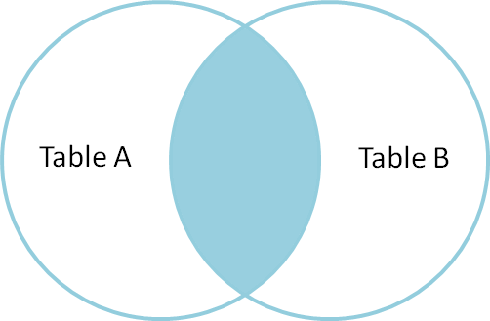

### **2) LEFT JOIN/left outer join :join all the rows of the left table,matches rows of the right table ,when there is no matching rows for the right side table ,the result set will contain null.**

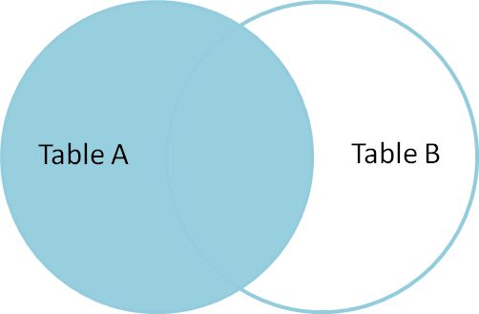

1. right join :right side table data and matching rows from the left side table data ,when there is no match of left side ,then result will contain null

### **4)FULL JOIN:** The result-set will contain all the rows from both tables. For the rows for which there is no matching, the result-set will contain *NULL* values.

### ****Q34.**** ****What is the difference between CHAR and VARCHAR2****

|  |  |
| --- | --- |
| char | Varchar2 |
| character | **Variable Character** |
| Fixed type of data store pin code,mobile number | Store variable length data ,,name ,address |
| Maximum size 2000 bytes | Maximum size 4000 bytes |
| Static data type | Dynamic data type |
| Can lead to memory wastage | Manages memory efficiently |
| 50% much faster than varcahr2 | Slower as compared to char |
|  |  |

### ****Q35. What is a Primary key?,Foreign key,unique key****

|  |  |  |
| --- | --- | --- |
| **Unique** | **Primary key** | **Foreign key** |
| **Identify each row in a database.it provides uniqueness for the column or set of columns.** | **It is a special type of key which is uniquely identified a specific row** | **A foreign key in one table use to point primary key of another table.** |
| It may have 1 null values per column wise . **Can not accept a duplicate values** | **it is combination of not null+unique key** | **Relationship need to be created between 2 tables by referencing the foreign key with the primary key of another table.** |
| **There can be many unique key** | **There is only 1 primary key** |  |
| **unique key does not support auto increment value.** | **Primary key support auto increment value.** |  |
| ****Exp:stud_id**** | ****Exp:roll number**** |  |
| ****We can modify the unique key columns values .**** | ****We can not change or delete the primary key values**** |  |
| ****Create tableemp(id int unique ,name varchar(5));**** | ****Create table tbname (id int primary key,name ,address)**** | ****Create table orders(o_id int not null,s_id int,primary key(o_id),foreign key(s_id) references persons (s_id))**** |

### ****Q36. What is the difference between drop DELETE and TRUNCATE statements?****

|  |  |  |
| --- | --- | --- |
| **DELETE** | **DROP** | **TRUNCATE** |
| **Dml command** | **Ddl command** | **Ddl command** |
| **In delete command we can delete row at one go or one by one according to given condition** |  | **Delete all the rows (relation) in one go.** |
| **Where clause used with delete** |  | **Where clause is not used** |
| **Slower than truncate** |  | **Faster than delete** |
| **Does not effect the table structure** | **Existence of the whole table is finished or lost** | **Does not remove the structure of the table** |
| **Delete from tablename whe*re condition ;*** | **Drop the whole structure of the table in one go .** |  |
| **We can use rollback command to restore the tuple** | **We can not roll back the table** | **We can not roll** **back the tuples** |

### ****Q37). What do you `mean by data integrity?****

**Data integrity means there is no mistake in data while insertion,updating or deleting .then we follow data integrity rules.**

**Stud table**

|  |  |  |  |  |
| --- | --- | --- | --- | --- |
| **Studid(uique key)** | **stdname** | **stdarress** | **bookname** | **issusedate** |
| **501** | **jyoti** | **delhi** | **C++** | **20/5/2022** |
| **502** | **amit** | **mumbai** | **java** | **30/5/2022** |
| **503** | **dishu** | **goa** | **c** | **4/5/2022** |

**Now I want there will no error then we follow data integrity rules.**

**1)suppose I want to add a new book ,so it is difficult to do it till then I don’t have any stud id .(there is problem to insert record)**

**2)we have book and a student return with stud id 502 book name java ,now in this case I want to remove this ,so record will delete .**

**3)case I have to issue any 1 book again and again ,after some time book misplaced so I can not issue this book .now I want to remove the book ,now all record of 502 will delete .**

**To resolving this I have to make our data simple for understanding .**

**Divide large tables into small tables according to our requirement .**

1. **Library table**

|  |  |  |  |
| --- | --- | --- | --- |
| **bookid** | **bookname** | **issuedate** | **studid** |
| **B1** | **C++** |  | **501** |
| **B2** | **c** |  | **502** |
| **B3** | **java** |  | **503** |

**Now I have divide the table and we create a relation between both tables using foreign key .studid is a foreign key**

**Now I want to delete any book name so we can delete easily following data integrity rules .**

**Entity integrity:with no duplicate rows on 1 table using primary keys.**

**Referential integrity:rows can not be deleted .which are referenced in other tables/records using foreign keys.**

**Domain integrity:restricting column the type/format/range of values .**

**User-defined integrity:user can defined some specific business rules as per their business aspects/.**

### ****Q38.) What is index and the difference between clustered and non-clustered index in SQL?****

**ANS:INDEXES are used by queries to find data from tables quickly.indexes are created on tables and views .index on a table or a view,is very similar to an index that we find in a book.if we don’t have an index ,and I ask to locate a specific chapter in the book,we will have to have to look at every page starting from the first page of the book.**

**If we have index,we look up the page number of the chapter in the index ,then directly go to the page number to locate the chapter.**

**Infact the existence of the right indexes ,can drastically improve the performance of the query.if there is no index ,then the query engine,checks every row in the table from the beginning to the end.this is called table scan .table scan is very bad for performance.**

**Create index :create index IX_TABLENAME_colname on tbname (salary asc)---salary is column which I want to set index**

|  |  |
| --- | --- |
| clustered | Non-clustered index |
| A clustered index is a table where the data for the rows are stored. In a relational database, if the table column contains a primary key, MySQL automatically creates a clustered index named **PRIMARY**. | The indexes other than PRIMARY indexes (clustered indexes) called a non-clustered index. The non-clustered indexes are also known as secondary indexes. |
| It can be used to sort the record and store the index in physical memory. | It creates a logical ordering of data rows and uses pointers for accessing the physical data files. |
| Its size is large. | Its size is large. |
| It accesses the data very fast. | It has slower accessing power in comparison to the clustered index. |
| It stores records in the leaf node of an index. | It does not store records in the leaf node of an index that means it takes extra space for data. |
| A table can only one clustered index. | |  | | --- | | A table can contain one or more than  a non-clustered index. | |
| A clustered index always contains an index id of 0. | |  | | --- | | A non-clustered index always contains  an index id>0. | |
|  |  |

### ****Q39.What do you understand by query optimization?****

### ****Q40. What do you mean by Denormalization?****

### ****Q41. What is Normalization and what are the advantages of it?and its types ?****

**Ans:it is a database design technique that organizes tables in a manner that reduces redundancy(duplicacy)(useless) and dependency of data.**

**To avoid insertion,updte and deletion anomaly.normalization divides larger tables into smaller tables and links them using reationships(primry key and foreign key)**

**Anomaly:something that is not in according to standard or normal.**

|  |  |  |  |
| --- | --- | --- | --- |
| **id** | **name** | **address** | **Dept(notnull)s** |
| **101** | **rick** | **delhi** | **sales** |
| **101** | **rick** | **delhi** | **purchase** |
| **123** | **maggie** | **agra** | **accounts** |
| **166** | **glenn** | **chennai** | **sales** |
| **166** | **glenn** | **chennai** | **purchase** |

**Now there is 1 person with id 101 have 2 id and have 2 dept name so table is not in a good format.suppose I want to insert any employee and after some timei want update dept then we will get error ,and e can’t insert any data**

1. **on the basis of id 2 rows will update -insertion anamoly**
2. **Want to delete with id101 delete 2 rows**
3. **To removethe anamoly we normalize the tables**

**Normalization types**

**1)1nf,2nf,3nf,bcnf,4nf,5nf,6nf**

**1nf:as per the rule of 1 nf: an attribute(column) of a table can not hold multiple values**

1. **it should hold only atomic(formic a single unit/an atomic value is a valuethat can not be divided.) values.3)each records needs to be unique.**

**2nf:is should be in the 1nf.**

1. **all non-key attributes are fully functional dependent on the primary key.in simple ords it should not have partial dependecy.**

|  |  |  |
| --- | --- | --- |
| **Emp_id** | **qualification** | **Age(no-key attribute)** |
| **111** | **ma** | **38** |
| **111** | **btech** | **38** |
| **222** | **mca** | **38** |
| **333** | **ms** | **40** |
| **333** | **mba** | **40** |

**Composite key=emp_id+qualification**

**Q42. What is SQL Injection?**

**Q43. )How many Aggregate functions are available in SQL?**

aggregate function is a function where the values of multiple rows are grouped together as input on certain criteria to form a single value of more significant meaning.

1) Count()

2) Sum()

3) Avg()

4) Min()

5) Max()

**Q44.) What is the default ordering of data using the ORDER BY clause? How could it be changed?**

Ans:asc is the by default order by using desc we can change the order

**Q45. How do we use the DISTINCT statement? What is its use?**

Ans:distinct is use to find the unique elements .and also eliminated the duplicay.

**Q46. What are the syntax and use of the COALESCE function?**

### ****Q47. What is thse ACID property in a database?****

### ****Q48. What do you mean by “Trigger” in SQL?****

### ****Q49. What are the different operators available in SQL?****

## SQL Arithmetic Operators--->+,-,*,/,%

## Comparison Operators-->=,!=,<>,>,<,<=,>=

## Logical Operators-->all,and,any,between,in,like,not,or

### ****Q50)  Are NULL values same as that of zero or a blank space?****

A NULL value is not at all same as that of zero or a blank space. NULL value represents a value which is unavailable, unknown, assigned or not applicable whereas a zero is a number and blank space is a character.

### ****Q51. What is the difference between cross join and natural join?****

Natural Join joins two tables based on same attribute name and datatypes. The resulting table will contain all the attributes of both the tables but only one copy of each common column.

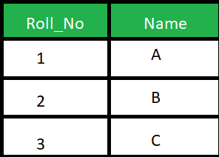s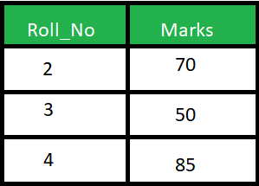

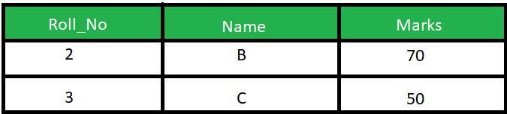

Select* from student s naturaljoin marks m ;

Cross Join will produce cross or Cartesian product of two tables if there is no condition specifies. The resulting table will contain all the attributes of both the tables including duplicate or common columns also.

s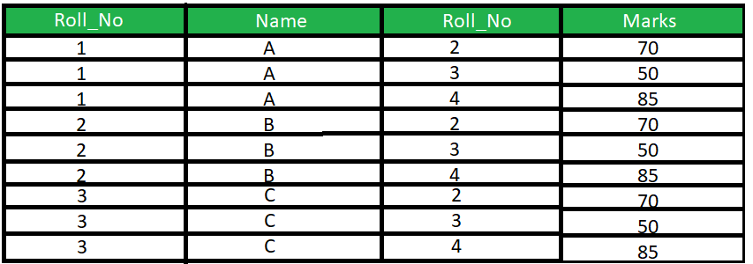

### ****Q52. What is subquery in SQL?****

### **subquery means query inside another query.outer query is called main query and inner query is called subquery.(it is exceutedfirst )then main query execute.**

### ****Q53 List the ways to get the count of records in a table?****

Select count(*) from tablename;

### ****Q54. Write a SQL query to find the names of employees that begin with ‘A’?****

Select name from tablename LIKE ‘A%’;

### ****Q55 What is the need for group functions in SQL?****

if a particular column has same values in different rows then it will arrange these rows in a group.

Syntax:select colname from tablename group by colname;

### ****Q56.  How can you insert NULL values in a column while inserting the data?****

### **We can insert null value into an column with not null constraints (MEANS I DON’T WANT TO Pass any value for column.**

**Insert into tbname(col1,col2) values(101,NULL);**

**INSERT INTO TBNAME (COL NAME VALUES(NULL);**

### ****Q57. What is the main difference between ‘BETWEEN’ and ‘IN’ condition operators?****

**BETWEEN:IS USE TO CHECK THE WHETHER VALUES IN THIS RANGE OR NOT**

**USED WITH SELECT,INSERT,DELETE,UPDATE**

**SYNTAX:SELECT COLNAME FROM TBNAME WHERE COLNAME BETWEEN V1**

**AND V2; v1 and v2 included**

**In:in condition operator is used to check for values in a specific set of values .**

**Select * from employees where salary IN(23000,25000,30000);**

### Q58. Why are SQL functions used?

To perform some calculations onthedata 2)modify individual data items,to manipulate the output,4)to cconvert the data types

### ****Q59. What is the difference between ‘HAVING’ CLAUSE and a ‘WHERE’ CLAUSE?****

### Q60. How can you fetch alternate records from a table?

**SELECT COLNAME FROM TBNAME WHERE ID%2==0,1-->EVEN OR ODD DATA**

**USING ROW_NUMBER**

**SELECT *FROM TBNAME (SELECT * ROW_NUMBER()OVER(ORDER BY ID)AS ROW_NUMB FROMTBNAME ) E WHERE E.ROW_NUMB%2==0;**

### Q61. How can you fetch first 5 characters of the string?

SELECT SUBSTRING(COLNAME,1,5) AS NEWNAME FROMTBNAME;

### ****Q62. What are Entities and Relationships?****

### Q63)write an sql queryto find the employee id whose salar lies in the range of 9000 and 15000?

### Ans select employeeid from tbname where salary between 9000 and 15000;

### Q64)NOT VS !=

### ANS not:it is unary operator which reverse its argument

### !=:it is a binary operator ,it compares 2 values ,return true if both are same otherwise false.

### Q65)write an sql query to fetch the employees whose name begins with any 2 chracters followed by”hn” and ending with any sequences of any character

### Select fulname from tbname where name like ‘_hn%’;

### Q66)write q query to fetch common records between 2 tables

### Select * from tb1 intersect select * from tb2;

**Q67)to fetch the name and replace space with -**

Select replace(fullname,’ ‘,’-’) from tablename;

**Q68)query to display both empid and managerid together**

Select concat(col1,col2) as new_name from tablename;

**Nitin malik**

**Q1)what is sql query used for creating data base and a table?**

**Ans:create database dbname**

**Create table tbname(col1,col2,col3);**

**If database is not already then new database will create.if database is created already then we will get a message that it is already exists**

**create database if not exists dname;**

**Q2) create a table with same structure with data of another table ?**

**Ans:create table emp select * from employee;**

**Q3)find all employees who also hold managerial solution?**

**Asns:select * from tbname where employee_id in (select manager_id from tbname);**

**Q4)(I)FECTH ALTERNATE RECORDS FROM A TABLE ?**

**Q5)FIND THE DUPLICATE ROWS IN TABLE?**

**ANS:1)select count(colname) from tbname group by col having count(col)>1;**

**Ii)remove the duplicate rows in table ?**

**Delete from tbname t1 inner join tbname t2 where t1.id<t2.id and t1.name=t2.name;**

**Q6)query to find first and last record ofa table?**

**Ans:select * from tbname limit1;**

**Select * from tbname where id=(select min(id),max(id) from tbname;**

**Q7)sql query to find the records without using distinct keyword**

**Ans:select salary from employee group by salary;**

**Select colname from tbname union select colname fromtb2;**

**Q8)what is the maximum salary ofeach department**

**Select max(salary) from tbname group by dept_id;**

**Select dept_id,max(salary) from employee e right outer join department d on e.dept_id=d.id group by dept_id;**

**Q9)find the department -wise count of employees sorted by department’s count in ascending order ?**

**Select dept_id, count(dept) from tbname group by dept_id order by count(dept_id);**

**Q10)change thedata type ofa column?**

**Ans:Alter table modify colname new datatype;**

**Q11)what function is used to return remainder a division operator ?**

**Ans:select mod(27,5) as “value”;**