Activity1:
Change the logo in the following files

- manifest.json

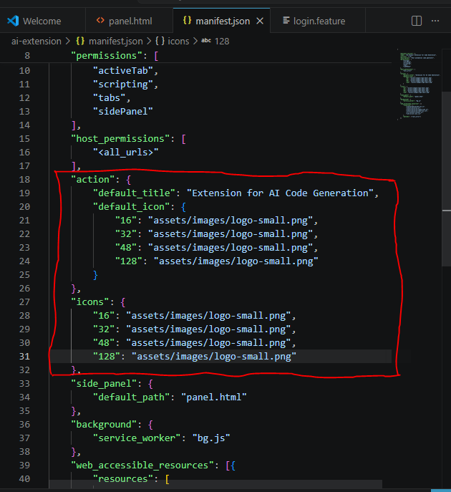

Extension Icon :

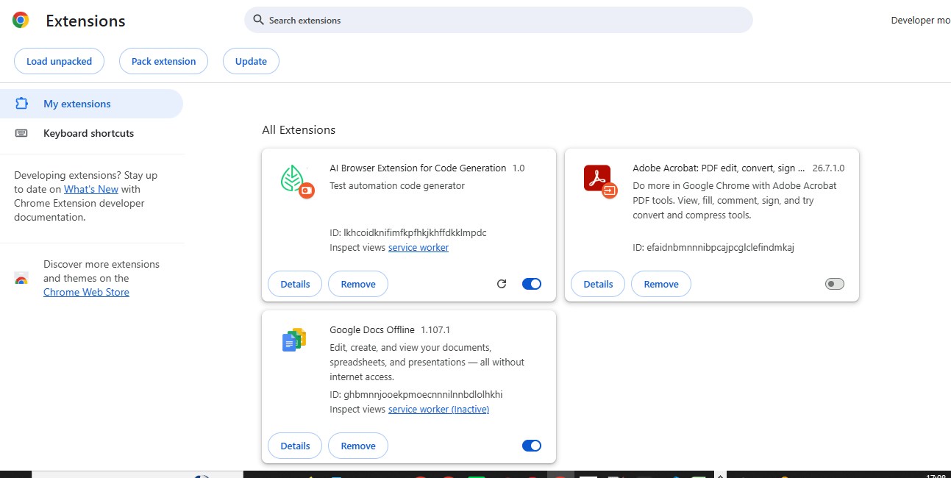

- appConfig.js

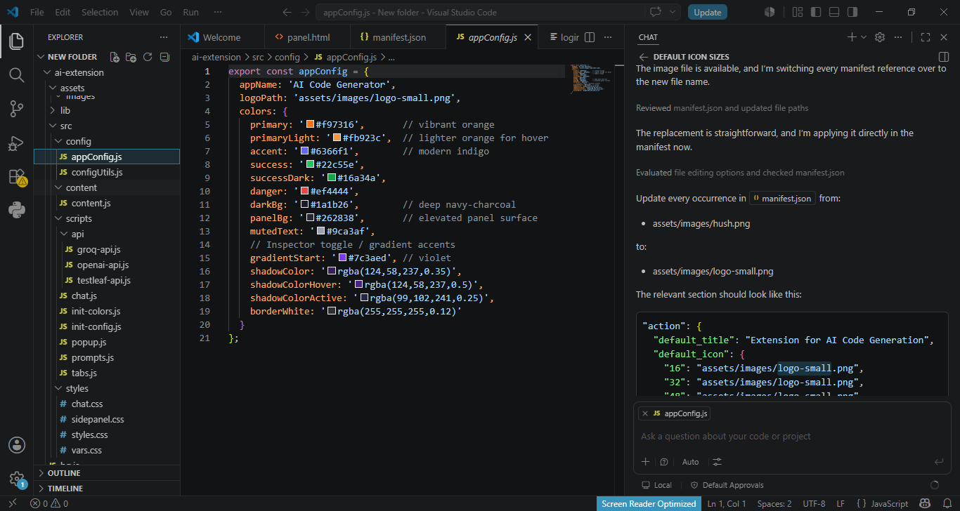

Activity2:
Add "openai/gpt-oss-120b" to the existing list

1)popup.js

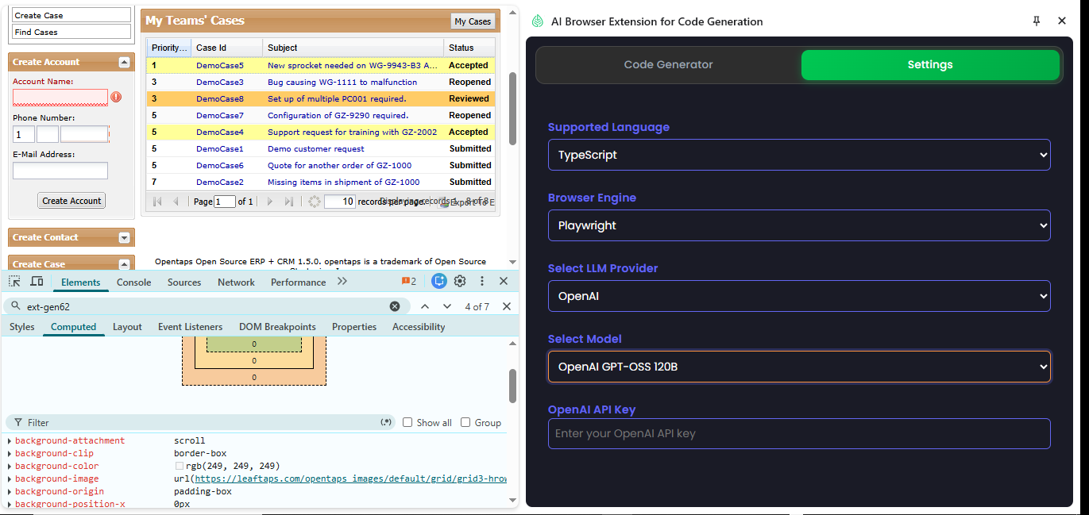

Activity 3:

Implement Playwright with TypeScript

1)Prompts.js

/**
* Collection of default prompts for different use cases (ICE POT Format)
*/
export const DEFAULT_PROMPTS = {

/**
* Selenium Java Page Object Prompt (No Test Class)
*/
SELENIUM_JAVA_PAGE_ONLY: `
Instructions:
- Generate ONLY a Selenium Java Page Object Class (no test code).
- Add JavaDoc for methods & class.
- Use Selenium 2.30+ compatible imports.
- Use meaningful method names.
- Do NOT include explanations or test code.

Context:
DOM:
\`\`\`html
\${domContent}
\`\`\`

Example:
\`\`\`java
package com.testleaf.pages;

/**
* Page Object for Component Page
*/
public class ComponentPage {
// Add methods as per the DOM
}
\`\`\`

Persona:
- Audience: Automation engineer focusing on maintainable POM structure.

Output Format:
- A single Java class inside a \`\`\`java\`\`\` block.

Tone:
- Clean, maintainable, enterprise-ready.
`,

/**
* Cucumber Feature File Only Prompt
*/
CUCUMBER_ONLY: `
Instructions:
- Generate ONLY a Cucumber (.feature) file.
- Use Scenario Outline with Examples table.
- Make sure every step is relevant to the provided DOM.
- Do not combine multiple actions into one step.
- Use South India realistic dataset (names, addresses, pin codes, mobile numbers).
- Use dropdown values only from provided DOM.
- Generate multiple scenarios if applicable.

Context:
DOM:
\`\`\`html
\${domContent}
\`\`\`

Example:
\`\`\`gherkin
Feature: Login to OpenTaps

Scenario Outline: Successful login with valid credentials
Given I open the login page
When I type "<username>" into the Username field
And I type "<password>" into the Password field
And I click the Login button
Then I should be logged in successfully

Examples:
| username | password |
| "testuser" | "testpass"|
| "admin" | "admin123"|
\`\`\`

Persona:
- Audience: BDD testers who only need feature files.

Output Format:
- Only valid Gherkin in a \`\`\`gherkin\`\`\` block.

Tone:
- Clear, structured, executable.
`,

/**
* Cucumber with Step Definitions
*/
CUCUMBER_WITH_SELENIUM_JAVA_STEPS: `
Instructions:
- Generate BOTH:
1. A Cucumber .feature file.
2. A Java step definition class for selenium.
- Do NOT include Page Object code.
- Step defs must include WebDriver setup, explicit waits, and actual Selenium code.
- Use Scenario Outline with Examples table (South India realistic data).

Context:
DOM:
\`\`\`html
\${domContent}
\`\`\`
URL: \${pageUrl}

Example:
\`\`\`gherkin
Feature: Login to OpenTaps

Scenario Outline: Successful login with valid credentials
Given I open the login page
When I type "<username>" into the Username field
And I type "<password>" into the Password field
And I click the Login button
Then I should be logged in successfully

Examples:
| username | password |
\ | "admin" | "admin123"|
\`\`\`

\`\`\`java
package com.leaftaps.stepdefs;

import io.cucumber.java.en.*;
import org.openqa.selenium.*;
import org.openqa.selenium.chrome.ChromeDriver;
import org.openqa.selenium.support.ui.*;

public class LoginStepDefinitions {
private WebDriver driver;
private WebDriverWait wait;

@io.cucumber.java.Before
public void setUp() {
driver = new ChromeDriver();
wait = new WebDriverWait(driver, Duration.ofSeconds(10));
driver.manage().window().maximize();
}

@io.cucumber.java.After
public void tearDown() {
if (driver != null) driver.quit();
}

@Given("I open the login page")
public void openLoginPage() {
driver.get("\${pageUrl}");
}

@When("I type {string} into the Username field")
public void enterUsername(String username) {
WebElement el = wait.until(ExpectedConditions.elementToBeClickable(By.id("username")));
el.sendKeys(username);
}

@When("I type {string} into the Password field")
public void enterPassword(String password) {
WebElement el = wait.until(ExpectedConditions.elementToBeClickable(By.id("password")));
el.sendKeys(password);
}

@When("I click the Login button")
public void clickLogin() {
driver.findElement(By.xpath("//button[contains(text(),'Login')]")).click();
}

@Then("I should be logged in successfully")
public void verifyLogin() {
WebElement success = wait.until(ExpectedConditions.visibilityOfElementLocated(By.className("success")));
assert success.isDisplayed();
}
}
\`\`\`

Persona:
- Audience: QA engineers working with Cucumber & Selenium.

Output Format:
- Gherkin in \`\`\`gherkin\`\`\` block + Java code in \`\`\`java\`\`\` block.

Tone:
- Professional, executable, structured.
`,

/**
* Playwright TypeScript Prompt
*/
PLAYWRIGHT_TYPESCRIPT: `
Instructions:
- Generate ONLY a Playwright TypeScript test file.
- Use import { test, expect } from '@playwright/test';
- Prefer page.locator() and async/await.
- Use reliable selectors and simple assertions.
- Do NOT include explanations or text outside the code block.
- Output only TypeScript code inside a \`\`\`ts\`\`\` block.

Context:
DOM:
\`\`\`html
\${domContent}
\`\`\`

URL:
\${pageUrl}

Example:
\`\`\`ts
import { test, expect } from '@playwright/test';

test('example test', async ({ page }) => {
await page.goto('\${pageUrl}');
await expect(page.locator('body')).toBeVisible();
});
\`\`\`

Persona:
- Audience: QA engineers and developers working with Playwright.

Output Format:
- A single TypeScript test file inside a \`\`\`ts\`\`\` block.

Tone:
- Clean, reliable, and production-ready.
`
};

/**
* Helper function to escape code blocks in prompts
*/
function escapeCodeBlocks(text) {
return text.replace(/```/g, '\\`\\`\\`');
}

/**
* Function to fill template variables in a prompt
*/
export function getPrompt(promptKey, variables = {}) {
let prompt = DEFAULT_PROMPTS[promptKey];
if (!prompt) {
throw new Error(`Prompt not found: ${promptKey}`);
}

Object.entries(variables).forEach(([k, v]) => {
const regex = new RegExp(`\\$\\{${k}\\}`, 'g');
prompt = prompt.replace(regex, v);
});

return prompt.trim();
}

export const CODE_GENERATOR_TYPES = {
SELENIUM_JAVA_PAGE_ONLY: 'Selenium-Java-Page-Only',
CUCUMBER_ONLY: 'Cucumber-Only',
CUCUMBER_WITH_SELENIUM_JAVA_STEPS: 'Cucumber-With-Selenium-Java-Steps',
PLAYWRIGHT_TYPESCRIPT: 'Playwright-TypeScript',
};

- Chat.js

- import { getPrompt } from '../scripts/prompts.js';

- // Constants
- const INITIAL_SYSTEM_MESSAGE = ``;

- class ChatUI {
- constructor() {
- // Grab references
- this.messagesContainer = document.getElementById('chatMessages');
- this.inputField = document.getElementById('chatInput');
- this.sendButton = document.getElementById('sendMessage');
- this.inspectorButton = document.getElementById('inspectorButton');
- this.resetButton = document.getElementById('resetChat');
- this.runTestButton = document.getElementById('runTestButton');
- this.pushAndRunButton = document.getElementById('pushAndRunButton');

- // Language / Browser dropdown

- // Language / Browser dropdown
- this.languageBindingSelect = document.getElementById('languageBinding');
- this.browserEngineSelect = document.getElementById('browserEngine');

- // Additional states
- this.selectedDomContent = null;
- this.isInspecting = false;
- this.markdownReady = false;
- this.codeGeneratorType = 'SELENIUM_JAVA_PAGE_ONLY'; // default
- this.tokenWarningThreshold = 10000;
- this.selectedModel = '';
- this.selectedProvider = '';
- this.generatedCode = '';

- // Clear existing messages + add initial system message
- this.messagesContainer.innerHTML = `
- <div class="loading-container">
- <div class="loading-spinner"></div>
- </div>
- `;
- this.addMessage(INITIAL_SYSTEM_MESSAGE, 'system');

- // Initialize everything
- this.initialize();
- this.initializeMarkdown();
- this.initializeTokenThreshold();
- this.initializeCodeGeneratorType();
- }

- initialize() {
- // Reset chat
- if (this.resetButton) {
- this.resetButton.addEventListener('click', () => {
- this.messagesContainer.innerHTML = '';
- this.addMessage(INITIAL_SYSTEM_MESSAGE, 'system');
- this.selectedDomContent = null;
- this.generatedCode = '';
- this.inspectorButton.classList.remove('has-content','active');
- this.inspectorButton.innerHTML = `
- <i class="fas fa-mouse-pointer"></i>
- <span>Inspect</span>
- `;
- this.isInspecting = false;

- // Hide all action buttons
- if (this.runTestButton) this.runTestButton.style.display = 'none';
- });
- }

- // Load stored keys
- chrome.storage.sync.get(
- ['groqApiKey','openaiApiKey','testleafApiKey','selectedModel','selectedProvider'],
- (result) => {
- if (result.groqApiKey) this.groqAPI = new GroqAPI(result.groqApiKey);
- if (result.openaiApiKey) this.openaiAPI = new OpenAIAPI(result.openaiApiKey);
- if (result.testleafApiKey) this.testleafAPI = new TestleafAPI(result.testleafApiKey);

- this.selectedModel = result.selectedModel || '';
- this.selectedProvider = result.selectedProvider || '';
- });

- // Listen for changes
- chrome.storage.onChanged.addListener((changes) => {
- if (changes.groqApiKey) this.groqAPI = new GroqAPI(changes.groqApiKey.newValue);
- if (changes.openaiApiKey) this.openaiAPI = new OpenAIAPI(changes.openaiApiKey.newValue);
- if (changes.testleafApiKey) this.testleafAPI = new TestleafAPI(changes.testleafApiKey.newValue);
- if (changes.selectedModel) this.selectedModel = changes.selectedModel.newValue;
- if (changes.selectedProvider) this.selectedProvider = changes.selectedProvider.newValue;
- });

- // Listen for SELECTED_DOM_CONTENT from content.js
- chrome.runtime.onMessage.addListener((msg) => {
- if (msg.type === 'SELECTED_DOM_CONTENT') {
- this.selectedDomContent = msg.content;
- this.inspectorButton.classList.add('has-content');
- }
- });

- // Send button
- this.sendButton.addEventListener('click', () => this.sendMessage());
- this.inputField.addEventListener('keydown', (e) => {
- if (e.key === 'Enter' && !e.shiftKey) {
- e.preventDefault();
- this.sendMessage();
- }
- });

- // Inspector button
- this.inspectorButton.addEventListener('click', async () => {
- try {
- const [tab] = await chrome.tabs.query({ active: true, currentWindow: true });
- if (!tab) return;
- if (tab.url.startsWith('chrome://') || tab.url.startsWith('chrome-extension://')) {
- console.log('Cannot use inspector on this page');
- return;
- }
- try {
- await chrome.scripting.executeScript({
- target: { tabId: tab.id },
- files: ['src/content/content.js']
- });
- } catch (error) {
- if (!error.message.includes('already been injected')) {
- throw error;
- }
- }
- const port = chrome.tabs.connect(tab.id);
- port.postMessage({ type: 'TOGGLE_INSPECTOR', reset: true });
- this.isInspecting = !this.isInspecting;
- this.updateInspectorButtonState();
- } catch (error) {
- console.error('Inspector error:', error);
- this.addMessage('Failed to activate inspector. Please refresh and try again.', 'system');
- this.isInspecting = false;
- this.updateInspectorButtonState();
- }
- });

- // Run Test button
- if (this.runTestButton) {
- this.runTestButton.addEventListener('click', () => this.runCucumberTest());
- }

- }

- // ===================
- // Markdown / Parsing
- // ===================
- initializeMarkdown() {
- const checkLibraries = setInterval(() => {
- if (window.marked && window.Prism) {

- window.marked.setOptions({
- highlight: (code, lang) => {
- // Normalize language name
- let normalizedLang = lang?.toLowerCase().trim();

- // Map common language aliases
- const languageMap = {
- 'feature': 'gherkin',
- 'cucumber': 'gherkin',
- 'bdd': 'gherkin'
- };

- if (languageMap[normalizedLang]) {
- normalizedLang = languageMap[normalizedLang];
- }

- if (normalizedLang && Prism.languages[normalizedLang]) {
- try {
- return Prism.highlight(code, Prism.languages[normalizedLang], normalizedLang);
- } catch (e) {
- console.error('Prism highlight error:', e);
- return code;
- }
- }
- return code;
- },
- langPrefix: 'language-',
- breaks: true,
- gfm: true
- });
- const renderer = new marked.Renderer();
- renderer.code = (code, language) => {
- console.log('🎨 Rendering code block:', { language, codeLength: code?.length });

- if (typeof code === 'object') {
- if (code.text) {
- code = code.text;
- } else if (code.raw) {
- code = code.raw.replace(/^```[\\w]*\\n/, '').replace(/\\n```$/, '');
- } else {
- code = JSON.stringify(code, null, 2);
- }
- }

- // Normalize language name
- let validLanguage = language?.toLowerCase().trim() || 'typescript';
- console.log('Original language:', language, '-> Normalized:', validLanguage);

- // Map common language aliases
- const languageMap = {
- 'feature': 'gherkin',
- 'cucumber': 'gherkin',
- 'bdd': 'gherkin',
- 'js': 'javascript',
- 'ts': 'typescript',
- 'py': 'python',
- 'cs': 'csharp'
- };

- if (languageMap[validLanguage]) {
- console.log('Language mapped:', validLanguage, '->', languageMap[validLanguage]);
- validLanguage = languageMap[validLanguage];
- }

- let highlighted = code;

- // Check if Prism language is available
- if (validLanguage && Prism.languages[validLanguage]) {
- try {
- console.log('Highlighting with Prism for language:', validLanguage);
- highlighted = Prism.highlight(code, Prism.languages[validLanguage], validLanguage);
- console.log('✅ Highlighting successful');
- } catch (e) {
- console.error('❌ Highlighting failed for', validLanguage, ':', e);
- highlighted = code;
- }
- } else {
- console.warn('⚠️ Language not supported by Prism:', validLanguage);
- }

- const result = `<pre class=\"language-${validLanguage}\"><code class=\"language-${validLanguage}\">${highlighted}</code></pre>`;
- console.log('Final HTML classes:', `language-${validLanguage}`);
- return result;
- };
- window.marked.setOptions({ renderer });
- this.markdownReady = true;
- clearInterval(checkLibraries);
- }
- }, 100);
- }

- parseMarkdown(content) {
- if (!this.markdownReady) {
- return `<pre>${content}</pre>`;
- }
- let textContent;
- if (typeof content === 'string') {
- const match = content.match(/^```(\w+)/);
- textContent = content.replace(/^```\w+/, '```');
- } else if (typeof content === 'object') {
- textContent = content.content ||
- content.message?.content ||
- content.choices?.[0]?.message?.content ||
- JSON.stringify(content, null, 2);
- } else {
- textContent = String(content);
- }
- let processedContent = textContent
- .replace(/&#x60;/g, '`')
- .replace(/&grave;/g, '`')
- .replace(/\\n/g, '\n')
- .replace(/\\"/g, '"')
- .replace(/```(\w*)/g, '\n```$1\n')
- .replace(/```\s*$/g, '\n```\n')
- .replace(/\n{3,}/g, '\n\n');
- try {
- const renderer = new marked.Renderer();
- renderer.code = (code, language) => {
- if (typeof code === 'object') {
- if (code.text) {
- code = code.text;
- } else if (code.raw) {
- code = code.raw.replace(/^```[\w]*\n/, '').replace(/\n```$/, '');
- } else {
- code = JSON.stringify(code, null, 2);
- }
- }
- const validLanguage = language?.toLowerCase().trim() || 'typescript';
- let highlighted = code;
- if (validLanguage && Prism.languages[validLanguage]) {
- try {
- highlighted = Prism.highlight(code, Prism.languages[validLanguage], validLanguage);
- } catch (e) {
- console.error('Highlighting failed:', e);
- }
- }
- return `<pre class="language-${validLanguage}"><code class="language-${validLanguage}">${highlighted}</code></pre>`;
- };
- window.marked.setOptions({ renderer });
- const parsed = window.marked.parse(processedContent);

- // Apply syntax highlighting after DOM is updated
- setTimeout(() => {
- const codeBlocks = document.querySelectorAll('pre code[class*="language-"]');
- console.log('📝 Post-parse highlighting for', codeBlocks.length, 'code blocks');

- codeBlocks.forEach((block, index) => {
- // Standard Prism highlighting for all languages
- try {
- Prism.highlightElement(block);
- } catch (e) {
- console.error('Prism highlighting error:', e);
- }
- });
- }, 100);

- return parsed;
- } catch (error) {
- console.error('Markdown parsing error:', error);
- return `<pre>${textContent}</pre>`;
- }
- }

- // =============
- // Send Message
- // =============
- async sendMessage() {
- const userMsg = this.inputField.value.trim();
- let apiRef = null;
- this.isInspecting = false;
- this.updateInspectorButtonState();

- if (this.selectedProvider === 'groq') apiRef = this.groqAPI;
- else if (this.selectedProvider === 'openai') apiRef = this.openaiAPI;
- else apiRef = this.testleafAPI;
- if (!apiRef) {
- this.addMessage(`Please set your ${this.selectedProvider} API key in the Settings tab.`, 'system');
- return;
- }

- if (!this.selectedDomContent) {
- this.addMessage('Please select some DOM on the page first.', 'system');
- return;
- }

- // --- Retain only 3 <option> elements in <select> tags to simulate real data ---
- function stripExtraOptions(selectElement) {
- const options = selectElement.querySelectorAll('option');
- if (options.length > 3) {
- for (let i = 3; i < options.length; i++) {
- options[i].remove();
- }
- }
- }

- let domContentProcessed = this.selectedDomContent;
- if (typeof domContentProcessed === 'string') {
- // Parse string to DOM
- const parser = new DOMParser();
- const doc = parser.parseFromString(domContentProcessed, 'text/html');
- const selects = doc.querySelectorAll('select');
- selects.forEach(stripExtraOptions);
- // Serialize back to string
- domContentProcessed = doc.body.innerHTML;
- } else if (domContentProcessed instanceof HTMLElement) {
- // Directly process if it's an HTMLElement
- const selects = domContentProcessed.querySelectorAll('select');
- selects.forEach(stripExtraOptions);
- }

- try {
- const [tab] = await chrome.tabs.query({ active: true, currentWindow: true });
- const pageUrl = tab?.url || 'unknown';
- const lang = this.languageBindingSelect.value;
- const eng = this.browserEngineSelect.value;
- const promptKeys = this.getPromptKeys(lang, eng);

- const finalSnippet = typeof domContentProcessed === 'string'
- ? domContentProcessed
- : JSON.stringify(domContentProcessed, null, 2);

- this.sendButton.disabled = true;
- this.inputField.disabled = true;
- this.sendButton.innerHTML = '<i class="fas fa-spinner fa-spin"></i>';
- this.addMessage(userMsg, 'user');
- this.inputField.value = '';

- let combinedContent = '';
- let totalInputTokens = 0;
- let totalOutputTokens = 0;

- for (const key of promptKeys) {
- const builtPrompt = getPrompt(key, {
- domContent: finalSnippet,
- pageUrl: pageUrl,
- userAction: '',
- });

- const finalPrompt = builtPrompt + " Additional Instructions: " + userMsg;
- const resp = await apiRef.sendMessage(finalPrompt, this.selectedModel);
- const returned = resp?.content || resp;
- combinedContent += returned.trim() + '\n\n';

- totalInputTokens += resp.usage?.input_tokens || 0;
- totalOutputTokens += resp.usage?.output_tokens || 0;
- }

- const loader = this.messagesContainer.querySelector('.loading-indicator.active');
- if (loader) loader.remove();

- this.addMessageWithMetadata(combinedContent.trim(), 'assistant', {
- inputTokens: totalInputTokens,
- outputTokens: totalOutputTokens
- });

- this.selectedDomContent = null;
- this.inspectorButton.classList.remove('has-content','active');
- this.inspectorButton.innerHTML = `
- <i class="fas fa-mouse-pointer"></i>
- <span>Inspect</span>
- `;
- this.isInspecting = false;
- if (tab) {
- try {
- await chrome.tabs.sendMessage(tab.id, { type: 'CLEAR_SELECTION' });
- } catch (err) {
- const port = chrome.tabs.connect(tab.id);
- port.postMessage({ type: 'CLEAR_SELECTION' });
- port.disconnect();
- }
- }
- this.generatedCode = combinedContent.trim();
- } catch (err) {
- const loader = this.messagesContainer.querySelector('.loading-indicator.active');
- if (loader) loader.remove();
- this.addMessage(`Error: ${err.message}`, 'system');
- } finally {
- this.sendButton.disabled = false;
- this.inputField.disabled = false;
- this.sendButton.innerHTML = 'Generate';
- }
- }

- // ==============
- // addMessage UI
- // ==============
- addMessage(content, type) {
- if (!content) return;
- const msgDiv = document.createElement('div');
- msgDiv.className = `chat-message ${type}-message`;
- if (type === 'system') {
- msgDiv.innerHTML = content;
- } else {
- const markdownDiv = document.createElement('div');
- markdownDiv.className = 'markdown-content';
- markdownDiv.innerHTML = this.parseMarkdown(content);
- msgDiv.appendChild(markdownDiv);
- }
- this.messagesContainer.appendChild(msgDiv);
- if (type === 'user') {
- const loader = document.createElement('div');
- loader.className = 'loading-indicator';
- const genType = this.codeGeneratorType.includes('PLAYWRIGHT') ? 'Playwright' : 'Selenium';
- loader.innerHTML = `
- <div class="loading-spinner"></div>
- <span class="loading-text">Generating ${genType} Code</span>
- `;
- this.messagesContainer.appendChild(loader);
- setTimeout(() => loader.classList.add('active'), 0);
- }
- this.messagesContainer.scrollTop = this.messagesContainer.scrollHeight;
- const msgCount = this.messagesContainer.querySelectorAll('.chat-message').length;
- if (msgCount > 1 && this.resetButton) {
- this.resetButton.classList.add('visible');
- }
- }

- addMessageWithMetadata(content, type, metadata) {
- if (type !== 'assistant') {
- this.addMessage(content, type);
- return;
- }
- const container = document.createElement('div');
- container.className = 'assistant-message';
- const mdDiv = document.createElement('div');
- mdDiv.className = 'markdown-content';
- mdDiv.innerHTML = this.parseMarkdown(content);
- container.appendChild(mdDiv);
- const metaContainer = document.createElement('div');
- metaContainer.className = 'message-metadata collapsed';
- const actions = document.createElement('div');
- actions.className = 'message-actions';
- const toggleBtn = document.createElement('button');
- toggleBtn.className = 'metadata-toggle';
- const copyBtn = document.createElement('button');
- copyBtn.className = 'metadata-toggle';
- copyBtn.innerHTML = `<i class="fas fa-copy"></i> Copy`;
- copyBtn.onclick = () => {
- const codeBlocks = mdDiv.querySelectorAll('pre code');
- if (codeBlocks.length === 0) {
- copyBtn.innerHTML = `<i class="fas fa-times"></i> No content found`;
- setTimeout(() => { copyBtn.innerHTML = `<i class="fas fa-copy"></i> Copy`; }, 2000);
- return;
- }
- let combinedCode = Array.from(codeBlocks).map(block => block.textContent.trim()).join('\n\n');
- combinedCode = combinedCode.replace(/^```[\w-]*\n/, '').replace(/\n```$/, '');
- navigator.clipboard.writeText(combinedCode)
- .then(() => {
- copyBtn.innerHTML = `<i class="fas fa-check"></i> Copied!`;
- setTimeout(() => { copyBtn.innerHTML = `<i class="fas fa-copy"></i> Copy code`; }, 2000);
- })
- .catch(err => {
- console.error('Copy failed:', err);
- copyBtn.innerHTML = `<i class="fas fa-times"></i> Failed to copy`;
- setTimeout(() => { copyBtn.innerHTML = `<i class="fas fa-copy"></i> Copy code`; }, 2000);
- });
- };
- actions.appendChild(toggleBtn);
- actions.appendChild(copyBtn);
- metaContainer.appendChild(actions);
- const details = document.createElement('div');
- details.className = 'metadata-content';
- details.innerHTML = `
- <div class="metadata-row"><span>Input Tokens:</span><span>${metadata.inputTokens}</span></div>
- <div class="metadata-row"><span>Output Tokens:</span><span>${metadata.outputTokens}</span></div>
- `;
- metaContainer.appendChild(details);
- container.appendChild(metaContainer);
- this.messagesContainer.appendChild(container);
- // Add a copy button to each generated code block
- this.addCodeBlockCopyButtons(mdDiv);
- this.messagesContainer.scrollTop = this.messagesContainer.scrollHeight;
- if (this.resetButton) {
- this.resetButton.classList.add('visible');
- }
- }

- // Adds a floating "Copy" button to each generated code block
- addCodeBlockCopyButtons(container) {
- // Wait for markdown/Prism to finish rendering the <pre> blocks
- setTimeout(() => {
- const preBlocks = container.querySelectorAll('pre[class*="language-"]');
- preBlocks.forEach((pre) => {
- // Skip if already wrapped/decorated
- if (pre.parentElement && pre.parentElement.classList.contains('code-block-wrapper')) return;

- // Wrap the <pre> and add a sticky header bar with a copy button
- const wrapper = document.createElement('div');
- wrapper.className = 'code-block-wrapper';
- pre.parentNode.insertBefore(wrapper, pre);

- const header = document.createElement('div');
- header.className = 'code-block-header';

- const btn = document.createElement('button');
- btn.className = 'code-copy-btn';
- btn.type = 'button';
- btn.innerHTML = `<i class="fas fa-copy"></i><span>Copy</span>`;
- btn.addEventListener('click', () => {
- const codeEl = pre.querySelector('code');
- const code = (codeEl ? codeEl.textContent : pre.textContent).trim();
- navigator.clipboard.writeText(code)
- .then(() => {
- btn.classList.add('copied');
- btn.innerHTML = `<i class="fas fa-check"></i><span>Copied!</span>`;
- setTimeout(() => {
- btn.classList.remove('copied');
- btn.innerHTML = `<i class="fas fa-copy"></i><span>Copy</span>`;
- }, 2000);
- })
- .catch((err) => {
- console.error('Code copy failed:', err);
- btn.innerHTML = `<i class="fas fa-times"></i><span>Failed</span>`;
- setTimeout(() => {
- btn.innerHTML = `<i class="fas fa-copy"></i><span>Copy</span>`;
- }, 2000);
- });
- });
- header.appendChild(btn);
- wrapper.appendChild(header);
- wrapper.appendChild(pre);
- });
- }, 150);
- }

- updateInspectorButtonState() {
- if (this.isInspecting) {
- this.inspectorButton.classList.add('active');
- this.inspectorButton.innerHTML = `
- <i class="fas fa-circle-stop"></i>
- <span>Stop</span>
- `;
- } else {
- this.inspectorButton.classList.remove('active');
- if (!this.selectedDomContent) {
- this.inspectorButton.classList.remove('has-content');
- }
- this.inspectorButton.innerHTML = `
- <i class="fas fa-mouse-pointer"></i>
- <span>Inspect</span>
- `;
- }
- }

- getPromptKeys(language, engine) {
- const checkboxes = Array.from(document.querySelectorAll('input[name="javaGenerationMode"]:checked'));
- const promptKeys = [];
- const lang = language?.toLowerCase() || '';
- const eng = engine?.toLowerCase() || '';

- if (this.isPlaywrightTypeScript(lang, eng)) {
- promptKeys.push('PLAYWRIGHT_TYPESCRIPT');
- return promptKeys;
- }

- // Extract selected generation modes
- const isFeatureChecked = checkboxes.some(box => box.value === 'FEATURE');
- const isPageChecked = checkboxes.some(box => box.value === 'PAGE');

- // Validate that at least one option is selected
- if (!isFeatureChecked && !isPageChecked) {
- console.warn('No generation mode selected. Defaulting to Page Object generation.');
- // Default fallback to page object generation
- if (this.isJavaSelenium(lang, eng)) {
- promptKeys.push('SELENIUM_JAVA_PAGE_ONLY');
- }
- return promptKeys;
- }

- // Generate appropriate prompt keys based on selections and language/engine combination
- if (isFeatureChecked && isPageChecked) {
- // Both feature and page selected - generate combined output
- if (this.isJavaSelenium(lang, eng)) {
- promptKeys.push('CUCUMBER_WITH_SELENIUM_JAVA_STEPS');
- } else {
- // For non-Java/Selenium combinations, generate separately
- promptKeys.push('CUCUMBER_ONLY');
- this.addUnsupportedLanguageMessage(lang, eng);
- }
- } else if (isFeatureChecked) {
- // Feature file only
- promptKeys.push('CUCUMBER_ONLY');
- } else if (isPageChecked) {
- // Page object only
- if (this.isJavaSelenium(lang, eng)) {
- promptKeys.push('SELENIUM_JAVA_PAGE_ONLY');
- } else {
- this.addUnsupportedLanguageMessage(lang, eng);
- }
- }

- return promptKeys;
- }

- /**
- * Helper method to check if the combination is Playwright + TypeScript
- */
- isPlaywrightTypeScript(language, engine) {
- return language === 'ts' && engine === 'playwright';
- }

- /**
- * Helper method to check if the combination is Java + Selenium
- */
- isJavaSelenium(language, engine) {
- return language === 'java' && engine === 'selenium';
- }

- isCSharpSelenium(language, engine) {
- return language === 'csharp' && engine === 'selenium';
- }

- isPythonSelenium(language, engine) {
- return language === 'python' && engine === 'selenium';
- }

- // typescript/selenium not supported by the selenium webdriver

- /**
- * Helper method to show unsupported language/engine combination message
- */
- addUnsupportedLanguageMessage(language, engine) {
- const message = `⚠️ ${language}/${engine} combination is not yet supported. Only Java/Selenium is currently available.`;
- this.addMessage(message, 'system');
- }

- async initializeCodeGeneratorType() {
- const { codeGeneratorType } = await chrome.storage.sync.get(['codeGeneratorType']);
- if (codeGeneratorType) {
- this.codeGeneratorType = codeGeneratorType;
- const codeGenDrop = document.getElementById('codeGeneratorType');
- if (codeGenDrop) codeGenDrop.value = this.codeGeneratorType;
- }
- }

- async initializeTokenThreshold() {
- const { tokenWarningThreshold } = await chrome.storage.sync.get(['tokenWarningThreshold']);
- if (tokenWarningThreshold) {
- this.tokenWarningThreshold = tokenWarningThreshold;
- }
- const threshInput = document.getElementById('tokenThreshold');
- if (threshInput) {
- threshInput.value = this.tokenWarningThreshold;
- threshInput.addEventListener('change', async (e) => {
- const val = parseInt(e.target.value,10);
- if (val >= 100) {
- this.tokenWarningThreshold = val;
- await chrome.storage.sync.set({ tokenWarningThreshold: val });
- } else {
- e.target.value = this.tokenWarningThreshold;
- }
- });
- }
- }

- async resetChat() {
- try {
- this.messagesContainer.innerHTML = `
- <div class="loading-container">
- <div class="loading-spinner"></div>
- </div>
- `;
- this.selectedDomContent = null;
- this.isInspecting = false;
- this.markdownReady = false;
- this.inspectorButton.classList.remove('has-content','active');
- this.inspectorButton.innerHTML = `
- <i class="fas fa-mouse-pointer"></i>
- <span>Inspect</span>
- `;
- this.inputField.value = '';
- this.sendButton.disabled = false;
- this.sendButton.textContent = 'Generate';
- const [tab] = await chrome.tabs.query({ active: true, currentWindow: true });
- if (tab && !tab.url.startsWith('chrome://')) {
- try {
- await chrome.tabs.sendMessage(tab.id, { type: 'CLEANUP' });
- } catch (err) {
- console.log('Cleanup error:', err);
- }
- try {
- await chrome.scripting.executeScript({
- target: { tabId: tab.id },
- files: ['src/content/content.js']
- });
- } catch (err) {
- if (!err.message.includes('already been injected')) {
- console.error('Re-inject error:', err);
- }
- }
- }
- if (this.resetButton) {
- this.resetButton.classList.remove('visible');
- }
- if (this.runTestButton) {
- this.runTestButton.style.display = 'none';
- }
- this.addMessage(INITIAL_SYSTEM_MESSAGE, 'system');
- } catch (err) {
- console.error('Error resetting chat:', err);
- this.addMessage('Error resetting chat. Please close and reopen.', 'system');
- }
- }
- }

- // Initialize
- document.addEventListener('DOMContentLoaded', () => {
- new ChatUI();
- });

Changes in Extension:
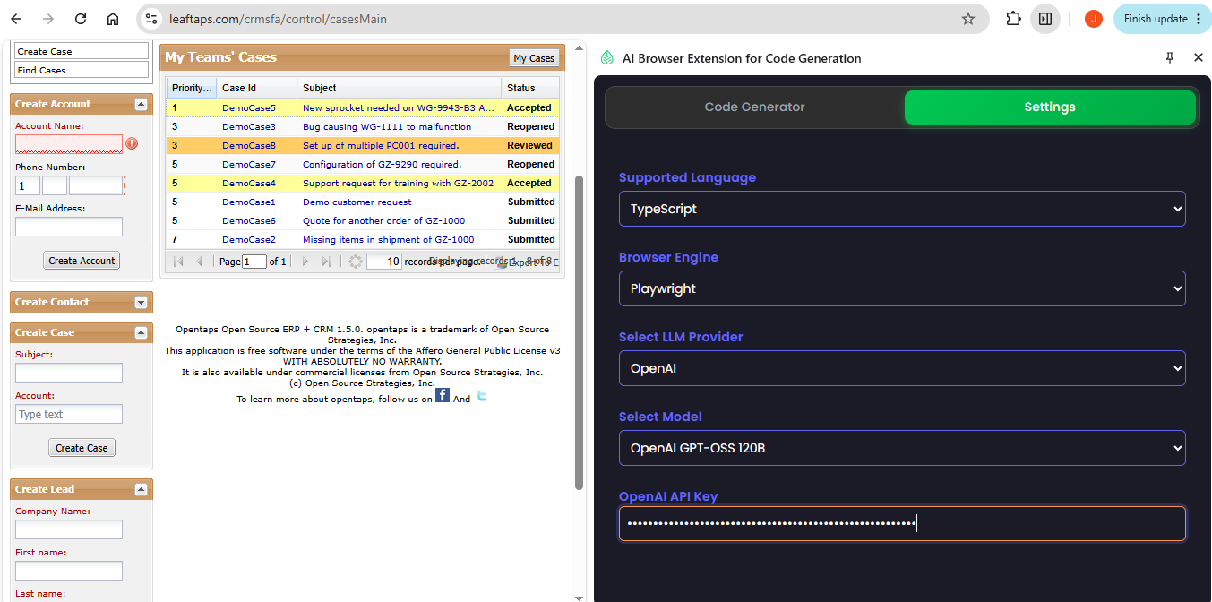

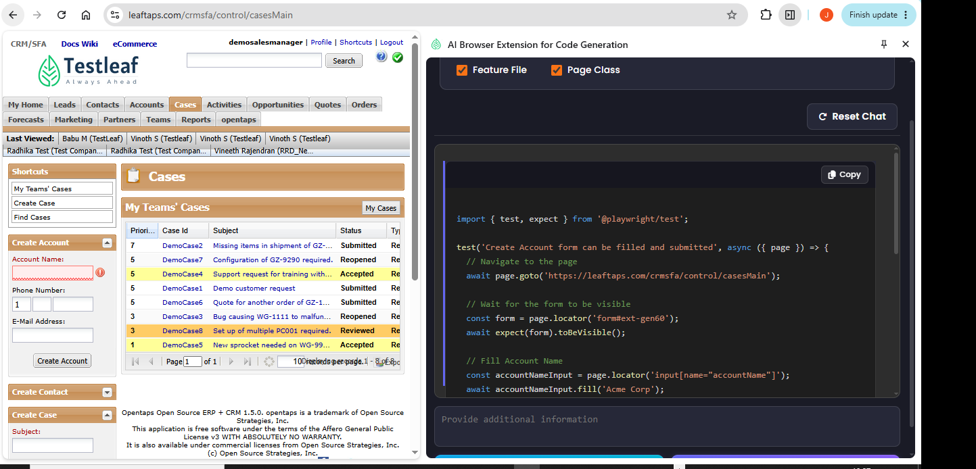

import { test, expect } from '@playwright/test';

test('Create Account form can be filled and submitted', async ({ page }) => {
// Navigate to the page
await page.goto('https://leaftaps.com/crmsfa/control/casesMain');

// Wait for the form to be visible
const form = page.locator('form#ext-gen60');
await expect(form).toBeVisible();

// Fill Account Name
const accountNameInput = page.locator('input[name="accountName"]');
await accountNameInput.fill('Acme Corp');

// Fill Phone fields
const countryCodeInput = page.locator('input[name="primaryPhoneCountryCode"]');
const areaCodeInput = page.locator('input[name="primaryPhoneAreaCode"]');
const phoneNumberInput = page.locator('input[name="primaryPhoneNumber"]');

await countryCodeInput.fill('1');
await areaCodeInput.fill('800');
await phoneNumberInput.fill('1234567');

// Fill Email address
const emailInput = page.locator('input[name="primaryEmail"]');
await emailInput.fill('contact@acme.com');

// Click the Create Account button
const createBtn = page.locator('button', { hasText: 'Create Account' });
await expect(createBtn).toBeEnabled();
await createBtn.click();

// Verify that the validation icon for Account Name is no longer visible
const accountInvalidIcon = page.locator('#ext-gen912');
await expect(accountInvalidIcon).toBeHidden();
});

