Algorithm is a step-by-step procedure, which defines a set of instructions to be executed in a certain order to get the desired output. Algorithms are generally created independent of underlying languages, i.e. an algorithm can be implemented in more than one programming language.

From the data structure point of view, following are some important categories of algorithms −

* **Search** − Algorithm to search an item in a data structure.
* **Sort** − Algorithm to sort items in a certain order.
* **Insert** − Algorithm to insert item in a data structure.



* **Update** − Algorithm to update an existing item in a data structure.
* **Delete** − Algorithm to delete an existing item from a data structure.



Characteristics of an Algorithm

Not all procedures can be called an algorithm.

An algorithm should have the following characteristics −

* **Unambiguous** − Algorithm should be clear and unambiguous. Each of its steps (or phases), and their inputs/outputs should be clear and must lead to only one meaning.
* **Input** − An algorithm should have 0 or more well-defined inputs.
* **Output** − An algorithm should have 1 or more well-defined outputs, and should match the desired output.
* **Finiteness** − Algorithms must terminate after a finite number of steps.
* **Feasibility** − Should be feasible with the available resources.
* **Independent** − An algorithm should have step-by-step directions, which should be independent of any programming code.

How to Write an Algorithm?

There are no well-defined standards for writing algorithms. Rather, it is problem and resource dependent. Algorithms are never written to support a particular programming code.

As we know that all programming languages share basic code constructs like loops (do, for, while), flow-control (if-else), etc. These common constructs can be used to write an algorithm.

We write algorithms in a step-by-step manner, but it is not always the case. Algorithm writing is a process and is executed after the problem domain is well-defined. That is, we should know the problem domain, for which we are designing a solution.

Example

Let's try to learn algorithm-writing by using an example.

**Problem** − Design an algorithm to add two numbers and display the result.

**Step 1** − START

**Step 2** − declare three integers **a**, **b** & **c**

**Step 3** − define values of **a** & **b**

**Step 4** − add values of **a** & **b**

**Step 5** − store output of step 4 to **c**

**Step 6** − print **c**

**Step 7** − STOP

Algorithms tell the programmers how to code the program. Alternatively, the algorithm can be written as −

**Step 1** − START ADD

**Step 2** − get values of **a** & **b**

**Step 3** − c ← a + b

**Step 4** − display c

**Step 5** − STOP

In design and analysis of algorithms, usually the second method is used to describe an algorithm. It makes it easy for the analyst to analyze the algorithm ignoring all unwanted definitions. He can observe what operations are being used and how the process is flowing.

Writing **step numbers**, is optional.

We design an algorithm to get a solution of a given problem. A problem can be solved in more than one ways.

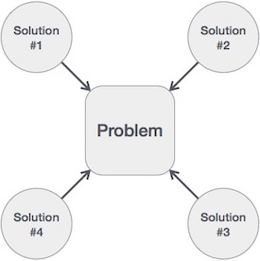

Hence, many solution algorithms can be derived for a given problem. The next step is to analyze those proposed solution algorithms and implement the best suitable solution.

Algorithm Analysis

Efficiency of an algorithm can be analyzed at two different stages, before implementation and after implementation. They are the following −

* ***A Priori* Analysis** − This is a theoretical analysis of an algorithm. Efficiency of an algorithm is measured by assuming that all other factors, for example, processor speed, are constant and have no effect on the implementation.
* ***A Posterior* Analysis** − This is an empirical analysis of an algorithm. The selected algorithm is implemented using programming language. This is then executed on target computer machine. In this analysis, actual statistics like running time and space required, are collected.

We shall learn about *a priori* algorithm analysis. Algorithm analysis deals with the execution or running time of various operations involved. The running time of an operation can be defined as the number of computer instructions executed per operation.

Algorithm Complexity

Suppose **X** is an algorithm and **n** is the size of input data, the time and space used by the algorithm X are the two main factors, which decide the efficiency of X.

* **Time Factor** − Time is measured by counting the number of key operations such as comparisons in the sorting algorithm.
* **Space Factor** − Space is measured by counting the maximum memory space required by the algorithm.

The complexity of an algorithm **f(n)** gives the running time and/or the storage space required by the algorithm in terms of **n** as the size of input data.

Space Complexity

Space complexity of an algorithm represents the amount of memory space required by the algorithm in its life cycle. The space required by an algorithm is equal to the sum of the following two components −

* A fixed part that is a space required to store certain data and variables, that are independent of the size of the problem. For example, simple variables and constants used, program size, etc.
* A variable part is a space required by variables, whose size depends on the size of the problem. For example, dynamic memory allocation, recursion stack space, etc.

Space complexity S(P) of any algorithm P is S(P) = C + SP(I), where C is the fixed part and S(I) is the variable part of the algorithm, which depends on instance characteristic I. Following is a simple example that tries to explain the concept −

Algorithm: SUM(A, B)

Step 1 - START

Step 2 - C ← A + B + 10

Step 3 - Stop

Here we have three variables A, B, and C and one constant. Hence S(P) = 1 + 3. Now, space depends on data types of given variables and constant types and it will be multiplied accordingly.

Time Complexity

Time complexity of an algorithm represents the amount of time required by the algorithm to run to completion. Time requirements can be defined as a numerical function T(n), where T(n) can be measured as the number of steps, provided each step consumes constant time.

For example, addition of two n-bit integers takes **n** steps. Consequently, the total computational time is T(n) = c ∗ n, where c is the time taken for the addition of two bits. Here, we observe that T(n) grows linearly as the input size increases.

# **Data Structures - Divide and Conquer**

In divide and conquer approach, the problem in hand, is divided into smaller sub-problems and then each problem is solved independently. When we keep on dividing the subproblems into even smaller sub-problems, we may eventually reach a stage where no more division is possible. Those "atomic" smallest possible sub-problem (fractions) are solved. The solution of all sub-problems is finally merged in order to obtain the solution of an original problem.

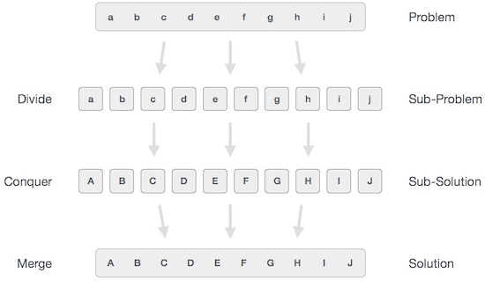

Broadly, we can understand **divide-and-conquer** approach in a three-step process.

## Divide/Break

This step involves breaking the problem into smaller sub-problems. Sub-problems should represent a part of the original problem. This step generally takes a recursive approach to divide the problem until no sub-problem is further divisible. At this stage, sub-problems become atomic in nature but still represent some part of the actual problem.

## Conquer/Solve

This step receives a lot of smaller sub-problems to be solved. Generally, at this level, the problems are considered 'solved' on their own.

## Merge/Combine

When the smaller sub-problems are solved, this stage recursively combines them until they formulate a solution of the original problem. This algorithmic approach works recursively and conquer & merge steps works so close that they appear as one.

### Examples

The following computer algorithms are based on **divide-and-conquer** programming approach −

* Merge Sort
* Quick Sort
* Binary Search
* Strassen's Matrix Multiplication
* Closest pair (points)

There are various ways available to solve any computer problem, but the mentioned are a good example of divide and conquer approach.

Dynamic programming approach is similar to divide and conquer in breaking down the problem into smaller and yet smaller possible sub-problems. But unlike, divide and conquer, these sub-problems are not solved independently. Rather, results of these smaller sub-problems are remembered and used for similar or overlapping sub-problems.

Dynamic programming is used where we have problems, which can be divided into similar sub-problems, so that their results can be re-used. Mostly, these algorithms are used for optimization. Before solving the in-hand sub-problem, dynamic algorithm will try to examine the results of the previously solved sub-problems. The solutions of sub-problems are combined in order to achieve the best solution.

So we can say that −

* The problem should be able to be divided into smaller overlapping sub-problem.
* An optimum solution can be achieved by using an optimum solution of smaller sub-problems.
* Dynamic algorithms use Memoization.

Comparison

In contrast to greedy algorithms, where local optimization is addressed, dynamic algorithms are motivated for an overall optimization of the problem.

In contrast to divide and conquer algorithms, where solutions are combined to achieve an overall solution, dynamic algorithms use the output of a smaller sub-problem and then try to optimize a bigger sub-problem. Dynamic algorithms use Memoization to remember the output of already solved sub-problems.

Example

The following computer problems can be solved using dynamic programming approach −

* Fibonacci number series
* Knapsack problem
* Tower of Hanoi
* All pair shortest path by Floyd-Warshall
* Shortest path by Dijkstra
* Project scheduling

Dynamic programming can be used in both top-down and bottom-up manner. And of course, most of the times, referring to the previous solution output is cheaper than recomputing in terms of CPU cycles.

## Data Definition

Data Definition defines a particular data with the following characteristics.

* **Atomic** − Definition should define a single concept.
* **Traceable** − Definition should be able to be mapped to some data element.
* **Accurate** − Definition should be unambiguous.
* **Clear and Concise** − Definition should be understandable.

Data Object

Data Object represents an object having a data.

Data Type

Data type is a way to classify various types of data such as integer, string, etc. which determines the values that can be used with the corresponding type of data, the type of operations that can be performed on the corresponding type of data. There are two data types −

* Built-in Data Type
* Derived Data Type

Built-in Data Type

Those data types for which a language has built-in support are known as Built-in Data types. For example, most of the languages provide the following built-in data types.

* Integers
* Boolean (true, false)
* Floating (Decimal numbers)
* Character and Strings

Derived Data Type

Those data types which are implementation independent as they can be implemented in one or the other way are known as derived data types. These data types are normally built by the combination of primary or built-in data types and associated operations on them. For example −

* List
* Array
* Stack
* Queue

Basic Operations

The data in the data structures are processed by certain operations. The particular data structure chosen largely depends on the frequency of the operation that needs to be performed on the data structure.

* Traversing
* Searching
* Insertion
* Deletion
* Sorting
* Merging

# 

# **Data Structures and Algorithms - Arrays**

Array is a container which can hold a fix number of items and these items should be of the same type. Most of the data structures make use of arrays to implement their algorithms. Following are the important terms to understand the concept of Array.

* **Element** − Each item stored in an array is called an element.
* **Index** − Each location of an element in an array has a numerical index, which is used to identify the element.

## Array Representation

Arrays can be declared in various ways in different languages. For illustration, let's take C array declaration.

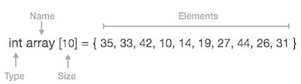

Arrays can be declared in various ways in different languages. For illustration, let's take C array declaration.

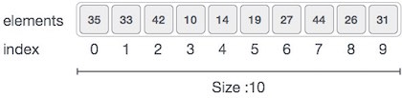

As per the above illustration, following are the important points to be considered.

* Index starts with 0.
* Array length is 10 which means it can store 10 elements.
* Each element can be accessed via its index. For example, we can fetch an element at index 6 as 9.

## Basic Operations

Following are the basic operations supported by an array.

* **Traverse** − print all the array elements one by one.
* **Insertion** − Adds an element at the given index.
* **Deletion** − Deletes an element at the given index.
* **Search** − Searches an element using the given index or by the value.
* **Update** − Updates an element at the given index.

In C, when an array is initialized with size, then it assigns defaults values to its elements in following order.

|  |  |
| --- | --- |
| **Data Type** | **Default Value** |
| Bool | false |
| Char | 0 |
| int | 0 |
| float | 0.0 |
| double | 0.0f |
| void |  |
| wchar_t | 0 |

# Traverse Operation

This operation is to traverse through the elements of an array.

### Example

Following program traverses and prints the elements of an array:

#include <stdio.h>

main() {

int LA[] = {1,3,5,7,8};

int item = 10, k = 3, n = 5;

int i = 0, j = n;

printf("The original array elements are :\n");

for(i = 0; i<n; i++) {

printf("LA[%d] = %d \n", i, LA[i]);

}

}

When we compile and execute the above program, it produces the following result −

### Output

The original array elements are :

LA[0] = 1

LA[1] = 3

LA[2] = 5

LA[3] = 7

LA[4] = 8

## Insertion Operation

Insert operation is to insert one or more data elements into an array. Based on the requirement, a new element can be added at the beginning, end, or any given index of array.

Here, we see a practical implementation of insertion operation, where we add data at the end of the array −

### Example

Following is the implementation of the above algorithm −

#include <stdio.h>

main() {

int LA[] = {1,3,5,7,8};

int item = 10, k = 3, n = 5;

int i = 0, j = n;

printf("The original array elements are :\n");

for(i = 0; i<n; i++) {

printf("LA[%d] = %d \n", i, LA[i]);

}

n = n + 1;

while( j >= k) {

LA[j+1] = LA[j];

j = j - 1;

}

LA[k] = item;

printf("The array elements after insertion :\n");

for(i = 0; i<n; i++) {

printf("LA[%d] = %d \n", i, LA[i]);

}

}

When we compile and execute the above program, it produces the following result −

### Output

The original array elements are :

LA[0] = 1

LA[1] = 3

LA[2] = 5

LA[3] = 7

LA[4] = 8

The array elements after insertion :

LA[0] = 1

LA[1] = 3

LA[2] = 5

LA[3] = 10

LA[4] = 7

LA[5] = 8

For other variations of array insertion operation [click here](https://www.tutorialspoint.com/data_structures_algorithms/array_insertion_algorithm.htm)

## Deletion Operation

Deletion refers to removing an existing element from the array and re-organizing all elements of an array.

### Algorithm

Consider **LA** is a linear array with **N** elements and **K** is a positive integer such that **K<=N**. Following is the algorithm to delete an element available at the Kth position of LA.

1. Start

2. Set J = K 5

3. Repeat steps 4 and 5 while J < N 10

4. Set LA[J] = LA[J + 1]

5. Set J = J+1

6. Set N = N-1

7. Stop

### Example

Following is the implementation of the above algorithm −

#include <stdio.h>

void main() {

int LA[] = {1,3,5,7,8};

int k = 3, n = 5;

int i, j;

printf("The original array elements are :\n");

for(i = 0; i<n; i++) {

printf("LA[%d] = %d \n", i, LA[i]);

}

j = k;

while( j < n)

{

LA[j-1] = LA[j];

j = j + 1;

}

n = n -1;

printf("The array elements after deletion :\n");

for(i = 0; i<n; i++) {

printf("LA[%d] = %d \n", i, LA[i]);

}

}

When we compile and execute the above program, it produces the following result −

### Output

The original array elements are :

LA[0] = 1

LA[1] = 3

LA[2] = 5

LA[3] = 7

LA[4] = 8

The array elements after deletion :

LA[0] = 1

LA[1] = 3

LA[2] = 7

LA[3] = 8

## Search Operation

You can perform a search for an array element based on its value or its index.

### Algorithm

Consider **LA** is a linear array with **N** elements and **K** is a positive integer such that **K<=N**. Following is the algorithm to find an element with a value of ITEM using sequential search.

1. Start

2. Set J = 0

3. Repeat steps 4 and 5 while J < N

4. IF LA[J] is equal ITEM THEN GOTO STEP 6

5. Set J = J +1

6. PRINT J, ITEM

7. Stop

### Example

Following is the implementation of the above algorithm −

[Live Demo](http://tpcg.io/613FSK)

#include <stdio.h>

void main() {

int LA[] = {1,3,5,7,8};

int item = 5, n = 5;

int i = 0, j = 0;

printf("The original array elements are :\n");

for(i = 0; i<n; i++) {

printf("LA[%d] = %d \n", i, LA[i]);

}

while( j < n){

if( LA[j] == item ) {

break;

}

j = j + 1;

}

printf("Found element %d at position %d\n", item, j+1);

}

When we compile and execute the above program, it produces the following result −

### Output

The original array elements are :

LA[0] = 1

LA[1] = 3

LA[2] = 5

LA[3] = 7

LA[4] = 8

Found element 5 at position 3

## Update Operation

Update operation refers to updating an existing element from the array at a given index.

### Algorithm

Consider **LA** is a linear array with **N** elements and **K** is a positive integer such that **K<=N**. Following is the algorithm to update an element available at the Kth position of LA.

1. Start

2. Set LA[K-1] = ITEM

3. Stop

### Example

Following is the implementation of the above algorithm −

#include <stdio.h>

void main() {

int LA[] = {1,3,5,7,8};

int k = 3, n = 5, item = 10;

int i, j;

printf("The original array elements are :\n");

for(i = 0; i<n; i++) {

printf("LA[%d] = %d \n", i, LA[i]);

}

LA[k-1] = item;

printf("The array elements after updation :\n");

for(i = 0; i<n; i++) {

printf("LA[%d] = %d \n", i, LA[i]);

}

}

When we compile and execute the above program, it produces the following result −

### Output

The original array elements are :

LA[0] = 1

LA[1] = 3

LA[2] = 5

LA[3] = 7

LA[4] = 8

The array elements after updation :

LA[0] = 1

LA[1] = 3

LA[2] = 10

LA[3] = 7

LA[4] = 8

A linked list is a sequence of data structures, which are connected together via links.

Linked List is a sequence of links which contains items. Each link contains a connection to another link. Linked list is the second most-used data structure after array.

Following are the important terms to understand the concept of Linked List.

* **Link** − Each link of a linked list can store a data called an element.
* **Next** − Each link of a linked list contains a link to the next link called Next.
* **LinkedList** − A Linked List contains the connection link to the first link called First.

Linked List Representation

Linked list can be visualized as a chain of nodes, where every node points to the next node.

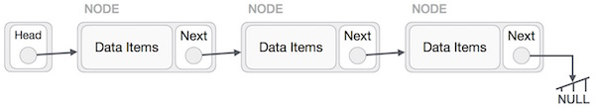

As per the above illustration, following are the important points to be considered.

* Linked List contains a link element called first.
* Each link carries a data field(s) and a link field called next.
* Each link is linked with its next link using its next link.
* Last link carries a link as null to mark the end of the list.

Types of Linked List

Following are the various types of linked list.

* **Simple Linked List** − Item navigation is forward only.
* **Doubly Linked List** − Items can be navigated forward and backward.
* **Circular Linked List** − Last item contains link of the first element as next and the first element has a link to the last element as previous.

Basic Operations

Following are the basic operations supported by a list.

* **Insertion** − Adds an element at the beginning of the list.
* **Deletion** − Deletes an element at the beginning of the list.
* **Display** − Displays the complete list.
* **Search** − Searches an element using the given key.
* **Delete** − Deletes an element using the given key.

Insertion Operation

Adding a new node in linked list is a more than one step activity. We shall learn this with diagrams here. First, create a node using the same structure and find the location where it has to be inserted.

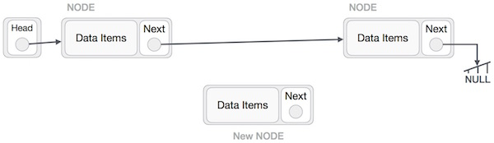

Imagine that we are inserting a node **B** (NewNode), between **A** (LeftNode) and **C** (RightNode). Then point B.next to C −

NewNode.next −> RightNode;

It should look like this −

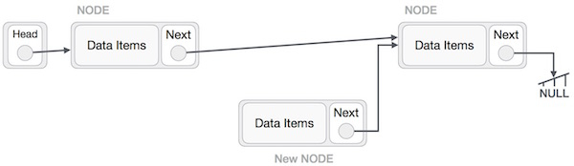

Now, the next node at the left should point to the new node.

LeftNode.next −> NewNode;

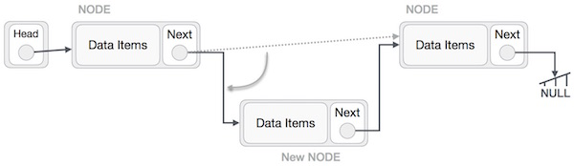

This will put the new node in the middle of the two. The new list should look like this −

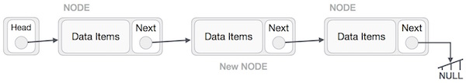

Similar steps should be taken if the node is being inserted at the beginning of the list. While inserting it at the end, the second last node of the list should point to the new node and the new node will point to NULL.

Deletion Operation

Deletion is also a more than one step process. We shall learn with pictorial representation. First, locate the target node to be removed, by using searching algorithms.

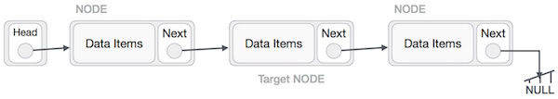

The left (previous) node of the target node now should point to the next node of the target node −

LeftNode.next −> TargetNode.next;

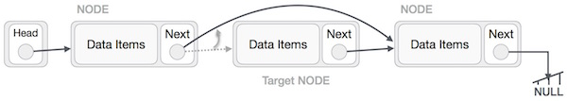

This will remove the link that was pointing to the target node. Now, using the following code, we will remove what the target node is pointing at.

TargetNode.next −> NULL;

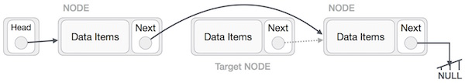

We need to use the deleted node. We can keep that in memory otherwise we can simply deallocate memory and wipe off the target node completely.

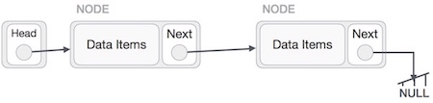

Reverse Operation

This operation is a thorough one. We need to make the last node to be pointed by the head node and reverse the whole linked list.

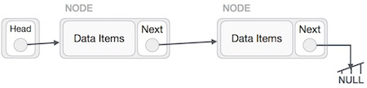



First, we traverse to the end of the list. It should be pointing to NULL. Now, we shall make it point to its previous node −

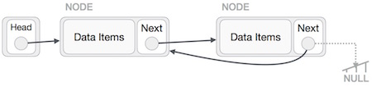



We have to make sure that the last node is not the last node. So we'll have some temp node, which looks like the head node pointing to the last node. Now, we shall make all left side nodes point to their previous nodes one by one.

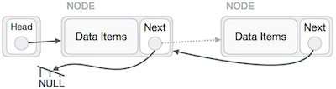

Except the node (first node) pointed by the head node, all nodes should point to their predecessor, making them their new successor. The first node will point to NULL.

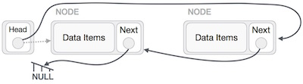

We'll make the head node point to the new first node by using the temp node.

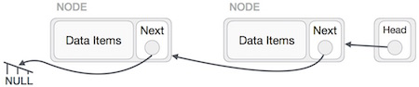



The linked list is now reversed. To see linked list implementation in C programming language, please [click here](https://www.tutorialspoint.com/data_structures_algorithms/linked_list_program_in_c.htm).

# **Data Structure - Doubly Linked List**



Doubly Linked List is a variation of Linked list in which navigation is possible in both ways, either forward and backward easily as compared to Single Linked List. Following are the important terms to understand the concept of doubly linked list.



* **Link** − Each link of a linked list can store a data called an element.



* **Next** − Each link of a linked list contains a link to the next link called Next.



* **Prev** − Each link of a linked list contains a link to the previous link called Prev.



* **LinkedList** − A Linked List contains the connection link to the first link called First and to the last link called Last.



## Doubly Linked List Representation

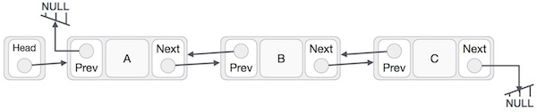



As per the above illustration, following are the important points to be considered.

* Doubly Linked List contains a link element called first and last.
* Each link carries a data field(s) and two link fields called next and prev.
* Each link is linked with its next link using its next link.



* Each link is linked with its previous link using its previous link.



* The last link carries a link as null to mark the end of the list.



## Basic Operations

Following are the basic operations supported by a list.

* **Insertion** − Adds an element at the beginning of the list.
* **Deletion** − Deletes an element at the beginning of the list.
* **Insert Last** − Adds an element at the end of the list.
* **Delete Last** − Deletes an element from the end of the list.
* **Insert After** − Adds an element after an item of the list.
* **Delete** − Deletes an element from the list using the key.
* **Display forward** − Displays the complete list in a forward manner.
* **Display backward** − Displays the complete list in a backward manner.

## Insertion Operation

Following code demonstrates the insertion operation at the beginning of a doubly linked list.

### Example

//insert link at the first location

void insertFirst(int key, int data) {

//create a link

struct node *link = (struct node*) malloc(sizeof(struct node));

link->key = key;

link->data = data;

if(isEmpty()) {

//make it the last link

last = link;

} else {

//update first prev link

head->prev = link;

}

//point it to old first link

link->next = head;

//point first to new first link

head = link;

}

## Deletion Operation

Following code demonstrates the deletion operation at the beginning of a doubly linked list.

### Example

//delete first item

struct node* deleteFirst() {

//save reference to first link

struct node *tempLink = head;

//if only one link

if(head->next == NULL) {

last = NULL;

} else {

head->next->prev = NULL;

}

head = head->next;

//return the deleted link

return tempLink;

}

## Insertion at the End of an Operation

Following code demonstrates the insertion operation at the last position of a doubly linked list.

### Example

//insert link at the last location

void insertLast(int key, int data) {

//create a link

struct node *link = (struct node*) malloc(sizeof(struct node));

link->key = key;

link->data = data;

if(isEmpty()) {

//make it the last link

last = link;

} else {

//make link a new last link

last->next = link;

//mark old last node as prev of new link

link->prev = last;

}

//point last to new last node

last = link;

}

To see the implementation in C programming language, please [click here](https://www.tutorialspoint.com/data_structures_algorithms/doubly_linked_list_program_in_c.htm).

# **Data Structure - Circular Linked List**

Circular Linked List is a variation of Linked list in which the first element points to the last element and the last element points to the first element. Both Singly Linked List and Doubly Linked List can be made into a circular linked list.

## Singly Linked List as Circular

In singly linked list, the next pointer of the last node points to the first node.

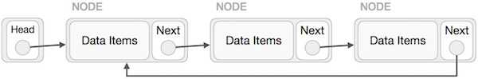

## Doubly Linked List as Circular

In doubly linked list, the next pointer of the last node points to the first node and the previous pointer of the first node points to the last node making the circular in both directions.

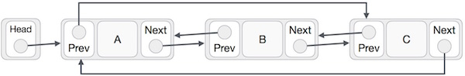

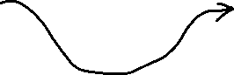

As per the above illustration, following are the important points to be considered.

* The last link's next points to the first link of the list in both cases of singly as well as doubly linked list.
* The first link's previous points to the last of the list in case of doubly linked list.

## Basic Operations

Following are the important operations supported by a circular list.

* **insert** − Inserts an element at the start of the list.
* **delete** − Deletes an element from the start of the list.
* **display** − Displays the list.

## Insertion Operation

Following code demonstrates the insertion operation in a circular linked list based on single linked list.

### Example

insertFirst(data):

Begin



create a new node

node -> data := data

if the list is empty, then

head := node

next of node = head

else

temp := head

while next of temp is not head, do

temp := next of temp

done

next of node := head

next of temp := node



head := node

end if

End

## Deletion Operation

Following code demonstrates the deletion operation in a circular linked list based on single linked list.

deleteFirst():

Begin

if head is null, then

it is Underflow and return

else if next of head = head, then

head := null

deallocate head

else

ptr := head

while next of ptr is not head, do

ptr := next of ptr

next of ptr = next of head

deallocate head

head := next of ptr

end if

End

## Display List Operation

Following code demonstrates the display list operation in a circular linked list.

display():

Begin

if head is null, then

Nothing to print and return

else

ptr := head

while next of ptr is not head, do

display data of ptr

ptr := next of ptr

display data of ptr

end if

End

To know about its implementation in C programming language, please [click here](https://www.tutorialspoint.com/data_structures_algorithms/circular_linked_list_program_in_c.htm).



# **Data Structure and Algorithms - Stack**



A stack is an Abstract Data Type (ADT), commonly used in most programming languages. It is named stack as it behaves like a real-world stack, for example – a deck of cards or a pile of plates, etc.



A real-world stack allows operations at one end only. For example, we can place or remove a card or plate from the top of the stack only. Likewise, Stack ADT allows all data operations at one end only. At any given time, we can only access the top element of a stack.

This feature makes it LIFO data structure. LIFO stands for Last-in-first-out. Here, the element which is placed (inserted or added) last, is accessed first. In stack terminology, insertion operation is called **PUSH** operation and removal operation is called **POP** operation.

## Stack Representation

The following diagram depicts a stack and its operations −

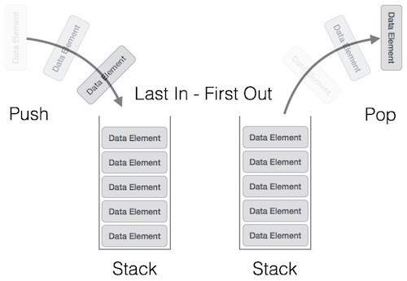

A stack can be implemented by means of Array, Structure, Pointer, and Linked List. Stack can either be a fixed size one or it may have a sense of dynamic resizing. Here, we are going to implement stack using arrays, which makes it a fixed size stack implementation.

## Basic Operations

Stack operations may involve initializing the stack, using it and then de-initializing it. Apart from these basic stuffs, a stack is used for the following two primary operations −

* **push()** − Pushing (storing) an element on the stack.
* **pop()** − Removing (accessing) an element from the stack.

When data is PUSHed onto stack.

To use a stack efficiently, we need to check the status of stack as well. For the same purpose, the following functionality is added to stacks −

* **peek()** − get the top data element of the stack, without removing it.
* **isFull()** − check if stack is full.



* **isEmpty()** − check if stack is empty.



At all times, we maintain a pointer to the last PUSHed data on the stack. As this pointer always represents the top of the stack, hence named **top**. The **top** pointer provides top value of the stack without actually removing it.

First we should learn about procedures to support stack functions −

### peek()

Algorithm of peek() function −

begin procedure peek

return stack[top]

end procedure

Implementation of peek() function in C programming language −

**Example**

int peek() {

return stack[top];

}

### isfull()

Algorithm of isfull() function −

begin procedure isfull

if top equals to MAXSIZE

return true

else

return false

endif

end procedure

Implementation of isfull() function in C programming language −

**Example**

bool isfull() {

if(top == MAXSIZE)

return true;

else

return false;

}

### isempty()

Algorithm of isempty() function −

begin procedure isempty

if top less than 1

return true

else

return false

endif



end procedure

Implementation of isempty() function in C programming language is slightly different. We initialize top at -1, as the index in array starts from 0. So we check if the top is below zero or -1 to determine if the stack is empty. Here's the code −

**Example**

bool isempty() {

if(top == -1)

return true;

else

return false;

}

## Push Operation

The process of putting a new data element onto stack is known as a Push Operation. Push operation involves a series of steps −

* **Step 1** − Checks if the stack is full.
* **Step 2** − If the stack is full, produces an error and exit.
* **Step 3** − If the stack is not full, increments **top** to point next empty space.
* **Step 4** − Adds data element to the stack location, where top is pointing.
* **Step 5** − Returns success.

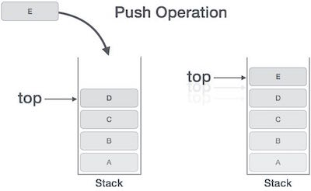

If the linked list is used to implement the stack, then in step 3, we need to allocate space dynamically.

### Algorithm for PUSH Operation

A simple algorithm for Push operation can be derived as follows −

begin procedure push: stack, data

if stack is full

return null

endif

top ← top + 1

stack[top] ← data

end procedure

Implementation of this algorithm in C, is very easy. See the following code −

**Example**

void push(int data) {

if(!isFull()) {

top = top + 1;

stack[top] = data;

} else {

printf("Could not insert data, Stack is full.\n");

}

}

## Pop Operation

Accessing the content while removing it from the stack, is known as a Pop Operation. In an array implementation of pop() operation, the data element is not actually removed, instead **top** is decremented to a lower position in the stack to point to the next value. But in linked-list implementation, pop() actually removes data element and deallocates memory space.

A Pop operation may involve the following steps −

* **Step 1** − Checks if the stack is empty.
* **Step 2** − If the stack is empty, produces an error and exit.
* **Step 3** − If the stack is not empty, accesses the data element at which **top** is pointing.
* **Step 4** − Decreases the value of top by 1.
* **Step 5** − Returns success.

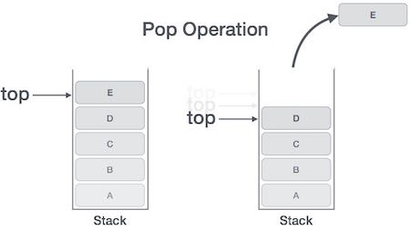

### Algorithm for Pop Operation

A simple algorithm for Pop operation can be derived as follows −

begin procedure pop: stack

if stack is empty

return null

endif

data ← stack[top]

top ← top - 1

return data

end procedure

Implementation of this algorithm in C, is as follows −

**Example**

int pop(int data) {

if(!isempty()) {

data = stack[top];

top = top - 1;

return data;

} else {

printf("Could not retrieve data, Stack is empty.\n");

}

}

#include <stdio.h>

int MAXSIZE = 8;

int stack[8];

int top = -1;

int isempty() {

if(top == -1)

return 1;

else

return 0;

}

int isfull() {

if(top == MAXSIZE)

return 1;

else

return 0;

}

int peek() {

return stack[top];

}

int pop() {

int data;

if(!isempty()) {

data = stack[top];

top = top - 1;

return data;

} else {

printf("Could not retrieve data, Stack is empty.\n");

}

}

int push(int data) {

if(!isfull()) {

top = top + 1;

stack[top] = data;

} else {

printf("Could not insert data, Stack is full.\n");

}

}

int main() {

// push items on to the stack

push(3);

push(5);

push(9);

push(1);

push(12);

push(15);

printf("Element at top of the stack: %d\n" ,peek());

printf("Elements: \n");

// print stack data

while(!isempty()) {

int data = pop();

printf("%d\n",data);

}

printf("Stack full: %s\n" , isfull()?"true":"false");

printf("Stack empty: %s\n" , isempty()?"true":"false");

return 0;

}



# **Data Structure and Algorithms - Queue**



Queue is an abstract data structure, somewhat similar to Stacks. Unlike stacks, a queue is open at both its ends. One end is always used to insert data (enqueue) and the other is used to remove data (dequeue). Queue follows First-In-First-Out methodology, i.e., the data item stored first will be accessed first.



A real-world example of queue can be a single-lane one-way road, where the vehicle enters first, exits first. More real-world examples can be seen as queues at the ticket windows and bus-stops.

## Queue Representation

As we now understand that in queue, we access both ends for different reasons. The following diagram given below tries to explain queue representation as data structure −

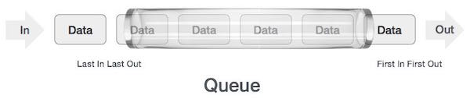

As in stacks, a queue can also be implemented using Arrays, Linked-lists, Pointers and Structures. For the sake of simplicity, we shall implement queues using one-dimensional array.

## Basic Operations

Queue operations may involve initializing or defining the queue, utilizing it, and then completely erasing it from the memory. Here we shall try to understand the basic operations associated with queues −

* **enqueue()** − add (store) an item to the queue.
* **dequeue()** − remove (access) an item from the queue.

Few more functions are required to make the above-mentioned queue operation efficient. These are −

* **peek()** − Gets the element at the front of the queue without removing it.
* **isfull()** − Checks if the queue is full.
* **isempty()** − Checks if the queue is empty.

In queue, we always dequeue (or access) data, pointed by **front** pointer and while enqueing (or storing) data in the queue we take help of **rear** pointer.

Let's first learn about supportive functions of a queue −

### peek()

This function helps to see the data at the **front** of the queue. The algorithm of peek() function is as follows −

**Algorithm**

begin procedure peek

return queue[front]

end procedure

Implementation of peek() function in C programming language −

**Example**

int peek() {

return queue[front];

}

### isfull()

As we are using single dimension array to implement queue, we just check for the rear pointer to reach at MAXSIZE to determine that the queue is full. In case we maintain the queue in a circular linked-list, the algorithm will differ. Algorithm of isfull() function −

**Algorithm**

begin procedure isfull

if rear equals to MAXSIZE

return true

else

return false

endif

end procedure

Implementation of isfull() function in C programming language −

**Example**

bool isfull() {

if(rear == MAXSIZE - 1)

return true;

else

return false;

}

### isempty()

Algorithm of isempty() function −

**Algorithm**

begin procedure isempty

if front is less than MIN OR front is greater than rear

return true

else

return false

endif

end procedure

If the value of **front** is less than MIN or 0, it tells that the queue is not yet initialized, hence empty.

Here's the C programming code −

**Example**

bool isempty() {

if(front < 0 || front > rear)

return true;

else

return false;

}

## Enqueue Operation

Queues maintain two data pointers, **front** and **rear**. Therefore, its operations are comparatively difficult to implement than that of stacks.

The following steps should be taken to enqueue (insert) data into a queue −

* **Step 1** − Check if the queue is full.
* **Step 2** − If the queue is full, produce overflow error and exit.
* **Step 3** − If the queue is not full, increment **rear** pointer to point the next empty space.
* **Step 4** − Add data element to the queue location, where the rear is pointing.
* **Step 5** − return success.

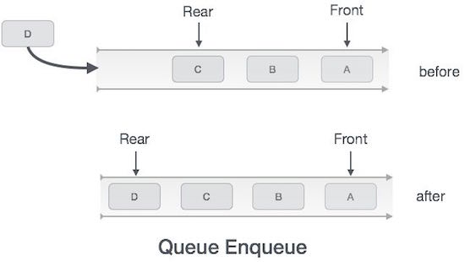

Sometimes, we also check to see if a queue is initialized or not, to handle any unforeseen situations.

### Algorithm for enqueue operation

procedure enqueue(data)

if queue is full

return overflow

endif

rear ← rear + 1

queue[rear] ← data

return true

end procedure

Implementation of enqueue() in C programming language −

**Example**

int enqueue(int data)

if(isfull())

return 0;

rear = rear + 1;

queue[rear] = data;

return 1;

end procedure

## Dequeue Operation

Accessing data from the queue is a process of two tasks − access the data where **front** is pointing and remove the data after access. The following steps are taken to perform **dequeue** operation −

* **Step 1** − Check if the queue is empty.
* **Step 2** − If the queue is empty, produce underflow error and exit.
* **Step 3** − If the queue is not empty, access the data where **front** is pointing.
* **Step 4** − Increment **front** pointer to point to the next available data element.
* **Step 5** − Return success.

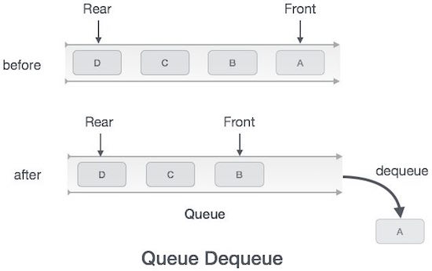

### Algorithm for dequeue operation

procedure dequeue

if queue is empty

return underflow

end if

data = queue[front]

front ← front + 1

return true

end procedure

Implementation of dequeue() in C programming language −

**Example**

int dequeue() {

if(isempty())

return 0;

int data = queue[front];

front = front + 1;

return data;

}

#include <stdio.h>

#include <string.h>

#include <stdlib.h>

#include <stdbool.h>

#define MAX 6

int intArray[MAX];

int front = 0;

int rear = -1;

int itemCount = 0;

int peek() {



return intArray[front];

}

bool isEmpty() {

return itemCount == 0;



}

bool isFull() {

return itemCount == MAX;

}

int size() {

return itemCount;

}

void insert(int data) {

if(!isFull()) {

if(rear == MAX-1) {

rear = -1;

}

intArray[++rear] = data;

itemCount++;

}

}

int removeData() {

int data = intArray[front++];

if(front == MAX) {

front = 0;

}

itemCount--;

return data;

}

int main() {

/* insert 5 items */

insert(3); insert(5); insert(9); insert(1);insert(12);

// front : 0

// rear : 4

// ------------------

// index : 0 1 2 3 4

// ------------------

// queue : 3 5 9 1 12

insert(15);

// front : 0

// rear : 5

// ---------------------

// index : 0 1 2 3 4 5

// ---------------------

// queue : 3 5 9 1 12 15

if(isFull()) {

printf("Queue is full!\n");

}

// remove one item

int num = removeData();

printf("Element removed: %d\n",num);

// front : 1

// rear : 5

// -------------------

// index : 1 2 3 4 5

// -------------------

// queue : 5 9 1 12 15

// insert more items



insert(16);



// front : 1

// rear : -1

// ----------------------

// index : 0 1 2 3 4 5

// ----------------------

// queue : 16 5 9 1 12 15

// As queue is full, elements will not be inserted.



insert(17);

insert(18);

// ----------------------

// index : 0 1 2 3 4 5

// ----------------------

// queue : 16 5 9 1 12 15

printf("Element at front: %d\n",peek());

printf("----------------------\n");

printf("index : 5 4 3 2 1 0\n");

printf("----------------------\n");

printf("Queue: ");

while(!isEmpty()) {



int n = removeData();

printf("%d ",n);

}



}

# **Data Structure and Algorithms Linear Search**



Linear search is a very simple search algorithm. In this type of search, a sequential search is made over all items one by one. Every item is checked and if a match is found then that particular item is returned, otherwise the search continues till the end of the data collection.







## Algorithm



Linear Search ( Array A, Value x)

Step 1: Set i to 1

Step 2: if i > n then go to step 7

Step 3: if A[i] = x then go to step 6



Step 4: Set i to i + 1



Step 5: Go to Step 2

Step 6: Print Element x Found at index i and go to step 8

Step 7: Print element not found

Step 8: Exit

## Pseudocode

procedure linear_search (list, value)

for each item in the list

if match item == value

return the item's location

end if

end for

end procedure

#include <stdio.h>

#define MAX 20

// array of items on which linear search will be conducted.

int intArray[MAX] = {1,2,3,4,6,7,9,11,12,14,15,16,17,19,33,34,43,45,55,66};

void printline(int count) {

int i;

for(i = 0;i <count-1;i++) {

printf("=");

}

printf("=\n");

}

// this method makes a linear search.

int find(int data) {



int comparisons = 0;

int index = -1;

int i;

// navigate through all items

for(i = 0;i<MAX;i++) {



// count the comparisons made

comparisons++;



// if data found, break the loop

if(data == intArray[i]) {

d

break;

}

}

printf("Total comparisons made: %d", comparisons);

return index;



}

void display() {

int i;

printf("[");

// navigate through all items

for(i = 0;i<MAX;i++) {



printf("%d ",intArray[i]);

}

printf("]\n");

}

void main() {

printf("Input Array: ");

display();

printline(50);

//find location of 1

int location = find(55);

// if element was found

if(location != -1)

printf("\nElement found at location: %d" ,(location+1));

else

printf("Element not found.");

}

99

# **Data Structure and Algorithms Binary Search**

Binary search is a fast search algorithm with run-time complexity of Ο(log n). This search algorithm works on the principle of divide and conquer. For this algorithm to work properly, the data collection should be in the sorted form.

Binary search looks for a particular item by comparing the middle most item of the collection. If a match occurs, then the index of item is returned. If the middle item is greater than the item, then the item is searched in the sub-array to the left of the middle item. Otherwise, the item is searched for in the sub-array to the right of the middle item. This process continues on the sub-array as well until the size of the subarray reduces to zero.

## How Binary Search Works?



For a binary search to work, it is mandatory for the target array to be sorted. We shall learn the process of binary search with a pictorial example. The following is our sorted array and let us assume that we need to search the location of value 31 using binary search.



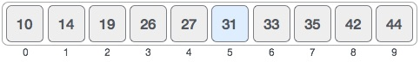

First, we shall determine half of the array by using this formula −

mid = low + (high - low) / 2

Here it is, 0 + (9 - 0 ) / 2 = 4 (integer value of 4.5). So, 4 is the mid of the array.

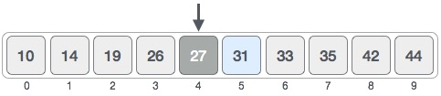

Now we compare the value stored at location 4, with the value being searched, i.e. 31. We find that the value at location 4 is 27, which is not a match. As the value is greater than 27 and we have a sorted array, so we also know that the target value must be in the upper portion of the array.

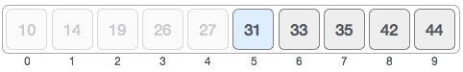

We change our low to mid + 1 and find the new mid value again.

low = mid + 1

mid = low + (high - low) / 2

Our new mid is 7 now. We compare the value stored at location 7 with our target value 31.

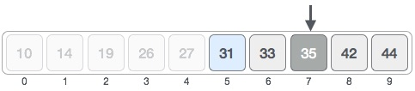

The value stored at location 7 is not a match, rather it is more than what we are looking for. So, the value must be in the lower part from this location.

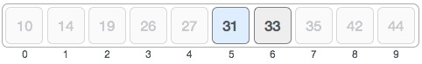

Hence, we calculate the mid again. This time it is 5.

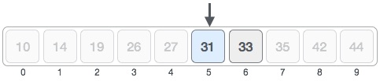

We compare the value stored at location 5 with our target value. We find that it is a match.

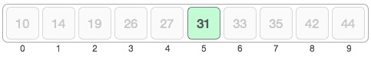

We conclude that the target value 31 is stored at location 5.

Binary search halves the searchable items and thus reduces the count of comparisons to be made to very less numbers.

## Pseudocode

The pseudocode of binary search algorithms should look like this −

Procedure binary_search

A ← sorted array

n ← size of array

x ← value to be searched

Set lowerBound = 1

Set upperBound = n

while x not found

if upperBound < lowerBound

EXIT: x does not exists.

set midPoint = lowerBound + ( upperBound - lowerBound ) / 2



if A[midPoint] < x

set lowerBound = midPoint + 1

if A[midPoint] > x

set upperBound = midPoint - 1

if A[midPoint] = x

EXIT: x found at location midPoint

end while

end procedure

#include <stdio.h>

#define MAX 20

// array of items on which linear search will be conducted.

int intArray[MAX] = {1,2,3,4,6,7,9,11,12,14,15,16,17,19,33,34,43,45,55,66};

void printline(int count) {

int i;

for(i = 0;i <count-1;i++) {

printf("=");

}

printf("=\n");

}

int find(int data) {

int lowerBound = 0;

int upperBound = MAX -1;

int midPoint = -1;

int comparisons = 0;

int index = -1;

while(lowerBound <= upperBound) {

printf("Comparison %d\n" , (comparisons +1) );

printf("lowerBound : %d, intArray[%d] = %d\n",lowerBound,lowerBound,

intArray[lowerBound]);

printf("upperBound : %d, intArray[%d] = %d\n",upperBound,upperBound,

intArray[upperBound]);

comparisons++;

// compute the mid point

// midPoint = (lowerBound + upperBound) / 2;

midPoint = lowerBound + (upperBound - lowerBound) / 2;

// data found

if(intArray[midPoint] == data) {

index = midPoint;

break;

} else {

// if data is larger

if(intArray[midPoint] < data) {

// data is in upper half

lowerBound = midPoint + 1;

}

// data is smaller

else {

// data is in lower half

upperBound = midPoint -1;

}

}

}

printf("Total comparisons made: %d" , comparisons);

return index;

}

void display() {

int i;

printf("[");

// navigate through all items

for(i = 0;i<MAX;i++) {

printf("%d ",intArray[i]);

}

printf("]\n");

}

void main() {

printf("Input Array: ");

display();

printline(50);

//find location of 1

int location = find(55);

// if element was found

if(location != -1)

printf("\nElement found at location: %d" ,(location+1));

else

printf("\nElement not found.");

}

If we compile and run the above program then it would produce following result −

## Output

Input Array: [1 2 3 4 6 7 9 11 12 14 15 16 17 19 33 34 43 45 55 66 ]

==================================================

Comparison 1

lowerBound : 0, intArray[0] = 1

upperBound : 19, intArray[19] = 66

Comparison 2

lowerBound : 10, intArray[10] = 15

upperBound : 19, intArray[19] = 66

Comparison 3

lowerBound : 15, intArray[15] = 34

upperBound : 19, intArray[19] = 66

Comparison 4

lowerBound : 18, intArray[18] = 55

upperBound : 19, intArray[19] = 66

Total comparisons made: 4

Element found at location: 19

