Technical System Design Document: Payment Marshal Service
Document Version: 1.0
Status: Draft for Review
Authors: Jyoti, Akhilesh, Vaibhav
Last Updated: [Date]

1. Introduction & Overview
The Payment Marshal Service is a new backend service designed to manage account-level locking during bulk transaction processing. Its primary role is to ensure data consistency and prevent race conditions by serializing access to accounts that are being debited or credited concurrently by different transactions.
This service integrates with the new Accounting Entry Service to provide a safe and consistent mechanism for processing high-volume financial transactions, such as Single Debit-Multiple Credit (SDMC) and Single Debit-Single Credit (SDSC).

2. Business Goals & Non-Functional Requirements (NFRs)
- Data Consistency: Ensure that account balances are always accurate, even under high concurrency.
- High Throughput: Efficiently process a large volume of simultaneous transactions.
- Low Latency: Minimize the impact of locking on transaction processing time.
- Reliability: The service must be highly available and fault-tolerant to support critical financial operations.

3. System Architecture

3.1 High-Level Component Diagram
This diagram illustrates the main components and their interactions.
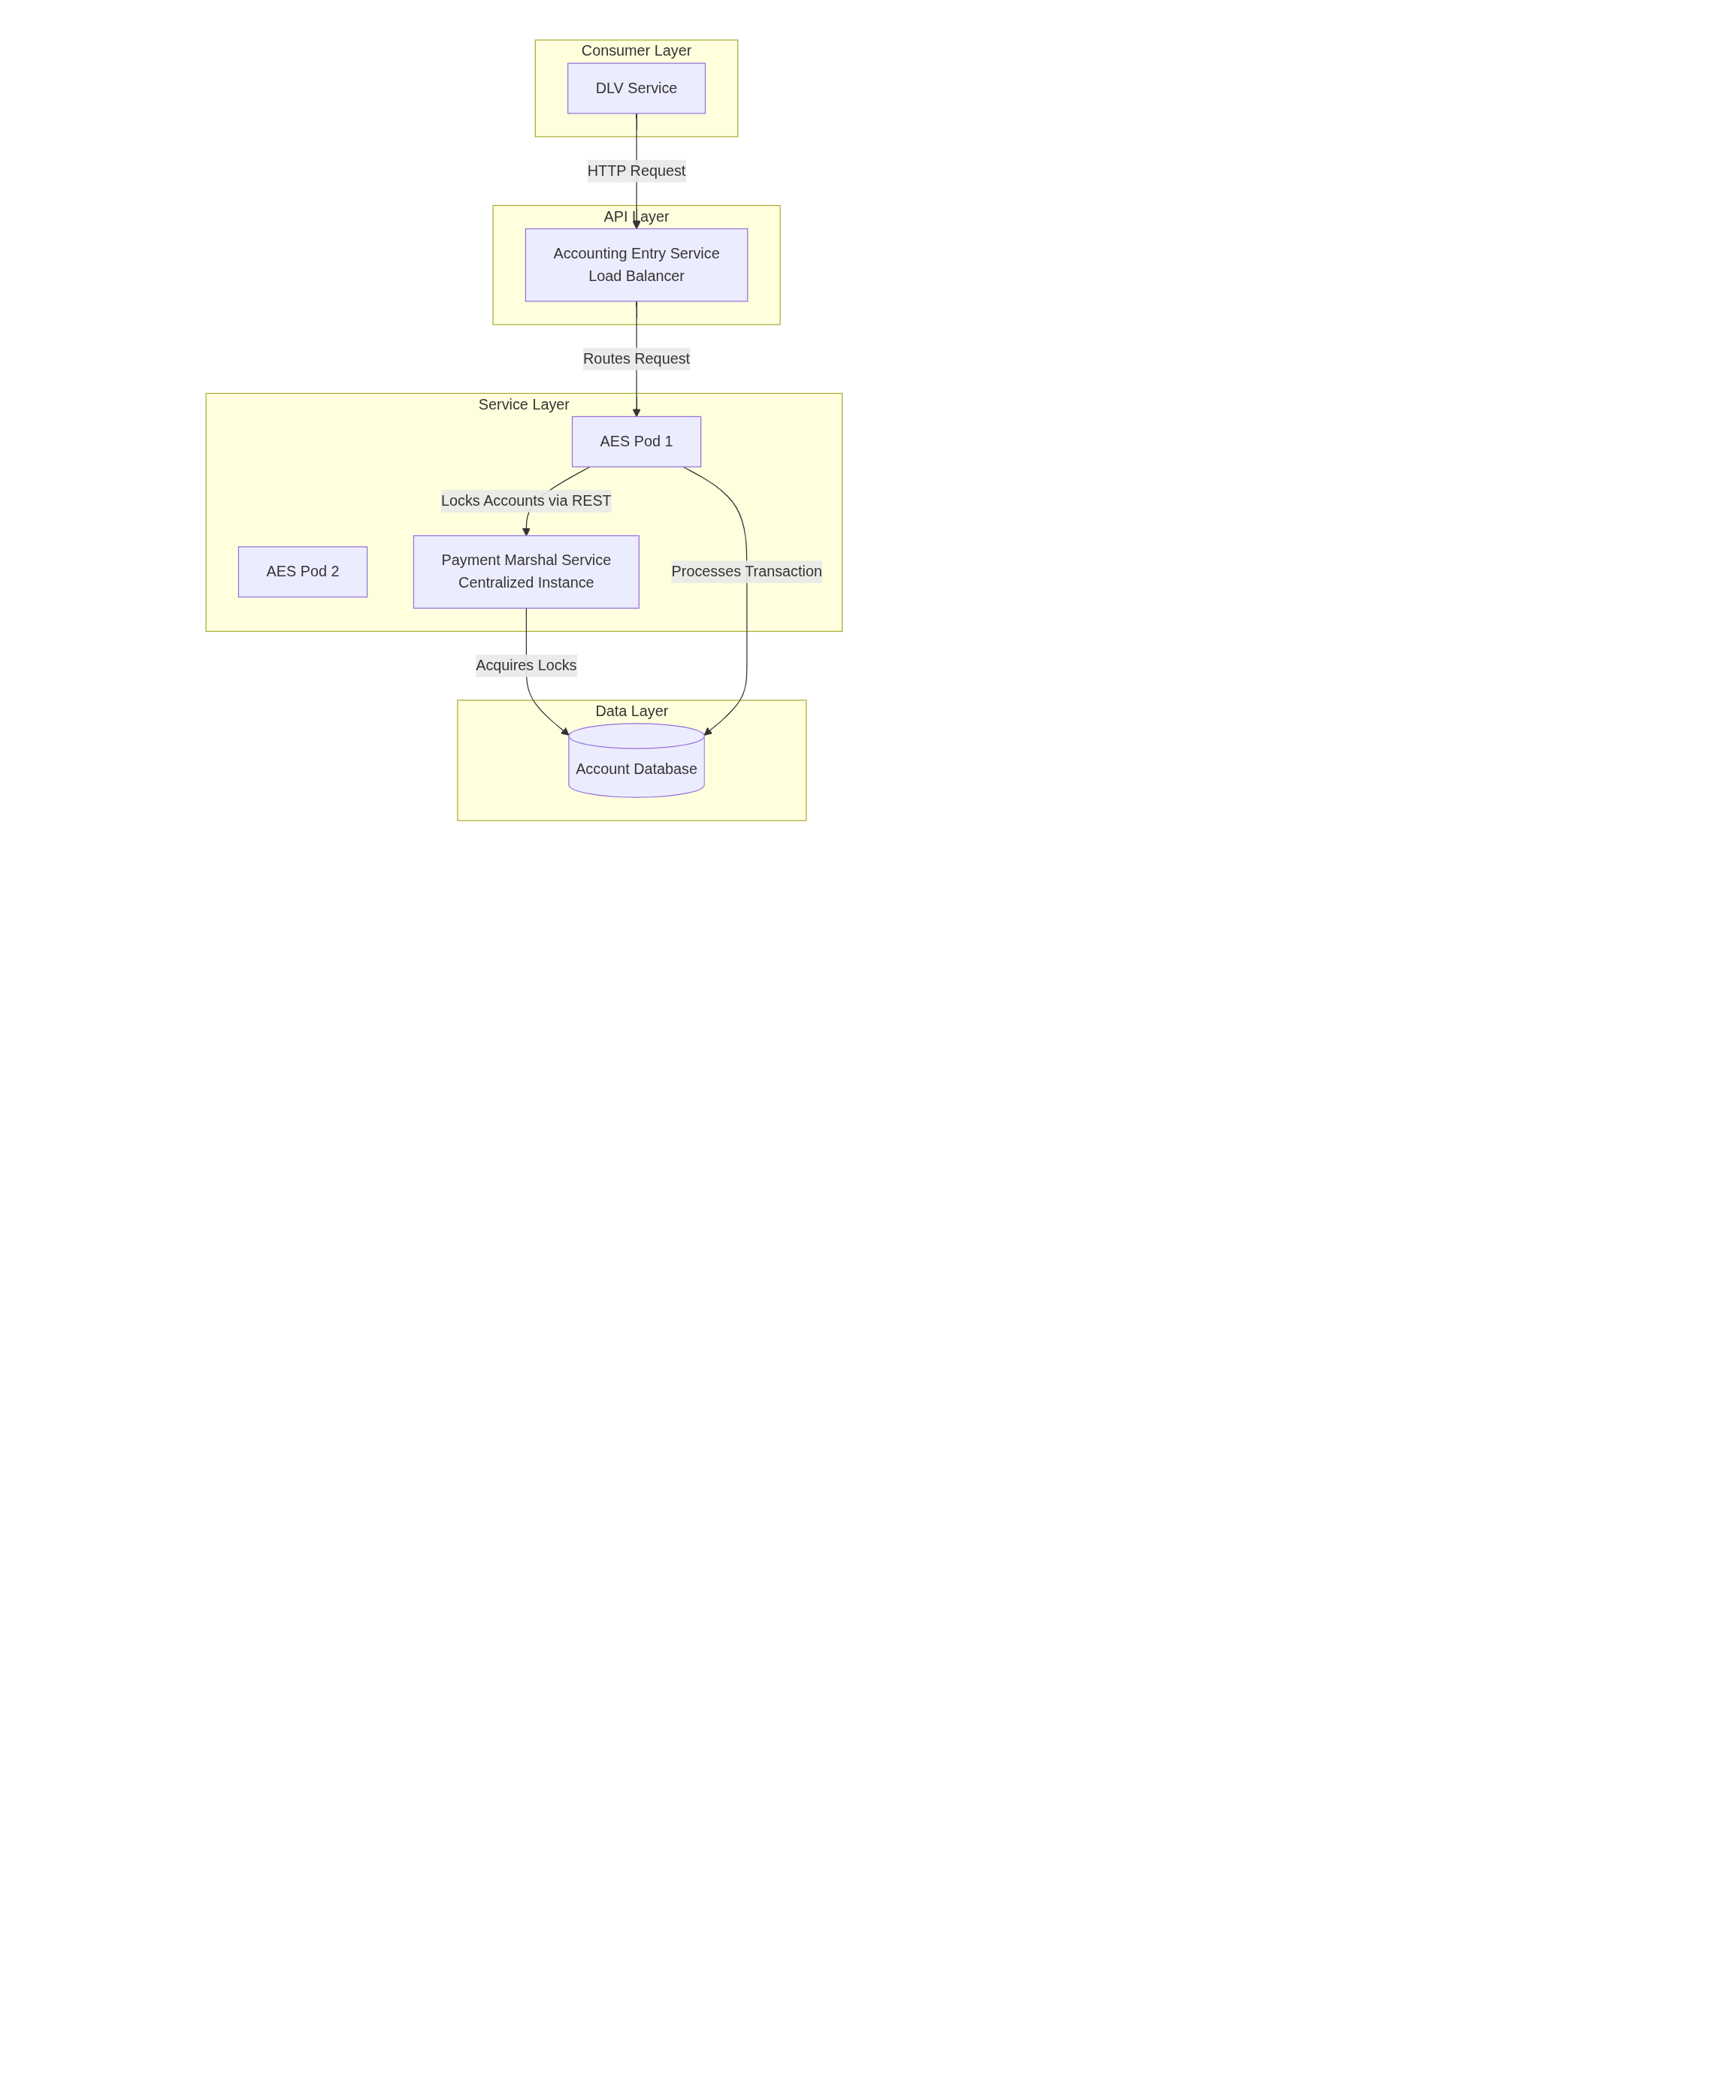

Key Components:
- DLV Service: The primary consumer that initiates transaction processing requests.
- Accounting Entry Service (AES):
  - Deployed as multiple pods for scalability and high availability.
  - Sits behind a load balancer, exposing a single endpoint to consumers.
  - Each pod has its own URI for internal communication with the Payment Marshal Service.
- Payment Marshal Service (PMS):
  - A centralized, singleton-like instance responsible for all locking logic.
  - Has its own dedicated URI.
  - Manages the acquisition and release of account locks.
- Account Database: The persistent storage for account information and balances.

4. Detailed Design & Logic

4.1 Core Locking Strategy
The cornerstone of the design is the strategy to lock both the debit and credit account for every transaction.
Rationale:
To prevent race conditions and ensure balance consistency, any account involved in a transaction must be locked against concurrent modification. Since an account can play the role of a debit account in one transaction and a credit account in another simultaneously, locking both is necessary.

Concurrency Scenario Example:

Time | Transaction T1 (Thread 1) | Transaction T2 (Thread 2) | Balance of Account A without Proper Locking
t1 | Reads Balance of A (=$100) to credit +$50 |  | $100
t2 |  | Reads Balance of A (=$100) to debit -$20 | $100
t3 | Calculates New Balance: $150 | Calculates New Balance: $80 | $100
t4 | Writes $150 to A | Writes $80 to A | $80 (Incorrect!)

With the PMS locking both accounts, T1 and T2 would be serialized, preventing this interleaving and ensuring the final balance is correct ($130).

4.2 Transaction Processing Sequence Diagram
This sequence diagram details the end-to-end flow for a Single Debit-Single Credit (SDSC) transaction, highlighting the critical role of the Payment Marshal Service in acquiring and releasing locks.

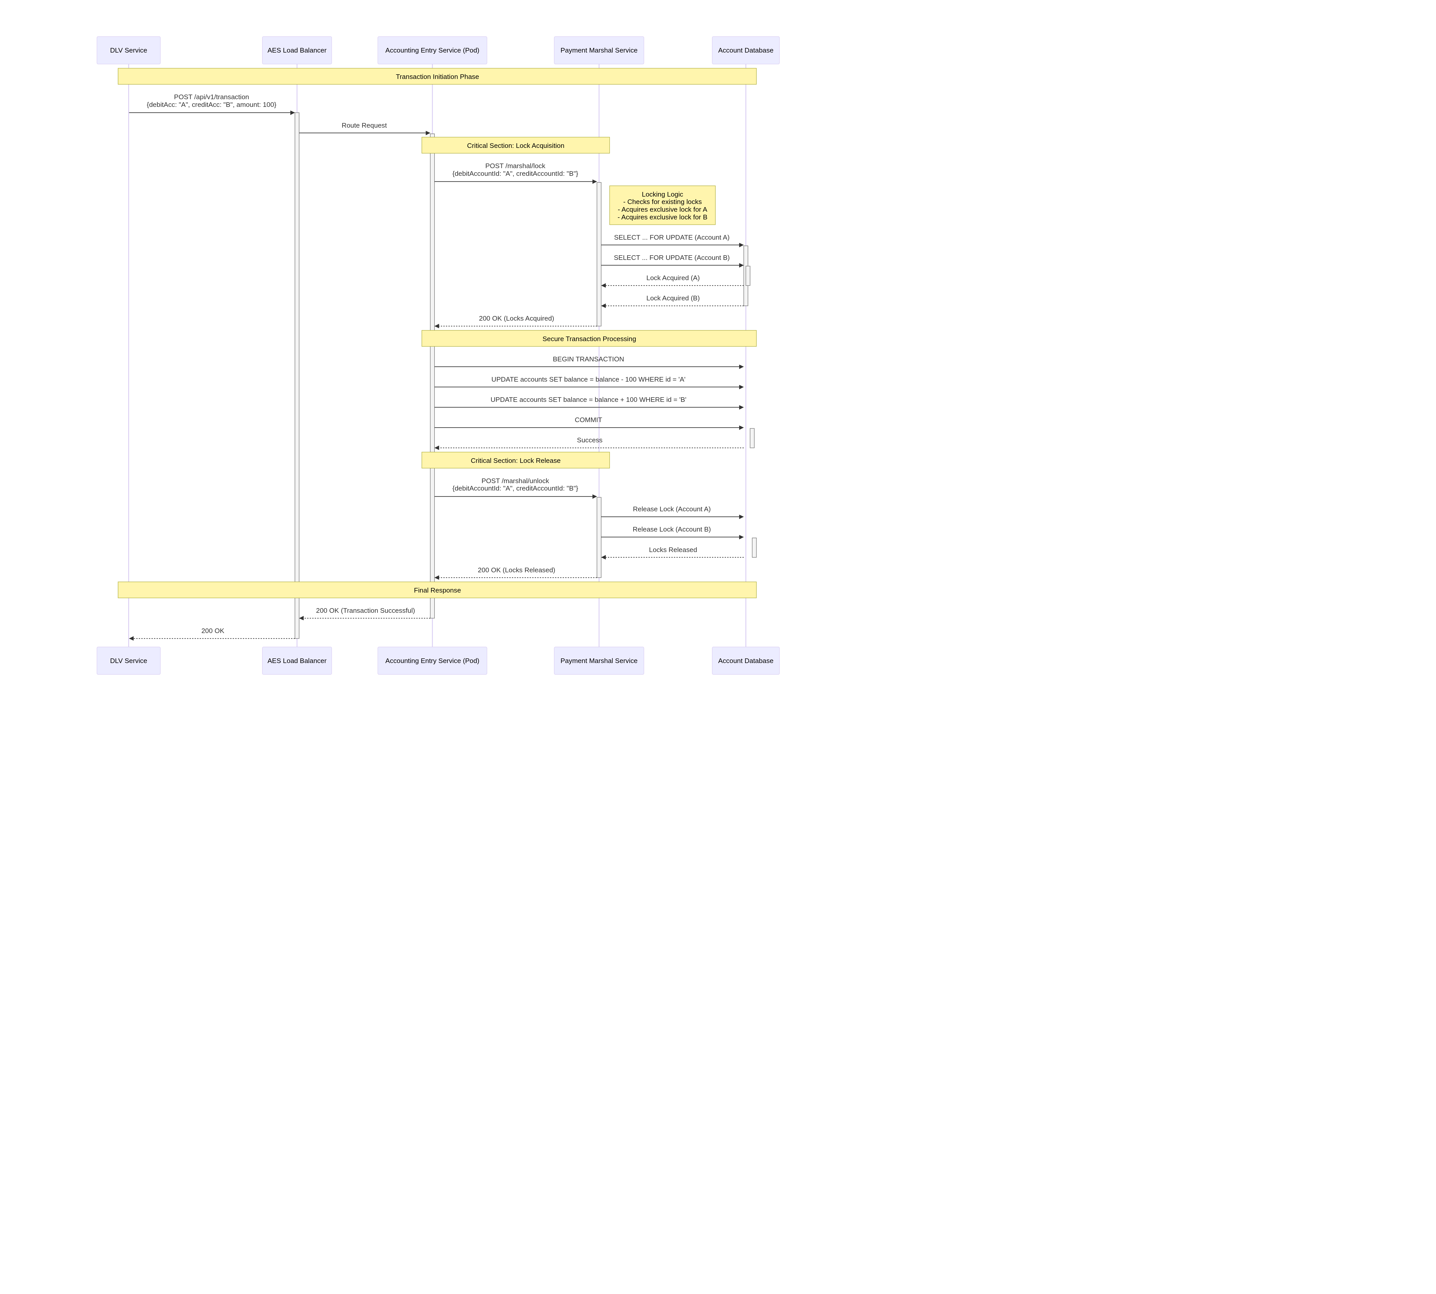

Steps Explained:
- Request Initiation: DLV sends a transaction request to the Accounting Entry Service's load-balanced endpoint.
- Lock Acquisition: The AES pod calls the Payment Marshal Service to lock both the debit and credit accounts. The PMS acquires exclusive locks on these accounts in the database.
- Transaction Execution: With the locks held, the AES safely updates the account balances in the database.
- Lock Release: After a successful update, the AES instructs the PMS to release the locks, making the accounts available for other transactions.

5. Locking Scenarios Analysis (For Stakeholder Review)
This section directly addresses the action item to document scenarios for Hidian's review.

Scenario ID | Transaction Type | Description | Accounts Involved | Locking Strategy | Rationale & Potential Issue Prevented
SC-01 | Single Debit-Single Credit (SDSC) | A simple transfer from Account A to Account B. | Debit: A  Credit: B | Lock A and B | Prevents another transaction from modifying A or B while the transfer is in progress.
SC-02 | Single Debit-Multiple Credit (SDMC) | One account (A) debited, multiple accounts (B, C, D) credited. (e.g., a payroll run). | Debit: A  Credits: B, C, D | Lock A, B, C, D | Prevents a concurrent transaction from debiting A while it's being depleted, or crediting B/C/D while they are being funded.
SC-03 | Concurrent SDSC with Overlap | Two transfers happen at once:  T1: A -> B  T2: B -> C | T1: A, B  T2: B, C | T1: Locks A, B  T2: Locks B, C | The PMS will serialize access to Account B. T2 will wait for T1 to release the lock on B, preventing a corrupt balance on B. This is the key scenario justifying locking both accounts.
SC-04 | Concurrent SDMC & SDSC | T1 (SDMC): A -> B, C, D  T2 (SDSC): B -> E | T1: A, B, C, D  T2: B, E | T1: Locks A, B, C, D  T2: Locks B, E | The lock on Account B by T1 will force T2 to wait, ensuring B's credit from T1 is complete before it is debited by T2.

6. Deployment & Infrastructure

6.1 Service Deployment View

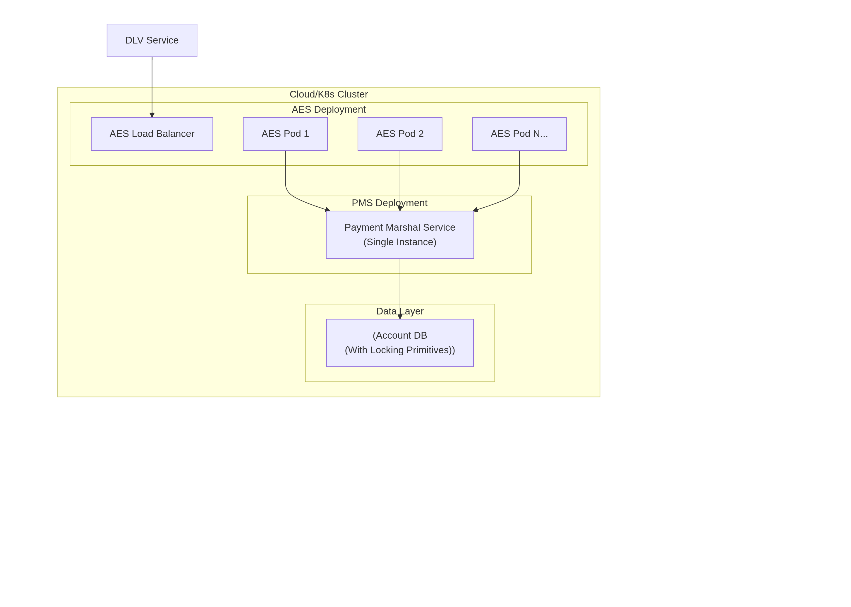

Key Points:
- Accounting Entry Service: Stateless, horizontally scaled using multiple pods behind a load balancer.
- Payment Marshal Service: Deployed as a centralized service to act as a single source of truth for lock management. This prevents race conditions that could occur if multiple instances were managing locks independently.
- Database: Must support reliable locking mechanisms (e.g., row-level locks, SELECT FOR UPDATE in SQL, or similar in NoSQL).

7. Testing Strategy

7.1 Performance & Load Testing
- Tool: JMeter
- Scope: Focus on the Payment Marshal Service endpoint (/marshal/lock).
- Objectives:
  - Throughput: Measure the maximum number of lock/unlock operations per second the PMS can handle.
  - Latency: Measure the average, 95th, and 99th percentile response time for the lock acquisition under load.
  - Scalability: Identify the point at which the PMS or database becomes a bottleneck.
  - Concurrency Validation: Simulate the scenarios from Section 5 (especially SC-03 and SC-04) with high concurrency to verify that no data races occur.
- Test Data: As per the action item, real-world accounting entry request examples will be collected and used to create realistic JMeter test plans.

8. Open Points & Decisions
- Locking Strategy Final Sign-Off: The current design locks both debit and credit accounts. This requires formal review and sign-off from Hidian before go-live.
- Fallback Strategy: The implementation is flexible and can be adjusted to lock only debit accounts if required by stakeholders after review.

9. Action Items & Next Steps
Item | Owner | Status
1. Prepare and share an Excel sheet with detailed scenario analysis (as in Section 5) for Hidian. | Jyoti, Akhilesh | Pending
2. Schedule a review call with Hidian to align on the locking strategy and obtain sign-off. | Vaibhav | Pending
3. Based on Hidian's feedback, implement any changes to the locking logic (if required). | Jyoti | Pending
4. Collect production-like test data and finalize JMeter scripts for performance testing. | Jyoti | Pending
5. Execute performance tests and validate results against NFRs. | Jyoti | Pending

