Architecture of Web-based systems

Client Server and 2 tier Web Architectures

Typically, when you are browsing the Internet, you will be using Web Browser software such as Internet Explorer or Mozilla Firefox. The computer which is running a browser is called a client, whilst the machine which is providing Web pages is called a server.

When you dial up to an Internet Service Provider ( ISP ) e.g. Blue Yonder, Aol, your computer is forming a network connection to a Web server. In this situation, your computer is in effect a client, which is linked to an ISP Web server. The web server, as the name suggests, serves your browser with Web pages (e.g. HTML, ASPX, JSP pages etc).

Single Tier or 1-Tier Architecture:
It is the simplest one as it is equivalent to running the application on the personal computer. All of the required components for an application to run are on a single application or server.
Presentation layer, Business logic layer, and data layer are all located on a single machine.

2-Tier Architecture:
It is like Client-Server architecture, where communication takes place between client and server.
In this type of software architecture, the presentation layer or user interface layer runs on the client side while dataset layer gets executed and stored on server side.
There is no Business logic layer or immediate layer in between client and server.

Figure B - A simple diagram of 2 tier Client/server architecture

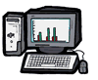
Web Server
Client
The Internet
Page Request
Page Request
Web Page
Web page
Enter Web Address
Web page

3-Tier architectures

Generally computing applications consist of three different and distinct types of functionalities.

Data Management
Functional Logic
Presentation Services

- Presentation Services: These manifest themselves in the form of information display and user data input facilities. Generally the front-end for user interaction. For example logging in requires interaction in the form of collecting username and password information using a HTML-form.
- Functional logic: Every application includes some data processing and this may also involve database interactivity. For example user authentication requires the logic unit to read username-password combinations from a database and compare until a good comparison (hopefully) is arrived at.
- Data Management: Data, its storage, insertion and retrieval, its management and alteration is central to computing applications. For example a database management system (DBMS) is required for the management of usernames and associated passwords, their owners, etc.

Figure C - An illustration of a 3 tier architecture model

TCP/IP, HTTP, HTML

ADO.NET, JDBC
DCOM, CORBA

1st tier- Web browser 2nd tier- Web server 3rd tier- Data storage

n-Tier Architectures

An N-Tier Application program is one that is distributed among three or more separate computers in a distributed network.
The most common form of n-tier is the 3-tier Application, and it is classified into three categories.
- User interface programming in the user's computer
- Business logic in a more centralized computer, and
- Required data in a computer that manages a database.
This architecture model provides Software Developers to create Reusable application/systems with maximum flexibility.
In N-tier, "N" refers to a number of tiers or layers are being used like – 2-tier, 3-tier or 4-tier, etc. It is also called “Multi-Tier Architecture”.
The n-tier architecture is an industry-proven software architecture model. It is suitable to support enterprise level client-server applications by providing solutions to scalability, security, fault tolerance, reusability, and maintainability. It helps developers to create flexible and reusable applications.
Each layer within an N-tier architecture could be thought of as 'logical components' interacting with the layer above or below. Layers provide a means of grouping functionality within the application structure.

Some benefits of this approach include flexibility of component location - each layer may be held on a different server, this facilitates scalable applications capable of handling heavier server loads. Additionally each layer is encapsulated making it possible to change one layer without affecting another.

What is SOAP?
SOAP is an XML-based protocol for accessing web services over HTTP. It has some specification which could be used across all applications.
SOAP is known as the Simple Object Access Protocol, but in later times was just shortened to SOAP v1.2. SOAP is a protocol or in other words is a definition of how web services talk to each other or talk to client applications that invoke them.
SOAP was developed as an intermediate language so that applications built on various programming languages could talk easily to each other and avoid the extreme development effort.

SOAP Building blocks
The SOAP specification defines something known as a "SOAP message" which is what is sent to the web service and the client application.
The diagram below shows the various building blocks of a SOAP Message.
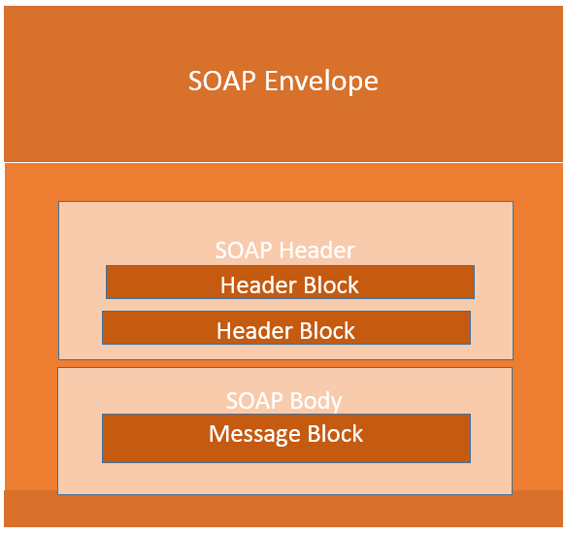
The SOAP message is nothing but a mere XML document which has the below components.
- An Envelope element that identifies the XML document as a SOAP message – This is the containing part of the SOAP message and is used to encapsulate all the details in the SOAP message. This is the root element in the SOAP message.
- A Header element that contains header information – The header element can contain information such as authentication credentials which can be used by the calling application. It can also contain the definition of complex types which could be used in the SOAP message. By default, the SOAP message can contain parameters which could be of simple types such as strings and numbers, but can also be a complex object type.
A Body element that contains call and response information – This element is what contains the actual data which needs to be sent between the web service and the calling application

SOAP Message Structure
SOAP messages are normally auto-generated by the web service when it is called.
Whenever a client application calls a method in the web service, the web service will automatically generate a SOAP message which will have the necessary details of the data which will be sent from the web service to the client application.

