# **CURRICULUM VITAE**

## Personal Details

Name : Lin Soo Kian

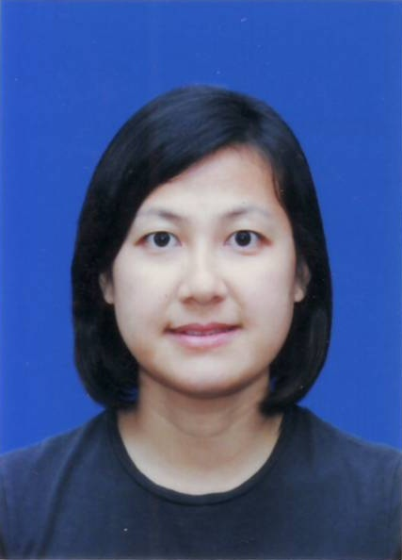

Address : C301, Gugusan Teratai No.1,

Jalan Cecawi 6/30, Seksyen 6,

Kota Damansara,

47810, Petaling Jaya,

Selangor, Malaysia.

Telephone No. : 60-19 2781433

E-mail : sklin26@yahoo.com.sg

Date of Birth : 26th December 1977

Gender : Female

Nationality : Malaysian (Singapore Permanent Resident)

Race : Chinese

Marital Status : Single

Language : English, Chinese, Malay

Dialect : Cantonese, Teochew, Hokkien

## Education Background

Level : Bachelor's Degree

Field of Study : Mechanical Engineering

Major : Industrial

University : University Technology of Malaysia

**Working Experiences**

Jul 2010 – Dec 2013 Self employed, Hotel business in Guangxi, China.

Mar 2008 – May 2010 Foxconn Technology Group, Shenzhen, China.

Technical Program Manager

1. Involve in technical program management during NPI stage of Apple's product.
2. Interface between customer and internal team for technical issues during NPI stage.
3. Manage technical issue including test equipment, test software, fixtures, tooling, process and quality plan readiness during new product build preparation stage.
4. Drive for closure of technical issue including test, mechanical, process and quality issue arises during new product build.
5. Present yield report, technical issue and solutions to customer twice a day during new product build.

Completed oversea assignments for

* 2 months in Foxconn United States to support new lines set up and qualification builds
* 1 month in Foxconn Czech to support new product qualification build

Oct 2000 – May 2007 Venture Corporation Ltd, Singapore.

Senior Process Engineer (Jul 2005 – May 2007)

Process Engineer (Oct 2000 – Jun 2005)

1. New product start up (including PCBA and box build), eg. process flow definition, new line and station set up, tooling and equipment preparation.
2. Optimize process to improve quality and achieve good yield.
3. Time study to improve productivity.
4. Layout planning.
5. Update and maintain BOM.
6. Keep track of ECO and implement changes.
7. Work Instruction preparation.
8. Good analytical skill in providing solutions to process and test related issues.
9. Work closely with customer or counterpart for new product set up or transfer.
10. Work closely with vendors to support Production's indirect material, tooling and equipment.

### Technical Skills

Statistical Process Control

Failure Modes and Effects Analysis

Design of Experimental

SAP

GC Preview

AutoCAD

Mole Profiler