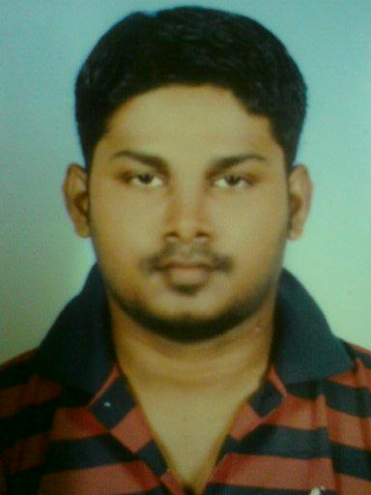

|  |
| --- |
| **PERSONAL DETAILS** |

|  |  |  |  |  |  |
| --- | --- | --- | --- | --- | --- |
| Name | : | Jeeva Ananthan A/L Ramiah | | | |
| Age | : | 27 | Nationality | : | Malaysia |
| Place of Birth | : | Selangor | Contact No. | : | +6 0149370150 |
| Marital Status | : | Single | E-mail | : | ajayraaj2@gmail.com |
| Address | : | B 213 JLN 19, Taman Muhibbah, | | | |
|  |  | 43300 Seri Kembangan , Selangor. | | | |

|  |
| --- |
| **OBJECTIVE** |

To seek an employment opportunity in a challenging environment in which I can fully utilize my abilities and skills in order to contribute to the success of my career growth as well as to the achievement of an organization’s objective.

|  |
| --- |
| **LANGUAGE PROFICIENCY** |

|  |  |  |
| --- | --- | --- |
| **Language** | **Speaking** | **Writing** |
| English | Good | Good |
| Malay | Good | Good |
| Tamil | Excellent | Excellent |

|  |
| --- |
| **QUALIFICATIONS** |

1. Certificates : STPM

Institution : SMK Rantau.N.S

Duration : 2006

1. Certificates : SPM

Institution : SMK Rantau,N.S

Duration : 2004

|  |
| --- |
| **WORK EXPERIENCED** |

**1. Company Name** **: EMDE MARITIME SDN BHD**

Position Title :Ordinary seamen(**Deck Trainee**)

Duration :Apr2013-Feb2014

**2. Company Name** **: SunInn’s Hotel**

Position Title : Front Office Assistance

Duration : Dec 2011- Nov 2012

**3. Company Name** **:** **Durge’s Transport Sdn. Bhd**

Position Title : Dispatch

Duration : Dec 2009-Nov2011

|  |
| --- |
| **COURSES ATTENDED** |

|  |  |  |  |
| --- | --- | --- | --- |
| **Certificate** | **Certificate No.** | **Valid Until** | **Institution** |
| Basic Safety Training | LUM/BST/2357/2013(META) | - | META (Manjung,Perak) |
| Tanker Familiarization | LUM/TF/2381/2013(META) | - | META (Manjung,Perak) |
| Basic Offshore Safety Emergency Training | BSTS/ERT-05/01211/14 | 20/06/2018 | BSTS (Miri,Sarawak) |
| Rigging & Slinging | BRS077/14 | 02/03/2017 | - |
| Food Handling | LPM368 | - | - |

|  |
| --- |
| **EXPERIENCE / SEATIME SUMMARY** |

|  |  |  |  |  |
| --- | --- | --- | --- | --- |
| **Company** | **Ship** | **Vessel Type** | **Rank** | **Period** |
| Jabatan Laut Malaysia | M.V.‘PEMANCAR’ | 1800 x 2 | Deck Trainee | 3 Month’s & Near Coastal |

|  |
| --- |
| **REFERENCE** |

Saifuzi bin Zakaria

Project Manager (Training Dept.)

EMDE Maritime Sdn Bhd

Tel: +609 573 9027

Fax: +609 573 9026  
  
. Mr. Nazaruddin   
 (in charger at hotel Sunn Inn’s)  
 h/p : 012 446 2585  
 E-mail : Enolkluang@gmail.com

Mr.Subramaniam Paraman  
 (Durge’s Transport Employer)   
 h/p : 019 374 7974