RESUME

**­­­­­­­­­­­­­­­­­­­­­**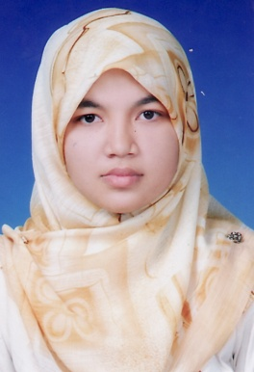

**PERSONAL PARTICULARS**

**Name :** Siti Husna Bt Othman

**Identity card No. :** 900406-02-5528

**Date of birth :** April 06, 1990

**Age :** 24 years

**Religion :** Islam

**Courses** **:** Bachelor of Business Administration

(Majoring in Human Recourse)

**Current Address** **:** No. 26, Kampung Masjid Lama,

Jalan Tualang,

06400 Pokok Sena, Kedah

**Hand phone No. :** 011-26606359

**E-mail** **:**  *husna.bt.othman@gmail.com*

**FORMAL EDUCATION**

June 2009 to June 2013 **Bachelor of Business Administration**

Faculty of Economic and Management,

University of Putra Malaysia

Serdang, Selangor.

CGPA: 3.126

2008 **Perlis Matriculation College**

2007 **Sijil Pelajaran Malaysia (SPM)**

Sekolah Menegah Kebangsaan Sultanah Bahiyah, Kedah

**WORK EXPERIENCE**

|  |  |  |  |
| --- | --- | --- | --- |
| **Bil** | **Company’s Name** | **Position** | **Year** |
| 1 | YTL Communication Sdn Bhd. (YES 4G) | Sales Promoter (part-timer) | 2011-2013 |
| 2 | J-mart Sdn Bhd | Store Keeper (part-timer) | Aug 2011- Sept 2011 |
| 3 | Pejabat Tanah Pokok Sena | Trainee at Financial Department | July 2012- Sept 2012 |
| 4 | UTS Marketing Solution | Telemarketer Executive | Dec 2013 - present |

**ACTIVITIES AND EXPERIENCE**

**Protocol committee members**  Mahasiswa Satu Malaysia Program organized by UPM

**Placement committee members** Jelajah Berbasikal Mahasiswa Satu Malaysia organized by UPM

**UPM Representative** Real Undergraduate Conference (RUC’10) Program

Real Undergraduate Conference (RUC’11) Program

**College Representative** Gerak Usahawan Siswa UPM II 2010 Seminar

Organized by UPM and Johor Corporation (JCorp)

**Volunteer**  Malaysian Government Open Sources Software Conferences (MYGOSSCON)  
Organized by ABLE (Administrative Modernizations and Management Planning Unit Malaysia, Prime Minister) and OSCC.

“Amazing Kids”

International Children Arts Festival 2011

Organized by the Ministry of Information,

Communications and Culture, Department of Culture

Karnival Kerjaya & Keusahawanan Graduan

Organized by Ministry of Education and UPM

**SKILL AND ABILITY**

* Excellent in speaking and writing Bahasa Malaysia
* Good in speaking and writing English
* Good in using Microsoft Office Word, PowerPoint and Excel
* Internet savvy
* Hardworking, patient, responsible, and highly motivated in every task assigned to.

**Expected Salary:** RM 2,000 (Nego)

**REFERENCE**

Mr. Neelamehan a/l Manickiam

Lecturer,

Faculty of Economics and Management,

University Putra Malaysia,

43400 Serdang,

Selangor