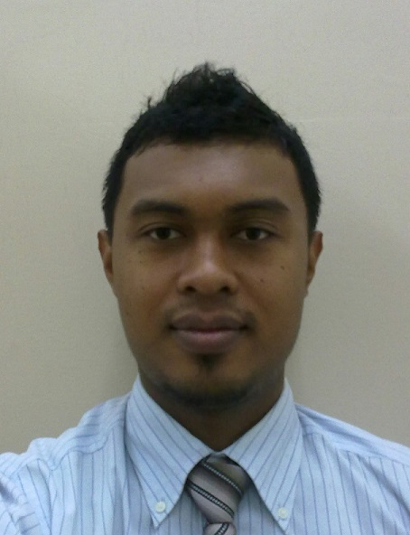

AZMAN BIN ADNAN

Objective: To gain extensive knowledge and seeking a challenging position in a company that will give opportunities for professional growth.

CONTACT DETAILS
Address : BLOK 27-04-10 R/P DBKL, FLAT SRI KEDAH, GOMBAK 1A, 53100 KUALA LUMPUR, MALAYSIA
Mobile No. : 012-6945604 & 019-3208768
Email : azman.weiyn@gmail.com

PERSONAL PARTICULARS

Age : 29 Years
Gender : Male
Date of birth : 11 Feb 1985
Marital Status : Married
Height : 179cm
Weight : 89kg

EDUCATIONAL QUALIFICATION
Bachelor of Business Administration (Hons) Islamic Banking. Universiti Teknologi MARA (UiTM), Shah Alam, Selangor D.E. Full time Student; Year from 2006 – 2008; CGPA 2.95
Diploma of Business Studies. Universiti Teknologi MARA (UiTM), Full time Student; Year from 2003 – 2006; CGPA 2.95

EMPLOYMENT HISTORY
Experience Level : Total 4 Year(s) of Experience
KLSOGO DEPARTMENT STORE SDN BHD
Senior Supervisor, Feb 2013 – Present
- Managed department staffs to provide sales & services in helping store to achieve sales target every month.
- Planning & coordinating the whole year sales and promotion for department
- Handling sales and promotion and dealing with the supplier to enhance the sales target. Work together with all level staffs & superior on improving sales & services.
- Prepare monthly sales management report and manage the department transaction.

MYDIN MOHAMED HOLDING BERHAD
Assistant Operation Executive – Internal Retail Audit, Feb 2010 – Feb 2013

- Conduct audit of branch processes, procedures and activities with the goal of highlighting company problem and recommend solution.
- Prepare audit report and recommend improvement for current branch processes and procedures.
- Coordinate with HQ OPERATIONS in the implementation of audit recommendation and other special project.
- Assist company in improving the effectiveness and efficiency and branches compliance with rules and regulations.
- Advise management regarding how to better execute responsibilities.
- Assist company in every setup of new opening and to ensure the new branch compliance with company policies and procedures.
- Perform other related duties as assigned.

MYDIN MOHAMED HOLDING BERHAD; Management Trainee – Retail, Aug 2009 – Feb 2010

- Managed department staffs to provide sales & services in helping hypermarket store to achieve sales target every month.
- Work together with all level staffs & superior on improving sales & services.
- Handling yearly annual stock take for hypermarket.
- Preparing the report on the sales & stock movement to management team.

SKILLS AND LANGUAGES
Computer Knowledge: Microsoft Office Specialist (MOS) Word, Excel, Power point.
Good in Bahasa and English.

TEXT RESUME / ADDITIONAL INFORMATION
2012 – 4 Branches in (Kedah & Perak): WTG, MJH, MRH, TSH
2011 – 4 Branches (Johor, Penang & N.Sembilan): KUH, STH, BJH, MAB
2010 – 2 Branches (Kelantan & Shah Alam): KKH, MSM
*UITM Facilitator; Modul Latihan Program Pembangunan & Kepimpinan Pelajar (LPPKP) UiTM, 2007/08
- Guide participants in building leadership and management skills.
- Constructed modules and tasks to facilitators.
*Vice President II of BBA (Hons) Islamic Banking Association (ISBA) internal society, 2007/08
*Vice Project Manager of BBA (Hons) Islamic Banking Family Day, June 2007
*Vice-President II of Kelab Fasilitator IPB, 2004

STRENGHT OBTAIN THROUGH EXPERIENCES
Personal Traits:

- Able to work independently with minimum supervision as well as a team player, fast and keen learner and willing to work long if required.
- Effective management of time and interpersonal skills.
- Honest, patient and Interest in learning new things and quick learner.
- Motivated and enthusiastic about developing good relation with clients.
- Able to persuade well with clients and colleague.
- Effective working alone or as a cooperative team number.

JOB PREFERENCES
Current Income : MYR 2, 700
Expected Monthly Salary : MYR 3, 500 (n)

REFERENCES

Puspha Nadarajah
Human Resource, AM
Mydin Mohamed Holdings Berhad,
H/P: 012-2646255, Email: puspha05@yahoo.com
En. Hilmey Bin Md. Aris
Assistant Manager (Branch Audit Team)
Mydin Mohamed Holdings Berhad,
H/P: 016-6595938

Danial Bin Othman
Human Resource Executive
Malayan Banking Berhad,
H/P: 019-2222987

