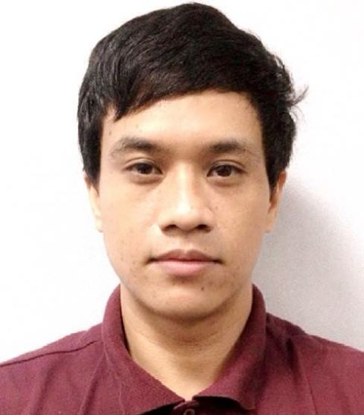
ALVIN A. BAJURA
50 Choa Chu Kang North 7, Block A,
#06-08, S689527
HP: 81946300 / 96835071
alvin-bajura@live.com

- 3 years work experience in Workforce Management (Real-Time Analyst)
- Knowledge in CMS, eWFM, IEX and Data Analytics
- Proficient in Microsoft Office and Lotus Notes
- Knowledge in Hardware/Software/Networking Troubleshooting

PROFESSIONAL EXPERIENCE

Assistant Engineer
Acer Computers Pte Ltd (Singapore) 17/01/2012 – 30/11/2013
- Troubleshoot hardware, software and network problems encountered by users (consumer/corporate).
- Configure, undo or customize Operating System settings as per end-user’s request
- Educate, advice and answer enquiries from end-users and on proper use of computers.
- Inform and advise users on repair status and ETA (Service Centre repair cases).
- Arrange onsite appointment schedule for onsite engineers to attend.
- Call and follow-up user on computer condition after troubleshooting/servicing.
- Discover and determine new specification/features of a new Acer model (Technical Platform) for enquiring customers.
- Handle technical escalation calls and provide resolution.

Campaign Executive 24/10/2011 – 30/12/11
Chartis Singapore Pte Ltd (Singapore)
- Call clients and offer insurance packages.
(Reason for leaving: Offered IT position from Acer Computers Pte Ltd)

Export Sales Executive 04/05/2011 – 08/08/2011
Pinnacle International Pte Ltd (Singapore)
- In-charge in exporting (used/new)cars to countries across the globe.
- Advertising vehicles on the internet and attending to client enquiries online.
(Reason for leaving: End of 3 months contract) .
Customer Service Representative(IT) 30/ 03/2009 – 02/02/2011
Convergys Philippines Services Corporation

- Provide troubleshooting to client’s computer(hardware, software and TCP/IP) and internet connection in an efficient manner.
- Help end-user properly to properly set-up router with the recommended settings.
- Help set-up end user’s browser settings, email account and anti-virus applications.
- Educate end user’s on proper computer use. Provide customer satisfaction.
- Administer team leader tasks for the team if supervisor is on leave or when appointed.

(Reason for leaving: Singapore job opportunity)

Real-Time Analyst 04/10/2006 – 15/04/2009
Aegis People Support

- Performs real-time monitoring and schedule adherence tracking on a 24 x 7 basis
- Facilitates agent skill assignment communication of all information relevant to staffing through CMS.
- Update employee and team data maintained in the workforce management software (absences, tardiness, )
- Call reports generation through MS Excel from raw files generated from CMS and e-WFM.
- Monitor hourly call volumes, handling time, and staffing requirements needed to maintain SLA.
- Alerts Operations management on threshold violations from agents (over auxes and long handling time).
- Monitors, tracks and reports agent schedule adherence and employee occurrences.
- Monitors and reports allocation to workforce management team that may trigger changes in staffing plan and schedule.
- Acts as cross-functional single point of contact with Information Technology and Telecommunication regarding system-related issues that impact production. Track and report issues and resolution
- Assists Operations Management with any schedule or staffing information requirement by contacting agents to perform overtime.
- Provide hourly report on staffing, calls received, calls abandoned on an hourly and daily basis to the client.
- In charge of approving agent leaves (Paid Time Off[PTO] and Volunteer Time Off[VTO]) based on production impact.

(Reason for leaving: Received job offer from Convergys Philippines)

EDUCATIONAL BACKGROUND

Diploma / Associate in Computer Science 2004
University of San Carlos - Cebu City, Philippines

PERSONAL PARTICULARS

Age: 29 Date of Birth: 27 November 1984
Nationality: Filipino Gender: Male

Earliest start date: Immediate
Nationality: Filipino
Status: Social Visit Pass
Reason for leaving: End of contract on 30 Nov 2013

