Curriculum Vitae
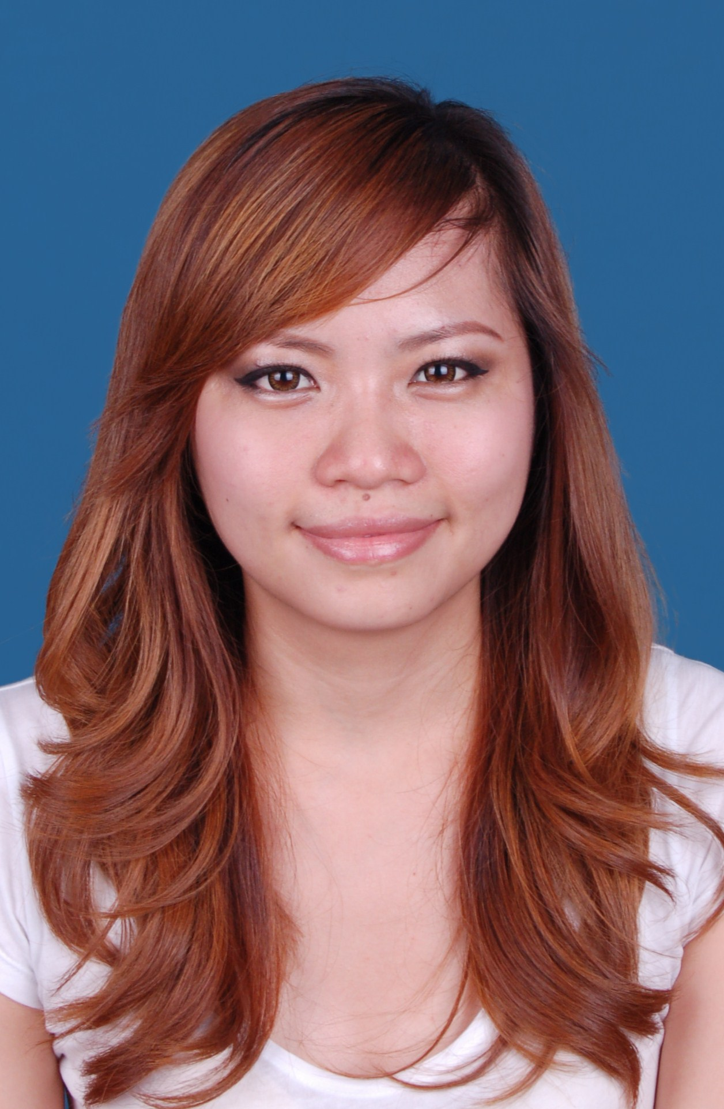
SEENA VERONICA KEE
CAREER OBJECTIVE
To seek a suitable position and role to meet my competencies, capabilities, skills, experiences and education for greater opportunity besides of to develop in a challenging and well established organization.
CONTACT INFORMATION
Address : G02-59 Marina Apartment, Pangsapuri Polo, Jalan Bentara Luar 1,
Taman Iskandar, 80500 Johor Bahru, Malaysia
Tel. Number : +60168930688 (Mobile)
Email : seenaveron@gmail.com
PERSONAL INFORMATION
Date of Birth : 6th October 1984
Place of Birth : Sibu, Sarawak
Citizenship : Malaysian
Gender : Female
Marital status : Married

EDUCATION
- Bachelor’s Degree in Business Administration (major in Human Resource Management), Open University Malaysia, Year 2013
- Diploma in Business Management, Universiti Putra Malaysia, Kampus Bintulu, Malaysia, Year 2006
- Sijil Pelajaran Malaysia, Sekolah Menengah Teknik Sibu, Sarawak, Malaysia, Year 2001

PROFESSIONAL EXPERIENCE
- December 2013 to May 2014: Account Manager (Manager), Business Banking Division, United Overseas Bank (M) Berhad, Citysquare, Johor Bahru, Malaysia
- Portfolio Management:
- Taking care of the existing business banking (SME) loan portfolios below MYR4.0Mil while maximizing the profitability of the portfolios assigned
- Conducting account review as well as additional loans’ application to achieve the target set by the management (as ‘farmer’ role)
- Ad-hoc requests for facilities utilization and maintain / retain relationship with customers / anti-attrition propositions
- Sales / Cross selling:
- Marketing and processing of loans’ application / originations for approval and acceptance
- Identifying FOREX business and referrals of commercial deposits / account openings
- Referring / cross selling of other banking products to other departments or peers under retail / consumer banking
- December 2008 to December 2013: Account Relationship Manager (Senior Executive), Commercial Banking Business Centre, RHB Bank Berhad Johor Bahru (year 2012 – 2013) and Sibu, Sarawak, Malaysia (year 2008 – 2012)
- Sales:
- Soliciting new potential commercial customers or portfolios (SMEs) and growing the existing portfolios.
- Processing and structuring of credit applications / originations including new additional facilities’ requests for management approval.
- Analyzing of financial statements and accounts’ performances as well as credit risks of the portfolios
- Portfolio Management:
- Monitoring of clients’ loan accounts for utilization, repayments and exposure.
- Conducting account review and monitoring existing accounts for ‘red flags’
- Relieving administration officer during their absence especially in monitoring daily accounts’ excesses (for commercial customers) as well as Bank Guarantee applications.
- Providing related consultations and attending to customers’ enquiries on commercial products, as well as related banking products while ensuring good customer service practice in daily encounter with customers.
(Been promoted to Senior Executive in May 2011)

- May 2006 to November 2008:Customer Service Representative (Executive), AmBank (M) Berhad, Sibu, Sarawak, Malaysia
- Customer Service:
- Attending customers’ enquiries on retail banking products, such as Savings Account, Current Account, Unit Trust, Insurance, Personal and Housing Loans.
- Maintaining good relationships with customers as well as practicing good customer service in daily works while achieving the bench mark set by the management.
- Opening of both saving and current accounts for customers and issuing of ATM cards.
- Sales:
- Promoting and cross selling of consumer banking products. Assisted customers in housing and personal loans’ applications.
- Branch Operations:
- Act as branch operation officer eg. replenish ATM, relief Chief Cashier, daily cash balancing, checking of daily branch’ transactions and act as custodian for security items.
- General administrative works:
- Filing, faxing, drafting of letters / memos and minutes, photocopying, compiling of reports, recording of security items / stationeries and others.
SKILLS:
- Good communication and interpersonal skills. Able to communicate with individuals from all ages and background.
- Fast learner and willing to learn
- Proficient in MS Office applications.
- Credit processing / originations and financials’ analysis
- Independent and able to work under minimal supervision. Able to adapt with fast paced working environment.
LANGUAGE PROFICIENCY
Written & spoken : English and Bahasa Malaysia
Spoken : Mandarin and Hokkien
Reference:
  - Mr Tiong Chung Teck (RHB Bank Berhad). Contact number: +6084323743
  - Ms. Norlela Binti Fredrick (AmBank). Contact number: +6084348746
  - Ms. Yvonne Tan (UOB). Contact number: +6072196300

