Professional Objective:
To achieve and innovate myself as an ideal knowledge worker.
To become associated with a manufacturing/production firm in which I would like to make a significant contribution and secure a good position.

Personal Particulars:
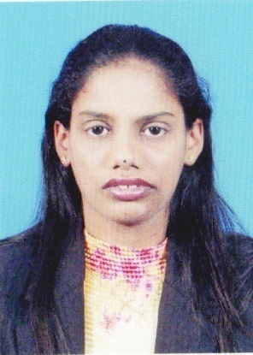

Name: Christina Mary a/p Arudas
Age: 32 years
Date of Birth: 03rd March 1982
Nationality: Malaysian
Gender: Female
Marital Status: Single
IC No: 820303-08-5798

Education /Qualification
1 Qualification: Advanced Diploma In Computer Studies
Grade : Grade C/2nd class Lower
Institute : Informatics Institute, Ipoh, Malaysia.
Graduated : 2003

2 Qualification: Professional Certificate In Computer Science
Grade : Pass/Non –gradable
Institute : Keris Institute,Ipoh, Malaysia
Graduated : Jan 2003

Certifications:1. Certificates in Information Technology and Communication (1) (2003)
2. IN-050-Web Publishing with HTML, JavaScript and Java (2002)
3. Computer Appreciation Course (2001)

3 Qualification: GCE “O” LEVEL
Grade : Grade II
Major : Science Stream
School : Sek.Men. Keb. Seri Intan, Ipoh
Graduated : 2000

Employment History:
Carsem (M) S-site Sdn.Bhd. (Jun 2004 until March 2014) as a Planner
Website Add : www.carsem.com.my

Work Description:
- Execute production order and ensure timely manufacturing.
- Forecast material usage and ensure adequacy
- Provide a weekly schedule based on the forecast plan given by customer.
- Monitor the output, check forecast versus actual out. – Follow up in overall pkg / device for that particular customer.
- Communicate with production team (supv / supr / mngr) and engineering team on the constrain they face to meet the commit, discuss, find a solution or recovery plan. Worst cases escalate the issue to customer for their advice (for some cases such as program issue / customer consign setup down). – Follow up in detail
- Monitor the performance – whether it meet our expectation or under expectation. – Follow up in detail
- Settle transaction issues with IT dept – Follow up in detail
- Provide daily report to customer, management and internal team for some focused devices / packages. – Follow up in detail and need to send the complete report daily and provide a valid reason & re-commit for the missed shipment.
- Well verse in SAP.
- Monitoring and updating current manufacturer/ supplier’s performance (quality, delivery, service).To carry out price review activities for existing purchase materials.
- To do routine update on material items, quantity and price in the system and records. Filing for all quotations, documents and others. To perform ad-hoc assignments when instructed, and assigned by.
the immediate superior.

Extra skills:
Queensland Institute of Information Technology (QICT) - March 2014 until August 2014 – Study Pastry Course under Culinary.

Working Skills:
The skills that I have and believe to be highly relevant to this job and your company which includes:
- Excellent planning skills
- Excellent customer service
- Good analytical thinking
- Ability to motivate team members
- Hardworking and passion to learn more about my job
- Good knowledge in handling logistic arrangements during normal and ad-hoc situation
- Good control of inventory management
- Purchasing and material planning based on production need
- Staying calm under pressure

Other Skills: Proficiency:
MICROSOFT PROJECTS Advanced
MES Advanced
GENESIS LIGHT Advanced
AXAPTA Advanced
SAP Advanced
MRP Advanced
Languanges (Spoken & Written):
English (Well Spoken & Written)
Malay (Well Spoken & Written)
Tamil (Well Spoken)

Personal Characteristics:
Bold and challenging, creative, highly motivated, well disciplined, energetic, good problem solver, passionate and eager to learn, resourceful, able to work under pressure and meet tight deadlines with minimal supervision.

