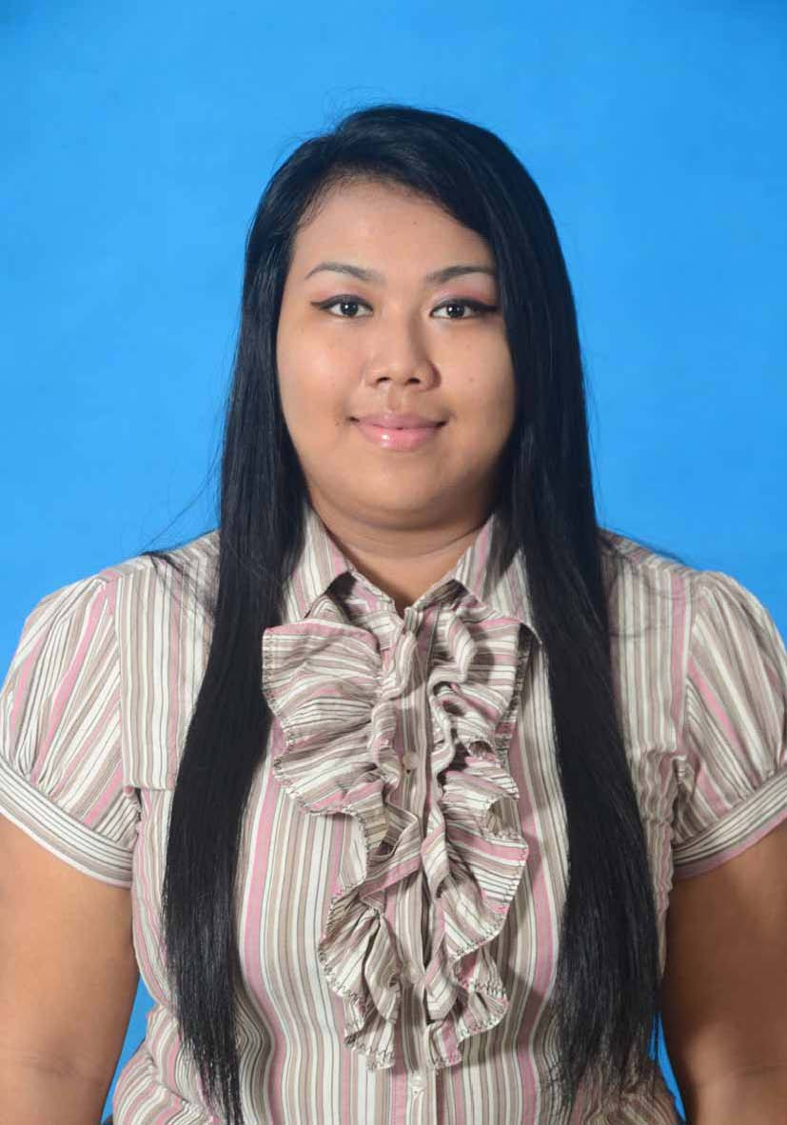

CURRICULUM VITAE

Bachelor of Human Resource Management
in Kuala Lumpur,Malaysia with Term GPA (3.27)
Present as Bachelor Degree.

PERSONAL DETAILS

NAME :DITA HUSNA NUROHMAN

MAJOR STUDY :Human Resource Management

PLACE OF BIRTH :Balikpapan,Indonesia

DATE OF BIRTH :18 NOVEMBER 1991

ADDRESS :Subang jaya,usj 3/3H 53200 Selangor,malaysia
GENDER :Female

Nationality :Indonesia

EMAIL :etavolt@gmail.com

TELEPHONE :+60 129048351

PROFILE

Career of my study has turned me to become a someone active in any organization and i can work in a team.

I am ambitious person,active,dynamic,multi task and hardworking.

Thought I have no experience yet but I learn a lot from people around me.I want to be success, i want to have a good careers and i will faith for that.

As a Bachelor Degree Human Resource of Management I could have give the best explanations including performance my skill to give the best challenge for the company.

EDUCATION

No | Education Background | Location | Year | Qualification
1. | American Liberty University | Malaysia,  Kuala lumpur | 2009-2012 | Bachelor Of Human Resource Management (3 years Study)
2. | APIIT University | Malaysia,  Kuala lumpur | 2009(3 months) | Foundation Program (1 year)
3. | Social High School | Balikpapan,  Kalimantan Timur | 2005-2008 | Social Environment(8A’s)
4. | Social Junior School | Balikpapan,  Kalimantan Timur | 2003-2005 | Social Organization  (Grade A,B )

OBJECTIVE

I am a fresh graduate with willingness to experience in communication,i can deal with people with good solution,great service,team player,vendor negotiations and management at an entry level.

WORK EXPERIENCE
Junior Research Analyst Cum Customer Service Associate BI-Lingual, Mayfair Technology ,Philippines-Manila (6 Month)
- Handling outbound and inbound calls
- Handling live chats
- Translator
- Working in teams to deliver high quality reports, peer-reviewed publications, and presentations to clients and at professional meetings
- Contributing to the development of protocols and statistical analysis plans.
- Handling Local & international Customer
- Maintains customer records by updating account information.
- Resolves product or service problems by clarifying the customer's complaint; determining the cause of the problem; selecting and explaining the best solution to solve the problem; expediting correction or adjustment; following up to ensure resolution.
- Maintains financial accounts by processing customer adjustments.
- Recommends potential products or services to management by collecting customer information and analyzing customer needs.
- Prepares product or service reports by collecting and analyzing customer information

Admin At Rental Equipment Mining Service EMECO, 2012,RENTAL EQUIPMENT (Temporary 8 months)
Job Description :
- Meeting and greeting clients
- Invoice Tracking,Follow Up
- Arranging couriers
- Keeping the reception area tidy, Answering Calls, and etc
Assistant Ambassadors ,at American Liberty University Kuala Lumpur 2011,(Temporary 6 Months)
Job Description :
- Giving tours of campus to prospective students and families
- Greet and provide directions, general information and assistance to visitors, students and staff.
- Attend Student Ambassador Professional Development
- Schedule campus visits and interviews for perspective students
- Mail requested College material within 24 hrs.
- Maintain and assist with tracking of Admissions Inventory
- Must Ready and Available by anytime

Public Relation of Even Organization Indonesia, 2010
CONCERT EVEN ARTIST.(Part Time 5 months)
Job Description:
- planning publicity strategies and campaigns
- writing and producing presentations and press releases
- dealing with enquiries from the public, the press, and related organisations
- Speaking publicly at interviews, press conferences and presentations, Interview and etc.

AWARDS

YEAR | EVENT
2008 | Modelling Coboy Costume 3rd Cup Indonesian Country
2008 | National and zone championship in chore competition
2009 | Public Of Speaking University event
2010 | TOEFL

LANGUAGE ABILITIES

English : Spoken & written (Excellent)

Malaysia : Spoken & written (Excellent)

Indonesia : Spoken & written (Excellent)

GENERAL SKILLS & STRENGTHS
- Leadership and management skills
- Keep good relationship with customers by giving good service
- Handled the customer problems by providing their needs
- Strong Organizational , Planning , and time management skill
- Plans and Schedules meetings Responsible
- Critical Thinking
- Decision Making
- Planner
SKILL BASE & COMPETENCES

- Familiarity with both the artistic and the commercial worlds, the
- culture of government, and Indonesian regulation
- Proven leadership and human management skills
- Time-efficient, Cooperation system
- Discipline
- Rapid adaptability to new problem-solving and new locations
- IT : MS WORD , MS EXCEL , MS Power Point , MS
Outlook, Internet browsing,Livechat,Etc

SOFT SKILLS

- Willing and ability to work under high Pressure
- Well interpersonal and cross-cultural communication skills
- Good in communication and collaboration with others
- Ability to adopt any changes in situation and working extra hours to archive a task
- Self Independent and fast leaner
- Multitask

WORK PREFERENCES

- Willing to work shift :Yes

- Willing to relocated :Yes,Any Area

- Expected monthly salary :Negotiable

- Availability :Immediate

- Eligable To Work Overseas :Yes

EXECUTIVE SUMMARY

With 4 years study as human resource management is learn me alot of things.and some experienced as well really making me how to be a good handle person.i am looking for better career for my future that is way i am interested with this position.please acccept my application and i am available at anytime.i hope to hear a good decision after the consideration from you.

