RESUME

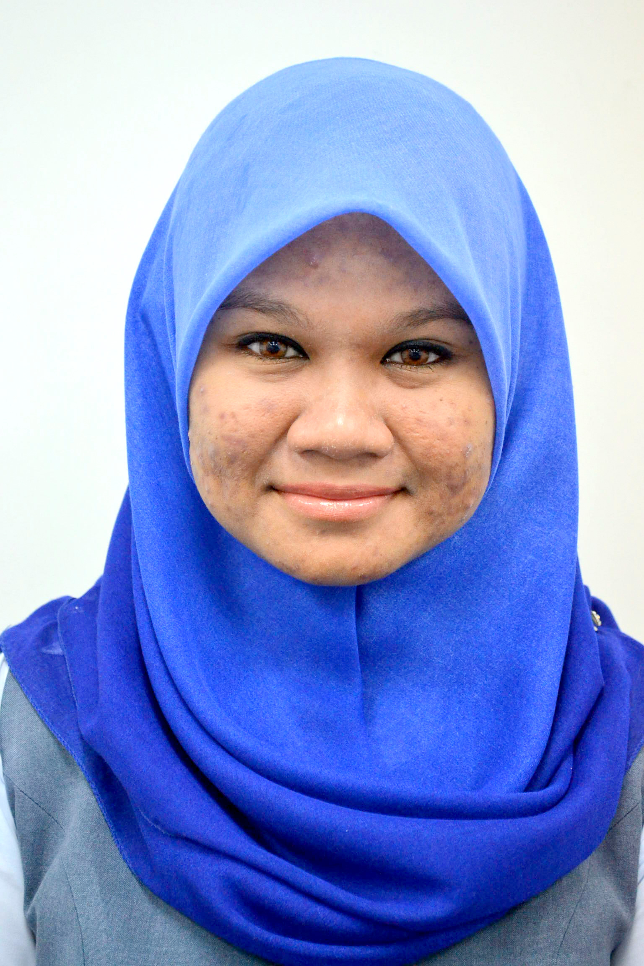

FARA ILLYANNA ABDUL GHANI

Lot 451A
Lorong Haji Zahari Ismail
Jalan Sungai Berteh
41100 Klang
Selangor Darul Ehsan
Phone: 016 2414816
Email: glamorous_elle@yahoo.com
PERSONAL PARTICULARS

Date of Birth : November 19, 1984 Race : Malay
Place of Birth : Klang, Selangor Religious : Islam
NRIC No : 841119-10-5384 Marital Status : Married
Height : 163 cm
Weight : 65 kg

OBJECTIVE

To pursue a career in the field of Human Resource, Psychology and Human Factor as well as to acquire knowledge and experience in an organization especially in Human Resource function. Also, to obtain a challenging position with a dynamic organization and to support the organization’s growth as well as for own improvement and achievements.

CAPABILITIES

Highly motivated, responsible and hard working. Fast learner and energetic as well. Able to cope up with any kind of situation and can handle with pressure. Willing to learn any new job function. Capable of doing project as a team and a leader. Organized and able to perform quality work for the organization. Computer literate from a very basic application to developing a system. Good command of English, both spoken and written.

EDUCATION BACKGROUND

1991-1996 Sekolah Rendah Sungai Udang
Ujian Penilaian Sekolah Rendah : 3A 1B

1997-2001 Sekolah Menengah Kebangsaan (P) Bukit Kuda
Penilaian Menengah Rendah : 4A 3B 1C
Sijil Pelajaran Malaysia : 2A 5B 1C 1D (Grade 1)

2002-2003 Matrikulasi Sains Hayat Kementerian Pendidikan Malaysia
(Kolej Teknologi Timur)
CGPA: 3.18
Malaysian University English Test : BAND 4

2003-2007 Universiti Malaysia Sarawak (UNIMAS)
Bachelor Degree of Cognitive Science
Current CGPA: 2.66

SKILLS

- Language
 | Speaking (1-10) | Writing (1-10)
Bahasa Melayu | 10 | 10
English | 10 | 9

- Computer literacy

Microsoft Office (WORD, Excel & Powerpoint) | Excellent
Lotus Notes | Excellent
Internet and Web browser | Excellent
QuickPay, Quick TMS | Excellent
Adobe Photoshop | Average

- Training attended

Bengkel Keselamatan Sosial Pekerja | 2008
Kursus Obligasi Majikan dan Akta KWSP | 2008
Labour Law – Understanding and Its Implementation | 2010
The EA Form Seminar – Employer’s Tax Reporting on Employee’s Salary and Benefits | 2011
Managing Difficult Employees | 2012

WORKING EXPERIENCE

- August 2008 – Current
Position : Human Resource Executive
Company : Hitachi Chemical (Selangor) Sdn. Bhd.
(formerly known as Nitto Denko Electronics (M) Sdn Bhd.)
Current salary : RM 3,300.00
Responsibilities :
- Handling salary matters for the staffs including Overtime and allowances.
- Processing salary every month using Quickpay.
- Monitor and register new staffs.
- Calculate overtime, monitor and analyze overtime activity.
- Monitoring staff’s attendance (fingerprint activity for attendance).
- Liaising with Government bodies such as EPF, SOCSO and LHDN.
- Liasing with participated agencies for monthly salary deduction matters such as PTPTN, Lembaga Urusan Tabung Haji dan Lembaga Zakat Selangor.
- Attend to staff’s request or query related to salary matters.
- Prepare reports for Audit.
- Responsible for recruitment such as screening candidates, interview and employment.
- Responsible for personnel expense forecast and budget.
- Staff Management
  - Appointment new staff
  - Resignation
  - Staff confirmation – monitoring and letter confirmation
- Employee record update
  - Maintaning personal files
- Leave management – monitoring staff’s consumption of leave
- Prepare and generate HR report
  - Preparing payroll report every month to be submitted to Accounts.
  - Prepare Manpower report, Attendance Report and Overtime Report to for monthly achievement report.
  - Prepare headcount report to HQ Japan
  - Prepare manpower planning (yearly budget) and staff requisitions.
  - Prepare personnel expense and budget.
- Employee benefit
  - Medical card management
  - Employee ID card (Canteen card)
  - Employee claim (mileage, medical claim, company donation)
  - Staff Advance

- June 2007 – August 2008
Position : Human Resources Assistant (Recruitment)
Company : Sunway Group (Group Human Resources)
Current salary : RM 1,470.00
Responsibilities :
- Shortlist candidates based on qualifications and requirements from Website (Jobstreet and ELX), write-in and walk in candidates and Recruiter email.
- Phone screening (phone interview) for first screening procedure.
- Interview arrangement (calling up potential candidates for interview).
- Liase with Recruitment agency (Headhunter) for interview arrangement and candidate profiling.
- Advertisement (vacancy) insertion in Jobstreet and internal (within the group).
- Conducting 1st interview for the position of Drivers.
- Handling brief interview for walk-in candidates.
- Tracking down each and every candidate from first screening until being hired.
- Reference checking for potential to be hired candidates.
- Offering employment.
- Handling Inernship application, preparing Internship letters and liase with certain University for Internship procedure.
- Take part in Career Fair and Career Talk in local universities and colleges.

- May – August 2006
Position : Human Resource Assistant (Internship)
Company : Concorde Hotel, Shah Alam.
Responsibilities
- 3 months practical.
- Temporarily replacing the HR assistant while she was on maternity leave for 2 months.
- Report to HR manager.
- Preparing payroll report every end of the month for staff’s wages.
- Preparing monthly report (Human Resource Development Report).
- Issuing order for staff café using FIDELIO system.
- Responsible for staff’s leave application and annual leave.
- Managing new hires and resignation.
- Took part in HI-TEA Staff Annual Party.
- Prepare offer letter for new staff and pre-employment medical checkup letter.
- Track down staff’s turnover monthly.
- Arrange practical trainee’s department and designation.

- May – Jun 2005 (During semester break)
Position : Salesgirl
Company : Jewellery Tradeworld (Shaw Centrepoint, Klang).

- March 2005 (Temporary)
Position : Research Assistant
Company : Regroup Associate (Wisma Hopoh, Kuching)

- March – August 2004 (During semester break)
Position : Dental Nurse
Company : Dental Clinic Phua & Lai (Klang)

EXPECTED SALARY

RM 4,000 (negotiable)

REFERENCES (colleague)

Mohd Ishak bin Hashim
Senior Executive (Human Resource)
Hitachi Chemical (Selangor) Sdn. Bhd
03 55417733 ext 124

Noorsalezawati bin Beraldin
Human Resource Officer
Hitachi Chemical (Selangor) Sdn. Bhd
03 55417733 ext 125

