Personal Information
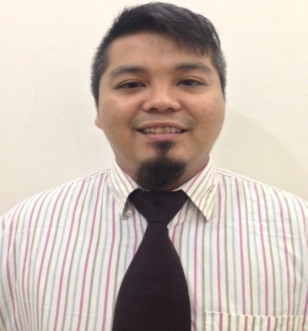 | Name | : | Mohd Khidir Bin Moktar
 | Nationality | : | Malaysian
 | Date of Birth | : | 22 February 1981
 | Place of Birth | : | Malaysia, Selangor
 | Marital Status | : | Married
 | Languages | : | English & Malay
 | Working Exp. | : | > 9 Years.
 | Email Address | : | key_dier@yahoo.com
 | Contact No. | : | +6019-6372628

Employment History

Company Name : CANNON FAR EAST (M) SDN BHD
Position Title : SENIOR SERVICE TECHNICIAN
Position Level : Senior Executive
Specialization : Engineering – Others
Industry : Repair & Maintenance Services
Duration : Oct 2009 - Present
Monthly Salary : MYR 2800.00
Allowance Others : MYR 500.00
Work Description :

- After sales service and maintenance specialist of Cannon Machine.
- Responsible to troubleshoot any breakdown of the machine at customer place.
- Troubleshoot any failure either mechanical or electrical parts.
- Troubleshoot the electrical wiring connection, PLC error and pneumatic system.
- Service such as hydraulic unit, motor, pumps, valve and etc.
- Responsible to provide efficient communication towards Clients.
- Handle start up new machine and new project planned.
- Commissioning and calibration procedure.
- Provide training to clients.
- Technical support
- Clients in automotive, refrigerator, oil and gas piping, furniture industries.

Company Name : Freescale Semiconductor(M) Sdn.Bhd
Position Title : Line Technician
Position Level : Non-Executive
Specialization : Maintenance/Repair (Facilities & Machinery)
Industry : Semiconductor/Wafer Fabrication
Duration : July 2005 - Sep 2009
Monthly Salary : MYR 1600
Work Description :

- Responsible the line production machine from front until end.
- Responsible production machine always in normal and good condition.
- Troubleshoot and repair machine if breakdown.
- Set up machine if needed to do conversion from 1 product to other product
- Done preventive maintenance machine.
- Repair failure of the machine when it broke down either the mechanical, software or electronic.
- Have experience on handling Asymtek, Micron, Shibuya and etc machine.

Educations

Qualification : Advanced/Higher/Graduate Diploma
Field of Study : Engineering (Electrical/Electronic)
Major : Electronic Information Technology
Institute/University : German Malaysian Institute(GMI), Malaysia
Graduation Date : 2005

Qualification : Professional Certificate
Field of Study : Engineering (Computer/Telecommunication)
Major : Electronic Communication
Institute/University : Institut Kemahiran Mara Johor Bahru, Malaysia
Graduation Date : 2002

Others

Language spoken English & Malay.
- Microsoft Office Advance user.
- Advance Computer hardware & software skills.

Skill Years Proficiency

Troubleshooting Skills >8 Advanced
Technical Skills >8 Advanced
Mechanical Engineering >5 Advanced
Electrical Circuit Troubleshooting >8 Advanced
Calibration and commissioning >5 Advanced
PLC Troubleshooting >8 Advanced

Job Preferences

Expected Monthly Salary : MYR4000 (nego)
Willing to Travel : Yes
Possess Own Transport : Yes
Availability : Immediately after notice period of 1 month(s)

