footprinting and reconnaissance.
Step 1: Open Recon-ng in the Kali linux, enter below command to search the library. Command “marketplace search”

Aim: Recon -ng Commands:
1. marketplace search
2. --marketplace search ssl
3. --marketplace info ssltools
4. marketplace install hackertarget
5. modules load hackertarget
6. show options
7. options set SOURCE tesla.com
8. run

Aim:- Use of FOCA Tools.
Step 1: Open FOCA Tool, goto project -> select new project.
Step 2: Enter the URL then click the “Create” button domain name = www.sncollege.com
Step 3: Select the search engine and add the extension. Click on the “Search all” button.=engine= google,doc,ppt.docx,pdf . then search all
Aim : USING TRACE ROUTE
Step 1: Open cmd prompt.
Step 2: Type cd\ and enter it will redirect to “C/directory”. (Coming to c: directory root diretcory )
Step3 :Type tracert command and type www.reddit.com and press “Enter”.
Step 4: Type tracert command and type ipaddress of reddit.com and press “Enter”.(198.41.209.142)
Ping:
Step 5:
This practical is used to find out the MTU of the destination machine.
We ping a computer using the ‘p
To specify the data length in bytes we use –lswitch
To specify that the packet should not be fragmented we use –f
We now have to adjust the –lvalue till we get a reply. The border where the reply is received is said to be its MTU
Ping 192.168.2.1 –l 1478 –f in next iteration redduce the 1478 value so will get the received packets also =1472

TraceRoute using Ping
• We can perform traceroute by using the –n and –Iswitches.
• -n means number of replies to show and –Imeans obtain reply from the machine in the next hop
• Open command prompt
• Ping certifiedhacker.com –n 1 –I1
Ping 192.168.2.1 –l 1500 –n 1
In next : ping 192.168.2.1 –l 1500 –n 1 -f

• Above, the local router replies back.
• Keep on increasing the I value until the certiedhacker.com site directly replies to the ping.
• At each I value, the device in the route will reply back
Ping certifiedhacker.com –n 1 –i 2 u will see sent packet count but no received packet . incerse i= 14 its will give packet if not keep incresing .

NSLookup:

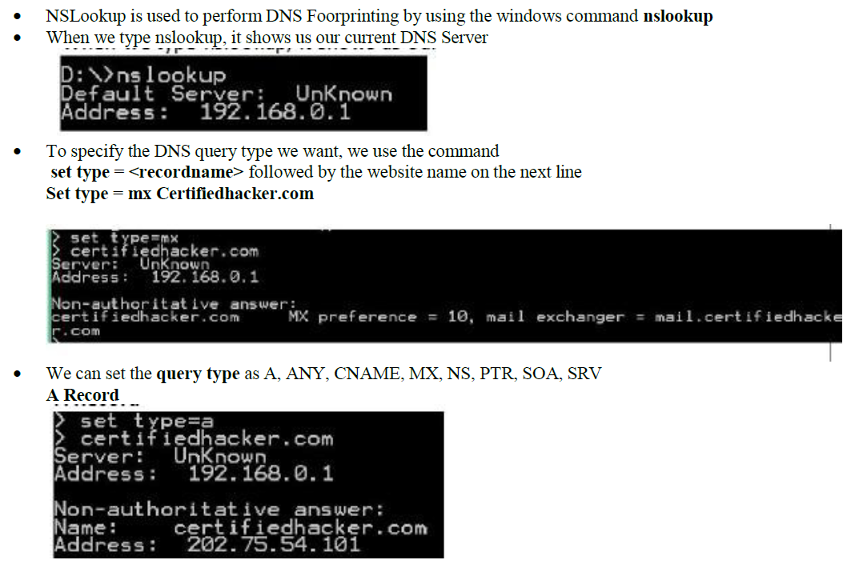

Aim: HTTrack Website Copier :
Download / open httrack application .
Start > Programs > HTTrack Website Copier -> Click on 'Next' to create Project > Give a name to project Click on 'Next'
SmartWHOis
SmartWHOis is used to perform WHOIS Footprinting against an entered IP Address or a Domain Name
Run it from, Start > Programs > SmartWhois
Type an IP address, hostname, or domain name in the address bar
A window will be there enter certifiedhacker.com at right side query = Autodetect
Different queries will return different results.
• IP Address / Hostname Query results

USING EMAIL TRACKER : not done
Hping2 / Hping3
Hping is a command-line TCP/IP packet assembler and analyzer tool that is used to send customized TCP/IP packets and display the target reply as ping command display the ICMP Echo Reply packet from targeted host. Hping can also handle fragmentation, arbitrary packetsbody, and size and file transfer. It supports TCP, UDP, ICMP and RAW-IP protocols. Using Hping, the following parameters can be performed: -
Test firewall rules.
Advanced port scanning. Testing net performance. Path MTU discovery.
Transferring files between even fascist firewall rules. Traceroute-like under different protocols.
Remote OS fingerprinting & others
• To create an ACK packet: root@kali:~#
hping3 –A 192.168.0.1

To create SYN scan against different ports: root@kali:~# hping3 -8 1-600 –S 10.10.50.202
To create a packet with FIN, URG, and PSH flags setsroot@kali:~# hping3 –F –P -U 10.10.50.202
ii. Advanced IP Scanner
Advanced IP Scanner is a fast and powerful network scanner with a user-friendly interface.In seconds, Advanced IP Scanner can locate all computers on your wired or wireless local network and scan their ports. The program provides easy access to various network resources such as HTTP, HTTPS, FTP, and shared folders.
Open advance Ip scanner - enter ip 192 .168.0.90-110
i. Angry IP Scanner
Angry IP Scanner (or simply ipscan) is an open-source and cross-platform network scanner designed to be fast and simple to use. It scans IP addresses and ports as well as has many otherfeatures.
It is widely used by network administrators and just curious users around the world, includinglarge and small enterprises, banks, and government agencies.
Open – iprange -195.80.116.0 to 195.80.116.255
Hostname = e-estonia.com ip /24 then start
III. Masscan:
Click the Terminal icon in Kali> sudo apt update->sudo apt install masscan-> sudo masscan -p22,80,445 192.168.1.0/24 That’s it u will see output
CurrPorts : open the software .open chrome . and open google . then see the curport u will see the process.
CurrPorts is a network monitoring tool for Windows that shows all active TCP/UDP connections and the processes using them. See all TCP and UDP connections currently open on your system.Useful for checking which applications are communicating over the network.Identify unknown processes opening network ports.Can help in malware analysis or detecting Trojan-like activity.Shows programs that are waiting for incoming connections.Useful to check if a server program is running correctly.Gather Detailed Connection Info
Colasoft : open colosoft software . create new packet . : install from internet . from top right click add. Choose protocol . from left see details . slect -> send -> start
Colasoft packet builder offers Import and Export options for a set of packets. You can also adda new packet by clicking Add/button. Select the Packet type from the drop-down option.
ARP -Maps IP addresses to MAC addresses in a local network.Works only in the local network (LAN). IP -Encapsulates data so it can travel across networks.Contains source and destination IP addresses. TCP-(Transmisison control proto)Provides reliable, connection-oriented communication between two devices.Ensures data arrives in order and without errror. UDP- user dtagram protocol . Provides connectionless, faster communication.No guarantee that data arrives or arrives in order. • No handshake (no SYN/ACK like TCP) → less overhead → faster data transfer.vdeio streaming.
The Dude : launch the app. Go to maps . Discover . in name-10.5.104.0/24
The Dude network monitor is a new application by MikroTik which can dramatically improve the way you manage your network environment. It will automatically scan all devices within specified subnets, draw and layout a map of your networks, monitor services of your devices andalert you in case some service has problems.
Nmap : open cmd
Use the ip of pc in ur netwoek .
nmap 192.168.1.10. scana singe ip
nmap -sn 192.168.1.0/24 Find All Online Devices on Your Network
nmap -p 1-1000 192.168.1.10 Scan for Open Ports
nmap -p 22,80,443 192.168.1.10 scans for specific port
nmap -sV 192.168.1.10 – detecct service version .
sudo nmap -O 192.168.1.10 – check os
nmap 192.168.1.0/24 scan entire lan
nmap -Pn 192.168.1.10 scan without ping if firewall blocks

Zenmap : opne inside targer add – sncollege.com -> choose profile like intense scaning
Netstat : Command Prompt . netstat = Show All Active Connections
netstat –a = Show Active Connections + Listening Ports
netstat –ano Show Process ID (PID) for Each Connection

Nessus : Nessus is a vulnerability scanner used to find weaknesses in systems, networks, and servers.

NTFS Stream Manipulation. ADSs filename.extension:alternativeNmae
Write file using cmd .
C:\test>echo “This is test context ” > file_1.txt press enter
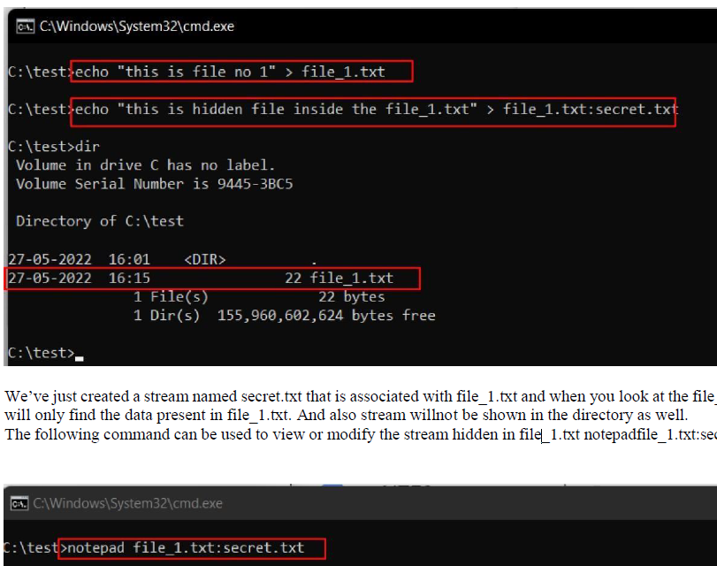

The following command has used the copy the trojan.exe into a note.txt(stream) C:\test>type Trojan.exe > note.txt:Trojan.exe
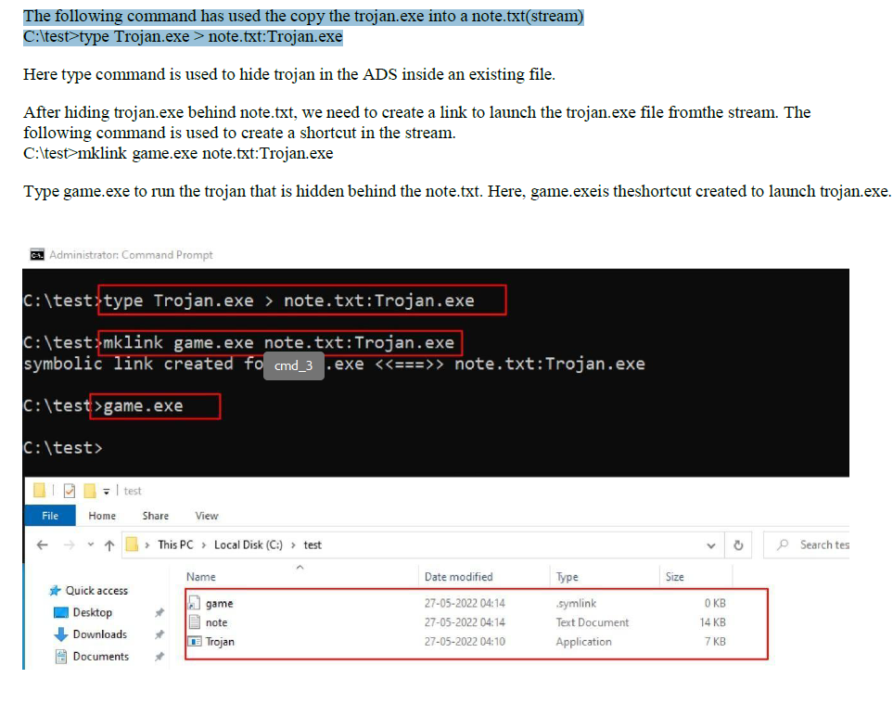
ix. Clearing Audit Policies
Enabling and Clearing Audit Policies
To check command’s available option Enter C:\Windows\system32> auditpol /?
Enter the following command to enable auditing for System and Account logon: - C:\Windows\system32>auditpol /set /category:"System","Accountlogon"
/success:enable /failure:enable
To check Auditing is enabled, enter the command C:\Windows\system32>auditpol logon","System"/get /category:"Account
To clear Audit Policies, Enter the following command C:\Windows\system32>auditpol /clear
Are you sure (Press N to cancel or any other key to continue)?Y
Go to Logs folder: u will see .

Start Wireshark.:
ping testphp.vulnweb.com then cpature the ip 44.228.249.3 the n satr the wireshark in the top search bar put the ip adress 44.228.249.3 . go on that https://testphp.vulnweb.com and enter the user id and password as test come back to wire shark and open and see for text success entery .

Under the “Capture” header, select the “Interface List” option; orclick on the “Interfaces” button on the toolbar:
This will bring up a list of network interfaces that Wireshark is able to capturepackets from:
Examining HTTP Traffic
The HTTP traffic that occurs during web browsing.
• Stop and close any capture that you may have open, and start a new capture.
• Set the filter to show only HTTP traffic.

Start with the HTTP request sent from your web browser.
• In your web browser, navigate to some webpage like http://www- scf.usc.edu/~csci571/Special/HTTP/proxy.html.
• In the top frame of the Wireshark main window, look for the packet that corresponds to your request. This contains the URL in the “Info” section. Selectthis packet.
• In the middle frame of the Wireshark window, expand the “Hypertext TransferProtocol” section. Notice the details given for the:
o GET request
SMAC is a Windows-based tool that allows you to change (spoof) the MAC address of your network adapter.
Shankar Narayan College 48
B. Use SMAC for MAC Spoofing.
SMAC is a MAC address changer that has a simple-to-use graphical interface that enables the less experienced user all the way up to the guru to change a piece of hardware’s MAC address. The less experienced user will appreciate the random generator whereas the guru will appreciatethe ability to hand enter a new MAC address.

Aim: Use Social Engineering Toolkit on Kali Linux.
Step 1: Select social engineering toolkit in the Kali Linux.
Step 2: Select option 1. Social engineering attack
Step 4: Select Credential Harvester attack method
Step4: Select option 2 Site cloner.
Step 5: Enter IP of the local server and URL of the attacking site Step 6: now enter the ip in the browser, you will find clone website:
Step 7: You can see in the terminal the user id and password is being displayed.

a. Aim: Perform the DDOS attack using the following tools
I. HOIC
Step 1. Open hoic2.1.exe, once it open click on the “+” button
Step2: enter the url you want to attack, then click on add button. = visionsoftplus.com
Booster= generic booster hoic

Using Burp Suite to inspect and modify traffic between the browser and target application

Open Burp Tool: Click on next

Click on start Burp

3. Select Proxy in the tab:
4. Go to proxy setting:

5. Click on Edit:
6. Change the port number in our case its change from 8080 to 9000. And then click on OK.

9. Now go to the firefox browser: goto settings or preference depending on the version:
10. Search for proxy in the search bar and then click on setting:
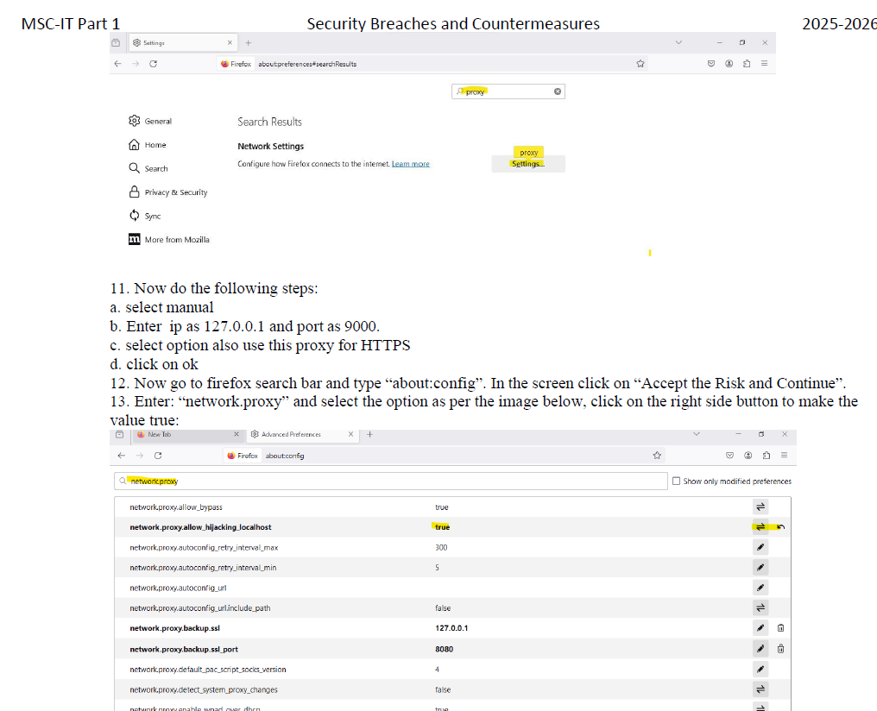

14. go to web security academy, login and select academy go to:
15. scroll dow click on all path button:
15. click on button “resume” on server side validation section:

17. Once the lab is open click on start the interception on in the burp tool. Note in he browser you will find page is not loading.

18. To load the field click on forward button.
Note you will have to click multiple time to load the entire page.
19. click on the first grid view details button:
20. Click forward on the burb application, go to request query parameter:
21. change the value of the productid to 3. Click on apply changes:

a. a. Perform Web App Scanning using OWASP Zed Proxy. Website = sncollege.com

Step 1. Open Zed Proxy, click on quick start enter he URL and click on attack. Step 2: go to report generate report, click on generate report:
Step 3: Output

Aim: Use the following tools for cryptography.

i. HashCalc
Calculating MD5 value using HashCalc
Open HashCalc tool : select data format . add key and check boxex.-> calculate

CrypTool : Cryptool is a free e-learning tool to illustrate the concepts of cryptography. Try Various Encryption/Decryption algorithms.
Install cryptool -?> at the top encrypt / decrept . go to key enter the key . enter alphabet character . it will show char no . clcikc encrypt / decrept it will show the windows according .
Havji : pasword dakrnet123

Havij : Open the Havij Application, in the target add any of the vulnerabilities site. We will be using below venerable URL: http://redtiger.labs.overthewire.org/level1.php?cat=1

