**GCMSBuddy**

* Domain: [www.gcmsbuddy.com](http://www.gcmsbuddy.com)
* Main Theme:
  + <https://websitedemos.net/plant-store-02/>
  + Similar color scheme
* Other Themes for influence:
  + <https://websitedemos.net/plant-shop-04/>
  + <https://websitedemos.net/garden-maintenance-02/>
  + <https://websitedemos.net/gardener-02/>
* The name will always be written as “GCMSBuddy”.
* There will be two components:
  + Front End - Visible to the user
  + Back End - Visible to the administrator and our employees
* Front End will have the landing page, user account and access, the products page and the payment gateway to process the payment.
* Back End will have the user database, order management, automated email management and other capabilities.
* User visits our website to order products listed. They create an account first to place an order and it is reflected under the order status page. The whole ordering process is explained in the Back End description of the website.
* We also have a partner website, where users place an order. The payment is handled by the partner website, and only after a successful payment, the user is re-directed to our website for further processing of the order.
* Payment will be processed in 3 currencies using the below payment gateways:
  + USD - Stripe
  + CAD - Stripe
  + INR - PayU

**Front End**

**Website Structure:**

* Home Page with the details about the website and services
* Product Order Page with all the products listed with payment buttons
* Contact Us Page
* FAQs
* User Account:
  + Register/Login (for new user or users who are not logged in)
  + Order Status (for registered user, who are logged in)

**Home Page Structure:**

* Menu
  + Services
  + FAQs
  + Login/Register or My Account (Based on user status)
  + Contact Us
  + Order Now (Highlighted in a box)
* Sections
  + Slider
  + Our Services
  + Why Order GCMS Notes
  + How to Order GCMS Notes
  + Why Use GCMSBuddy
  + Order Now
  + Footer

**Home Page Sections**

**Slider:**

* A slider with multiple images and text with an “Order Now” button linking to the Order page.
* The images will be provided.

**What are GCMS Notes:**

Global Case Management System (GCMS) is a centralized system used by Immigration, Refugees and Citizenship Canada (IRCC) to process applications for immigration and citizenship. The GCMS notes contains detailed records of each application to IRCC, which includes, the complete application file, the supporting documents submitted by the applicant, correspondences sent to and/or from IRCC and detailed comments made by the officers who review the applications. These notes can be used to get an insight in to the processing of the applications. They also help in knowing the status of the application and taking the necessary steps, if required.

**Our Services:**

*(The below list will be shown with some icons and a “Know More” link with a pop-up window or “i" icon with window appearing with information, when we hover the icon, for more information about each product)*

* GCMS Notes
* CBSA Notes
* CSIS Notes
* Notes Review
* PNP Application Status

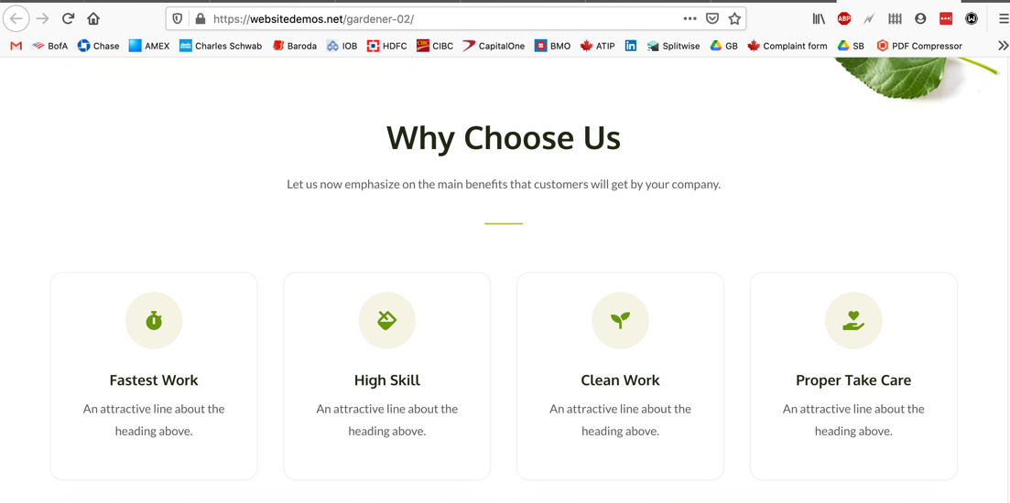

**Why Order GCMS Notes:**

*(This will be listed with icons and text together in one line, just like it is mentioned on the current website, but with better appearance)*

* To Track Your Application Status
* To Understand Your Application File
* To Prepare For The Next Steps
* To Know Reasons For Refusals

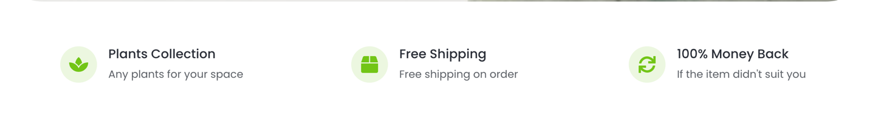

**How To Order:**

* **Create an account:** Register for an account on our website using your email address
* **Choose the type of notes you want:** GCMS Notes Basic, GCMS Documents, GCMS Notes Advanced Plus, CBSA Notes or CSIS Notes. If you want an explanation of these Notes, add the Explanation Report as well.
* **Select the payment currency:** You can pay in either USD or INR
* **Checkout using a Secured Payment Gateway:** Make the payment using a credit/debit card using our secured payment gateway.
* **Provide the relevant information about your application:** Please provide all the required information and avoid any errors, in order to avoid processing delays
* **Send us the Consent Form**: After the payment, you will receive an automated email with the consent form and the instructions to fill the form, please sign that form and after checking the details, email it to us. Once we receive the signed consent form, we will process your request
* **Receive Acknowledgement:** Once your request is processed, you will receive an acknowledgement email
* **Check Status:** You can check the status of your request on our website under the Order Status tab.
* **Notes Delivered**: Your notes will be emailed to as soon as we receive it

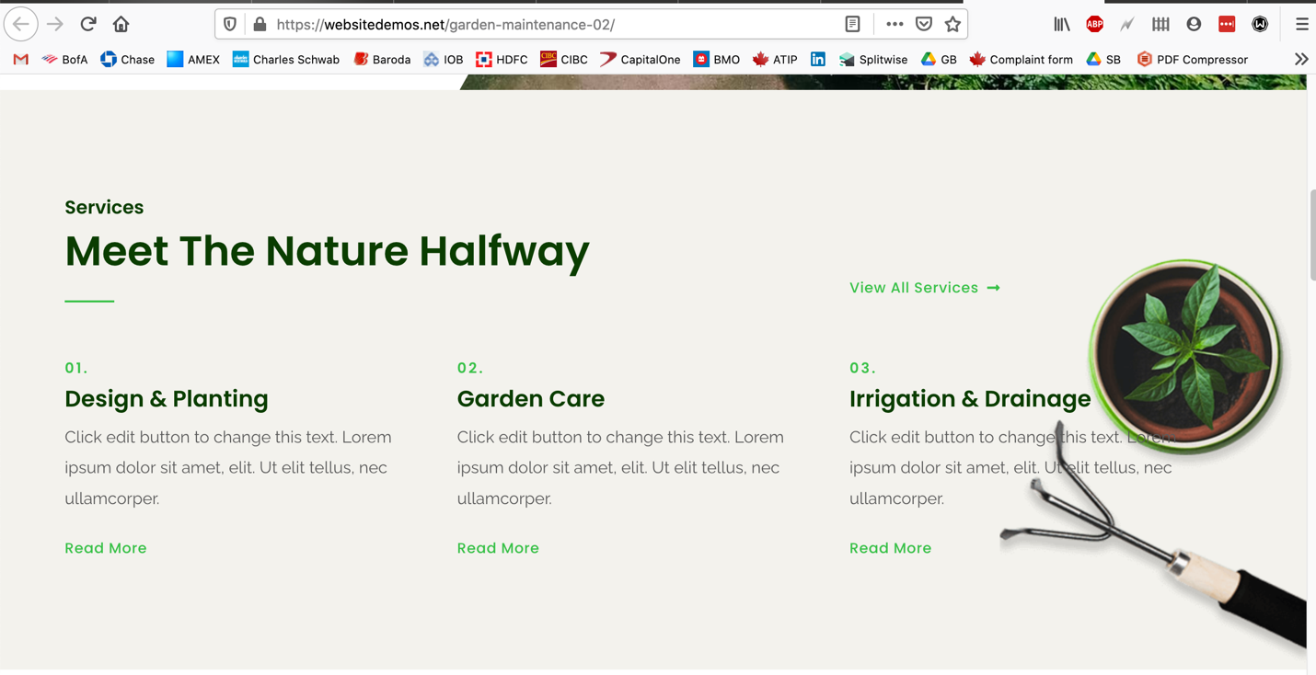

**Why Use GCMSBuddy**

Here’s Why GCMSBuddy Beats All The Other Websites

* **Competitive Prices**

We offer the most competitive prices than others on all of our services. We are not here to make profits but to help the applicants in ordering their GCMS/CBSA Notes, and that’s why our prices are low.

## Secured Account for Easy Access

Only on GCMSBuddy you create an account which helps in securely storing your information. This account can be used to track the orders and place multiple orders.

## Data Security & Privacy

Data security and privacy is our #1 concern and we do everything to protect it. We use secured servers and emails. Your personal information has restricted access across our organization.

## SSL Encryption

We use SSL Encryption to securely transmit the data. This ensures that any data transmitted between your web browser and our server remains private and integral.

## Same Day Order Processing

The order is processed on the same business day on which we receive the consent form. For the consent forms received after the business hours on Friday, we process the orders on Monday.

## Payment in Multiple Currencies

Our website accepts payment in USD and INR using secured payment gateways. Alternate payment options also available upon request.

## Quick Response Time

We reply to the emails or messages within 24 hours.

## Multi-Channel Support

We offer support via multiple channels: WhatsApp Messenger, Facebook Messenger and Email.

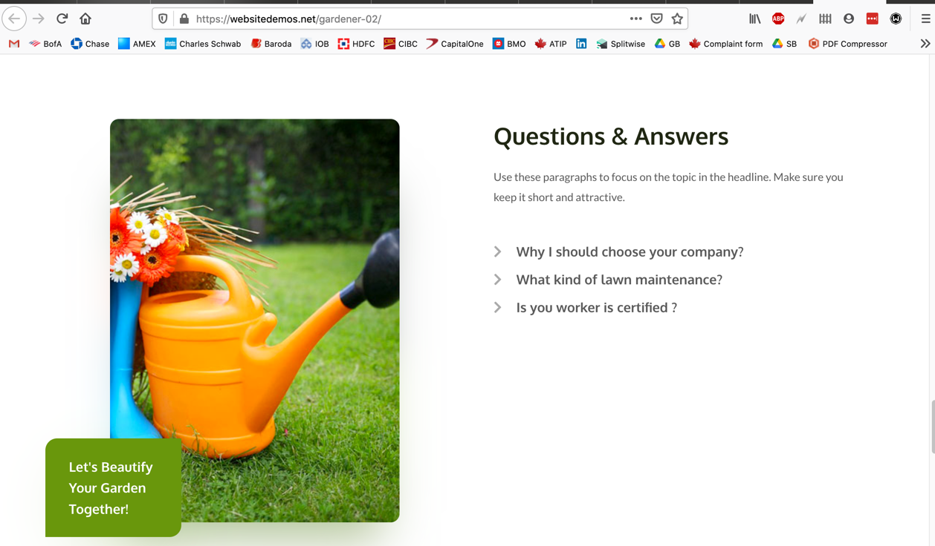

**Order Now:**

*(BG Image with 1 line and Order Now button)*

Let’s Get The Information About Your Application

Order Now Button

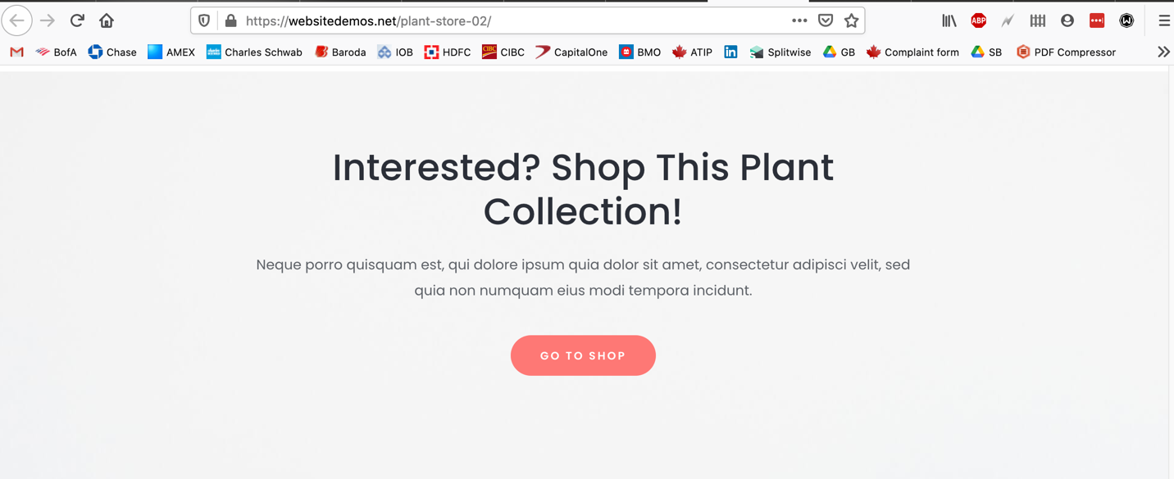

**Footer:**

Logo Contact Information Our Services Important Link

Text Email: [support@gcmsbuddy.com](mailto:support@gcmsbuddy.com) GCMS Notes Terms & Conditions

Text WhatsApp: +1 716-253-1415 CBSA Notes Privacy Policy

Text Mon - Fri: 9 am to 5 pm EST GCMS Review Refund Policy

Text FB and WhatsApp Link Settlement Services Partner with us

(Copyright info)

SSL and Payment Logos

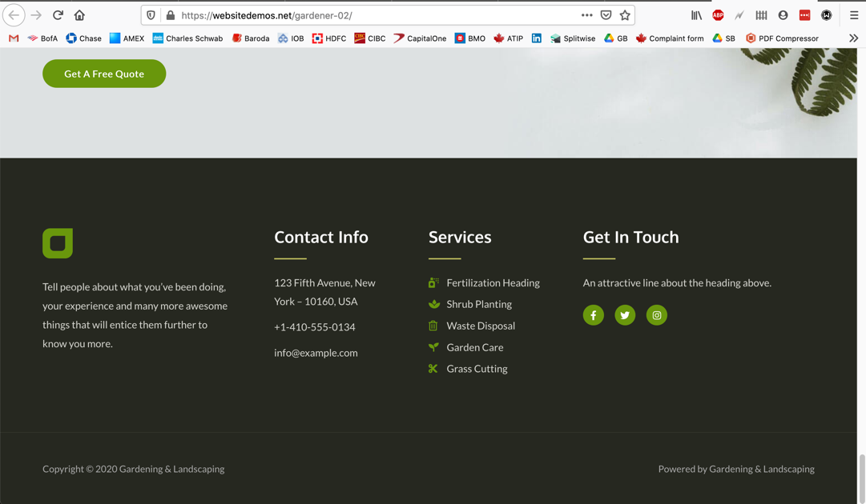

**Order Now Page**

*(This is where all the products will be listed with their description and payment buttons)*

Some introductory text here

*(Pricing Table is required here, need to discuss how to build the pricing table)*

**Products:**

* GCMS Notes Basic
* GCMS Documents
* GCMS Advanced Plus
* CBSA Notes
* CSIS Notes
* Notes Explanation Report
* GCMS Notes Basic + Explanation Report
* GCMS Advanced Plus + Explanation Report
* CBSA Notes + Explanation Report
* Notes Review
* PNP Application Status - Will redirect to a separate contact form

#### In case you are not able to use any of the above payment method and need an alternative, please let us know by using the **Contact Us (hyperlink)** form. We will try to provide an alternate payment method as per your convenience.

**Order Information Forms:**

*(These are the forms where the user will be redirected after the payment is successful to enter their order details)*

* GCMS Basic and GCMS Documents - With/Without Explanation
* GCMS Advanced Plus - With/Without Explanation
* CBSA Notes - With/Without Explanation
* CSIS Notes
* Explanation Report and Notes Review
* GCMS Basic from MyImmiTracker - Our Partner website

*(Need to make sure that the above pages are only accessible once and only after a successful payment)*

**Thank You Page:**

*(A thank you message for the order and the next steps, user will be redirected here after submitting the order form)*

**Product Descriptions:** *(For pricing table)*

|  |  |  |  |
| --- | --- | --- | --- |
| **GCMS Basic** | **GCMS Documents** | **GCMS Advances Plus** | **CBSA Notes** |
| USD 12.99  INR 999  CAD 16.99 | USD 12.99  INR 999  CAD 16.99 | USD 12.99  INR 999  CAD 16.99 | USD 12.99  INR 999  CAD 16.99 |
|  |  |  |  |
| Electronic GCMS Notes of the  immigration and citizenship  officers | Copies of your application and supporting documents sent to/from IRCC | Combination of the Basic GCMS Notes and the GCMS Documents | Notes from CBSA to check the status of Security Check or Screening |
|  |  |  |  |
| Delivered by email in 35-40  days from the day of application | Delivery time varies and is longer than Basic GCMS | Delivery time varies and is longer than Basic GCMS | Delivered by email in 45-50 days from the day of application |
| Pay in USD  Pay in INR  Pay in CAD | Pay in USD  Pay in INR  Pay in CAD | Pay in USD  Pay in INR  Pay in CAD | Pay in USD  Pay in INR  Pay in CAD |

**Order Forms**

**GCMS Basic/Documents/Advanced Plus**

Primary Applicant:

Family Name (Surname): Text Box

Given Name(s): Text Box

Date of Birth (yyyy/mm/dd): Date Picker/Calendar

Visa Application Number: Text Box

Email Address: Text Box

Spouse/Common Law Partner - Yes/No: Radio Buttons

If yes, then

Spouse

Family Name (Surname): Text Box

Given Name(s): Text Box

Date of Birth (yyyy/mm/dd): Date Picker/Calendar

How did you hear about us? Text Box

Submit Button

**CBSA Notes/CSIS Notes**

Primary Applicant:

Family Name (Surname): Text Box

Given Name(s): Text Box

Date of Birth (yyyy/mm/dd): Date Picker/Calendar

UCI Number: Text Box

Visa Application Number: Text Box

Email Address: Text Box

Spouse/Common Law Partner - Yes/No: Radio Buttons

If yes, then

Spouse

Family Name (Surname): Text Box

Given Name(s): Text Box

Date of Birth (yyyy/mm/dd): Date Picker/Calendar

UCI Number: Text Box

How did you hear about us? Text Box

Submit Button

**MyImmiTracker**

Primary Applicant:

Family Name (Surname): Text Box

Given Name(s): Text Box

Date of Birth (yyyy/mm/dd): Date Picker/Calendar

Visa Application Number: Text Box

Email Address: Text Box

Spouse/Common Law Partner - Yes/No: Radio Buttons

If yes, then

Spouse

Family Name (Surname): Text Box

Given Name(s): Text Box

Date of Birth (yyyy/mm/dd): Date Picker/Calendar

How did you hear about us? Text Box

Submit Button

**Contact Forms**

**Generic contact form on contact us page:**

Full Name:

Email:

Subject:

Tracking Number:

Message:

Email will be sent to [support@gcmsbuddy.com](mailto:support@gcmsbuddy.com)

Subject: Contact Form “Subject Entered”

Body:

Full Name:

Email:

Tracking Number:

Message:

This message was sent through the Generic Contact form on [www.gcmsbuddy.com](http://www.gcmsbuddy.com)

**Partner with us form on home page:**

Full Name:

Email:

WhatsApp Number:

Message:

Email will be sent to [support@gcmsbuddy.com](mailto:support@gcmsbuddy.com)

Subject: Partner with us “Subject Entered”

Body:

Full Name:

Email:

WhatsApp Number:

Message:

This message was sent through the Partner with us form on [www.gcmsbuddy.com](http://www.gcmsbuddy.com)