**Player-Match-Team Assignment**

**Name – Tejal Sanjay Londhe**

**Batch – B**

**player (player_id, pname,speciality,date_of joining,num_matches,team_id)**

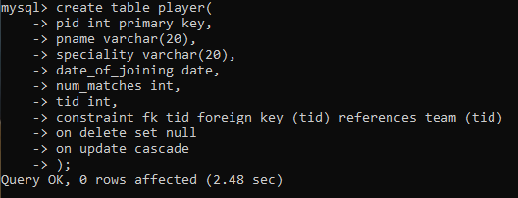

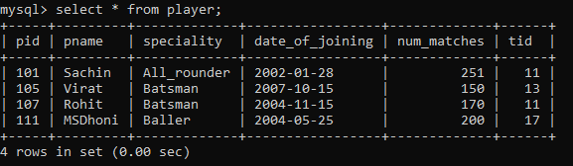

**team(team_id, tname,player_num)**

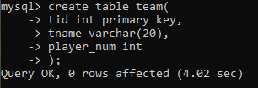

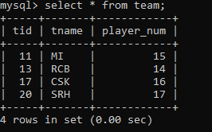

**matches(match_id , team1_id,team2_id,match_date,winner,man_of_the match)**

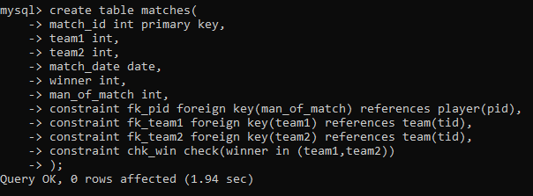

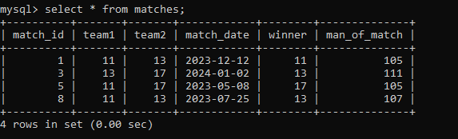

**simple query**

**1. display all players playerid, player name and experience**

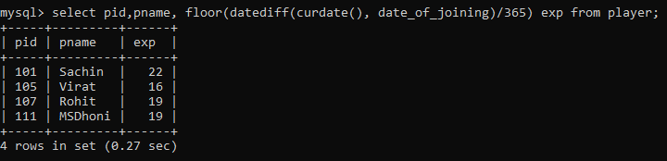

**2. display all player with experience > 5 years**

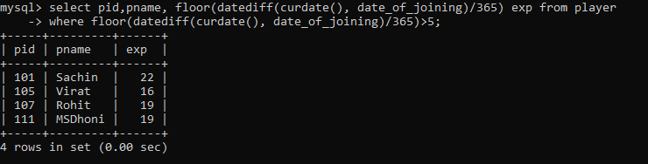

**3. display all players joined in march month, any year**

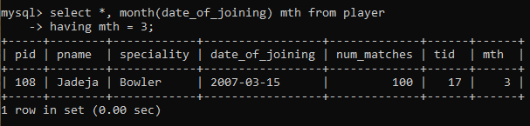

**4. display all players joined in march 1995**

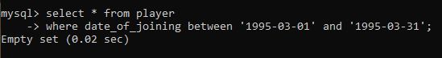

**5. display all player with number of matches played are either 5 or 10 or 8**

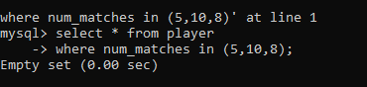

**6. display all employees who are either batsman, bowler**

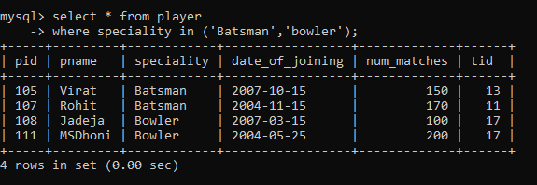

**7. display all employees who joined in year 1995 or 1996 or 1997**

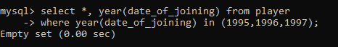

**Nested query**

**1. list all player who plays in virat kohali’s team**

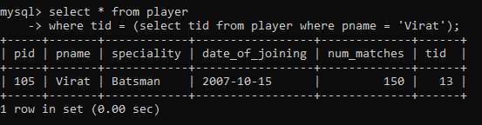

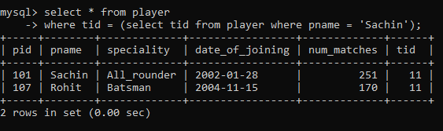

**2. list all players who played matches in year 2024**

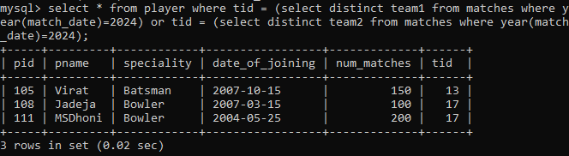

**3. list all matches in which man of the match is from team1**

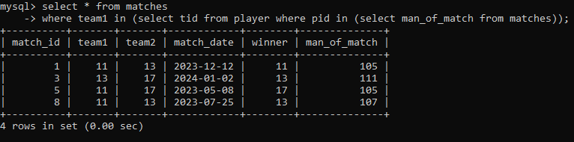

**4. list all matches in which man of the match is from team2**

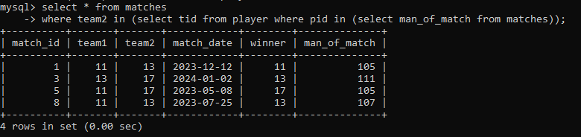

**5. list all matches in which csk team win.**

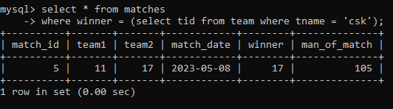

**6. list all matches in which either csk or rcb team won the match**

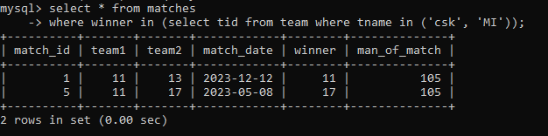

**7. list all teams who one at least one match**

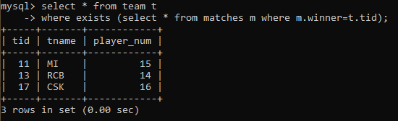

**8. list all teams who does not played any match**

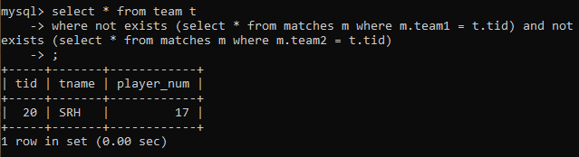

**9. list all team name, in which no players are their**

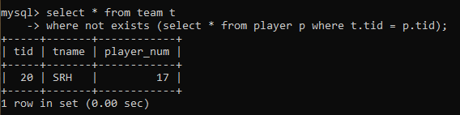

**10. list all players who are in dhoni’s team**

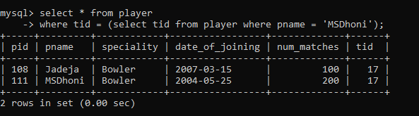

**11. list all players who are in either dhoni’s or virat’s team**

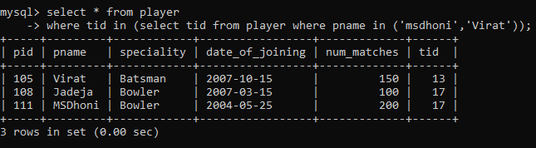

**12. find all team names who won more than 3 matches**

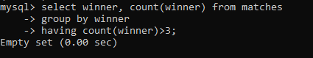

**or**

