Write SQL statement for the following

1. To find all managers with salary >1500

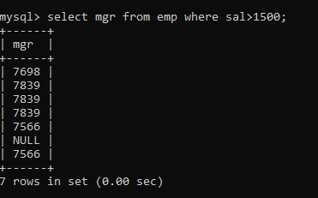

1. list all employees with sal >1200 and < 2000

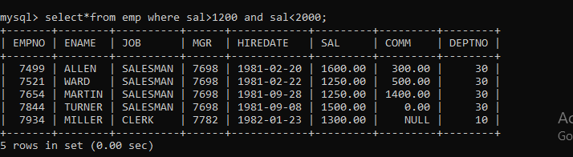

3. list all employees with sal is 1600 or sal is 800 or sal is 1900

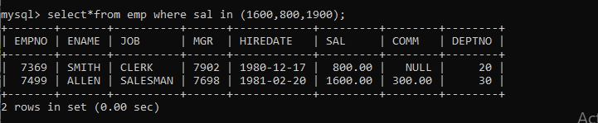

4. list all employees with R at second last position in name

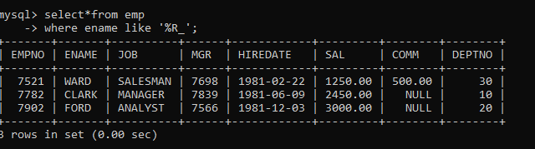

5. List all employees with name starts with A and ends with N

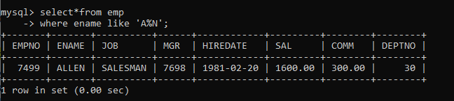

Q2. Solve following

1. list all employees with salary > 1250 and dept no=30

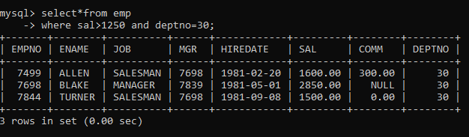

1. list all employees with salary >=1250 and <= 3000

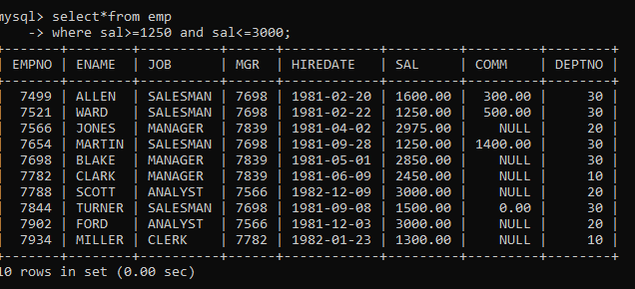

1. list all employees with salary >1250 and < 3000

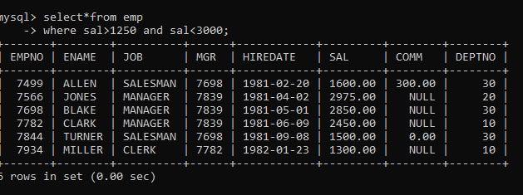

1. list all employees with salary either equal to 3000 or 1250 or 2500

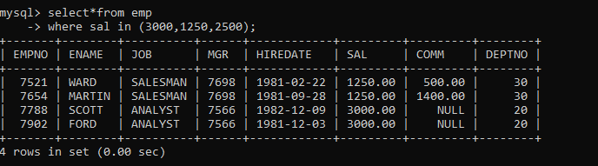

5. list all employee with name=SMITH

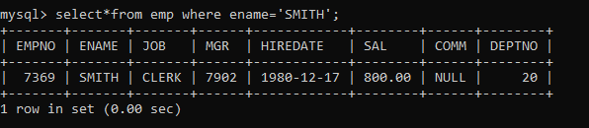

6. list all employees with name starting with S

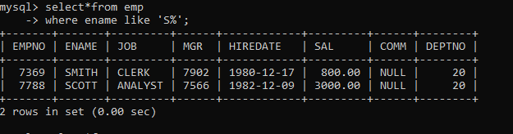

7. list all employees with name ending with S

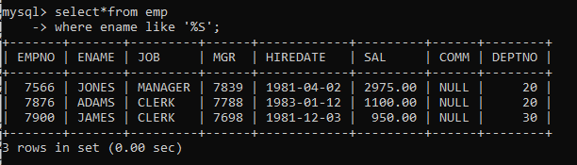

8. list all employees with name contains I at 2nd position



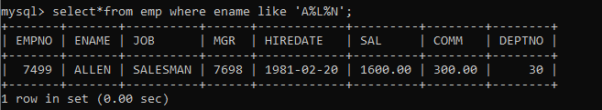

D:\Batch_A_39_89\2.10.PNG

