**WELCOME console:**

**Output of the project:**

**File Names in an Ascending order**

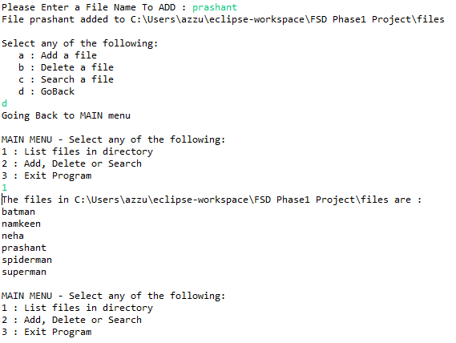

**Deleting a file**

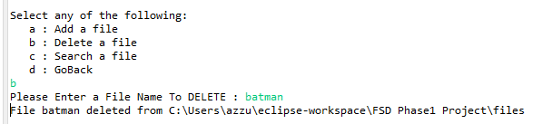

**Search a file**

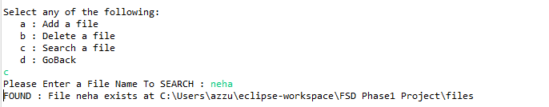

**Close the application**

