**WELCOME console**

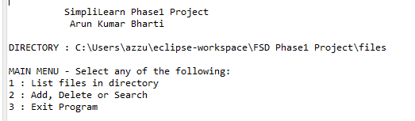

**Press 2 to add ,delete and search option then press “a” to add a file**

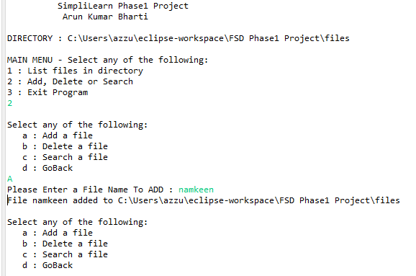

**File Names in an Ascending order**

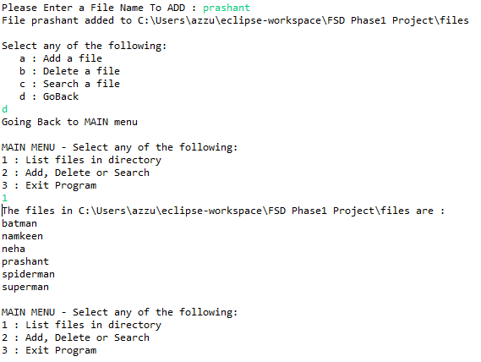

**Deleting a file**

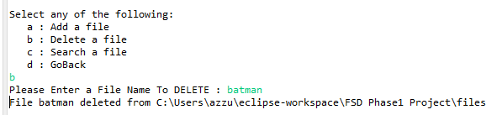

**Search a file**

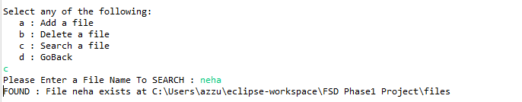

**Close the application**

