User CRUD Implementation Steps
This document records the work completed to generate, run, verify, and document the metadata-driven React 18 / TypeScript CRUD screen for the User entity.

Work Log
- Inspected the workspace and confirmed there was no existing React application structure to extend safely.
- Created a dedicated feature folder at src/features/user-crud to keep the CRUD module isolated and reusable.
- Defined strict TypeScript contracts for metadata fields, the user form shape, supported roles, and persisted records.
- Built a metadata-aware CRUD hook that generates default values, creates the Zod validation schema, manages edit state, and simulates a 1 second API delay for create and update flows.
- Implemented a dynamic form that maps field metadata into semantic inputs, accessible labels, inline validation messages, and a Radix switch for the boolean field.
- Implemented a responsive entity list that renders mobile cards and a desktop table, with accessible edit and delete actions.
- Composed the main screen with the schema configuration, summary metrics, form orchestration, and the entity table.
- Added Vitest and React Testing Library coverage for render, validation, create, and edit workflows.
- Scaffolded a minimal Vite + React 18 host application because the workspace originally did not contain a runnable frontend shell.
- Installed the required dependencies and added a Playwright capture script to generate deterministic screenshots from the running app.
- Verified the implementation by running npm test, npm run build, and the local Vite dev server.
- Captured runtime screenshots and appended the original prompt to this documentation.

Verification Status
- Runtime verification date: March 19, 2026
- Local application URL: http://127.0.0.1:4173/
- Test result: npm test passed
- Build result: npm run build passed
- Screenshot capture: completed with Playwright

Generated Files
- src/features/user-crud/types.ts
- src/features/user-crud/useCrudLogic.ts
- src/features/user-crud/DynamicForm.tsx
- src/features/user-crud/EntityTable.tsx
- src/features/user-crud/CrudScreen.tsx
- src/features/user-crud/CrudScreen.test.tsx
- src/main.tsx
- src/styles.css
- src/test/setup.ts
- package.json
- vite.config.ts
- tsconfig.json
- tsconfig.app.json
- tsconfig.node.json
- scripts/capture-screenshots.mjs
- docs/UserCrud_Implementation_Steps.docx

Captured Screens

1. Initial Dashboard State
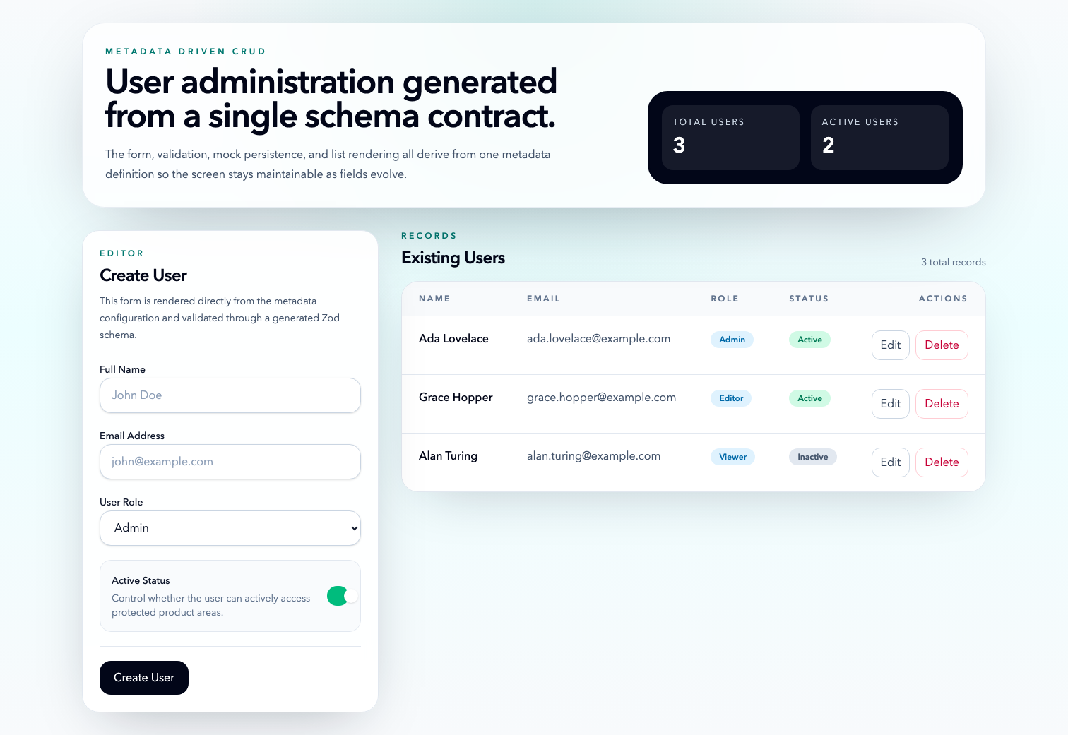
Initial dashboard state
The default state shows the metadata-driven form, the seeded records, and the aggregate counters rendered from the in-memory data set.

2. Edit Mode
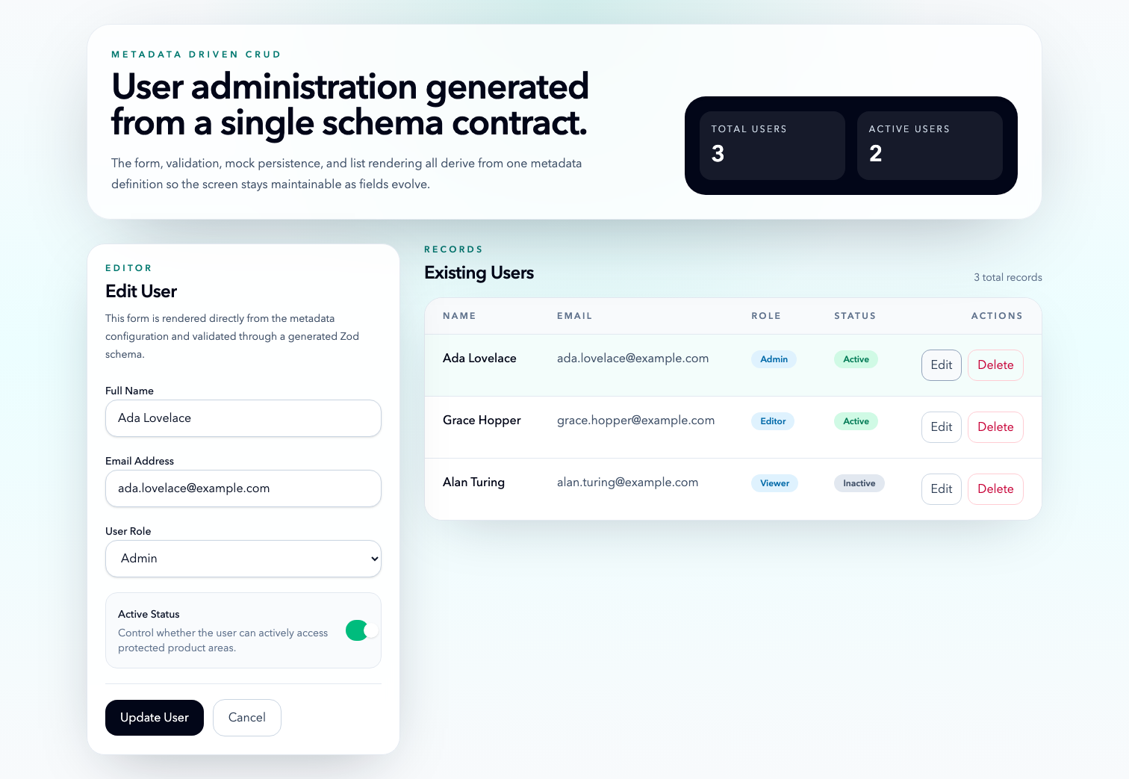
Edit mode state
The form switches into edit mode when an existing user is selected, while the corresponding row remains highlighted in the record list.

3. Updated Record State
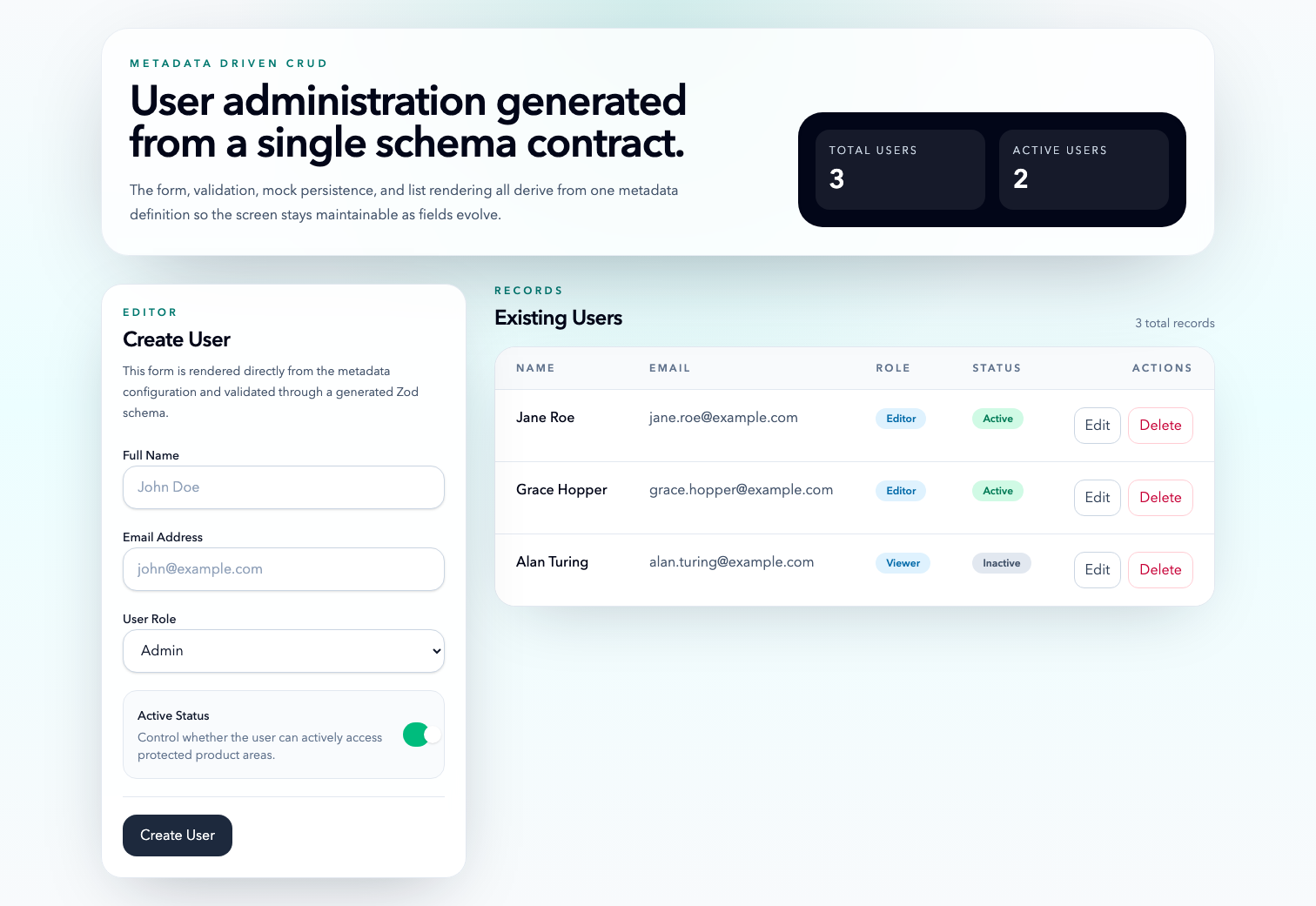
Updated record state
After the one-second simulated API delay, the updated record is reflected in the list and the edit state clears.

4. Created Record State
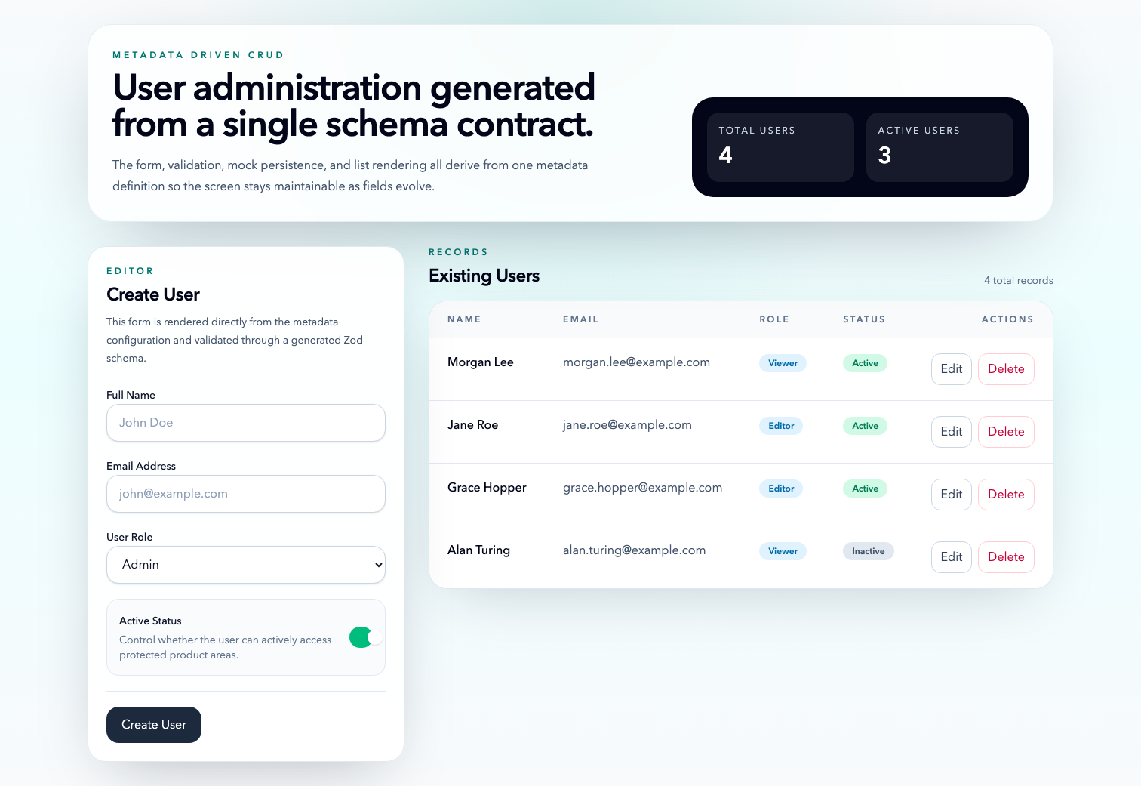
Created record state
A newly created user is inserted at the top of the list and the header metrics update immediately after the mock create request resolves.

Original Prompt
Role:
You are a Senior Frontend Architect and GenAI Specialist. Your goal is to generate a production-ready, metadata-driven CRUD (Create, Read, Update, Delete) screen.
Context:
Framework: React 18 / TypeScript
Styling: Tailwind CSS (Responsive design)
State Management: React Hook Form with Zod for validation
Component Library: Headless UI or Radix UI (accessible primitives)
Metadata Configuration (The Schema):
Use the following JSON schema to drive the UI generation:
JSON
{
"entity": "User",
"fields": [
{ "name": "fullName", "label": "Full Name", "type": "text", "validation": "required", "placeholder": "John Doe" },
{ "name": "email", "label": "Email Address", "type": "email", "validation": "email", "placeholder": "john@example.com" },
{ "name": "role", "label": "User Role", "type": "select", "options": ["Admin", "Editor", "Viewer"], "validation": "required" },
{ "name": "status", "label": "Active Status", "type": "boolean", "defaultValue": true }
]
}
Task:
Generate a modular CRUD system based on the metadata above. Strictly follow these requirements:
File-by-File Output: Do not provide a single monolithic file. Split the code into:
types.ts: TypeScript interfaces for the metadata and the Entity.
useCrudLogic.ts: A custom React hook to handle state, form submission, and API simulation.
DynamicForm.tsx: A component that maps the metadata to input fields.
EntityTable.tsx: A responsive table/list to display existing records.
CrudScreen.tsx: The main orchestrator component.
CrudScreen.test.tsx: Basic unit tests using Vitest/React Testing Library.
Code Quality & Constraints:
No "any" types: Every object and function must be strictly typed.
Accessibility: Use semantic HTML, ARIA labels, and ensure keyboard navigability.
Single Responsibility: Each file must have only one job.
Logic: Include "Mock API" delay (1 second) for Create/Update actions to simulate real-world usage.
Format:
Provide each file within its own Markdown code block with the filename as the header. Include a brief (1-sentence) explanation of why you structured the file this way.
Document every work that you do to achive it and create word file with steps

