Final Check list for the new server migration:

* Update MasterSystemConstants table  to update server path
* Process check of downloading updated installer from the new server
* Add users with permissions for reports to work. [Below image]

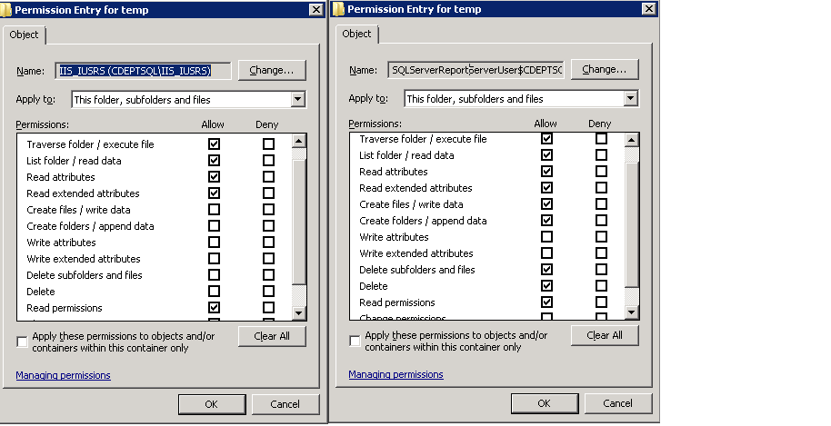

**Migration process:**

1. Update versionInfo.xml on both servers
   1. Update version
   2. New installer URL
2. Restore latest DB to new server
3. Create new web service version 3.0.9.3 pointing to DB
4. Create installer with new web service
5. Check download process of the new installer.

* Prompt should appear
* Download should be successful

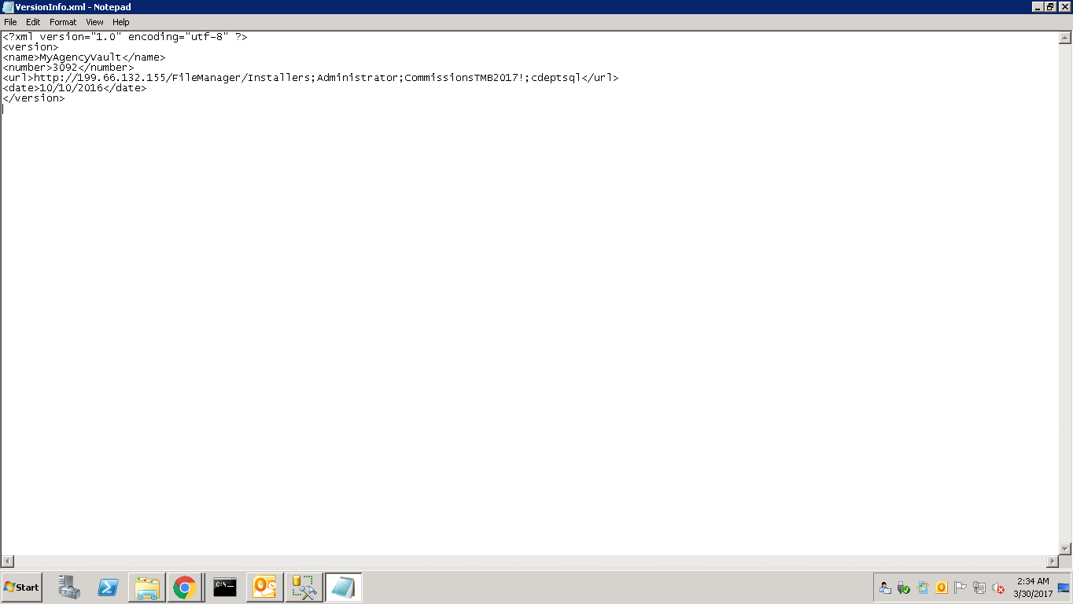VersionInfo.xml

Changes in versioninfo.xml

* Number-> 3093
* <url>http://<NewIP>/FileManager/Installers;Administrator;Comm!!$$!!onsD3pt123;cdeptsql</url>

1. Check outlook plug in
2. Check Import Process [Upload batch in comp manager]
3. Check follow up service
4. Check import policy feature