6. Count of status code = 200 / 404 / 400 / 500

status_code, count

**Count of records with Status 200**

**Command:-**

GRPD = group File1 by code;

STATUS_CODE_COUNT = foreach GRPD generate group,COUNT(File1.code);

STORE STATUS_CODE_COUNT into ‘/cloudera/project/hadoop/pig_10’ using PigStorage(‘,’);

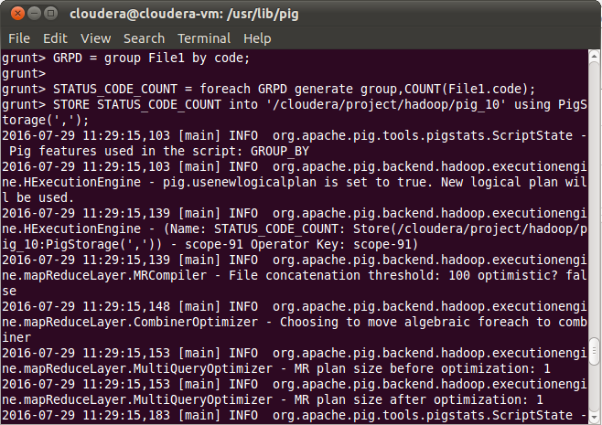

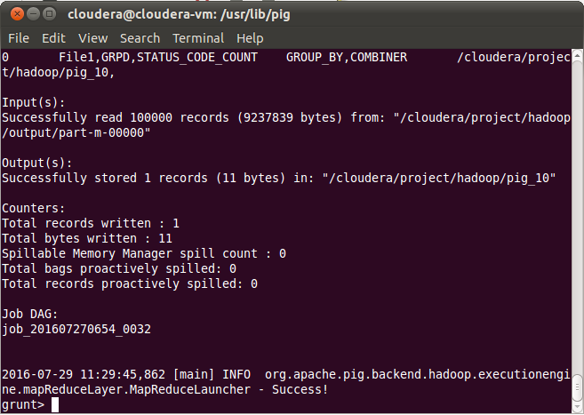

**OUTPUT:-Count of records with code 200:-**

