**5. Total page views / Category wise pageviews / Unique pageviews**

**page,total_number_of_views**

**category, total_views**

**page, total_number_of_unique_views**

**Category1 wise view:-**

**Group the original output file without any filter by category1.**

**Command:-**

GRPD_TOTALCATEGORY1 = group File1 by Category1;

**Count the records grouped by category1.**

**Command:-**

CNT_FOR_TOTALCATEGORY1 = FOREACH GRPD_TOTALCATEGORY1 generate group,COUNT(File1.Category1) as counting;

STORE CNT_TOTALCATEGORY1 into '/cloudera/project/hadoop/pig_7' using PigStorage(',');

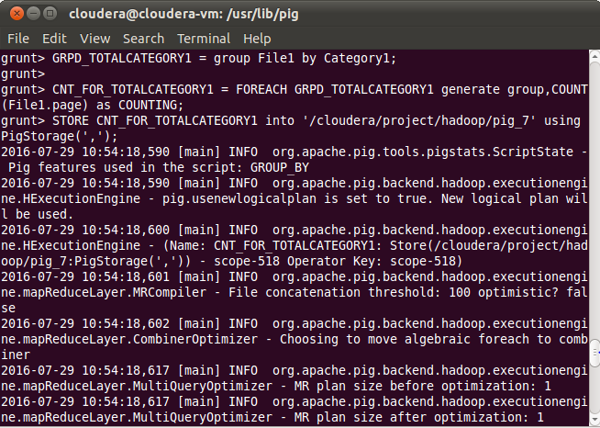

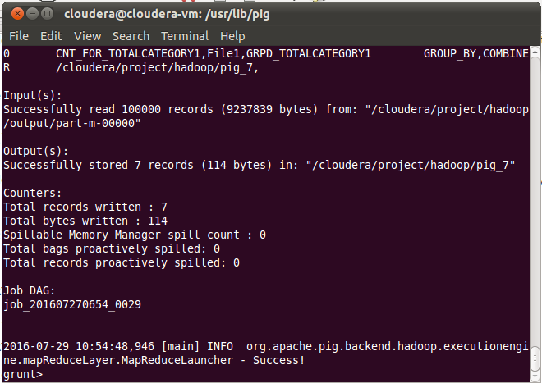

**O\P:-Category1 wise records:-**

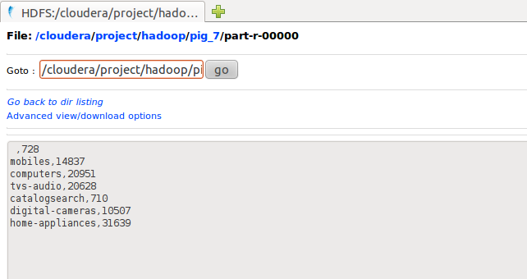

**Category2 wise view:-**

**Group the original output file without any filter by category2.**

**Command:-**

GRPD_TOTALCATEGORY2 = group File1 by Category2;

**Count the records grouped by category1.**

**Command:-**

CNT_FOR_TOTALCATEGORY2 = FOREACH GRPD_TOTALCATEGORY2 generate group,COUNT(File1.Category2) as counting;

STORE CNT_TOTALCATEGORY2 into '/cloudera/project/hadoop/pig_11' using PigStorage(',');

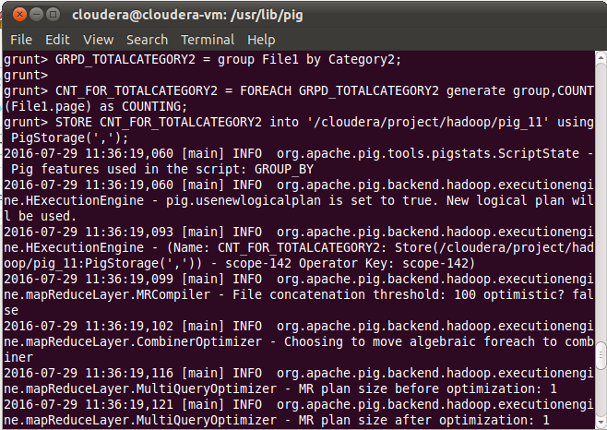

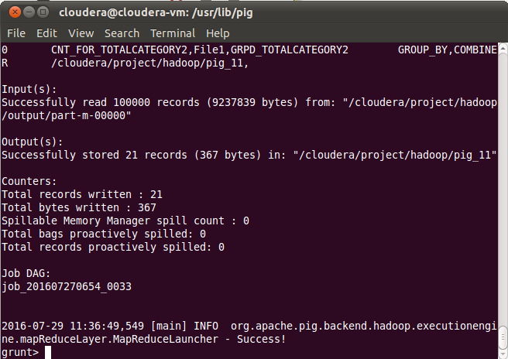

**O\P:-Category2 wise records**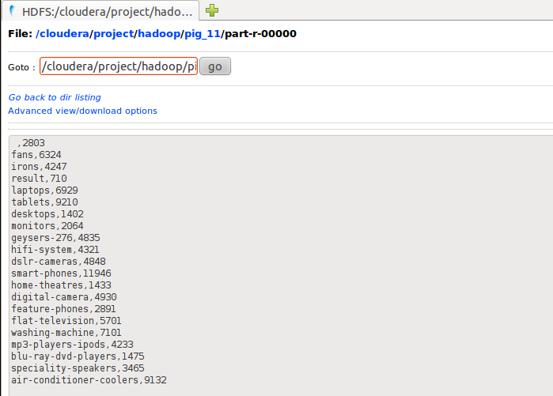

**Category1 wise view:-**

**Group the original output file without any filter by category1.**

**Command:-**

GRPD_TOTALCATEGORY1 = group File1 by page;

**Count the records grouped by category1.**

**Command:-**

CNT_FOR_TOTALPAGE = FOREACH GRPD_TOTALPAGE generate group,COUNT(File1.page) as counting;

STORE CNT_FOR_TOTALPAGE into '/cloudera/project/hadoop/pig_8' using PigStorage(',');

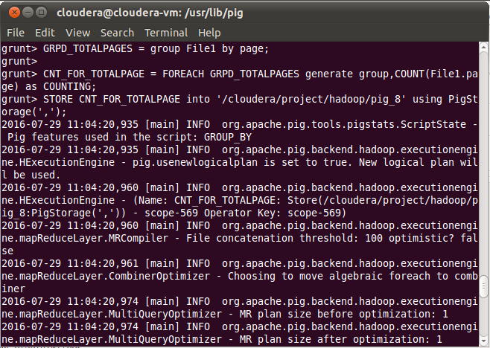

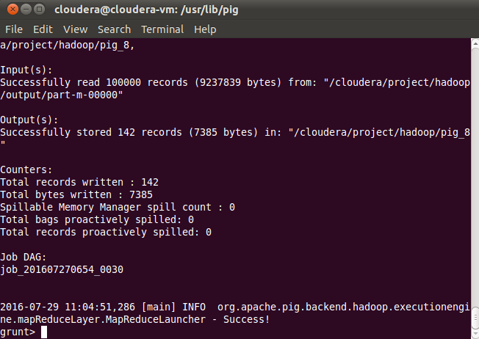

**O\P:-Page wise records:-**

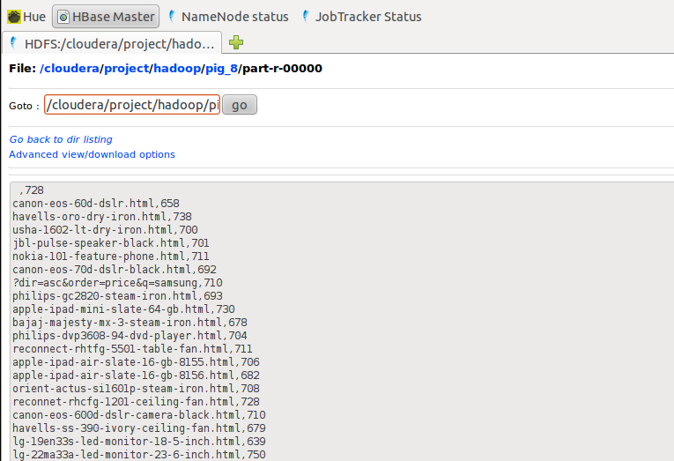

**Unique pageviews:-**

**Group the File1 by page.**

**Command:-**

GRPD_TOTALPAGES_UNIQUEVIEW = group File1 by page;

**For each group generate unique page count**

**Command:-**

CNT_FOR_TOTALPAGE_UNIQUEVIEW = FOREACH GRPD_TOTALPAGES_UNIQUEVIEW {ip = File1.IP;unique_ip = DISTINCT ip;GENERATE group,COUNT(unique_ip);}

STORE CNT_FOR_TOTALPAGE_UNIQUEVIEW into '/cloudera/project/hadoop/pig_9' using PigStorage(',');

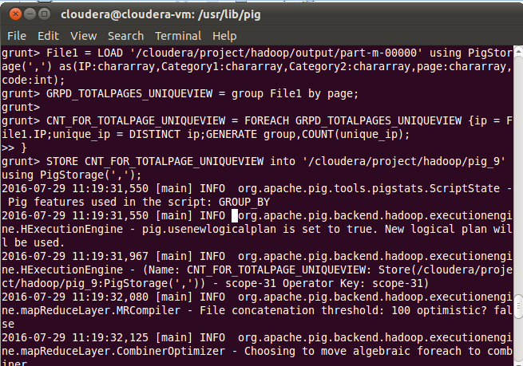

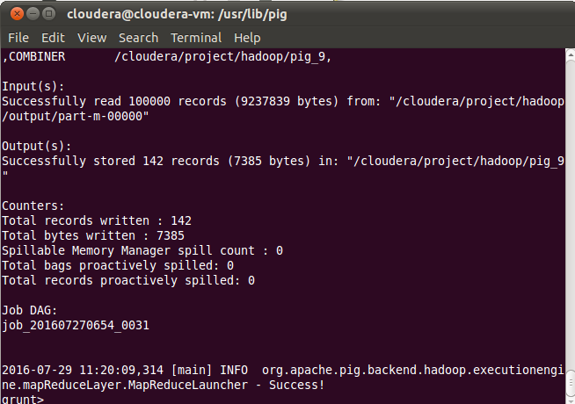

**Output (Unique Page view):-**

