**4. Top / Bottom 5: catagery-1/ catagery-2 / page /users (Exclude status code other than 200, also exclude record related to css/js/image)**

**Top 5 and bottom 5 records**

**Category, total_number_views**

**page, total_number_views**

**IP, total_number_of_views**

**TOP 5 records by Category1:-**

**Filter the records in File1 having status code as 200:-**

**Command:-**

File1_status_code_200 = FILTER File1 by code == 200;

**Group the filtered records by category1**

**Command:-**

GRPD_Category1 = group File1_status_code_200 by Category1;

**Generate count for each category1:-**

**Command:-**

CNT_FOR_Category1 = foreach GRPD_Category1 generate group,COUNT(File1_status_code_200.Category1) as counting;

**Sort the results from above step in descending order .**

**Command:-**

SORTED_CATEGORY1_DEC = ORDER CNT_FOR_Category1 by counting DESC;

**Limit the sorted output to 5 in order to obtain top 5 category1:-**

**Command:-**

TOP_5_CATEGORY1 = limit SORTED_CATEGORY1_DEC 5;

**Store the output to HDFS:-**

**Command:-**

STORE TOP_5_CATEGORY1 into ‘/cloudera/project/hadoop/pig_2’ using PigStorage(‘,’);

**Screenshot:-**

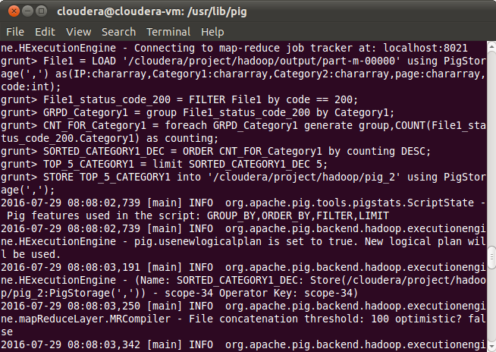

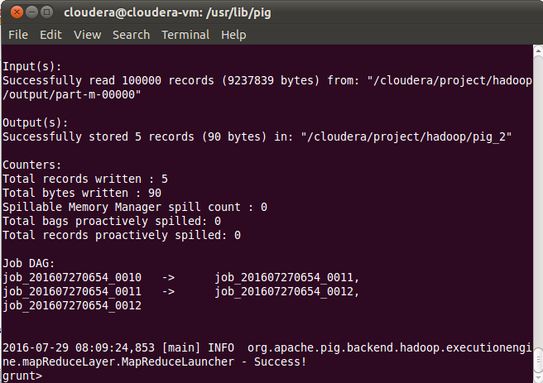

**O\P:- Top 5 records by category1:-**

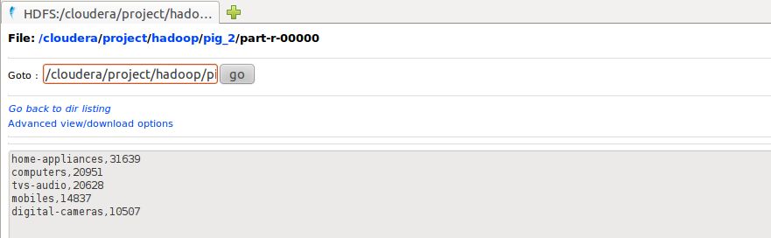

**BOTTOM 5 records by Category1:-**

**Sort the CNT_FOR_Category1 in ascending order:-**

**Command:-**

SORTED_CATEGORY1_ASC = ORDER CNT_FOR_Category1 by counting ASC;

**Limit the sorted output to 5 in order to obtain top 5 category1:-**

**Command:-**

BOTTOM_5_CATEGORY1 = limit SORTED_CATEGORY1_ASC 5;

**Store the output to HDFS:-**

**Command:-**

STORE BOTTOM_5_CATEGORY1 into ‘/cloudera/project/hadoop/pig_3’ using PigStorage(‘,’);

**Screenshot:-**

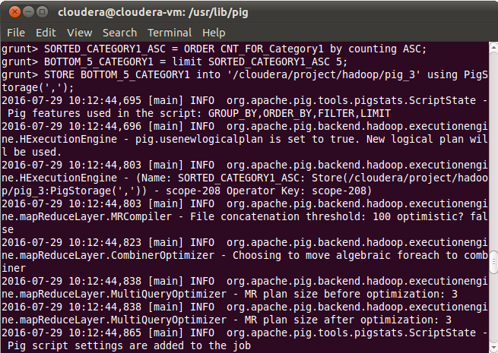

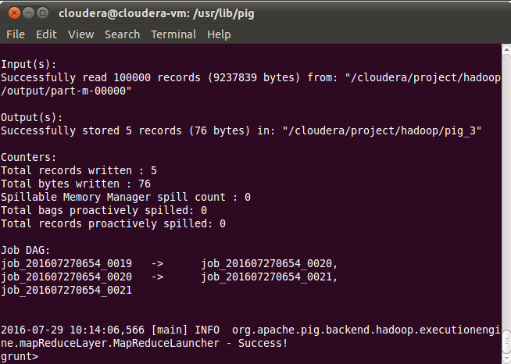

**O\P:- Bottom 5 records by category1:-**

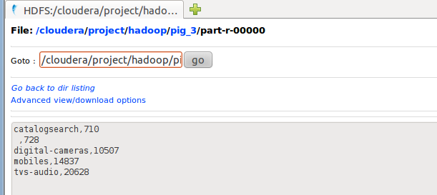

**Category2**

**Top 5 records by Category2**

**Filter the records in File1 having status code as 200:-**

**Command:-**

File1_status_code_200 = FILTER File1 by code == 200;

**Group the filtered records by category2**

**Command:-**

GRPD_Category2 = group File1_status_code_200 by Category2;

**Generate count for each category1:-**

**Command:-**

CNT_FOR_Category2 = foreach GRPD_Category2 generate group,COUNT(File1_status_code_200.Category2) as counting;

**Sort the results from above step in descending order.**

**Command:-**

SORTED_CATEGORY2_DEC = ORDER CNT_FOR_Category2 by counting DESC;

**Limit the sorted output to 5 in order to obtain top 5 category1:-**

**Command:-**

TOP_5_CATEGORY2 = limit SORTED_CATEGORY2_DEC 5;

**Store the output to HDFS:-**

**Command:-**

STORE TOP_5_CATEGORY2 into ‘/cloudera/project/hadoop/pig_4’ using PigStorage(‘,’);

**Screenshot:-**

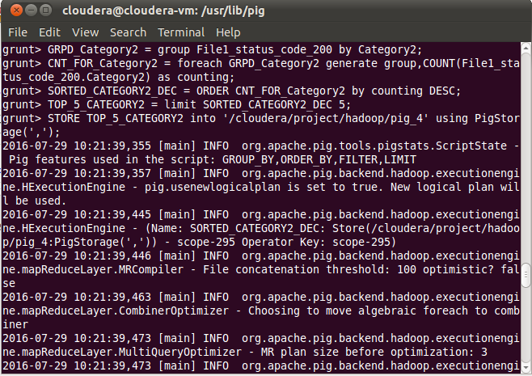

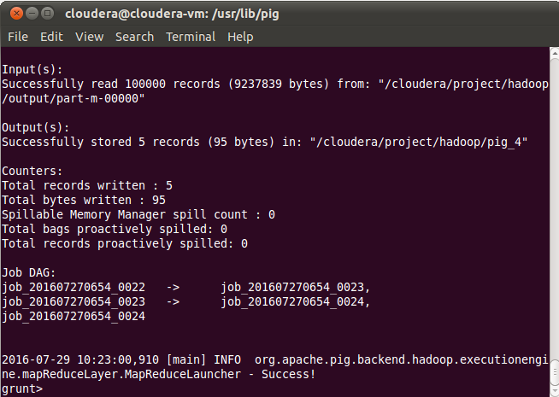

**O\P:-Top 5 records by category2:-**

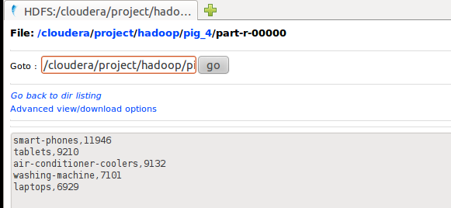

**BOTTOM 5 records by Category2:-**

**Sort the CNT_FOR_Category2 in ascending order:-**

**Command:-**

SORTED_CATEGORY2_ASC = ORDER CNT_FOR_Category2 by counting ASC;

**Limit the sorted output to 5 in order to obtain top 5 category1:-**

**Command:-**

BOTTOM_5_CATEGORY2 = limit SORTED_CATEGORY2_ASC 5;

**Store the output to HDFS:-**

**Command:-**

STORE BOTTOM_5_CATEGORY2 into ‘/cloudera/project/hadoop/pig_5’ using PigStorage(‘,’);

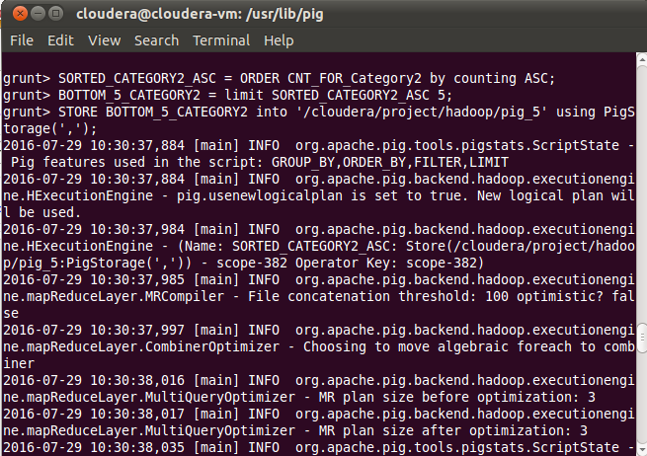

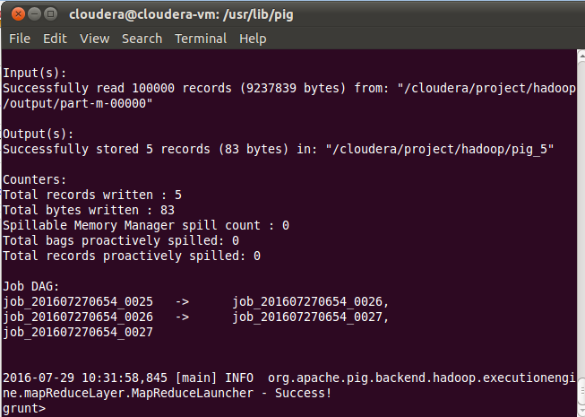

**O\P:-Bottom 5 records by category2**

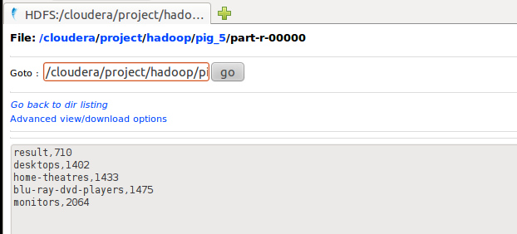

**TOP 5 records by Page:-**

GRPD_PAGES = group File1_Sstatus_code_200 by page;

CNT_FOR_PAGE = foreach GRPD_PAGES generate group,COUNT(File1_status_code_200.page) as counting;

SORTED_PAGE_DEC = ORDER CNT_FOR_PAGE by counting DESC;

TOP_5_Page = limit SORTED_PAGE_DEC 5;

STORE TOP_5_Page into ‘/cloudera/project/hadoop/pig_6’ using PigStorage(‘,’);

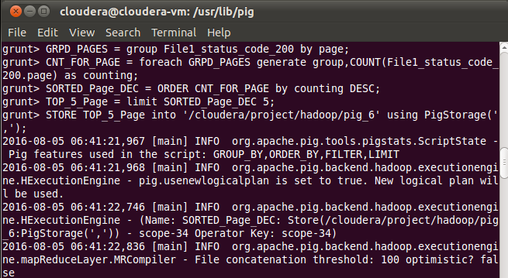

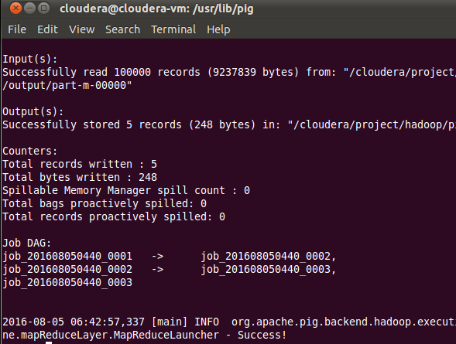

**Output:-TOP 5 Page count:-**

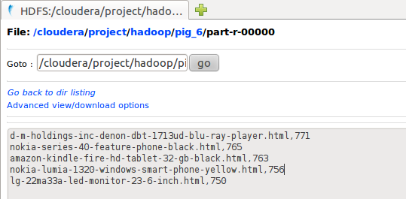

Bottom 5 page:-

SORTED_PAGE_ASC = ORDER CNT_FOR_PAGE by counting ASC;

Bottom_5_Page = limit SORTED_PAGE_ASC 5;

STORE Bottom_5_Page into ‘/cloudera/project/hadoop/pig_12’ using PigStorage(‘,’);

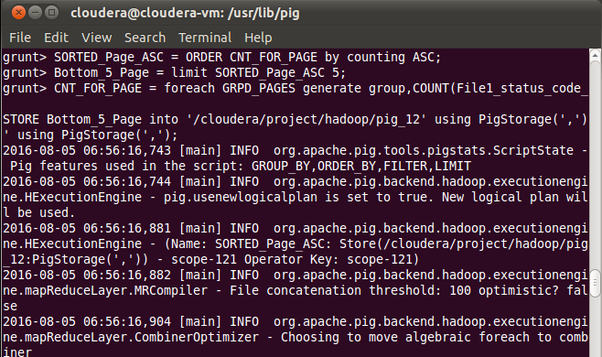

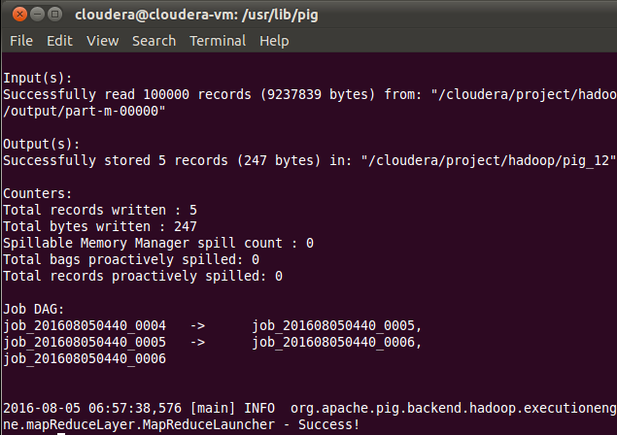

**Output:-Bottom 5 pages:-**

