**7. Load results into tables in MySql Database using Sqoop.**

Loading data through SQOOP:-

**Loading parsed weblogs:-**

bin/sqoop export –connect jdbc:mysql://192.168.60.1/project –table file1 –export-dir /cloudera/project/hadoop/output/part-m-00000 –username root –P –fields-terminated-by ‘,’

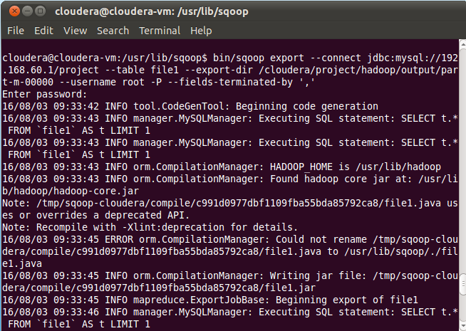

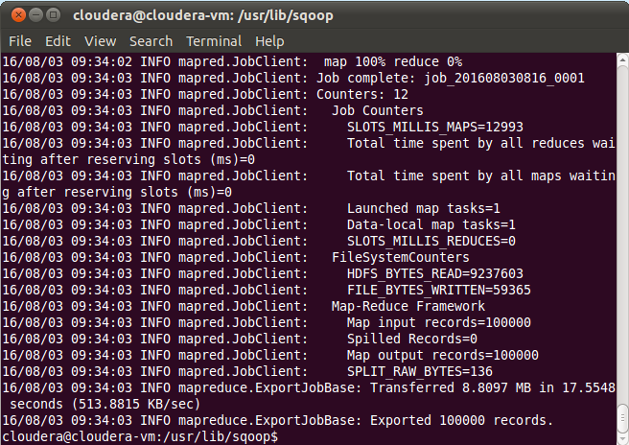

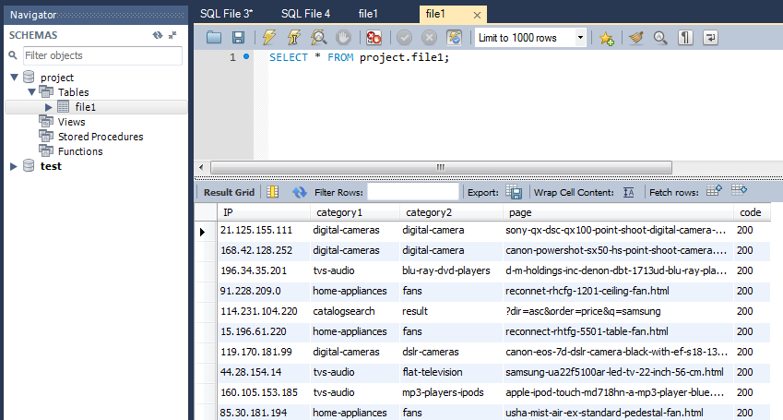

**IP count:-**

bin/sqoop export –connect jdbc:mysql://192.168.60.1/project –table ipcount –export-dir /cloudera/project/hadoop/pig_1 –username root –P –fields-terminated-by ‘,’

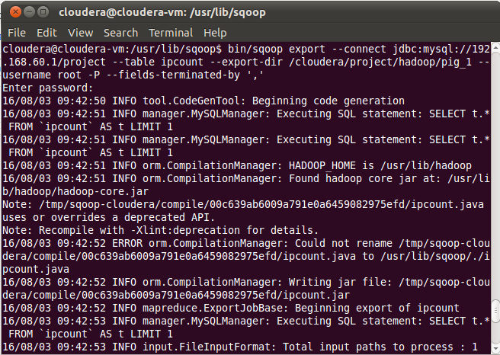

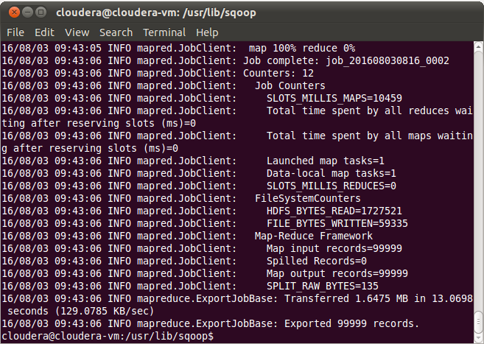

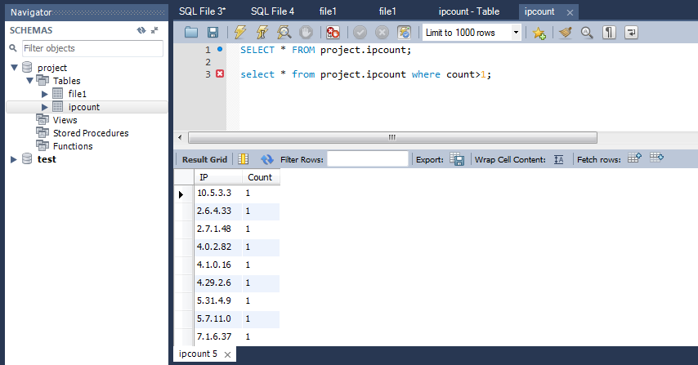

**Category1 TOP5 count**

bin/sqoop export –connect jdbc:mysql://192.168.60.1/project –table top5category1_count –export-dir /cloudera/project/hadoop/pig_2 –username root –P –fields-terminated-by ‘,’

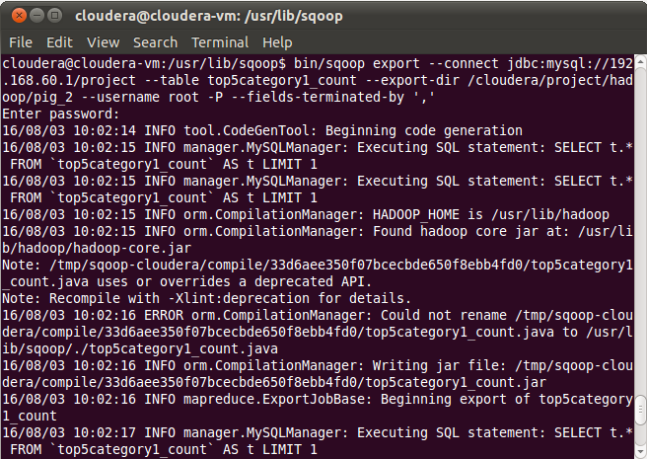

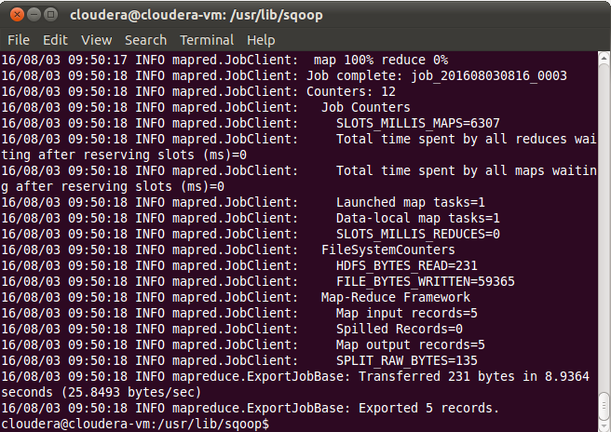

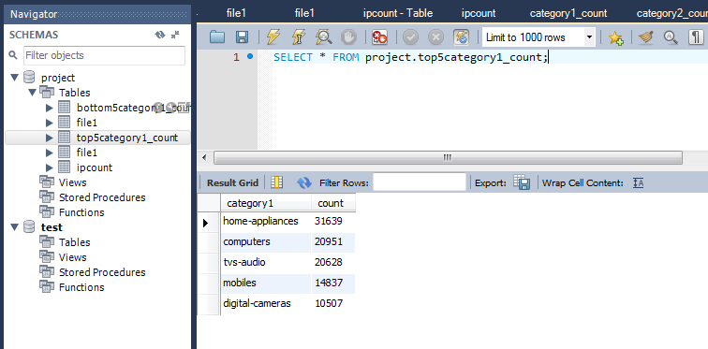

**Category1 bottom5 count:-**

bin/sqoop export –connect jdbc:mysql://192.168.60.1/project –table bottom5category1_count –export-dir /cloudera/project/hadoop/pig_3 –username root –P –fields-terminated-by ‘,’

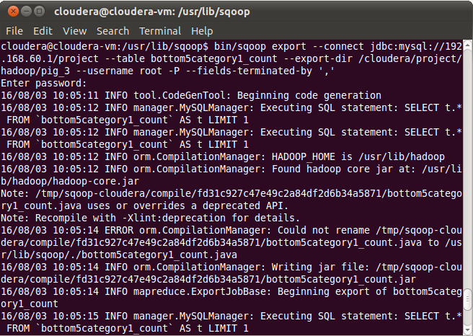

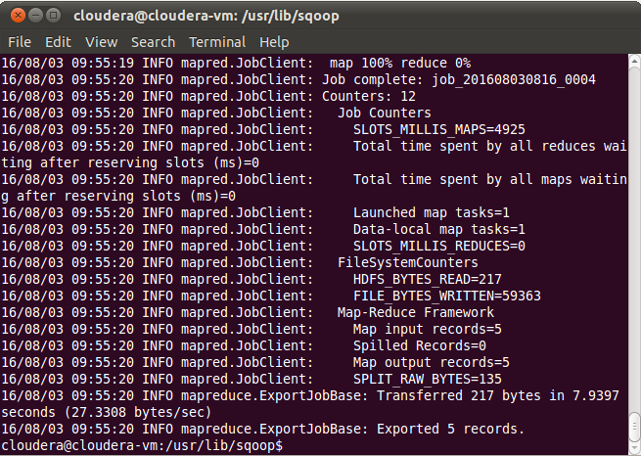

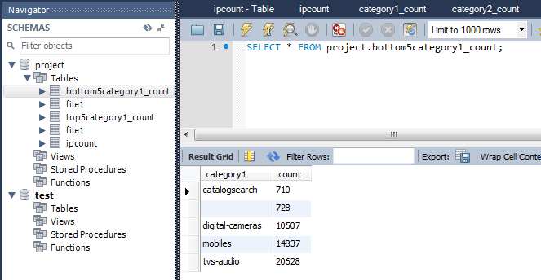

**Top 5 category 2:-**

bin/sqoop export –connect jdbc:mysql://192.168.60.1/project –table top5category2_count –export-dir /cloudera/project/hadoop/pig_4 –username root –P –fields-terminated-by ‘,’

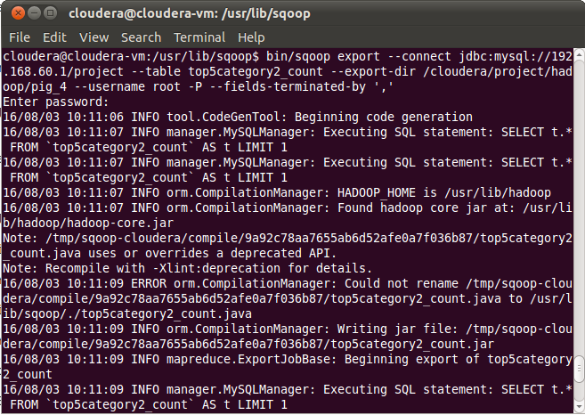

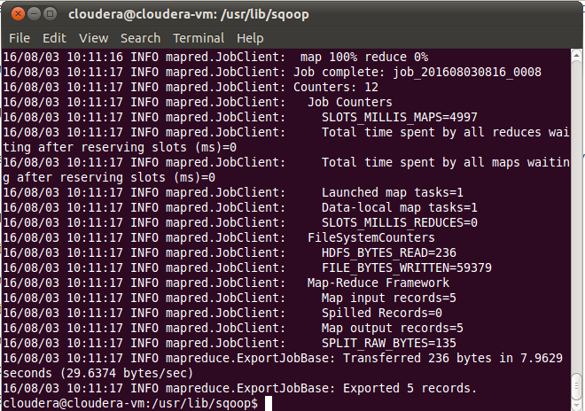

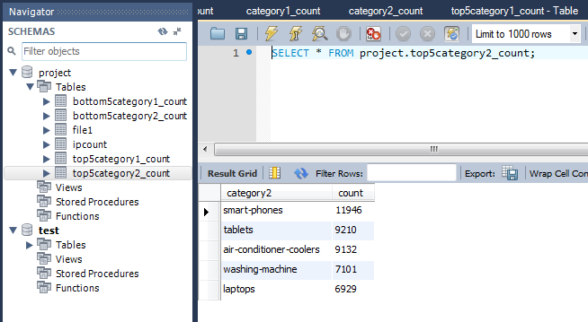

**Bottom 5 category 2**

bin/sqoop export –connect jdbc:mysql://192.168.60.1/project –table bottom5ctegory2_count –export-dir /cloudera/project/hadoop/pig_5 –username root –P –fields-terminated-by ‘,’

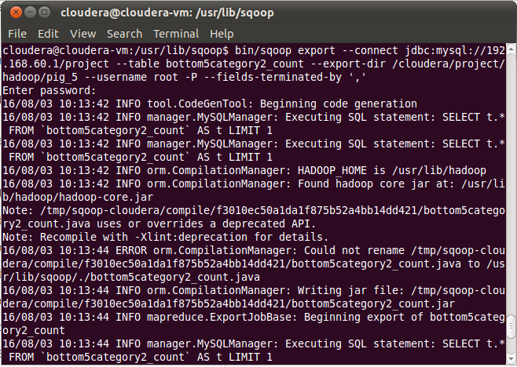

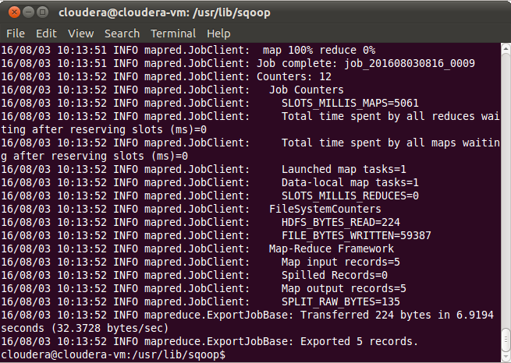

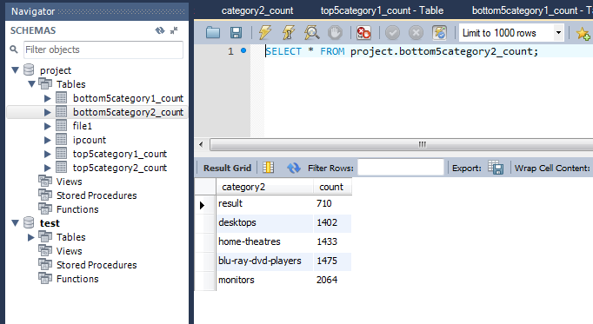

**TOP 5 Page count:-**

bin/sqoop export –connect jdbc:mysql://192.168.60.1/project –table top5page_count –export-dir /cloudera/project/hadoop/pig_6 –username root –P –fields-terminated-by ‘,’

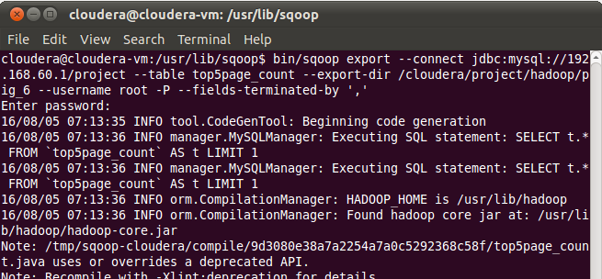

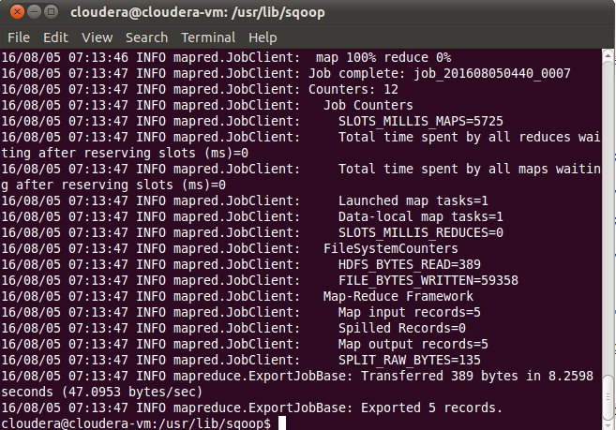

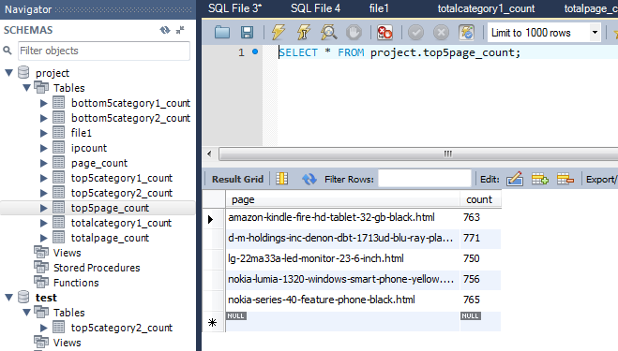

**BOTTOM 5 Page count:-**

bin/sqoop export –connect jdbc:mysql://192.168.60.1/project –table bottom5page_count –export-dir /cloudera/project/hadoop/pig_12 –username root –P –fields-terminated-by ‘,’

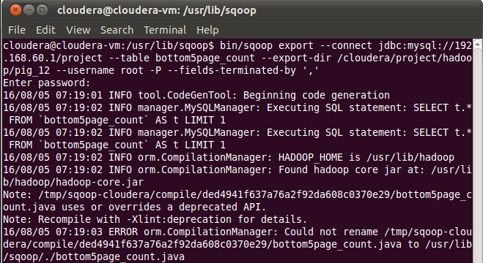

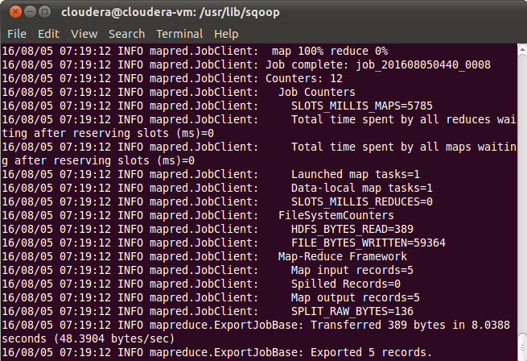

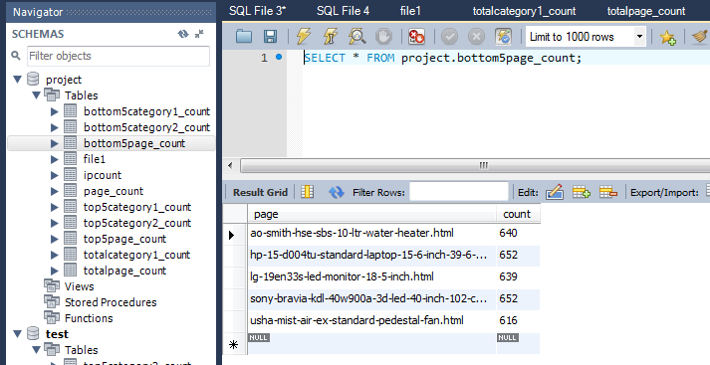

**Total category 1**

bin/sqoop export –connect jdbc:mysql://192.168.60.1/project –table totalcategory1_count –export-dir /cloudera/project/hadoop/pig_7 –username root –P –fields-terminated-by ‘,’

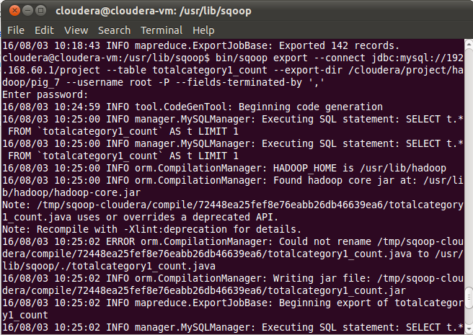

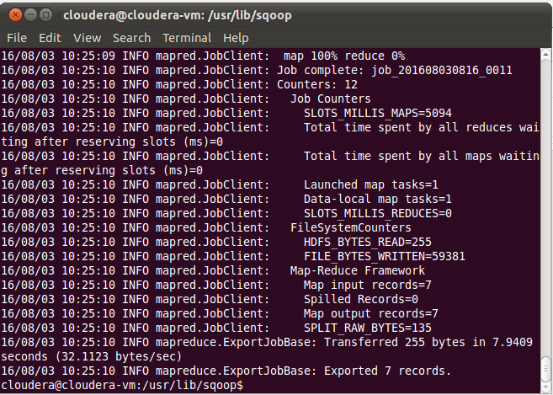

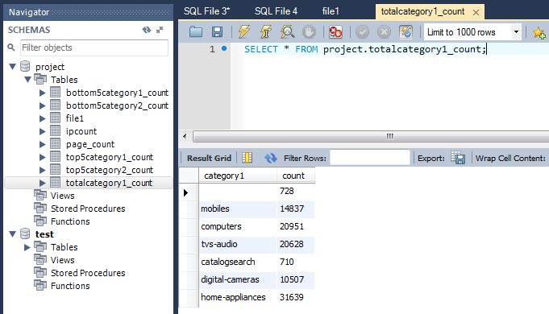

**Total page count**

bin/sqoop export –connect jdbc:mysql://192.168.60.1/project –table toatalpage_count –export-dir /cloudera/project/hadoop/pig_8 –username root –P –fields-terminated-by ‘,’

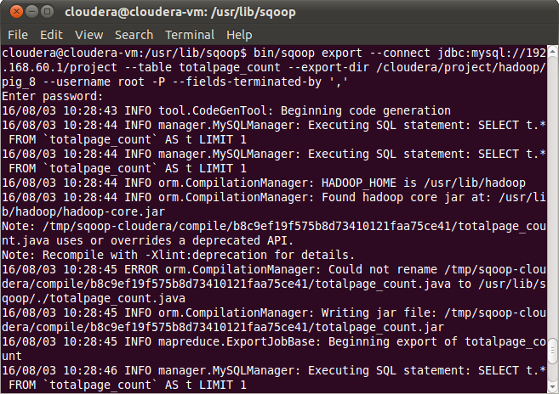

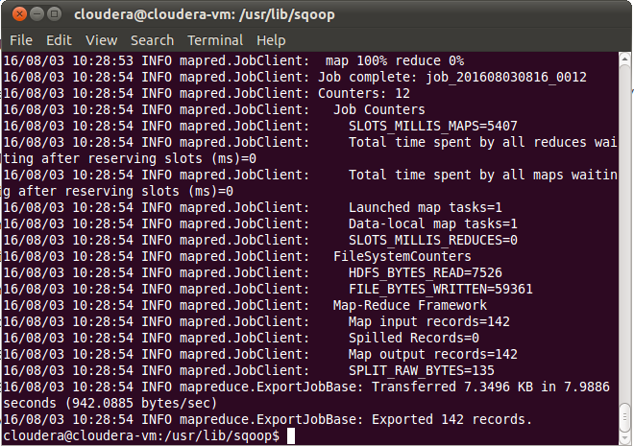

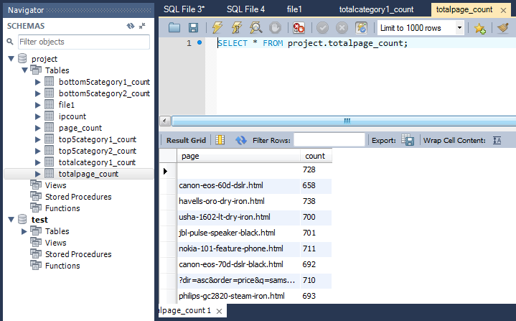

**Status code count:-**

bin/sqoop export –connect jdbc:mysql://192.168.60.1/project –table status_count –export-dir /cloudera/project/hadoop/pig_10 –username root –P –fields-terminated-by ‘,’

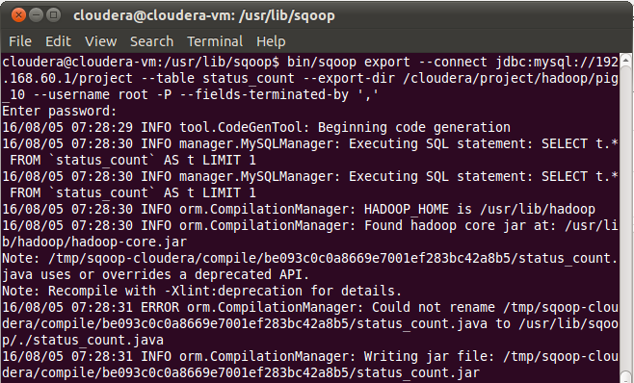

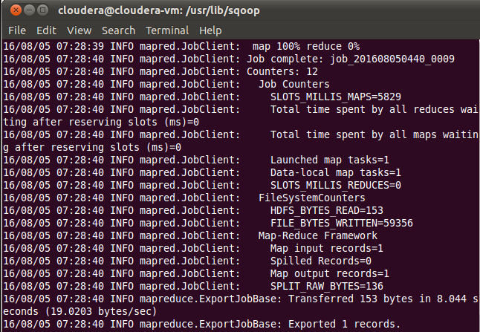

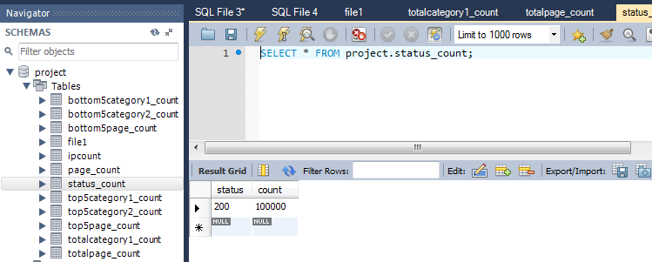

**Unique page count:-**

bin/sqoop export –connect jdbc:mysql://192.168.60.1/project –table unique_page_count –export-dir /cloudera/project/hadoop/pig_9 –username root –P –fields-terminated-by ‘,’

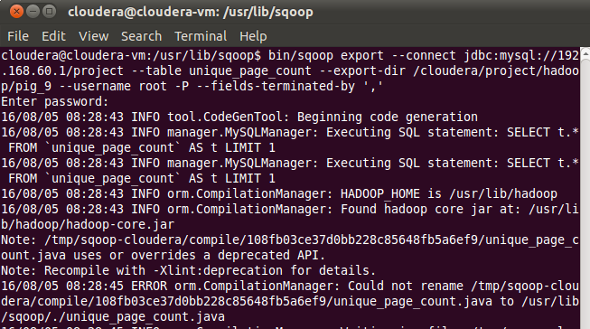

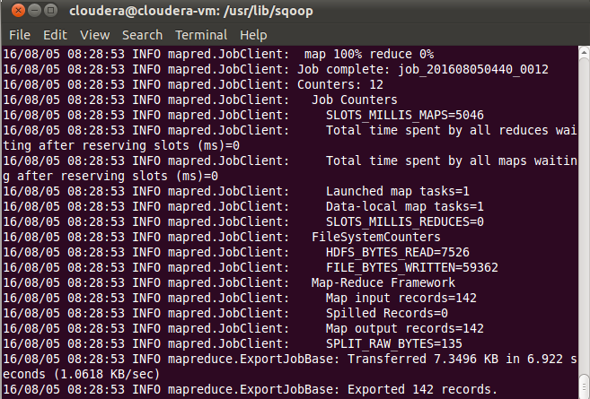

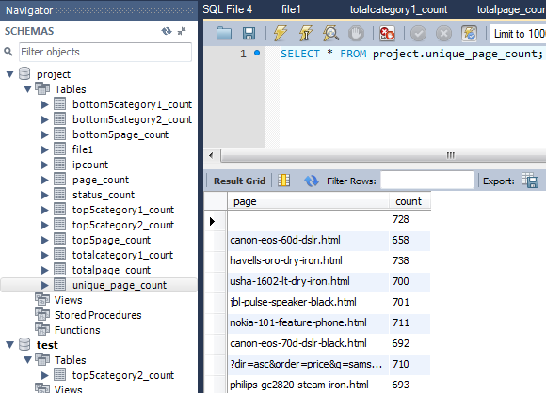

**Total Category2 count:-**

bin/sqoop export –connect jdbc:mysql://192.168.60.1/project –table totalcategory2_count –export-dir /cloudera/project/hadoop/pig_11 –username root –P –fields-terminated-by ‘,’

