Week 2 Exploratory Data Analysis (EDA)
Prepared using the cleaned Agribusiness dataset from Week 1.

Dataset Overview
Rows: 14
Columns: 7
Column | Data Type
State | object
Crop | object
Year | int64
Rainfall_mm | float64
Yield_kg_per_ha | float64
Avg_Temp_C | float64
Rainfall_Normalized | float64

Descriptive Statistics
Metric | State | Crop | Year | Rainfall_mm | Yield_kg_per_ha | Avg_Temp_C | Rainfall_Normalized
count | 14 | 14 | 14.0 | 14.0 | 14.0 | 14.0 | 14.0
unique | 14 | 9 | nan | nan | nan | nan | nan
top | Punjab | Rice | nan | nan | nan | nan | nan
freq | 1 | 5 | nan | nan | nan | nan | nan
mean | nan | nan | 2023.0 | 909.29 | 3498.21 | 26.79 | 0.28
std | nan | nan | 0.0 | 569.7 | 1670.28 | 2.46 | 0.26
min | nan | nan | 2023.0 | 300.0 | 1400.0 | 22.0 | 0.0
25% | nan | nan | 2023.0 | 545.0 | 2275.0 | 25.25 | 0.11
50% | nan | nan | 2023.0 | 780.0 | 3200.0 | 27.0 | 0.22
75% | nan | nan | 2023.0 | 1050.0 | 4100.0 | 28.0 | 0.34
max | nan | nan | 2023.0 | 2500.0 | 6837.5 | 31.0 | 1.0

Histogram
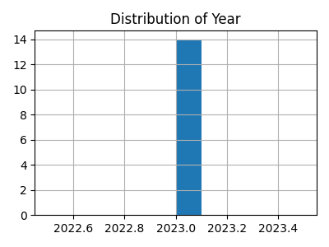
Figure: Histogram

Scatter Plot
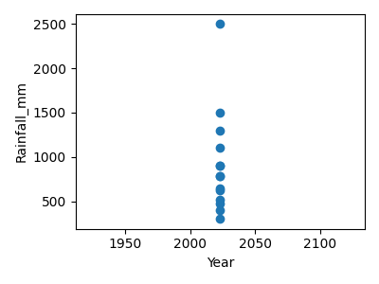
Figure: Scatter Plot

Correlation Heatmap
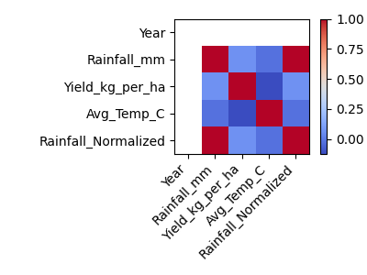
Figure: Correlation Heatmap

Key Findings & Insights
- The numerical variables were explored using descriptive statistics and visualizations.
- The histogram shows the overall distribution and helps identify skewness.
- The scatter plot highlights relationships between two numerical features.
- The correlation heatmap summarizes positive and negative correlations.
- No missing values were observed in the cleaned dataset used for analysis.

Conclusion
The exploratory data analysis provides a clear understanding of the agribusiness dataset through statistical summaries and visualizations. These insights can support future machine learning model development and business decision-making.

