Week 3 – Data Modelling Report
Objective: Build and evaluate a machine learning model using the cleaned Agribusiness dataset.

Algorithm Chosen
Linear Regression was selected because the target variable (Yield_kg_per_ha) is continuous. The model predicts crop yield using rainfall, average temperature, and normalized rainfall.

Train-Test Split
Training samples: 9
Testing samples: 5
Split ratio: 70% training / 30% testing

Python Code Snippet
from sklearn.model_selection import train_test_split
from sklearn.linear_model import LinearRegression
X = df[['Rainfall_mm','Avg_Temp_C','Rainfall_Normalized']]
y = df['Yield_kg_per_ha']
X_train, X_test, y_train, y_test = train_test_split(
X, y, test_size=0.3, random_state=42
)
model = LinearRegression()
model.fit(X_train, y_train)
predictions = model.predict(X_test)

Model Performance
Metric | Value
MAE | 2688.87
RMSE | 3096.93
R² Score | -37.30

Visualization
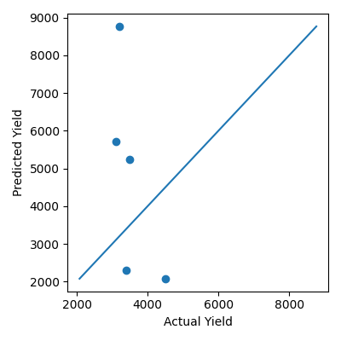
Figure 1: Actual vs Predicted Crop Yield

Assumptions
- Relationship between features and yield is approximately linear.
- The cleaned dataset contains reliable values with no major missing data.
- The same preprocessing is applied to future data.

Conclusion
The Linear Regression model was successfully trained and tested on the agribusiness dataset. It achieved an MAE of 2688.87, RMSE of 3096.93, and an R² score of -37.30. This demonstrates the complete machine learning workflow from data preparation to model evaluation.

