**REPORT**

The goal of this project is to implement in Scala using the actor model, the Chord protocol and a simple object access service to prove its usefulness.

**Analysis** –

1. Since multiple nodes are doing lookups based on multiple requests, futures have been implemented. Futures enable us to return the values from a case. For blocking futures “Await” has been used, for non-blocking futures “Ask on Complete” has been used.
2. From our observations we have found that in an N-node network, each node makes on an average less than O(log N) average hops to do the lookup.
3. The graph below plots the average number of hops per request against different number of requests for total nodes = 5. Note that log 5 base 2 = 2.32

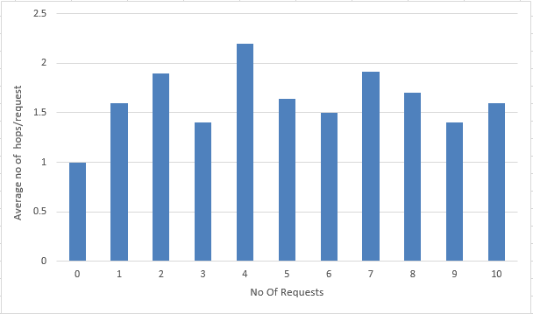

Here No of requests = 0 means only one file lookup will happen.

**Challenges faced** –

1. Setting the value of m = size of identifier circle which has been set based on the number of nodes input to avoid collisions.
2. Implementing consistent hashing which has been implemented to convert a 40 bytes hex char string to integer value.
3. Implementing Concurrent node joins and updating the finger tables.
4. Also for n = 100000, the system freezes because of its memory limitations.

**References –**

1. <http://docs.scala-lang.org/overviews/core/futures.html>
2. <http://www.herongyang.com/Cryptography/SHA1-Message-Digest-in-Java.html>
3. <https://www.youtube.com/watch?v=q29szpcnorA>