# Assignment-based Subjective Questions

1. From your analysis of the categorical variables from the dataset, what could you infer about their effect on the dependent variable? (3 marks)

**Solution**.

I have done analysis on categorical columns using the boxplot and bar plot. Below are the few

points we can infer from the visualization –

* Fall season seems to have attracted more booking. And, in each season the

booking count has increased drastically from 2018 to 2019.

* Most of the bookings has been done during the month of may, june, july, aug, sep

and oct. Trend increased starting of the year till mid of the year and then it

* started decreasing as we approached the end of year.
* Clear weather attracted more booking which seems obvious.
* Thu, Fir, Sat and Sun have more number of bookings as compared to the start of

the week.

* When it’s not holiday, booking seems to be less in number which seems

reasonable as on holidays, people may want to spend time at home and enjoy

with family.

* Booking seemed to be almost equal either on working day or non-working day.
* 2019 attracted more number of book

1. Why is it important to use **drop_first=True** during dummy variable creation? (2 mark)

**Solution**:

* a. **drop_First= True**  helps in reducing the extra column created during dummy variable creation. This helps get k-1 dummies out of k categorical levels by removing the first level
* b. Using **drop_First=True** helps prevent create collinear dummies

1. Looking at the pair-plot among the numerical variables, which one has the highest correlation with the target variable? (1 mark)

**Solution:**

* temp and atemp has the highest correlation

1. How did you validate the assumptions of Linear Regression after building the model on the training set? (3 marks)

**Solution:**

I have validated the assumption of Linear Regression Model based on below 5 assumptions -

* Normality of error terms
* Error terms should be normally distributed
* Multicollinearity check
* There should be insignificant multicollinearity among variables.
* Linear relationship validation
* Linearity should be visible among variables
* Homoscedasticity
* There should be no visible pattern in residual values.
* Independence of residuals
* No auto-correlation

1. Based on the final model, which are the top 3 features contributing significantly towards explaining the demand of the shared bikes? (2 marks)

**Solution:**

Below are the top 3 features contributing significantly towards explaining the demand of the

shared bikes –

➢ temp

➢ year

➢ winter

# General Subjective Questions

1. Explain the linear regression algorithm in detail. (4 marks)

**Solution:**

Linear regression is an algorithm that provides a linear relationship between an independent variable and a dependent variable to predict the outcome of future events. It is a statistical method used in data science and machine learning for predictive analysis.

Linear regression is a supervised learning algorithm that simulates a mathematical relationship between variables and makes predictions for continuous or numeric variables such as sales, salary, age, product price, etc.

A sloped straight line represents the linear regression model.

Data Points

Line of Regression

Dependant

Variable

Independant Variable

In the above figure,

X-axis = Independent variable,

Y-axis = Output/ dependant variable,

Line of regression = Best fit line for a model

Here, a line is plotted for the given data points that suitably fit all the issues. Hence, it is called the ‘best fit line.’ The goal of the linear regression algorithm is to find this best fit line seen in the above figure.

Mathematically the relationship can be represented with the help of following equation −

Y = mX + c

Here, Y is the dependent variable we are trying to predict.

X is the independent variable we are using to make predictions.

m is the slope of the regression line which represents the effect X has on Y

c is a constant, known as the Y-intercept. If X = 0, Y would be equal to c.

1. Explain the Anscombe’s quartet in detail. (3 marks)

**Solution:**

Anscombe’s Quartet was developed by statistician Francis Anscombe. It comprises four

datasets, each containing eleven (x, y) pairs. The essential thing to note about these datasets

is that they share the same descriptive statistics. But things change completely, and I must

emphasize COMPLETELY, when they are graphed. Each graph tells a different story

irrespective of their similar summary statistics.

Anscombe’s quartet tells us about the importance of [visualizing data](https://builtin.com/learn/data-visualization" \t "https://builtin.com/data-science/_blank) before applying various algorithms to build models. This suggests the data features must be plotted to see the distribution of the samples that can help you identify the various anomalies present in the data (outliers, diversity of the data, linear separability of the data, etc.). Moreover, the linear regression can only be considered a fit for the data with linear relationships and is incapable of handling any other kind of data set.

We can define these four plots as follows:

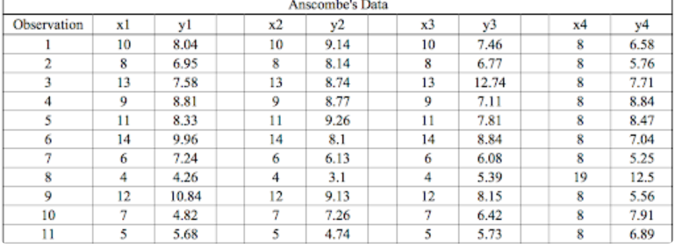

The statistical information for these four data sets are approximately similar. We can compute them as follows:

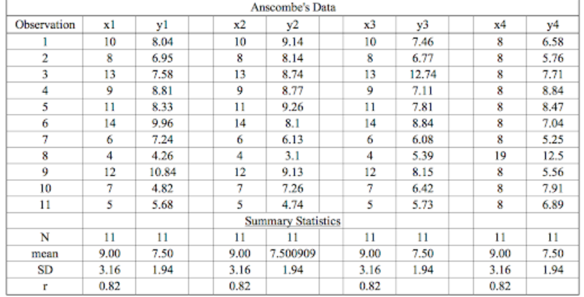

The summary statistics show that the means and the variances were identical for x and y

across the groups:

• Mean of x is 9 and mean of y is 7.50 for each dataset.

• Similarly, the variance of x is 11 and variance of y is 4.13 for each dataset

• The correlation coefficient (how strong a relationship is between two variables) between

x and y is 0.816 for each dataset

When we plot these four datasets on an x/y coordinate plane, we can observe that they show

the same regression lines as well but each dataset is telling a different story:

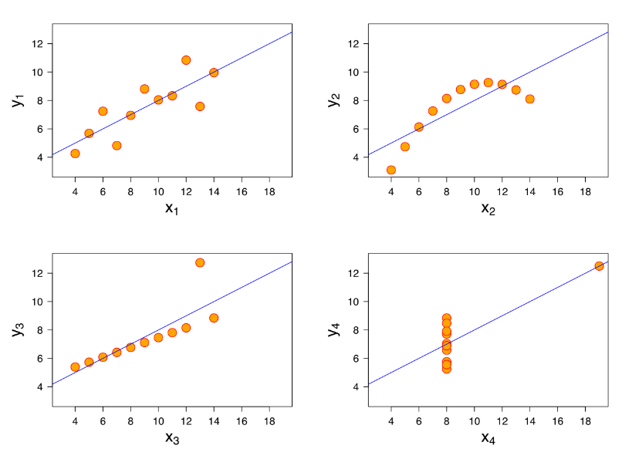

• Dataset I appears to have clean and well-fitting linear models.

• Dataset II is not distributed normally.

• In Dataset III the distribution is linear, but the calculated regression is thrown off by an

outlier.

• Dataset IV shows that one outlier is enough to produce a high correlation coefficient.

This quartet emphasizes the importance of visualization in Data Analysis. Looking at the data

reveals a lot of the structure and a clear picture of the dataset.

1. What is Pearson’s R? (3 marks)

**Solution:**

Pearson's r is a numerical summary of the strength of the linear association between the

variables. Pearson’s correlation (also called Pearson’s R) is a correlation coefficient commonly used in [linear regression](https://www.statisticshowto.com/probability-and-statistics/regression-analysis/find-a-linear-regression-equation/).

If the variables tend to go up and down together, the correlation coefficient will be

positive. If the variables tend to go up and down in opposition with low values of one variable

associated with high values of the other, the correlation coefficient will be negative.

The Pearson correlation coefficient, r, can take a range of values from +1 to -1. A value of 0

indicates that there is no association between the two variables. A value greater than 0

indicates a positive association; that is, as the value of one variable increases, so does the

value of the other variable. A value less than 0 indicates a negative association; that is, as the

value of one variable increases, the value of the other variable decreases. This is shown in the

diagram below:

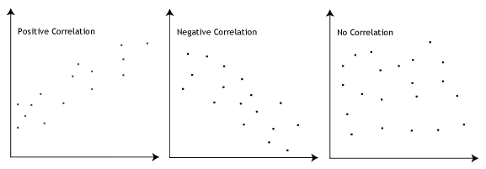

## Meaning

* A correlation coefficient of 1 means that for every positive increase in one variable, there is a positive increase of a fixed proportion in the other. For example, shoe sizes go up in (almost) perfect correlation with foot length.
* A correlation coefficient of -1 means that for every positive increase in one variable, there is a negative decrease of a fixed proportion in the other. For example, the amount of gas in a tank decreases in (almost) perfect correlation with speed.
* Zero means that for every increase, there isn’t a positive or negative increase. The two just aren’t related.

The [absolute value](https://www.statisticshowto.com/absolute-value-function/" \l "absolute" \t "https://www.statisticshowto.com/probability-and-statistics/correlation-coefficient-formula/_blank) of the correlation coefficient gives us the relationship strength. The larger the number, the stronger the relationship. For example, |-.75| = .75, which has a stronger relationship than .65.

One of the most commonly used formulas is Pearson’s correlation coefficient formula.

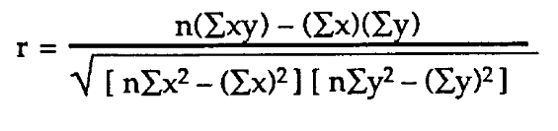

1. What is scaling? Why is scaling performed? What is the difference between normalized scaling and standardized scaling? (3 marks)

**Solution:**

Feature Scaling is a technique to standardize the independent features present in the data in a

fixed range. It is performed during the data pre-processing to handle highly varying magnitudes or

values or units. If feature scaling is not done, then a machine learning algorithm tends to weigh

greater values, higher and consider smaller values as the lower values, regardless of the unit of

the values.

Example**:** If an algorithm is not using feature scaling method then it can consider the value 3000

meter to be greater than 5 km but that’s actually not true and in this case, the algorithm will give

wrong predictions. So, we use Feature Scaling to bring all values to same magnitudes and thus,

tackle this issue.

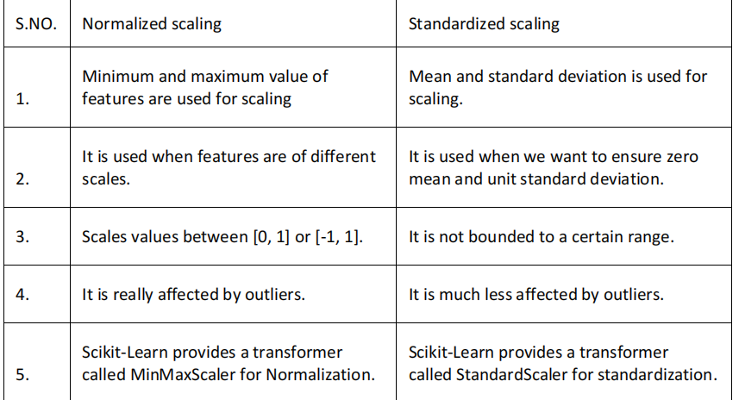

1. You might have observed that sometimes the value of VIF is infinite. Why does this happen?

(3 marks)

**Solution:**

If there is perfect correlation, then VIF = infinity. A large value of VIF indicates that there is a

correlation between the variables. If the VIF is 4, this means that the variance of the model

coefficient is inflated by a factor of 4 due to the presence of multicollinearity.

This would mean that that standard error of this coefficient is inflated by a factor of 2 (square root of variance is the standard deviation). The standard error of the coefficient determines the confidence interval of the model coefficients. If the standard error is large, then the confidence intervals may be large, and the model coefficient may come out to be non-significant due to the presence of multicollinearity.

When the value of VIF is infinite it shows a perfect correlation between two independent

variables. In the case of perfect correlation, we get R-squared (R2) =1, which lead to 1/ (1-R2)

infinity. To solve this we need to drop one of the variables from the dataset which is causing this

perfect multicollinearity

1. What is a Q-Q plot? Explain the use and importance of a Q-Q plot in linear regression.

(3 marks)

**Solution:**

The quantile-quantile (q-q) plot is a graphical technique for determining if two data sets come

from populations with a common distribution.  q-q plot is a plot of the quantiles of the first data set against the quantiles of the second data set. By a quantile, we mean the fraction (or percent) of points below the given value. That is, the 0.3 (or 30%) quantile is the point at which 30% percent of the data fall below and 70% fall above that value.

**Use of Q-Q plot:**

A q-q plot is a plot of the quantiles of the first data set against the quantiles of the second

dataset. By a quantile, we mean the fraction (or percent) of points below the given value.

That is, the 0.3 (or 30%) quantile is the point at which 30% percent of the data fall below and

70% fall above that value. A 45-degree reference line is also plotted. If the two sets come

from a population with the same distribution, the points should fall approximately along this

reference line. The greater the departure from this reference line, the greater the evidence for the conclusion that the two data sets have come from populations with different

distributions.

**Importance of Q-Q plot:**

When there are two data samples, it is often desirable to know if the assumption of a

common distribution is justified. If so, then location and scale estimators can pool both data

sets to obtain estimates of the common location and scale. If two samples do differ, it is also

useful to gain some understanding of the differences. The q-q plot can provide more insight

into the nature of the difference than analytical methods such as the chi-square and

Kolmogorov-Smirnov 2-sample tests.