APEXPLANET DATA ANALYTICS INTERNSHIP
TASK 2: EDA & BUSINESS INTELLIGENCE
Exploratory Data Analysis Report
Prepared as a learning project using the sales dataset supplied for Task 1.

1. Objective
Summarize the sales dataset, explore product/category/city/monthly patterns, answer business questions with SQL, and propose a simple KPI dashboard.

2. Dataset and preparation
The source workbook contains 1,000 rows and 12 columns. The analysis copy converts Order_Date to a date, fills missing Age values with the median (41), and fills missing City values with 'Unknown'. The source file is not overwritten.
Source missing values: Age = 20; City = 13. Exact duplicate rows: 0. Unique Order_ID values: 992 of 1000 rows. Repeated Order_IDs are retained for review rather than automatically deleted.

3. Summary statistics
Metric | Result
Total sales | 139,399,439.65
Average sales per row | 139,399.44
Total quantity sold | 5,435
Average customer age after filling missing values | 41.35
Highest sale | 493,677.50
Lowest sale | 437.34
Rows where Total_Sales approximately equals Quantity × Unit_Price | 1,000 of 1,000

4. Patterns and charts
Highest total-sales product: Laptop (25,443,008.51).
Highest total-sales category: Electronics (50,778,581.70).
Highest total-sales city: Patna (19,285,966.89).
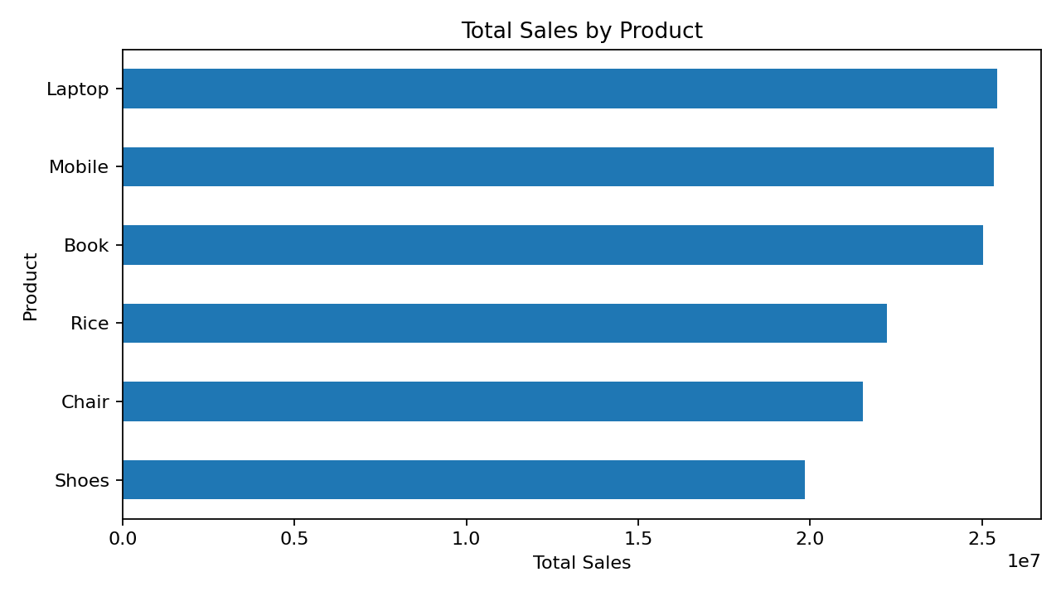
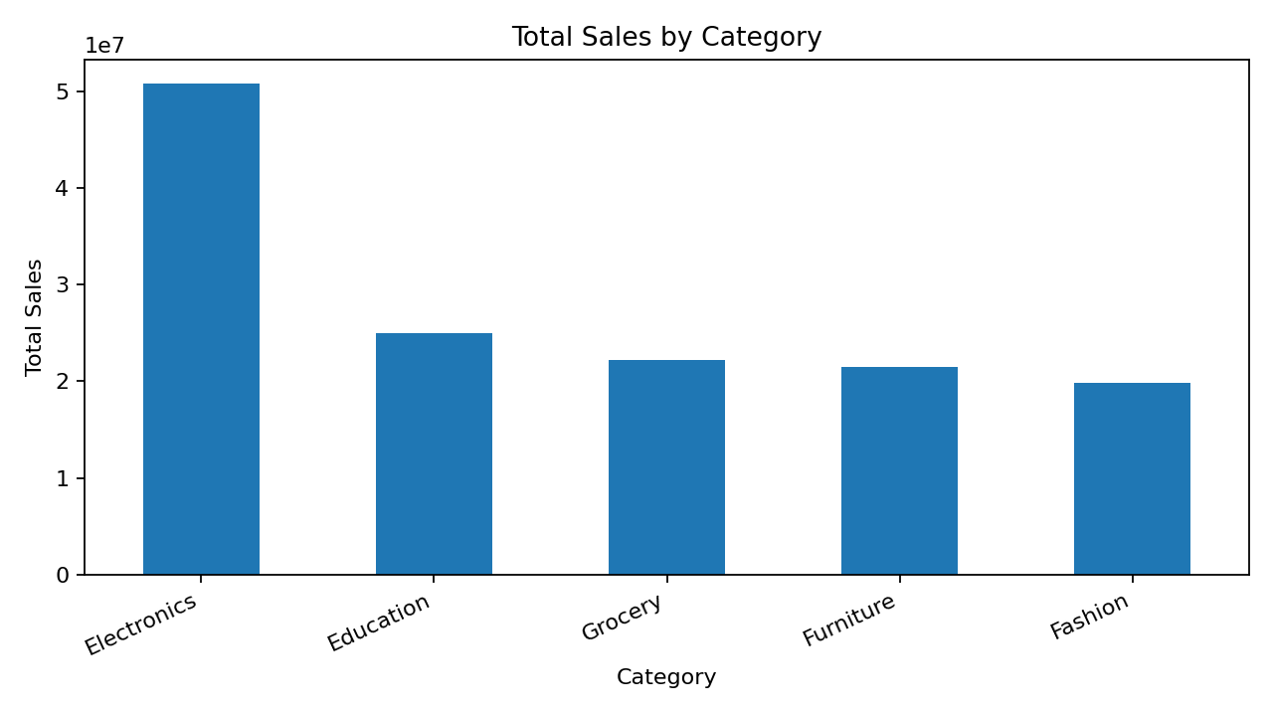
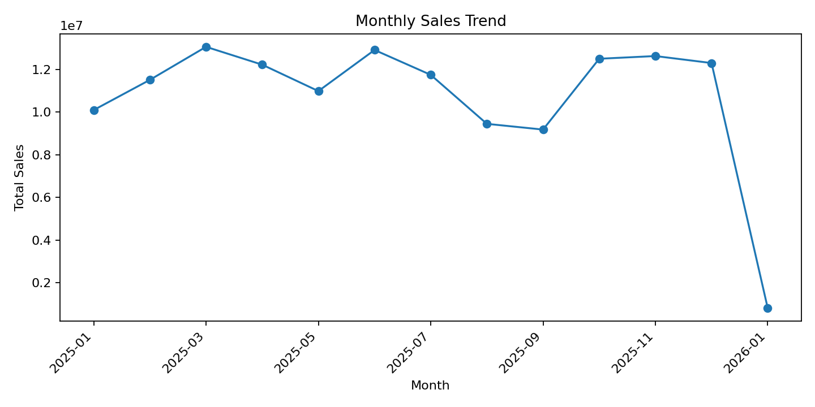

5. Business questions and SQL
Task2_SQL_Queries.sql contains seven SQLite-compatible queries. Query results are included in separate sheets in the Excel workbook.

Q1. Which products generate the highest total sales?
Ranked products by summed sales. Top product: Laptop.

Q2. Which categories generate the most sales?
Ranked categories by summed sales. Top category: Electronics.

Q3. Which cities generate the most sales?
Ranked cities by summed sales. Top city: Patna.

Q4. What is the monthly sales trend?
Grouped sales by calendar month.

Q5. How do sales compare by gender?
Compared row counts, total sales, and average sales by gender.

Q6. Which 10 customers have the highest total sales?
Aggregated sales by customer and sorted descending.

Q7. How do order count and sales vary by age?
Grouped sales and row counts by age.

6. Dashboard proposal
The Excel workbook includes a Dashboard_Mockup sheet with KPI cards and charts. Suggested KPIs: total sales, average sales per row, quantity sold, and unique order IDs. A future interactive version could add filters for date/month, category, product, city, and gender.

7. Limitations
These findings describe only the supplied dataset. The Sales_Check column flags whether Total_Sales approximately equals Quantity × Unit_Price. Repeated order IDs are not automatically treated as errors because the dataset's business rules are unknown.

8. Deliverables
- Task2_EDA_Analysis.xlsx — analysis-ready data, summary metrics, query result sheets, and dashboard mock-up.
- Task2_SQL_Queries.sql — seven SQL business questions.
- Task2_EDA_Report.docx — report with summary statistics, charts, findings, and limitations.
- README.md — package instructions.

