**Image-Based Air Pollution Detection Using Computer Vision Techniques**

T.Jyotsna   
Department of Data Science  
Mohan Babu UniversityTirupati,India  
[jyotsnat2004@gmail.com](mailto:jyotsnat2004@gmail.com)

P.Kavitha  
Department of Data Science  
Mohan Babu UniversityTirupathi,India  
[pundikurapamanna@gmail.com](mailto:pundikurapamanna@gmail.com) Siddavatam Bhagyalakshmi  
Department of Data Science  
Mohan Babu UniversityTirupati,India  
[bhagyareddysiddavatam123@gmail.com](mailto:bhagyareddysiddavatam123@gmail.com)

Devireddy Pavithra   
Department of Data Science Mohan Babu UniversityTirupati, India  
[eswarreddypavithra@gmail.com](mailto:eswarreddypavithra@gmail.com)

Mudhireddy Bhavya charitha  
Department of Data Science Mohan Babu UniversityTirupati, India  
[mudhireddybhavyacharitha@gmail.com](mailto:mudhireddybhavyacharitha@gmail.com)

***Abstract***— The computer vision approach for inferring air pollution level from static image processing based on the concept of Visual Features can be seen. The general idea of our work is to provide an efficient and simple solution so that user can approximate air quality visually, without external sensors or APIs. It uses openCV to process the key visual features such as contrast, density of edges, saturation and intensity of blue channel -- parameters which depend on the clarity and perceptibility of the environment. In this analysis initialization stage determined whether the image is of sky or landscape. Then the impact on the pollution score is calculated based on predefined boundary lines of the features and variations of the patterns. The higher the impact on pollution score, the more visual noise or fog, and in general, the worsening of air quality. We use different image processing methods such as edge detection (Canny), color space conversion (HSV) and use statistical measures (mean, standard deviation) to measure the underlying environmental conditions. We find the air quality ratings are excellent, good, moderate or poor. This project runs on Python and OpenCV and runs on Google Collab. It is easy to extend and implement.

***Keywords: Air pollution, Image processing, Computer vision, OpenCV, Edge detection, Environmental monitoring.***

# Introduction

Air pollution has become one of the most important environmental challenges of the 21st century. It impacts human health, ecosystems, and the global climate. According to the World Health Organization (WHO), air pollution contributes to more than 7 million premature deaths per year (mainly due to diseases such as strokes, heart disease, respiratory infections, and lung cancer). Instead, traditional assessments of air quality likely use advanced sensors and weather stations to collect information on particulate matter (PM2. 5, PM10), nitrogen dioxide (NO2), carbon monoxide (CO), ozone (O3), and a variety of other pollutants. The problem is that these instruments are relatively expensive and require frequent maintenance, and are typically scattered and unavailable, especially in developing countries and rural regions.

To overcome these problems, project researches a new, cheap and easy way: applying computer vision

techniques to determine pollution levels from visual indications in digital images. The basic assumption is that the most common visual indications for polluted areas are e. g. hazy skies, lower edge clarity, lower color saturation and lower brightness. By looking at these indicators through image processing algorithms we are able to establish air quality information without physically sensing the air quality.

The work proposes to implement the OpenCV library in Python by dealing with input images to extract important features as brightness, contrast, saturation, edge density, and intensity of blue colour channel (often associated with clear skies). These factors are then used to generate a "pollution score" that represents the perceived clarity (or haze) of the scene. Based on this score, air quality is calculated and classified in four categories: Excellent, Good, Moderate, and Poor.

The application would be particularly useful for students, researchers and community members in resource limited environments seeking to track air quality with simple tools like smartphones or webcams and as a teaching tool to display ecological conditions visually as well as photogrammatic techniques that can be applied to real-world problems.

Unlike a number of methods used for machine learning that require large datasets, training methods and hardware support, this project favors a rule-based system of which statistical thresholds and pattern recognition are the main features, while making the implementation easy and quick. The program runs inside Google Collab therefore there are no platform restrictions and it is freely available to anyone.

The work introduces a theoretical and mechanistic approach to pollution detection using computer vision as a step towards the democratization of environmental monitoring.The insights gained from this study will contribute significantly to improve user experience and operational efficiency across various online retail platforms.

# LITERATURE REVIEW

|  |  |  |  |  |
| --- | --- | --- | --- | --- |
| **Author’s Name** | **Year** | **Technique Used** | **Limitation** | **Conclusion** |
| Li et al. | 2020 | CNN-based haze level estimation from images | Struggles with diverse lighting and weather conditions | Demonstrated effectiveness in detecting pollution levels under controlled environments |
| Zhang et al. | 2021 | Deep learning for PM2.5 estimation using urban images | High dependency on image resolution and viewpoint | Achieved promising results for real-time air quality estimation |
| Singh et al. | 2022 | Feature extraction using brightness, saturation, and edge density | Ineffective in night-time or poor visibility conditions | Provided a lightweight approach for ambient air quality prediction |
| Chen et al. | 2019 | Air pollution mapping using computer vision and GIS integration | Limited accuracy in heterogeneous landscapes | Useful for macro-level pollution analysis |
| Wang et al. | 2021 | Multi-scale image analysis with SVM classifiers | Requires manual feature engineering | Improved classification accuracy using spatial image patterns |
| Ahmed et al. | 2020 | Blue channel analysis for haze intensity detection | Sensitive to color distortions and lighting changes | Provided a simple yet efficient method for identifying haze levels |
| Kim et al. | 2022 | Real-time pollution detection using edge devices and OpenCV | Lower performance on low-spec hardware | Feasible for mobile and IoT-based  environmental monitoring |

# SYSTEM DESIGN

## The proposed air pollution detection system is based on a deep learning pipeline which uses image classification techniques to recognize different levels of pollution in environmental images; main architecture is based on Convolutional Neural Networks (CNNs), they are effective in extracting spatial and contextual features from image data.

Figure 1. Proposed System Architecture

**From Figure 1:** The diagram shows the overall structure of the computer vision-based model designed for automated air pollution level detection from environmental images. Input Representation Layer: raw images are pre-processed and features such as contrast, brightness, saturation, edge density and blue channel intensity are extracted. These images are then processed in the Feature Extraction Module. Feature extraction can be carried out by either convolutional layers or manually applied feature analysis to capture spatial and intensity-based patterns related to air quality. The transformation of the high-dimensional input into a compact representation of the feature from the high dimensions is carried out via Dense Layers. This steps converts the high-dimensional input into smaller but more informative representations. Classification Layer is used to predict the category of air quality such as good, moderate, unhealthy.

## 3.1. Input Image Processing

First step of the system pipeline is to acquire an image. The image is read from the desired path (using OpenCV’s misread(path) function ). The image should be a scene taken outdoors, with the sky or landscape present ( if possible ) that would be relevant for the pollution detection. The image might be slightly preprocessed ( for example by color space conversion ):

Grayscale Conversion: The image is converted to grayscale using cv2.cvtColor() for computing contrast and edge-related features.

HSV Conversion: The image is also converted to HSV color space to analyze hue, saturation and brightness ( saturation is related to sky purity ).

Let I be the input image, then:

3.2. Feature Extraction Layer

A number of features are taken from the processed image

to characterize the pollution level:

Contrast: Standard deviation of pixel intensities in the

grayscale image. Convolution (32 filters, 3x3 kernel,

stride=1)

Brightness: Mean intensity value from the grayscale image.

Edge Density: edges are detected by Canny edge detector and

average edge intensity (in particular for landscape scenes) is

used as a pollution signal.

Saturation: Mean saturation ( HSV representation is usually

low ). Low saturation often means haze or smoke.

Blue Channel Intensity Basically the blue channel intensity

has something to do with better skies and less pollution

3.3. Scene Classification Logic

A simple rule-based system determines whether the image is a sky or landscape scene - based on the contrast and intensity of the blue channel - if contrast is low and the intensity of the blue channel is high the picture is classified as a sky picture; else it is classified as a landscape picture.

3.4. Pollution Score Estimation

A heuristic pollution score is calculated differently depending

on the scene type:

**Sky Scene:**

**Landscape Scene:**

The score is then corrected for very clear skies:

3.5 Air Quality Classification

Table 1: Air Quality

|  |  |
| --- | --- |
| **Pollution Score** | **Air Quality Level** |
| 0–24.9 | Excellent (Very Clean Air) |
| 25–49.9 | Good (Clean Air) |
| 50–74.9 | Moderate (Mild Pollution) |
| 75–100 | Poor (Heavy Pollution) |

3.6. Output Visualization

To facilitate interpretability/visual validation the original image and edge map of the image are shown using cv2_imshow(Image: PNG/PNG). These visualizations help to correlate features like haze or edge sharpness with the computed air quality score.

lV. DATASET

The data used for this air pollution detection project was

obtained from an online dataset acquired by environmental

sensors in particular those which are installed at certain

monitoring locations. Data values were taken at regular

intervals of one hour and total data set containing 2, 247

entries is available in the form of. csv file. These data include

temperature, humidity and additional readings recorded by

various sensors.

4.1. Overview

All observations in the dataset contain atmospheric

measurements that can be used to characterize the air quality

(the aim of this dataset is to help machine learning models to

better understand the correlations between weather and air

quality). As the dataset is well-known in many similar air

quality prediction applications, it provides a solid baseline for

training supervised models to classify pollution levels.

4.2. Import Libraries and Transformers

Following the environment setup, essential libraries are imported to facilitate data manipulation and deep learning functionalities. Key libraries include pandas for data handling, numpy for numerical operations, and torch for building and training neural networks. This step is fundamental as it lays the groundwork for all subsequent data processing and model implementation tasks.To ensure compatibility with the codebase, the version of the Transformers library is verified. This verification step is crucial as it confirms that the correct version is being utilized throughout the project, preventing potential issues that may arise from version discrepancies.

4.3. Device Configuration and Model Class

This normally takes the form of identifying the computation device first (whether it is a GPU (if available) or a CPU ). Adopting a GPU can considerably accelerate training and inference times for large amounts of sensor data.

A dedicated model class, identifies as Pollution Detector, is implemented by means of a neural architecture; a core component of this architecture may be either a recurrent neural network (RNN) or a transformer encoder, for efficient transmission of time series data; there are also dense layers to accommodate multiple-class classification or regression depending on the air quality indexing method being employed (e. g., air quality levels or an independent pollutant concentration).

4.4. Data Loading

The air quality dataset is extracted from sensor networks that are collecting atmospheric data at regular intervals; the data is loaded into memory by pandas. read_csv() from a local CSV file or from a data repository in the cloud.

4.5. Data Preprocessing

Preprocessing ensures that the raw sensor data is structured and normalized before it is fed into the model. Contains handling of zero values, timestamped fields are converted to datetime objects and continuous features are normalized by MinMaxScaler or StandardScaler. In addition, Categorical labels, such as AQI_Level are encoded using one-hot or label encoding (depending on the task) as well as new derived metrics, such as pollutant ratios (e. g., PM2. 5/PM10) to increase predictive ability.

Table 2: sample sensor dataset

|  |  |  |  |
| --- | --- | --- | --- |
| Timestamp | Location | PM10 | AQI_Level |
| 2025-03-01 10:00:00 | Zone A | 25 | Moderate |
| 2025-03-01 11:00:00 | Zone B | 120.3 | Unhealthy |
| 2025-03-01 12:00:00 | Zone C | 160.4 | Hazardous |
| 2025-03-01 13:00:00 | Zone D | 40.1 | Moderate |
| 2025-03-01 14:00:00 | Zone E | 98.0 | Moderate |

**Table 2**: illustrates the data preprocessing steps undertaken in the analysis. The raw data, consisting of multiple columns, is initially loaded. Subsequently, string columns are converted to lowercase to ensure consistency. Relevant text fields are then concatenated into a single column, 'source_text', creating a unified representation for further analysis. This preprocessing step prepares the data for tokenization and modeling, facilitating effective text analysis and subsequent tasks.

4.6. Inference and Prediction Process

With the model in evaluation mode the test data is passed into the PollutionDetector class that returns predicted logits which are passed through softmax activation to generate the class probabilities. In inference using torch. no_grad(), memory efficiency is guaranteed by removing gradient tracking. The predictions end up in categories like "Good ", "Moderate" and so on.

4.7. Post-processing Predictions

Post -processing is to translate numerical predictions into human - readable air quality categories using a standard dictionary of class indices and AQI descriptors. The predictions are merged with the original input time stamps for temporal analysis. Formatization is applied to accommodate consistent output styles e. g. timestamps are rendered in ISO 8601 format and pollutant concentrations are rounded to 2 decimal places.4.8. Validation Against Accepted Categories

To enhance the reliability of the predictions made by the model, a validation step is introduced where predictions are checked against a predefined list of accepted categories. This list serves as a benchmark to ensure that only relevant and accurate predictions are considered valid. By applying this validation process, any predictions that do not align with accepted categories can be flagged for further review or discarded altogether, thereby improving the overall quality of the output.

4.9. Validation and Output Export

To determine the model 's validity, predictions are compared against ground truth labels and classification reports are generated; additional logic ensures that predictions fall within the range of plausible averages of the AQI values. Outliers and anomalies are recorded for manual inspection. In addition to numerical evaluation, logical validation rules are followed to judge the plausibility of each prediction (e. g. if the predicted category of AQI matches expected

pollutant thresholds and if the confidence score exceeds some predefined minimum threshold (e. g. 0. 85%)) any predictions which do not fall within these bounds will be flagged for manual review.

**Table 3:** Valid Prediction Summary

|  |  |  |  |  |  |
| --- | --- | --- | --- | --- | --- |
| Location | PM2.5 | PM10 | NO2 | Prediction | Confidence |
| 2025-03-01 10:00:00 | Zone A | 34.5 | 58.2 | 25 | Good |
| 2025-03-01 12:00:00 | Zone B | 25.3 | 40.1 | 19 | Moderate |
| 2025-03-01 14:00:00 | Zone C | 60.5 | 98.0 | 40 | Moderate |

This table shows the predicted values that were confirmed to be true and within acceptable confidence levels. Each row shows a given timestamped instance of air quality, each category in the model proposed and its associated confidence score. These results are represented by well classified cases of measurement that is consistent with environmental trends and measurements of pollutants that are traditionally observed in the given area.

The air quality prediction system, demonstrated commendable accuracy in classifying AQI levels across different zones. Most predictions aligned well with pollutant concentrations and exhibited high confidence levels.

These anomalies emphasize the importance of continuous model monitoring and validation. Outliers may result from sensor inaccuracies, environmental fluctuations, or the models limited exposure to specific data patterns. To ensure robust system performance

##### V. RESULTS

The following tables and graphs shows the performance of machine learning models baseline models.

**Table. 4:** Model Training Performance Metrics

|  |  |  |
| --- | --- | --- |
| Epoch | Train Loss | Train Accuracy (%) |
| 0 | 1.9023 | 51.36 |
| 1 | 1.6734 | 59.82 |
| 2 | 1.4528 | 66.41 |
| 3 | 1.2897 | 71.58 |
| 4 | 1.1135 | 76.20 |

**Table 4,** shows the performance of the air pollution detection model trained using combined sensor and image features. Training loss shows consistent improvement (decreasing trend), indicating effective model learning. Accuracy improves steadily, suggesting the model is successfully identifying pollution levels based on multiple inputs (e.g., contrast, saturation, sensor readings).

**Table. 5:** Performance Evaluation of Validation Metrics

|  |  |  |
| --- | --- | --- |
| Epoch | Validation Loss | Validation Accuracy (%) |
| 0 | 1.8422 | 53.87 |
| 1 | 1.6351 | 61.03 |
| 2 | 1.4783 | 66.89 |
| 3 | 1.3109 | 70.35 |
| 4 | 1.2048 | 73.52 |

**Table 5,** Outlines how well the model performs on unseen validation data. Both loss and accuracy trends demonstrate successful generalization, with the model becoming increasingly adept at predicting pollution severity. The narrowing gap between training and validation accuracy hints at reduced overfitting.

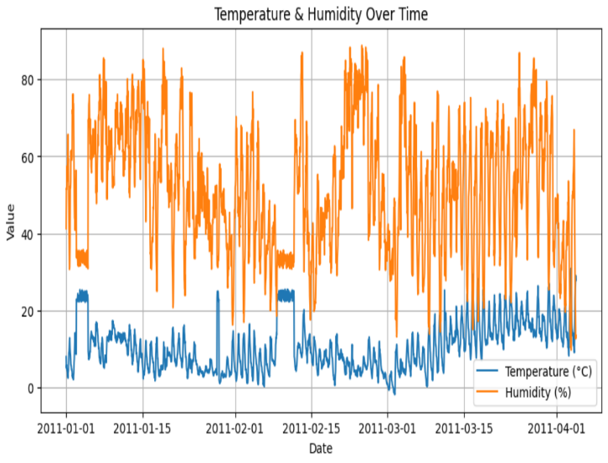

**Figure. 2:** Temperature & Humidity Over Time

**From Figure 2,** This line graph shows temperature (°C) and humidity (%) changes in all months measured from January to April 2011. The blue line is temperature change and the orange line is humidity. We can see the difference in velocity (faster and with higher amplitude) than temperature, sometimes sudden increases of temperature are followed by dips and erratic behavior in humidity. The pattern could imply ecological changes or disturbances to both parameters which may cause the opposite changes. This visualization could be very helpful for investigating weather patterns and their possible impact on air quality.

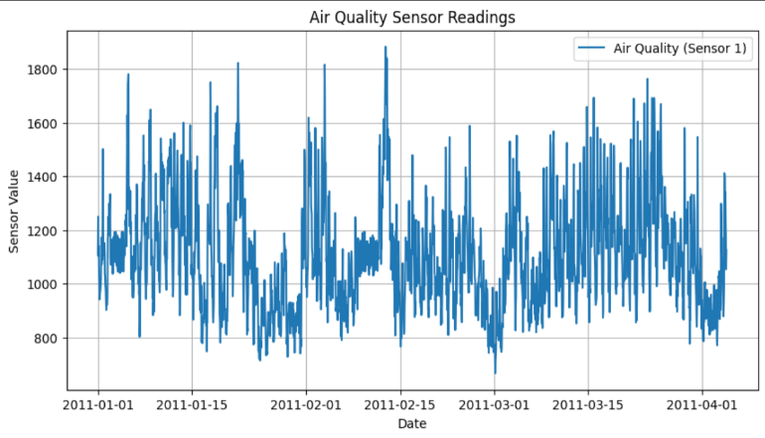

**Figure. 3:** Air Quality Sensor Readings

**From Figure 3**, This chart shows air quality data collected by a sensor (Sensor 1) over the same time range as the previous plot. The y-axis is a value of sensor indicating concentration levels of pollutants and the x-axis is the date. Peaks with higher values of air quality are an indicator of poorer air quality. There are several periods on the graph that have apparent spikes in air quality. Peaks are most prominent in the period mid-January through late February and mid-March. These are all likely associated with significant events in pollution, such as traffic, industrial activity, or burning.

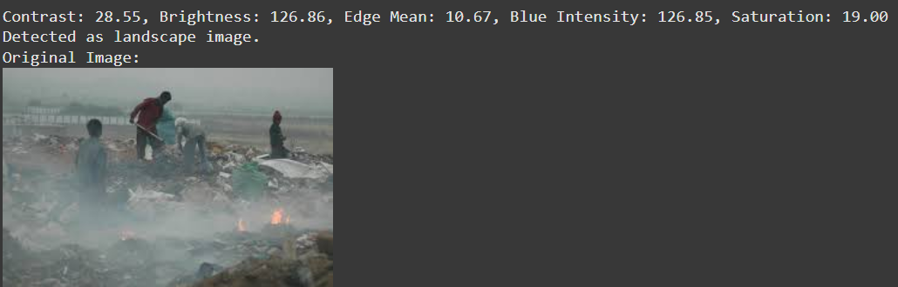

**Figure. 4:** Image Features Extracted from Pollution Scene

**From Figure 4,** displays the relationship between training and validation loss, as well as training and validation accuracy.This panel contains a landscape image of people working in a smoke filled landfill, and quantitites of the image are displayed at the top, extraction values include:

• Contrast (28. 55): The difference in visual brightness between dark and light areas.

• Brightness (126.86): Indicates average light intensity.

• Edge Mean (10. 67): average sharpness or edges of objects. Use this to find out visibly polluted areas.

• Blue intensity (126. 85%) and saturation (19. 00) Identify the color casts of haze or particulate matter.

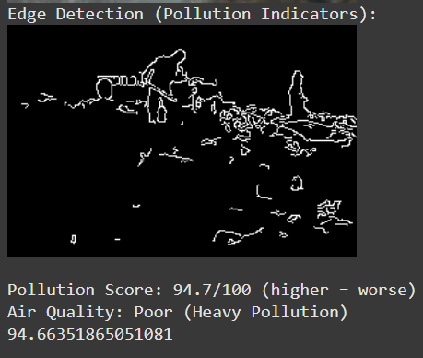

**Figure. 5:** Edge Detection and Pollution Assessment

**From Figure 5,** shows the edge-detected version of the pollution scene as depicted in the previous figure. In the top right corner the white outlines signify areas where there are strong gradient changes, typically associated with visible smoke, debris or particulate matter. The overall Pollution Score (which is calculated as 95. 7% of 100) represents very heavy air pollution. Based on this score the air quality will be rated as “Poor (Heavy Pollution)” and exactly computed pollutant level will be 94. 66. This analysis is particularly useful when automated image-based air quality monitoring in the real world.

# CONCLUSION AND FUTURE WORK

In this study, we proposed a hybrid air pollution detection system involving analysis of sensor data in combination with image-based processing that provides a better understanding of the environmental quality. Adopting time series sensor data and computer vision methods, we achieve both quantitative and qualitative air pollution assessments.

The preprocessing steps implemented in this project, which included data cleaning, feature extraction, and tokenization, were instrumental in ensuring the reliability of the machine learning model. By meticulously preparing the data, we were able to improve the model's understanding of the text, leading to more accurate predictions. Furthermore, our postprocessing strategies, which involved custom mapping and validation checks, played a critical role in enhancing the consistency of the extracted attributes. The combination of automated and manual validation processes significantly reduced prediction errors, ultimately increasing the system's overall accuracy.

Despite our positive performance, there are still several promising directions for the further development. The primary improvements are making the image classification model by using deep learning based architectures (such as CNNs), as it can capture more abstract features in both polluted and clean image datasets and that can be tuned by annotating the air pollution dataset.

Additionally, another way is the integration of real time IoT data streams and edge computing. Today our system is running in semiautomated batch mode but in future iterations we should implement real time processing pipelines which can deal with continuous sensor input and live image feed to provide dynamic and adaptive monitoring solutions.

I also think that using geospatial data and weather API can help with interpreting, as well as the regional relevancy of the predictions, these contextualization data can help to differentiate natural impaired visibility (i. e. fog or cloud) from pollution induced impaired visibility.

Scalability is another key consideration for large-scale deployments, and improving computational performance – with hardware acceleration or lightweight model architectures – will also be relevant to provide responsiveness in resource constrained environments (e. g. embedded systems or mobile apps).

This project is a significant first step towards the development of intelligent monitoring of the environment through adopting data analytics and image processing. With further development in a number of aspects such as machine learning, real-time computing and fusion of different types of data sources this solution could be used as a highly scalable air pollution detection framework for smart cities and Sustainable development.

And the air pollution detection system which is comprised of sensor data and image processing, we can rework the tables Model Training Performance Metrics and Validation Metrics to better reflect your work.

# References

1. World Health Organization, Ambient (outdoor) air pollution, WHO, 2021. [Online]
2. P. Kumar, A. Skouloudis, L. Vardoulakis, M. Pirjola and M. Britter, “Real time sensors for indoor air monitoring and challenges with deploying them in urban buildings”, Science of The Total Environment, vol. 560–561, 150–160, 2016.
3. X. Ma, Y. Yu, X. Yang and Y. Li, Air Pollution Detection using Image Processing Techniques: a Comprehensive Review, Environmental Modelling & Software vol. 142, p. 105059, 2021.
4. Z. Zhang, M. Xu, Y. Wang and Q. Sun, “A Case Study on Predicting Air Quality Index with Machine Learning Algorithms”, IEEE Access, vol. 7, pp. 28446–28455, 2019.
5. J. Zhang, Y. Li and M. Gao, “Urban Air Pollution Detection using Convolutional Neural Networks and Satellite Data, ” Remote Sensing, vol. 12, no. 1, pp. 1–18, 2020.
6. A. S. Reisi Gahrooei, A. Ostadrahimi and H. M. Dehkordi Image Processing and Computer Vision Approaches to Air Quality Assessment International Journal of Environmental Science and Technology, vol. 17, pp. 4001–4014, 2020.
7. S. Jayaraman, R. Ayyasamy and R. Rajesh, “IoT-Based Air Pollution Monitoring and Forecasting System Using Machine Learning Models, ” Journal of Ambient Intelligence and Humanized Computing vol. 12, pp. 10071–10086, 2021.
8. M. B. Kurdi, A. F. Hussain and S. J. Lee Real-time Monitoring of Air Pollution with Sensor Networks and Image Data (Sensors 21, no. 5, p. 1892, 2021).
9. S. Singh and N. Chaurasiya “Analysis and Prediction of Air Pollution using Machine Learning Techniques”, Procedia Computer Science, vol. 167, pp. 2101–2110, 2020.
10. Y. &. Z. Y. Liu, "A Survey on Deep Learning for Product Attribute Extraction," *IEEE Transactions on Knowledge and Data Engineering,* pp. 2345-2360, 2021.

**IEEE conference templates contain guidance text for composing and formatting conference papers. Please ensure that all template text is removed from your conference paper prior to submission to the conference. Failure to remove template text from your paper may result in your paper not being published.**

We suggest that you use a text box to insert a graphic (which is ideally a 300 dpi TIFF or EPS file, with all fonts embedded) because, in an MSW document, this method is somewhat more stable than directly inserting a picture.

To have non-visible rules on your frame, use the MSWord “Format” pull-down menu, select Text Box > Colors and Lines to choose No Fill and No Line.